**Te Horo Rorohiko**

**Department of Computing**

**CH3880 Graduate Diploma in Information and Communication Technologies**

**BCCE301 Cooperative Education Project**

**Semester 2, 2017**

Developing JavaScript Web Applications for Moodle 3

Proposal



Daming Zhang

99137058

# Executive Summary

Anne Wignall is a retired teacher of science and chemistry. She is also a textbook author. In recent few years, Anne has devoted herself to create a number of computer activities to help student to study on Moodle. Anne wishes to perfect Diagram quiz, Hangman exercise Chemistry element picture exercise and an option activity which is to automatically judge if it is one of the possible right answers of circuit diagram quiz.

My mission is to fix the quizzes, translate them from Flash/Actionsctipt into html5/ES6 and work on Moodle 3. The project also needs to be supported by smart phone and tablet (Android&IOS).

The tasks are:

* Diagram: Dragging the right keyword answer label into the appropriate box, the position of the boxes display random coordinate each time when users do the exercise or users input the right answer into the boxes.
* Hangman: Filling the blanks of missing words of a definition and show the process of getting the all of the words right.

# Introduction

This is a proposal document of online quiz on Moodle project. In this document, it includes a brief introduction of the client Anne Wignall, the project background, the benefits of the project, the objectives of the project. In the technical parts, it includes the technical approach and solutions. It also mentions about Quality Assurance and Methodology essay topic. The analysis of risks and the plan of the project are in the end of the document.

# Online Quiz Project Background

Anne uses a quiz tool called Hot Potatoes to create quizzes in HTML and JavaScript. The plugin Hot Potatoes, allows quizzes to be run on Moodle. The version of Moodle on Anne is Moodle2. The schools she works with are using Moodle 3 now, which is part of the reason that need to upgrade the files to the demanding environment of Moodle3. The currently issues are:

Diagram:

1. It can not to be set as an activity on the Moodle now. It cannot get mark from Moodle.
2. Each time that the diagram generated has different coordinate of answer boxes, The boxes always keep in the same position in the diagram at the moment, so when users do the diagram quiz they may just remember the order of the answer not really know the answer match what part in the picture.

Hangman:

1. It has not to be set as an activity on the Moodle now. It cannot get mark from Moodle.
2. Filling the missing word quiz can be created by the Hot Potatoes at the moment, but Anne wants a different form. She wants to fill in a whole sentence or a short paragraph. Also the Hangman needs a sort of count number to calculate how many chance users can get wrong guessing letter or word.

# Objectives

The programs have to work in Moodle 3, which has added security levels; they need to work with Firefox, Chrome, Safari and Microsoft Edge. We're not bothering with Internet Explorer. They need to work on mobile devices with touch screens, both iOS and Android, and desktops, and laptops. Users are primarily students in the third world.

1. The project is aiming to fix all agreed problems to the existing resources. Each activity has different issues.

2. After fixing them, it also needs to implement new features (animations) that Anne requires to add to these activities according to the requirements.

3. It needs to make the user more positive and motivating to use the quiz for studying on Moodle.

# Solutions & Technical Approach

For the project I am going to use JavaScript to rewrite the Flash code. I am going to use CSS3 to control the layout and style. XML also used in the project.

In the project, many places need the dragged labels, I currently have two ideas of how to implement it:

1. Diagram: Using HTML5 canvas feature to draw them, then change the coordinate if it has to.
2. Hangman: Using CSS and HTML tag to draw the component and use JavaScript to make them dragged.

For the animation of showing the process of getting success of Hangman, I am going to use several Gif images to show each steps. I have two animation scenarios may attract user to use it and make it more fun:

1. Building house: When user get right, the house is built gradually, if uses get wrong, there will be a bomb to destroy the house.
2. Car racing: The more the uses get the right answer, the closer the car gets to the destination. And the car will be stopped by car crash.

The animation is not priority, the function of Hangman is first. But if takes some time to get the animation done, Anne will be very glad to have it.

1. During the programming period of developing Diagram project, I made a tool for generating coordinates for quiz picture, my client wants it more powerful that it can support to create with superscript and subscript text and generate XML code automatically.

# Vision & Benefits

The project vision is fixing these quiz resources and add new features to fulfil following goals:

1.Identify and fix all bugs

2.Modernise

a) Mobile support (Android, iOS)

b) Multi-browser support (major browsers on Windows)

c) Replace Flash to JavaScript

3.Improve usability

User guide documentation

4.Add new features as agreed throughout the course of the project

Must have features that were given at the beginning of the project

Additional features requested that would be given from Anne if must have features were finished

5.Improve maintainability by restructuring the existing code (refactoring)

As a result, the client will get following benefits.

1. The programs that actually work
2. Better usability
3. Creating and maintaining quizzes become easy
4. Use of the programs on Moodle become easy and meaningful

# Quality Assurance

Quality Assurance is short for QA, which means the approaches of checking if a project meets the client’s requirements.

1. Readability by maintainer: In order to making easier for maintainer, write readable comments and modularity code help maintainer understand the system quickly.
   1. Comments: It includes function header comments and line comments. Describe what happens for the code.
   2. Modularity: Make the code structural and clear, can be easy to add up new function or reuse the code for maintainers.
2. Separate js file: Separate the js file into different file base on the class and design pattern
3. Classes: Create classes base on the
4. XML structure: The XML should be structural, it should not write every tag in one line. It needs to

use indentation for each child tag.

1. Functionality: The project should work as required, which means the project works. There are three main users that will use the project and care about the functionality.
   1. Client
   2. 3rd World students on mobile devices
   3. Teachers- create new quizzes by modify xml file

# Methodology essay topic

For this part, my methodology essay topic is “Agile software management”. Agile management of IT project is widely used for software development. Extreme Programing as a common agile method, it was first used in the mid 1990’s. It is successful method because it leads customer to fell satisfied. It is not easy to deliver everything that as developers planed forego on some date very far in the future. With using this method, the process delivers the achievement as you plan it. Extreme Programming makes developers to respond confidently to changing requirements or adapting to client feedback.

The XP planning game emphasizes teamwork. Clients, managers, and developers are all equal important role in the collaborative team. It implements a simple and effective environment that encourages and enables developing teams to become highly productive. During the programming period, I met my client Anne one a week. Every time after meeting the requirements changed or were added. It is quite normal happened in the industry. So a good strategy of effectively and clearly communication skill to negotiate with client is very important for managing the project.

# Risks

Risks in the software developing can not be avoid, many reason can slow down the project or even make the project fail. There are three parts of risk needs to consider.

| **Risk name** | **Impact** | **Possibility** | **Exposure** | **Mitigation** | **Contingency** |
| --- | --- | --- | --- | --- | --- |
| **Member not familiar with the technology** | 80% | 80% | 64% | Schedule time for learning and researching | To get support and helps from Academic and Industry Supervisor |
| **Requirements change or be added** | 60% | 70% | 42% | Check with the client’s priority. Then modify the plan of project | Change project plan and take changes into the next weekly plan |
| **Testing environment not available** | 80% | 20% | 16% | Check available environment | Build environment |
| **Too many bugs that not all can be fixed** | 80% | 20% | 16% | N/A | Change project scope to fix only those of high priority |
| **Member sick** | 80% | 10% | 8% | Do not work day and night, having rest is important | Have enough rest every day. |
| **Client is not available** | 30% | 20% | 6% | Get the client’s schedule beforehand | Make plan to do things that I can do without the client |
| **Data lost** | 90% | 5% | 4.5% | Using GitHub and One Drive to manage the version control | Download from repository  Or One Drive |
| **Budget might be needed** | 50% | 1% | 0.5% | Check if I can use budget and how much | Select methods that do not need money |

1. Project Risk – some factors could cause a project to fail;

1.1 Financial - the investment of the project is not enough;

1.2 Strategic – the requirement may change or need to add some new feature;

1.3 Technical – the key technology of the project may not get enough support in the future;

1. Production System Risk
   1. The production support team members may have not enough experience and skills sometimes.
2. Personal Risk

3.1 The degree or the knowledge of skill may not enough to support the project.;

3.2 The impact on developers health and the emotional will effect the project schedule;

# Plan & Deliverables

|  |  |  |
| --- | --- | --- |
|  | **Description of Work** | **Start and End Dates** |
| **Phase One** | Diagram implementation and test | Jul 29th ~ Sep 1st |
| **Phase Two** | Hangman implementation and test | Sep 2nd ~ Oct 12th |

The time table as follow:

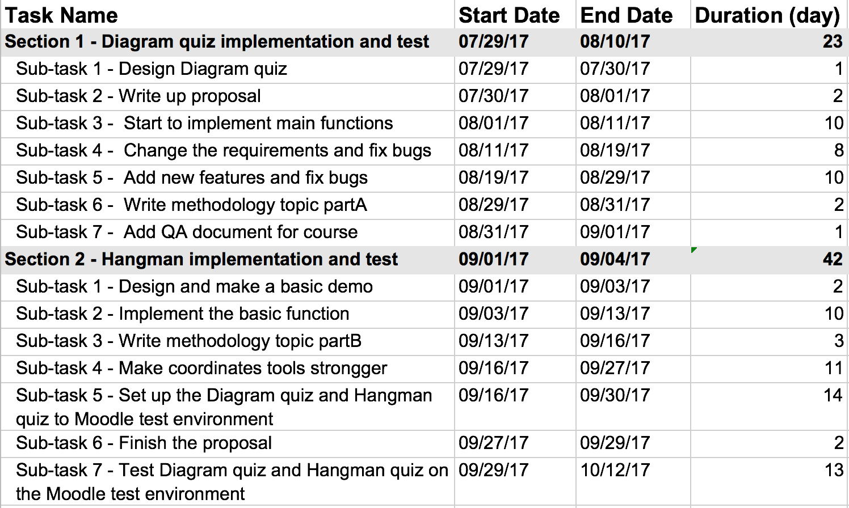

From Oct 13th to Nov 17th, I am doing the project report and other academic work.

# Budget

This is a no payment project, so there is no budget estimate.

Reference: