Q1. What steps would you take to improve this process?

Q2. What steps would you take to improve the user interface and user experience?

Q3. How would you test and make the enrolment process usable on all devices?

A1:

First, use cookies to auto-fill the form. As we often input our name, email, phone,DOB in different websites, so auto-fill that info can save a lot time and make it easy.

Second, add a save draft function. Users can proceed the process at any time.

Third, use tab page to switch page in different areas.

A2:

First, the space. A progress bar saves space and more clearly to show users where they are.

Second, responsive design. When it shows on different devices, the progress bar can show vertically, so users don’t need to scroll up and down to check which step they are at.



Third, colour and font. A good colour and font design makes website more attractive. “Arial” is save, as we know Apple website use this font. I think don’t use more than 3 different fonts, because that makes people feel visual fatigue and the website looks like it doesn’t have a theme.

Forth, show the website to people in different age groups. Get some feedback of what they are feelings.

A3:

Almost all the main stream browsers have developer tool which can switch to different devices.

Here is a screen shot from my Chrome developer tool. We can use that to switch in different devices and choose different orientation.

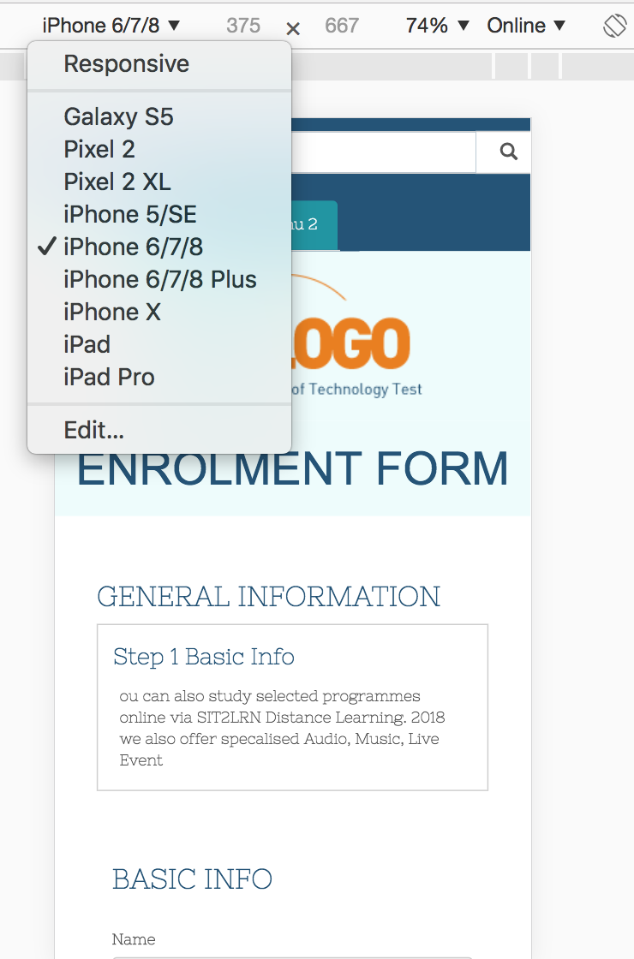

Except that, I upload my files to the Github page. Then test in the real environment on my smart phone and PC.

Other information about practical test:

The link below is my source code on Github(the online media).

https://github.com/mingdazhang2/enrolmentSite

You also can click this link to have a quick look at the result online:

https://mingdazhang2.github.io/enrolmentSite/index.html