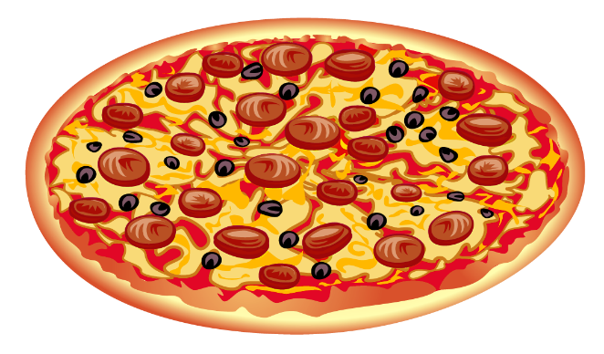

Dave’s Pizza

(541) 555-1234

## CREATE YOUR OWN PIZZA

Size: Small 11” Medium 13” Large 17”

$10 $13 $15

Choose your toppings: each topping is an additional $1

Pepperoni

Sausage

Canadian Bacon

Green Peppers

Olives

Pineapple

Mushrooms

Onions

Extra Cheese