Daily, Monthly, Yearly Charts

Plot charts to help visualise the number of yearly, monthly, and daily occurrences for each area.

# Data

* Data/ interview_data.csv

# Notebook & Code

Codes/Notebook for the charts can be found in

* basic_plot_explore.ipynb

Note that all the charts included within this word document are static and plotted with matplotlib/seaborn. They are just snippets of the chart extracted from notebook.

# Daily Charts

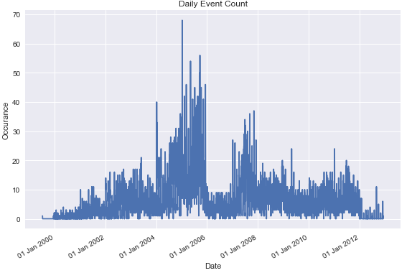

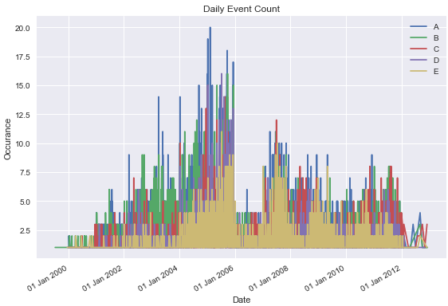

# Monthly Charts

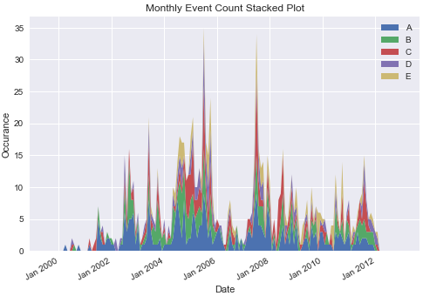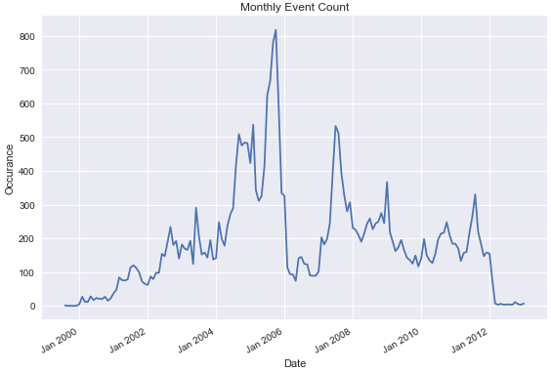

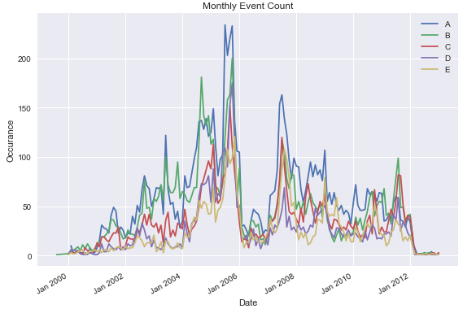

# Yearly Charts

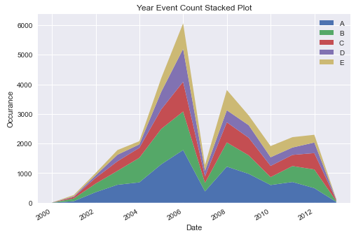

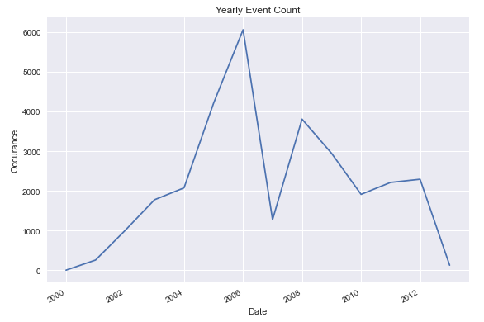

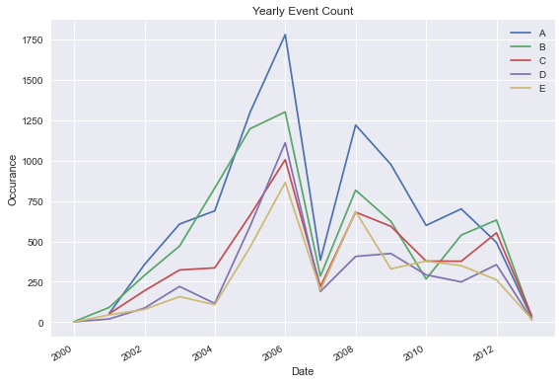

# Tree Map Chart

To visualize which Area the events have been occurring the most.

