LIQUID: 2-D FLUID DYNAMICS SIMULATOR

Software Requirements Specification

Version 1.0

09/22/2015

PRYMM
Pavan, Radhika, Yashraj, Minghua and Manoj

Prepared for
Principles of Software Engineering
Fall 2015

Revision History

Date | Description | Author | Comments
09/22/15 | Initial draft version | Pavan,  Radhika, Yashraj, Minghua and Manoj | Version 1.0 – Initial draft prepared and reviewed by complete team. SRS has been documented based on list of requirement listed in Project Requirements document on Blackboard

Document Approval

The following Software Requirements Specification has been accepted and approved by the following:
Signature | Printed Name | Title | Date

Table of Contents

Revision History ii
Document Approval ii
1. Introduction 1
1.1 Purpose 1
1.2 Scope 1
1.3 Definitions, Acronyms, and Abbreviations 1
1.4 References 2
1.5 Overview 2
2. General Description 2
2.1 Product Perspective 2
2.2 Product Functions 3
2.3 User Characteristics 3
2.4 General Constraints 3
2.5 Assumptions and dependencies 3
3. Specific Requirements 4
3.1 External Interface Requirements 4
3.1.1 User Interfaces 4
3.1.2 Hardware Interfaces 4
3.1.3 Software Interfaces 4
3.1.4 Communications Interfaces 4
3.2 Functional Requirements 5
3.2.1 The system shall enable users to set up the spatial configuration 5
3.2.2 The system shall be able to control various parameters: viscosity, type of liquid, flow speed and others. 5
3.2.3 The system shall visualize flow density dynamically 5
3.2.4 The system shall provide both textual and animated representation of what is happening during execution 6
3.2.5 The system shall be able to provide on-demand information about flow values about any location in the environment 6
3.2.6 The system shall provide the ability to the user to place monitoring points (flow meters) to show information during execution without affecting the behavior of the liquid 6
3.2.7 The system shall be able to clearly indicate when activities begin and end 7
3.2.8 The system shall be able to provide detailed logging about state of fluids at break points, flow meters, overall environment, provide information about properties and activities at each increment of execution 7
3.2.9 The system shall be able to provide text file logging capability so users can retrieve their results and trace the execution 7
3.2.10 The system shall be able to provide replay log capability (replay the animation of a prior execution) by reading a previously saved log file 8
3.2.11 The system shall accommodate change in temperature and fluid density. 8
3.2.12 The system shall use the Metric System. 8
3.2.13 The system should support the simulation of H2O and glycerin 9
3.2.14 User shall manually indicate the end of the simulation 9
3.2.15 Product environment shall be a rectangle with configurable sides, like a glass of water or a pipe. 9
3.2.16 Rectangular and spherical obstacles shall be addable to the container which will inherit height from container height in the simulation 9
3.2.17 The configuration shall have the ability to set-up an exit way from the container to examine fluid behavior (exit can resemble a pipe) 10
3.2.18 Breakpoint monitor data at certain point in container 10
3.2.19 Breakpoint can be labeled by increment. 10
3.2.20 All results of the simulation shall be written into a log file, settings and breakpoint info. 11
3.2.21 There will only be one source of initial force in a given simulation. Initial force is configurable 11
3.2.22 Fluid velocity (steady flow) is configurable. 11
3.2.23 The scale of the simulation (container size) will be configurable to either meters (m) or centimeters (cm) and will remain constant during execution. 12
3.3 Use Cases 12
3.3.1 Use Case 1 12
3.3.2 Use Case 2 13
3.3.3 Use Case 3 13
3.3.4 Use Case 4 14
3.4 Classes / Objects 14
3.4.1 Flow / flow 14
3.4.2 SingleDrop / singleDrop 15
3.4.3 InitialForce / initialForce 15
3.4.4 FlowMeter / flowMeter 16
3.4.5 Barrier / barrier 16
3.4.6 Logging / logging 17
3.4.7 Window / window 17
3.5 Non-Functional Requirements 18
3.5.1 Performance 18
3.5.2 Reliability 18
3.5.3 Availability 18
3.5.4 Security 19
3.5.5 Maintainability 19
3.5.6 Portability 19
3.6 Inverse Requirements 19
3.7 Design Constraints 19
3.8 Logical Database Requirements 20
3.9 Other Requirements 20
4. Analysis Models 20
4.1 Sequence Diagrams 20
4.2 Data Flow Diagrams (DFD) 21
4.3 State-Transition Diagrams (STD) 21
5. Change Management Process 21
A. Appendices 22
A.1 Requirements Document 22

1. Introduction
This section provides an overview of the Software Requirements Specification (SRS) for the project called LIQUID which is a 2-D Fluid Dynamics Simulator. The purpose of this document is to present in depth clarity of the requirements associated with the project to its intended audience. And the scope of the project gives a particular focus on what the software will do and the benefits related to it. The complete overview of the project is provided in this document for a complete and easy understanding for the reader.

1.1 Purpose
The purpose of the SRS is to outline both the functional and non-functional requirements of the project Fluid dynamics simulation. This document also provides a detailed profile of external interfaces, design constraints and performance considerations. This document is created to contain the detailed information of the project like the software requirements needed to develop the project. The document should act as a foundation for efficient and well-managed project completion and further serve as an accurate reference in the future.
And overall the document is divided for two types of audience. The primary audience of the SRS document will be development group, where they plan the project and develop the project and implements the project on the basis of client requirements. These are all done with the help of the SRS document only. And the secondary document audience comprises the other stakeholders of the project. The SRS will convey and confirm the required functionality and represent an agreement between the involved parties.

1.2 Scope
The software product to be produced here is fluid dynamic simulator. The scope of the project is to demonstrate the behavior of various fluids in different environment. This shall be demonstrated by highlighting properties of fluid like viscosity, density, velocity etc. The software product will help us to read the properties of the fluid used for simulation such as density and velocity at any point of the running simulation. Here mainly we are trying to find out the behavior of certain fluid in certain condition so that we can clearly understand the complete picture of that fluid for any of its application in similar condition. The objective and goal of the product is to show the data and record the data during the simulation run in order to understand the dynamics of fluid for certain environment. Here it provides both textual and animated representation of what is happening during execution.

1.3 Definitions, Acronyms, and Abbreviations
Here in this section it describes about the definitions and acronyms and abbreviations that we are using all over the SRS document. This is done for better understanding of the reader about the terms that is used throughout the document.

- SRS: Software Requirement Specifications
- cms: Centimeters
- MS: Microsoft
- GUI: Graphical User Interface
- DFD: Data Flow Diagram
- STD: State Transition Diagram

1.4 References
- https://nerget.com/fluidSim/
- http://physics.weber.edu/schroeder/fluids/
- https://haxiomic.github.io/GPU-Fluid-Experiments/html5/?q=UltraHigh
- SRS has been documented based on list of requirement listed in Project Requirements document on Blackboard

1.5 Overview
This SRS document Contains general description of the product’s perspective and its functions. This section also covers different characteristics of a user and list of constraints in this project. It also has Specific Requirements which is the major part of this SRS Document. In here the requirements are mainly classified into functional and non-functional requirements. It also describes the External Interface Requirements and use-case diagrams which has Classes and Objects. There are few other requirements mentioned in this Specific Requirements, those are the Inverse Requirements, Design Constraints, Logical Database Requirements and Other Requirements .This SRS Document also depicts Sequence Diagrams, Data Flow Diagrams and State-Transition Diagrams. Change Management Process is also included in order to mention manage change during the complete life cycle of the project.

2. General Description

Here in this section, general description of the product is covered. In this section product is compared with the other similar projects. Functionality of the project is also covered in this section along with any assumptions and dependencies.

2.1 Product Perspective

The application has to be an installable file and not a web based application. Being an installable software this project does not need an internet connection whereas most of the products implementing 2-D Dynamic Fluid Simulators are web based applications (Refer section 1.4 Reference for such projects) and need internet connection to perform simulation. Like other existing web based application which are mentioned in the reference section of SRS, this project also uses thermal lattice Boltzmann method to simulate fluid behavior and it also provide similar user interface to setup the configuration for the simulation. This project is a complete project in itself and not a part of bigger system.

2.2 Product Functions

This section gives an overview of functioning of the product. First of all this software is an executable file and will run on MS windows platform. The software allows the end user to understand the behavior and properties of the fluid. The software shall allow the user to configure simulation settings such as viscosity, fluid density, flow speed etc. Software should also provide output to the end user in both textual data and in animation form. It shows clearly how the fluid is behaving under certain conditions given configured by the end user. System shall also provide an option to pause the fluid simulation whenever the user wants to. Along with that system should also provide the option to add or remove barriers and modify shape of the barrier.

2.3 User Characteristics

The end users of the system should have basic understanding of Lattice Boltzmann method in order to use this simulation project to understand the fluid dynamics and its behavior under certain conditions. By having that understanding the user can take full advantage of analyzing any liquid or comparing properties of liquid.

2.4 General Constraints

This section describes the restrictions on the development environment of the application.
These constraints can be an algorithm or a development environment. In this project development team should use Lattice Boltzmann method to simulate the behavior of the fluid. The project should be developed to be an installable application which is modular in nature. By modular it means that the GUI and rendering engine should be able to be separated.

2.5 Assumptions and dependencies

This application will run on MS windows platform. The application which we are about to create will contain a GUI and a backend. Both of these units should be separable in order to work with any other GUI or backend with minimal integration.

3. Specific Requirements
This section will provide more clarity to the design and development team of the project. This section covers detailed requirement of the project. This section comprises of requirements related to external interface, functional requirement, use cases, classes and non-functional requirement.

3.1 External Interface Requirements

3.1.1 User Interfaces
The system user interface should provide both input and output interfaces to the user to interact with the software. Firstly, the user input interface should allow user to configure the simulation environment so that he can setup the configuration to be simulated. Secondly, the system shall provide output to the user in visual and textual form for the behavior of the fluid under simulation.

3.1.1.1 Output interface
Visual Output: Visual representation of the output shall be represented in a 2-Dimentional rectangular screen showing various properties of fluid such as fluid density at specific space and time in the rectangular screen.

Textual Output: Textual representation of the output shall be displaying parameter names and their values such as density at flow meters and break points.

Logging capability: User should be provided a log at the end of the simulation run.

3.1.1.2 Input interface
User should be provided with interface to control and configure various simulation parameters listed below:

- Viscosity: Ranging from 0.005 to 0.2000
- Type of liquid: At least H2O and glycerin
- Flow speed of liquid: Ranging from 0.000 to 0.120
- Size of rectangular simulation container: 6x12cms and 5x10cms
- Temperature: Ranging from -100 to +100 *c
- Density of fluid: Ranging from 1 to 3500 kg/m3
- Exit path: User can enable exit which resembles a small diameter pipe than that of the diameter of the pipe used for the simulation.

3.1.2 Hardware Interfaces
The system has no hardware interface requirements.

3.1.3 Software Interfaces
The system has no software interface requirements.

3.1.4 Communications Interfaces
The application shall be developed in such a way that the rendering engine and the GUI are independent. Hence system should have a communication interface layer between GUI and rendering engine allowing developers to use other GUIs created on the same operating system with minimal integration

3.2 Functional Requirements
This section describes specific features of the software project. If desired, some requirements may be specified in the use-case format and listed in the Use Cases Section.

3.2.1 The system shall enable users to set up the spatial configuration
- Introduction:
The system should only allow user to configure the spatial configuration through the control panel.
- Inputs:
None
- Processing:
The system will read the values configured by users in control panel for later process.
- Outputs:
None
- Error Handling:
All the controls should be display a legal range as defined for values. User should not configure by self-input thus no error input will occur.

3.2.2 The system shall be able to control various parameters: viscosity, type of liquid, flow speed and others.
- Introduction:
The system should pass the values configured by users to viscosity, type of liquid, flow speed, factors in order to adjust the simulation accordingly
- Inputs:
None
- Processing:
Values read from the user input should be assigned to viscosity, type of liquid, flow speed, Size of rectangular simulation container, Temperature, Density of fluid and Exit path in the system accordingly
- Outputs:
None
- Error Handling
The value read from user input should be in the legal range of each factors

3.2.3 The system shall visualize flow density dynamically
- Introduction
The system should display in a 2-Dimentional rectangular screen showing various properties of fluid such as fluid density at specific space and time in the rectangular screen
- Inputs
User configurations
- Processing
The system should apply user configurations and calculate necessary
- Outputs
New simulation should be shown on the display frame.
- Error Handling
System will discard invalid user input

3.2.4 The system shall provide both textual and animated representation of what is happening during execution
- Introduction
The system should provide animated representation based on the configurations and textual representation of the output displaying parameter values such as density at flow meters and break points
- Inputs
Any event happening during execution
- Processing
System should gather data of events that is happening during execution
- Outputs
System should give textual as well as animated output for any event.
- Error Handling
None

3.2.5 The system shall be able to provide on-demand information about flow values about any location in the environment
- Introduction
The system should give user detailed flow values about available locations in the environment if user requests such information.
- Inputs
User’s requests for flow information about location in the environment
- Processing
System should gather all the information as per user’s request and give such back to user.
- Outputs
System will display user’s requested information
- Error Handling
System should not response to an invalid request

3.2.6 The system shall provide the ability to the user to place monitoring points (flow meters) to show information during execution without affecting the behavior of the liquid
- Introduction
The system should let user place monitoring points on the display frame and show information on those points about the current liquid information.
- Inputs
User’s placing monitoring points on the display frame
- Processing
System should collects fluid information on the points where user put for monitoring.
- Outputs
System should show fluid info on the points to user.
- Error Handling
System should not enable user set points on the initial force and outside the area of container..

3.2.7 The system shall be able to clearly indicate when activities begin and end
- Introduction
The system should record begin and end time for each event and activity
- Inputs
System activities and events caused by user behaviors
- Processing
System should add begin and end time information for each events and activities.
- Outputs
In system log file, each activity and event should encompass begin and end time information
- Error Handling
None

3.2.8 The system shall be able to provide detailed logging about state of fluids at break points, flow meters, overall environment, provide information about properties and activities at each increment of execution
- Introduction
The system should generate log file recording state of fluids at break points, flow meters, overall environment; provide information about properties and activities at each increment of execution.
- Inputs
User’s requests during execution
- Processing
System should record state of fluids at break points, flow meters, overall environment, information about properties and activities at each increment of execution.
- Outputs
Log file should be generated by system recording state of fluids at break points, flow meters, overall environment and information about properties and activities at each increment of execution.
- Error Handling
System should not respond to user’s illegal behavior thus log file should not contain such information of requests.

3.2.9 The system shall be able to provide text file logging capability so users can retrieve their results and trace the execution
- Introduction
The system should provide text file logging function for users to retrieve their results and trace execution
- Inputs
User’s request for retrieving their tracing results during the execution
- Processing
System should generate log file for user’s request
- Outputs
Log file containing requested information should be provided to user.
- Error Handling
System should not respond to user’s illegal behavior thus log file should not be provided for such information of requests

3.2.10 The system shall be able to provide replay log capability (replay the animation of a prior execution) by reading a previously saved log file
- Introduction
The system should replay animation of a prior execution by reading a previously saved log file
- Inputs
User’s file of previously saved log for replay
- Processing
System should be able to read the log file and verify the validity of the value in it.
- Outputs
Replay the animation as per the log file
- Error Handling
System should not replay if there’s any illegal values or operations in that log file

3.2.11 The system shall accommodate change in temperature and fluid density.
- Introduction
The system should replay respond to the change in temperature and fluid density
- Inputs
User’s settings on temperature and fluid density
- Processing
System should process the change of temperature and fluid density and display the same
- Outputs
Graphic display as per the change of temperature and fluid density
- Error Handling
System should not let user configure invalid values for temperature and fluid density

3.2.12 The system shall use the Metric System.
- Introduction
The system should integrate Metric System
- Inputs
None
- Processing
None
- Outputs
Metric system is integrated and deployed on the system
- Error Handling
None

3.2.13 The system should support the simulation of H2O and glycerin
- Introduction
The system should simulate fluid of H20 and glycerin
- Inputs
User’s choosing type of the fluid between H20 and glycerin
- Processing
System should display the type of fluid that user has chosen. There will be a default value before the execution
- Outputs
System will display the simulation of the chosen type of fluid
- Error Handling
None

3.2.14 User shall manually indicate the end of the simulation
- Introduction
The system should let user manually indicate the end of simulation
- Inputs
User’s behavior of terminating the execution
- Processing
System should stop itself from running if receive command from user
- Outputs
System is no longer simulating the fluid
- Error Handling
None

3.2.15 Product environment shall be a rectangle with configurable sides, like a glass of water or a pipe.
- Introduction
The system should be a rectangle with configurable sides containing all the controlling features
- Inputs
None
- Processing
None
- Outputs
System should include its configurable sides in a rectangle
- Error Handling
None

3.2.16 Rectangular and spherical obstacles shall be addable to the container which will inherit height from container height in the simulation
- Introduction
The system should enable user add rectangular and spherical obstacles on the display frame
- Inputs
User adding rectangular and spherical obstacles on the display frame
- Processing
System should be able to let user add 2 different obstacles: rectangular and spherical.
System should also change the fluid dynamically depending on the obstacles where and which user has added
- Outputs
System should display the fluid effect after user’s placing the obstacles
- Error Handling
System should not display or let user add obstacles where initial force is located.

3.2.17 The configuration shall have the ability to set-up an exit way from the container
to examine fluid behavior (exit can resemble a pipe)
- Introduction
The system should enable user set an exit way from the container
- Inputs
Adding an exit way in the display frame
- Processing
System should re-calculate and alter the fluid near the exit way after user put one.
- Outputs
System should display the updated fluid effect after the exit way is added
- Error Handling
System should not display and let user add this exit way where the initial force is located.

3.2.18 Breakpoint monitor data at certain point in container
- Introduction
The system should calculate monitor and display flow location, velocity, density of fluid and at breakpoints
- Inputs
Breakpoints should be placed in advance
- Processing
System should monitor and record data where breakpoints are placed
- Outputs
Monitoring data should be displayed accordingly once the breakpoint is set
- Error Handling
None

3.2.19 Breakpoint can be labeled by increment.
- Introduction
The system should be able to label breakpoints by increment
- Inputs
Breakpoints should be placed in advance
- Processing
System should add label to these breakpoints placed by increment
- Outputs
Breakpoints are labeled and can be seen by user
- Error Handling
None

3.2.20 All results of the simulation shall be written into a log file, settings and breakpoint info.
- Introduction
The system should generate log containing settings and breakpoints info during the execution of the simulation
- Inputs
Breakpoints should be placed in advance
- Processing
System should record the data of breakpoints and other settings and write such info into a log file
- Outputs
Log file should contain settings and breakpoint info
- Error Handling
None

3.2.21 There will only be one source of initial force in a given simulation. Initial force is configurable
- Introduction
The system should have only one initial force generating the fluid and this force is configurable
- Inputs
None
- Processing
System should only enable user set one initial force and configure the force by default value. The values for the force can be modified by user in a given legal range respectively
- Outputs
Configuration frame should contain buttons for setting initial force for user. Initial force should be seen after user put onto the display frame
- Error Handling
Values configured out of the range should be discarded and cannot be applied to the initial force
System should not enable user set a second force

3.2.22 Fluid velocity (steady flow) is configurable.
- Introduction
System should enable user to configure fluid velocity
- Inputs
User’s configuring fluid velocity
- Processing
System should provide interface for user to configure fluid velocity and apply the value to the simulation
- Outputs
Fluid display should be updated as per the settings of fluid velocity
- Error Handling
Fluid velocity should be defined in a certain range and forbid user configure outside of the range

3.2.23 The scale of the simulation (container size) will be configurable to either meters
(m) or centimeters (cm) and will remain constant during execution.
- Introduction
The system should enable user configure the container size in centimeter before the execution
- Inputs
User’s changing the container size of the simulation
- Processing
System should change its display frame as per the user’s configuration
- Outputs
System’s display frame is changed according to the values configured by user
- Error Handling
System should no longer change the frame after the execution. All the values of the container size should be constant during the execution

3.3 Use Cases

3.3.1 Use Case 1
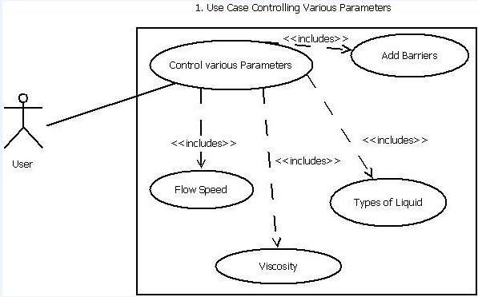

3.3.2 Use Case 2
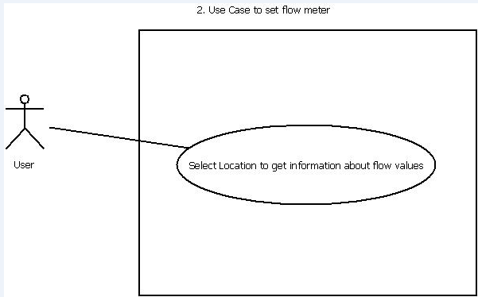

3.3.3 Use Case 3
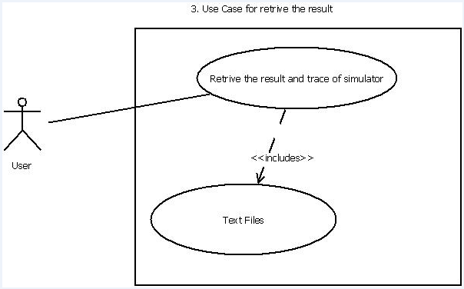

3.3.4 Use Case 4
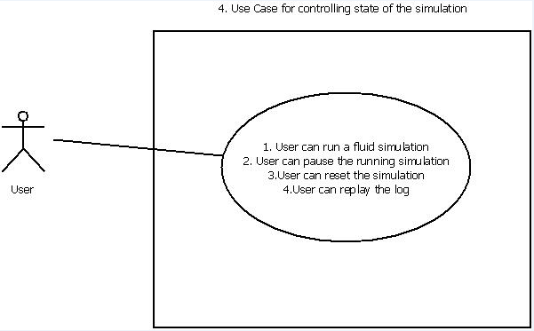

3.4 Classes / Objects
This section covers classes and functions. This section helps design and development team in better understanding the software requirement. The classes covered in this section will have two units in it attributes and functions. Attributes sub-section will have data or properties of the object whereas the other sub-section which is function will contain methods to operate on attributes.

3.4.1 Flow / flow
Class Flow contains basic attributes of the fluid and operations that are needed for setting and getting values of each attribute.

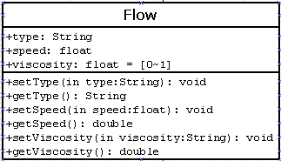

3.4.1.1 Attributes

As depicted above

3.4.1.2 Functions

As depicted above

3.4.2 SingleDrop / singleDrop

Class SingleDrop contains information of every points defined in the rectangle. For each SingleDrop instances, it should be initialized at the beginning and can be changed as per the fluid simulation.

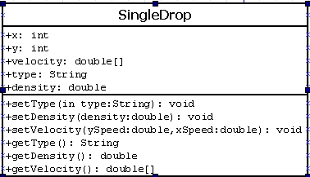

3.4.2.1 Attributes

As depicted above

3.4.2.2 Functions

As depicted above

3.4.3 InitialForce / initialForce

Class InitialForce is what we use to generate fluid thus it contains basic information of the fluid itself. It triggers the fluid motion and provide interfaces for pausing, resetting, replaying fluid simulation.

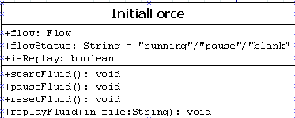

3.4.3.1 Attributes

As depicted above

3.4.3.2 Functions

As depicted above

3.4.4 FlowMeter / flowMeter

Class FlowMeter is instantiated whenever user place a flow meter so that the values at the flow meter can be monitored.
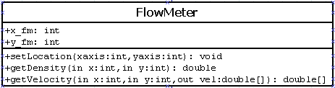

3.4.4.1 Attributes

As depicted above

3.4.4.2 Functions

As depicted above

3.4.5 Barrier / barrier

Class Barrier is instantiated whenever user place a barrier with different shapes to observe the behavior of the fluid under force.
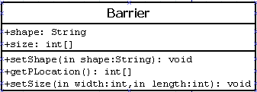

3.4.5.1 Attributes

As depicted above

3.4.5.2 Functions

As depicted above

3.4.6 Logging / logging

Class Logging can be used to export log by user and write log to file by the system.
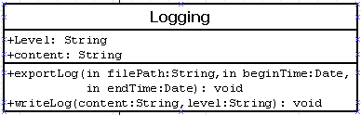

3.4.6.1 Attributes

As depicted above

3.4.6.2 Functions

As depicted above

3.4.7 Window / window

Class Window can be used to configure the size of rectangle which is used for the visualization of the simulation.
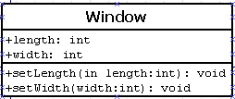

3.4.7.1 Attributes

As depicted above

3.4.7.2 Functions

As depicted above

3.5 Non-Functional Requirements
This section will cover the various topics related to non-functional requirements such as maintainability, performance, availability.

3.5.1 Performance
- Operating ranges for temperature will be from -100 to +100 *C.
- The system may include at most, ONE third party component (example: fluid dynamic engine, GUI). Thou shall not steal or plunder your neighbor’s controls. Must get customer approval before usage.
- The product will only have one fluid type simulated at a time.
- For rectangular objects we can assume they will always face the liquid on a side (never a corner)
- Max volume of liquid constrained by the container (no overflows)
- Measurements must be done to 4 decimal places for accuracy.
- There will only be one source of initial force in a given simulation. Initial force is configurable.
- No changes to force will be made during execution.
- The simulation will be using Earth’s gravity for any relevant calculations.
- The initial force shall be set from any of the sides of the container except for the corners of the containers

3.5.2 Reliability
- The application shall be developed in such a way that the rendering engine and the GUI are independent. Allowing developers to use other GUIs created on the same operating system (but not necessarily with the same language) with minimal integration.
- The application shall be responsive at all times during the simulation.

3.5.3 Availability
- The application shall be developed in such a way that the rendering engine and the GUI are independent. Allowing developers to use other GUIs created on the same operating system (but not necessarily with the same language) with minimal integration.
- The application shall be responsive at all times during the simulation.

3.5.4 Security
- The product must be released under the GNU GPLV3 licensing with the intention to be distributed freely for educational use. Joint ownership of the product by the client and every (and any) member of the team that made any contribution.

3.5.5 Maintainability
- The product must include an installer script or an installer program
- The product must include source code with compilation instructions if any and list of used libraries
- The product must include all documents artifacts generated during the engineering life cycle
- The product must include an installation guide
- The product must include a user guide with screen shots
- The product must include a programmers guide
- All document artifacts produced during the project developments and for the final release must be typed and electronically generated

3.5.6 Portability
The application must be an installable application either for Windows environments

3.6 Inverse Requirements
REQ-29 The simulation container does not need to be full of liquid.
Correction: The simulation container should contain** volume of liquid (non-functional)

REQ-45 No changes to force will be made during execution
Correction: The system should keep every controls off during the execution.(non- functional)

3.7 Design Constraints
- The system shall visualize flow density dynamically
- The system shall provide both textual and animated representation of what is happening during execution
- The application shall be developed in such a way that the rendering engine and the GUI are independent. Allowing developers to use other GUIs created on the same operating system (but not necessarily with the same language) with minimal integration.
- The system shall use the Metric System
- Breakpoint monitor data at certain point in container

3.8 Logical Database Requirements
Not applicable to this project

3.9 Other Requirements
- Point of view is as if user is looking down from above the container.

4. Analysis Models
This section consist of sequence diagram, Data Flow Diagram and State Transition Diagram to represent the behavior of the system in pictorial form.

4.1 Sequence Diagrams
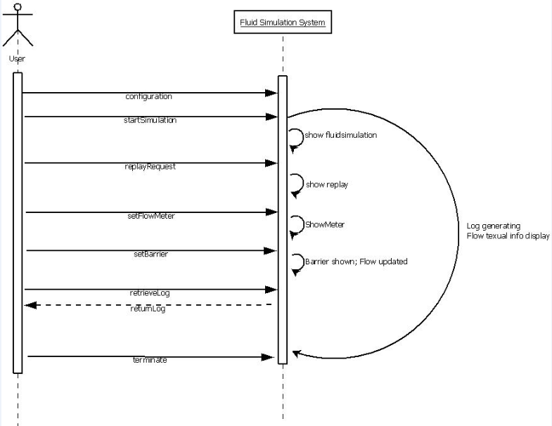

4.2 Data Flow Diagrams (DFD)
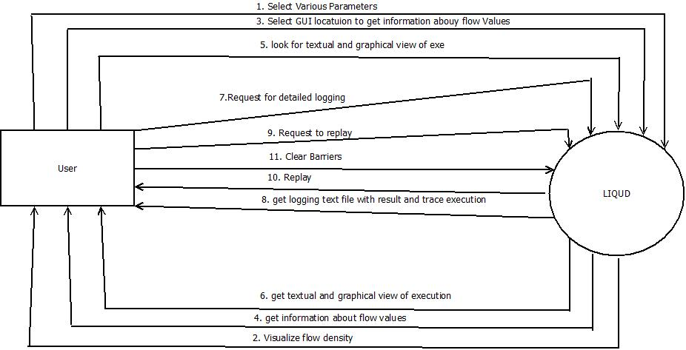

4.3 State-Transition Diagrams (STD)
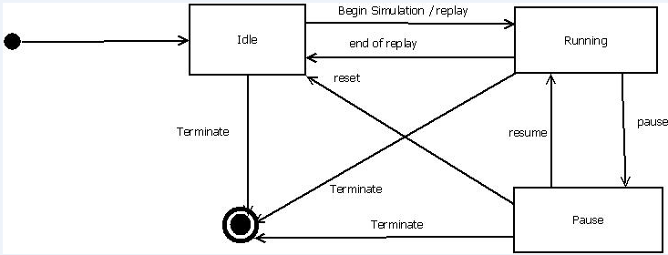

5. Change Management Process
Customer or project liaison shall submit request for any change in requirement or its scope but, the change request for any requirement shall go through the process of requirement negotiations. Only after approval from all stakes holders of the project shall the change be applied to SRS document. Detailed information of the impact on other existing requirement shall be mentioned in revision section of SRS for traceability purpose. Every new version of SRS document shall be shared across to all the stake holders.
.

A. Appendices

A.1 Requirements Document
