USER INTERFACE DOCUMENT

Version 1.0

LIQUID: 2-D FLUID DYNAMIC SIMULATOR

TEAM PRYMM
Pavan Kumar Gade, Radhika Panchal, Yashraj Sinha, Minghua Liu and Manoj Mathe

UID Revision History

Date | Version | Description | Author
10/26/2015 | 1.0 | User Interface Document based on MVC model | Team PRYMM  Individual contribution along with respective section number :  - - Yashraj, Minghua and Radhika  - - Yashraj, Minghua and Radhika  - - Yashraj, Minghua and Radhika  - - Manoj and Pavan  - - Yashraj, Minghua and Radhika  - - Yashraj, Minghua and Radhika  - - Minghua, Yashraj and Radhika

Table of Contents

1. Introduction 4
1.1 Purpose 4
1.2 Scope 4
1.3 Definitions, Acronyms and Abbreviations 4
1.4 References 4
1.5 Overview 4
2. GUI Architecture Pattern 4
3. GUI Behavior 5
3.1 Idle State 7
3.2 Running State 8
3.3 Pause State 10

Introduction
This document comes as a User Interface (UI) mock-design and its Graphical User Interface (GUI) prototype document for the project LIQUID: 2-D Fluid Dynamic Simulator. In this document mock-design for the project which is designed using proper design principles is illustrated.

Purpose
The User Interface Document (UID) provides the principles used for designing the user interface and explains the variety of criteria including completeness, compliance to good UI design principles, functionality, consistency, aesthetic design etc. considered for user interface design for project LIQUID: 2-D Fluid Dynamic Simulator. Various snapshots of the mock-GUI is included throughout the document to cover the various states and scenarios of the application.

Scope
The scope of this User Interface Document is to depict the User Interface design and mock-GUI of the project LIQUID: 2-D Fluid Dynamic Simulator.

Definitions, Acronyms and Abbreviations
UID: User Interface Document
UI: User Interface
GUI: Graphical User Interface

References
[1] “GUI Prototyping tools “, website: http://www.mockflow.com/
[2] “Principles of user interface design”, website:https://en.wikipedia.org/wiki/Principles_of_user_interface_design

Overview
In order to fully document all the aspects of the User Interface, an overview of MVC pattern used for GUI design of the project is provided in section 2 and that is followed by various snapshot of the mock-GUI which is used throughout the UI document to cover various scenarios and states of the application with explanation. The various states and scenarios of the mock-GUI in UI document are organized based on the various states of the system which are idle, running and pause.

GUI Architecture Pattern
As the system is a small installable desktop application MVC pattern is as GUI architecture pattern for the project Liquid: 2-D Fluid Dynamic Simulator. This MVC pattern is used to break down the application user interface, based on the responsibility handled by different units/components of the application.
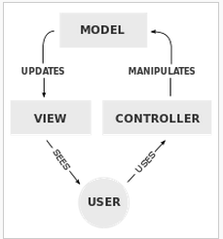
Figure – 1 highlighting the components of MVC pattern
Controller: Is used to send commands and configuration request to the model component in order to update model state. This includes updating configuration parameters, placing flow meters, starting simulation, stopping simulation etc.
Model: Stores and updates data passed by controller. Along with the configuration parameters it also stores data getting generated during simulation to provide logging capability.
View: This component of the MVC pattern provides the output presentation to the user based on the changes occurred in model component. This includes graphical representation in rectangular simulation box as well as textual in form of values at flow meters and log file.
This User Interface pattern has been chosen because it isolates various system responsibilities from one another, so that it improves both system development and maintenance by keeping low coupling and high cohesion.

GUI Behavior
The structure principle of GUI design has been used to put related things together and separating unrelated things, differentiating dissimilar things and making similar things resemble one another. The user input parameters are put together in three major sub-sections named control Panel, Fluid Settings and Log/SIM replay.
Control Panel: This sub-section provides user options to control the state of the application by providing buttons for Run/Pause, Stop and Reset. Run button is used to start the simulation and the same button toggles to Pause during the simulation is in progress providing option of pausing simulation to the user. Stop button in this section provides user an option to end or stop a simulation and the Reset button is used to clear all the user configuration settings in Fluid Setting sub-section of the GUI to their respective default values.
Fluid Settings: This sub-section contains all the configuration parameters which can be set by the user before starting the simulation and this complete Fluid Setting sub-section remains disabled during the simulation run and replay.
- Fluid Type: This is a drop down providing user an option to select fluid type which can be water or glycerin.
- Customize Fluid: This is a check box which when checked override the Fluid type selection done by the user giving an option to the user to customize fluid based on the viscosity value selected using scroll bar.
- Viscosity: This scroll bar value is used for selection of viscosity of the fluid and is used for simulation only when Customize Fluid check box is checked.
- Barrier Shape: This drop down provides option of adding circular or rectangular barrier in the 2-D simulation box.
- Customize Initial Speed: This check box when checked enables the user to set the initial velocity of the particles entering the container.
- Velocity: This scroll bar provides user to select the initial velocity of the fluid entering the container. This gets enabled to overwrite the default initial velocity only when Customize Initial Speed box is checked.
- Container Size: This drop down provides user the option of selecting from a range of container sizes for simulation container.
- Pipe Simulation: This provides user to simulate the entry or exit path from the container to resemble a pipe of smaller diameter. Add Entry check box change the entry to the container from a pipe and Add Exit check box changes the exit path of the container to resemble an exit path same as that of a pipe.
Log/SIM replay: This is the sub-section at the bottom part of the GUI and provides functionality related to logging and replay of log. Get Log button provides user an option to save the last run simulation log in system file system. Replay? Check box when enabled provides interface to the user to load a log file from the file system and replay it. When this check box is checked and Run button in Control Panel is pressed the replay of the selected log file takes place.

GUI behaviors should follow the original design based on SRS, which is shown below:
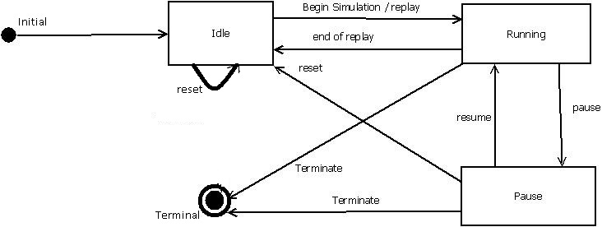
Figure 2 - STD design

Initial state
Figure – 3 above shows the initial or default state of mock-GUI of the project Liquid: 2D-Fluid Dynamic Simulator. The buttons or input options which will be disabled are highlighted in grey color like Stop, Reset, Get Log, Browse and box to insert path of log file

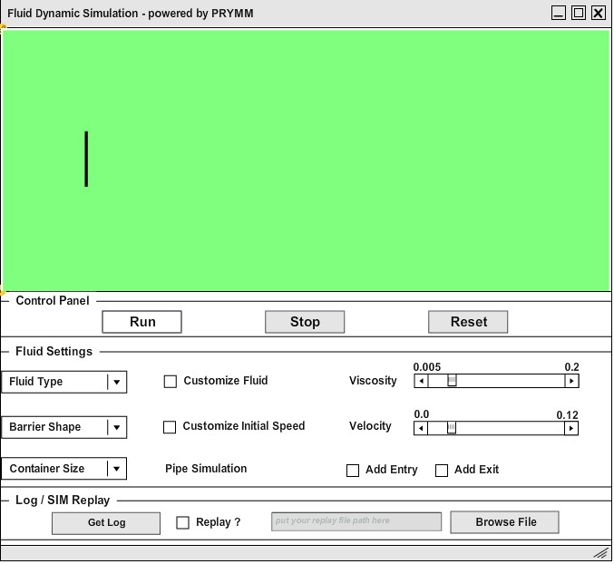
Figure – 3 Default GUI state when application is opened

Various snapshots of the mock-GUI is provided in following sections and are arranged to cover the different states and the transition from one of these states to another such as Idle, Running and Pause respectively.

Idle State
In this part of the document snapshots of the GUI is provided for the scenarios when the system is in idle state and simulation is not running. Figure – 3 above also show the GUI of the idle state and default state of the application when the application is opened by the user.Figure-4 below is another special case of idle state which highlights how the GUI appears when user has selected entry and exit path to resemble a pipe of smaller diameter than that of the container. Just to illustrate other configuration GUI also illustrates selection of Fluid type as water and barrier shape is circular.

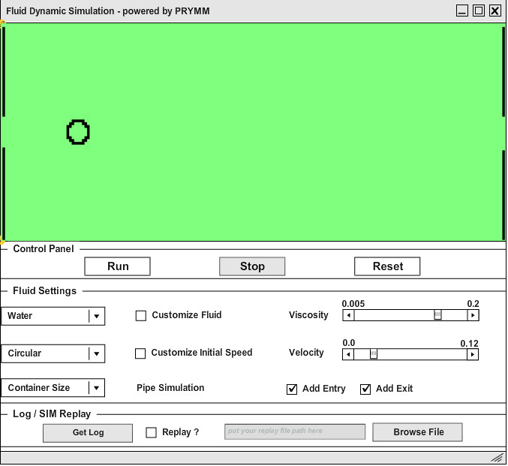
Figure – 4 GUI showing idle state of application with configuration for circular barrier, fluid type as water and entry and exit path simulating a pipe of smaller diameter

Figure – 5 below shows another special case of idle state of the application where Replay? Check box is checked. This enables user to Browse log file and provide path of log file but at the same disable section of the GUI which are not functional during replay such as Reset and complete Fluid Setting sub-section of GUI. This is highlighted using red colored boundary in Figure - 5 below.
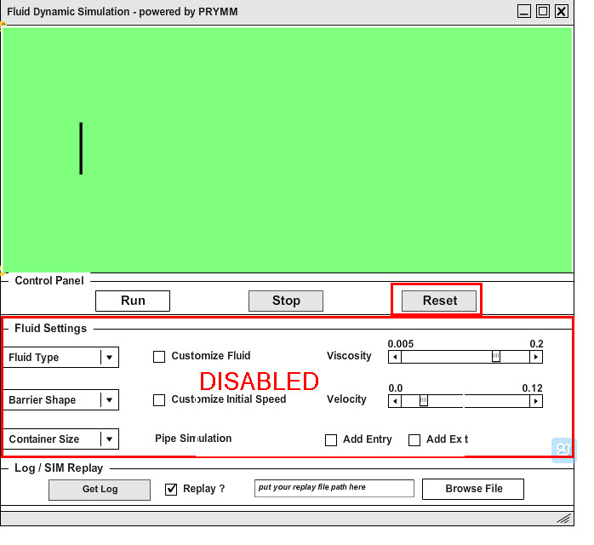
Figure – 5 Special case of idle state where Replay? Check box is checked enabling option to load log file and disabling Fluid Setting sub-section and Reset

Running State
In this part of the document snapshots of the mock-GUI is provided for the scenarios when the system is in running state and simulation in progress. Press of Run button from Control Panel sub-section while the system is in its default state results in transition to running state from idle. This has been shown in Figure – 6 below with highlighting the addition of Fluid Setting sub-section to the disabled functionality along with log and replay which were already disabled as default. Run button changes to Pause during simulation is in progress.

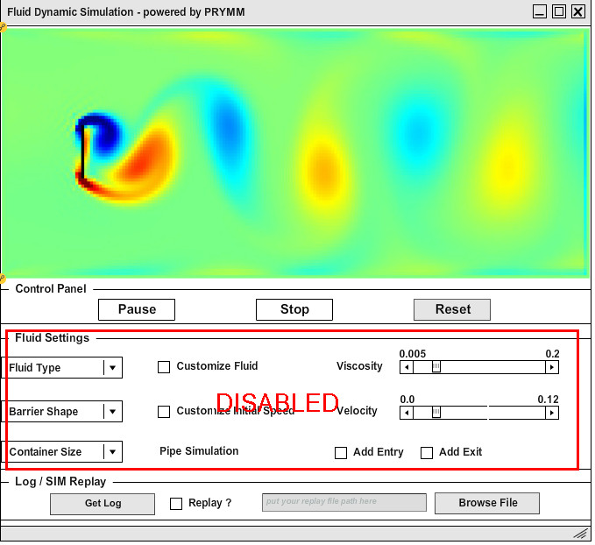
Figure – 6 Application in Run state after press of Run button. Run button changes to Pause during simulation is in progress and Fluid Setting sub-section gets disabled for the user.
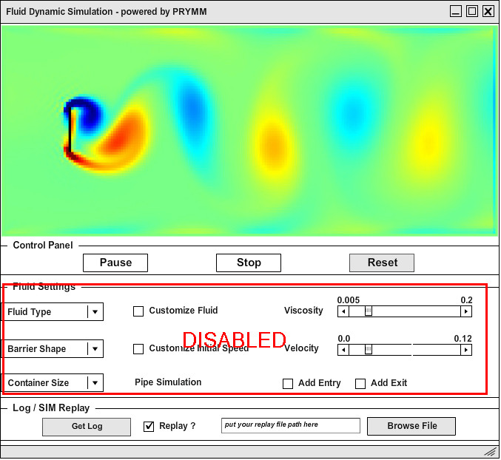
Figure – 7 Special case of running state where system is replaying a log when Run is pressed while a log file is loaded with Replay? check box checked
Figure – 7 above is a case where the system changes from idle state to running on press of Run button after selection of log file with check box for Replay checked. The third and final Figure - 8 of running state below illustrates the running state when entry and exit path are configured to resemble pipe and the barrier is circular.
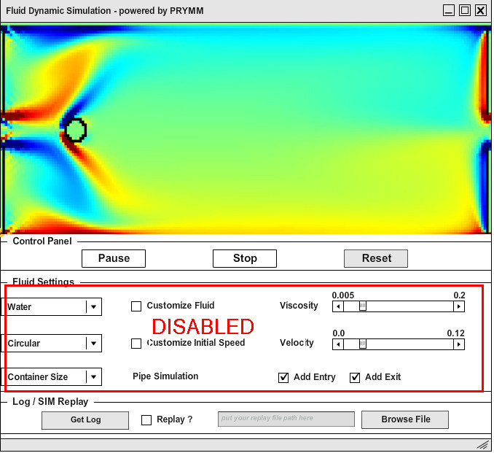
Figure - 8 illustrating the running state when entry and exit path are configured to resemble pipe and the barrier is circular and Fluid Type is water.

Pause State
In this part of the document, snapshots of the mock-GUI is provided for the scenarios when the system is in pause state and simulation in paused. System can switch from running state to pause state when the Pause button is pressed while the system is running simulation or replaying the log file. These two scenarios have been highlighted in Figure – 9 and Figure – 10 below. During pause state the Fluid Setting sub-section remains disabled same as running state restricting any user configuration in this state.
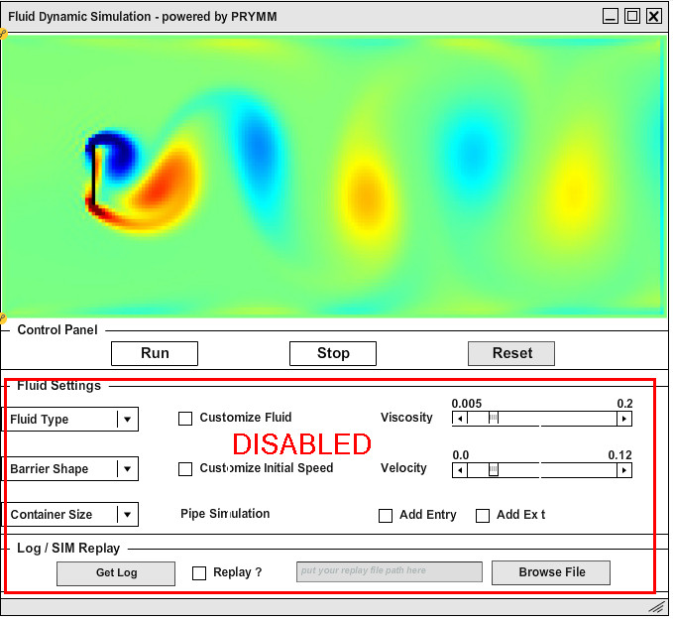
Figure – 9 Shows simulation is paused and Fluid Setting and log functionality remain disabled for user

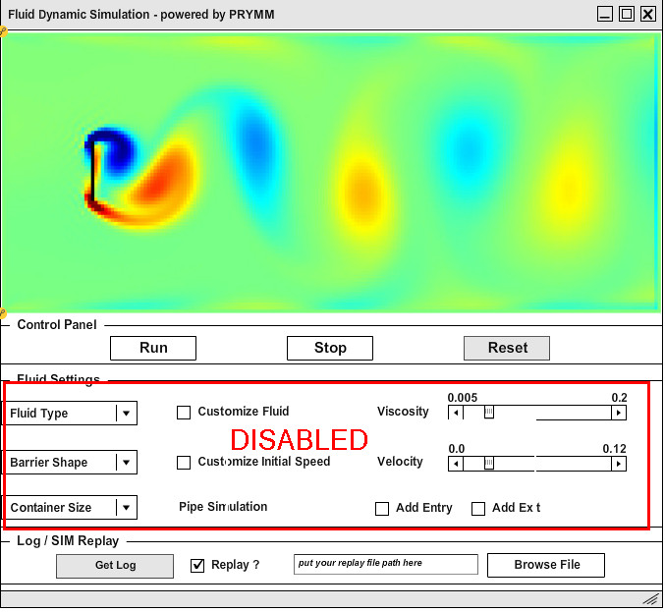
Figure – 10 Shows the pause state when the replay of log is paused

Terminal State

Terminal state is the eventual state of execution, it is basically the same as initial state but ‘Get Log’ button is enabled. User can only retrieve log in the Terminal state. After user close the application, default log file will be deleted so that user cannot get log of last execution.

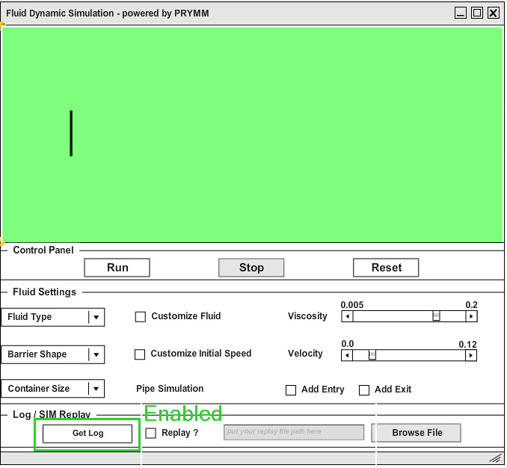
Figure 11 Terminal state of application, user now can export log for execution of this time.

Conclusion
This document is designed as per SRS document and design document

Reference

