MRTAI_BLE User Giude
- Download the provided firmware.bin file to your local disk.
- Browser : https://mingjer05.github.io/MRTAI-BLE/
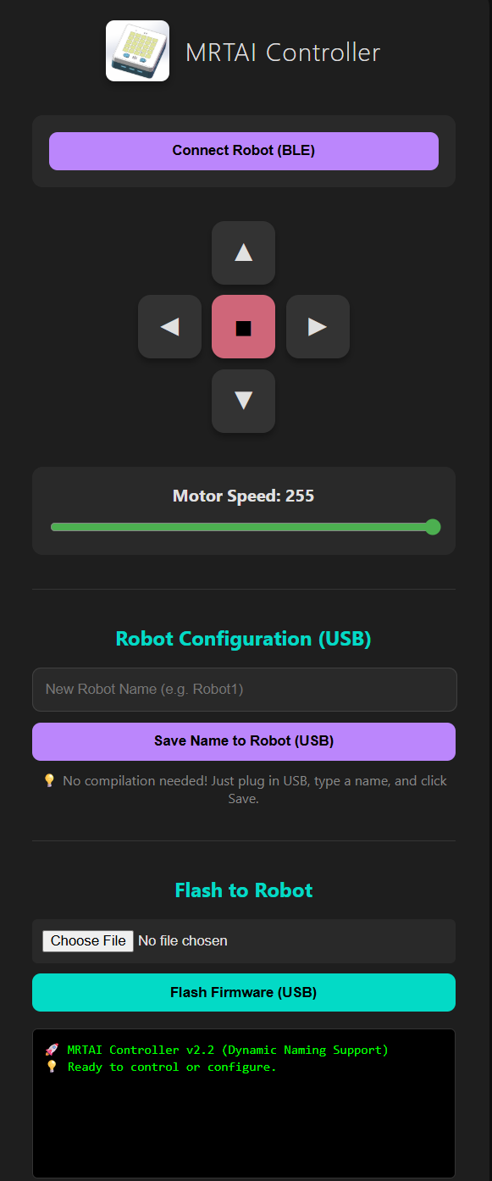
- Upload firmware. Click “Choose File” button and select the firmware.bin
- Make sure your robot is connected to computer via USB with a COM port
- Click “Flash Firmware (USB)” button to flash the robot’s firmware. The progress will show in the display window (green text) and wait until successful message is display.
- Now you can name your Bluetooth with your favorite name (max 20 characters) by key in the entry field then click “Save Name to Robot (USB). Need to connect to USB port for changing name.

