Model-based accounts of the Classification Transfer Data

Since the psychological dimensions composing the dot patterns are unknown, it is currently not feasible to develop a rigorous quantitative model of classification responses based on individual patterns, until further research is conducted to uncover the psychological representations of the dot patterns. The current modeling analysis aims to show that the exemplar model can provide a viable account of the qualitative patterns observed in the overall subject performance during the transfer phase. Following Hintzman’s (1986) influential style of modeling, we decided to simulate the psychological structure of dot-pattern stimuli and categories in an analogous manner to Posner-Keele statistical-distortion procedure.

In our simulations, we represent the dot patterns as points in a six-dimensional psychological space (psychological space is defined to have six dimensions as MDS studies by Shin and Nosofsky [1992] reported that six-dimensional solutions can adequately account for the similarity relations among dot patterns). For each simulation and for each category, a prototype was generated by randomly choosing a value in the range [0, *between*] along each of the six dimensions. The freely estimated parameter *between* controls the degree to which different category prototypes are similar to each other. In general, larger values of *between* will result in larger psychological distances among category prototypes, hence less similarity between categories.

For each category, the statistical distortions were then generated by sampling *z* scores from a standard normal distribution, and adding scaled values of *z* to the dimension values of the corresponding category prototype. Different scaling factors were used to represent different levels of distortions, as in equation 1.

*xim* = *Pim* + *within*\**low*\**z*, for low distortions

*xim* = *Pim* + *within*\**medium*\**z*, for medium distortions

*xim* = *Pim* + *within*\**high*\**z*, for high distortions

In the equation above, *Pim* denotes the value of prototype *i* on dimension *m*, and *xim* denotes the value of a statistical distortion generated from prototype *i* on dimension *m*. *within* is a free parameter that primarily determines the degree of within-category dissimilarity, or how dissimilar the patterns are from one another in the same category. The parameters *low*, *medium* and *high* specify the magnitude of low, medium and high distortion levels.

We fitted two versions of the exemplar models: the baseline version where the distortion-level parameters were constrained to take the same values as the average dot-distance movements according to the Posner-Keele statistical-distortion algorithm (*low* = 1.20, *medium* = 2.80, and *high*= 4.60), and the free-distance version where the distortion-level parameters were freely estimated. In the free-distance version, the parameter *within* is omitted since it cannot be estimated separately from the distortion-level parameters. Of course, to create a new distortion, a new random z score is sampled along each individual dimension.

Formal Models of Categorization

Once the patterns are created for each individual simulation, the standard equations of exemplar and prototype models (xxxx) are used to generate the classification predictions in the transfer phase.

According to the exemplar model (i.e. GCM), the probability that a pattern *i* is classified into category A is found by summing its similarity to all the training examples *a* that belong to category A, and dividing by the summed similarity of *i* to all the training examples of all categories:

$\operatorname{Pr}\left(A|i\right)= \frac{{\left(\sum_{a∈A}{S_{ia} }\right)}^{γ}}{{\left(\sum_{a∈A}{S_{ia} }\right)}^{γ}+ {\left(\sum_{b∈B}{S_{ib} }\right)}^{γ}+ {\left(\sum_{c∈C}{S_{ic} }\right)}^{γ} }$ (2)

Where the parameter γ is a response-scaling parameter. When γ grows larger in magnitude, the observer responds more deterministically with the category that yields the largest summed similarity.

The similarity between test pattern *i* and training example *j* (*sij*) was defined as an exponential-decay function of the distance between the two patterns in the psychological space:

$s_{ij}= e^{-cd_{ij}}$ (3)

where *c* is a sensitivity parameter that describes the rate at which similarity declines with distance. The sensitivity parameter provides a measure of overall discriminability among patterns in the feature space.

The standard Euclidean distance formula is used to compute the distance between test pattern *i* and training example *j*,

$d_{ij}={\left[\sum_{m}{{{(x}_{im}- x_{jm})}^{2}}\right]}^{1/2}$ (4)

where $x_{im}$ and $x_{jm}$ denotes the values of the patterns i and j on dimension *m*, respectively.

Overall, since the scaling parameters for the between-category distances *between* and for the within-category distances *within*, *low*, *medium*, *high* control the psychological distances between the patterns, while the sensitivity parameter *c* modulates the between-pattern similarities given the distances, raising the value of *c* will have the same effect as lowering the values of the distance-scaling parameters, which leads to uncertainty in parameter estimation. *within*, *low*, *medium*, *high*  In sum, there are three free parameters (*within*, *c*, *γ*) in the baseline exemplar model and five free parameters in the free-distance exemplar model (*low*, *medium*, *high*, *c*, *γ*).

According to the prototype model, the probability that pattern *i* is classified into category A is given by

$\operatorname{Pr}\left(A|i\right)= \frac{{\left(S_{i,P_{A}}\right)}^{γ}}{{\left(S_{i,P_{A}}\right)}^{γ}+ {\left(S_{i,P_{B}}\right)}^{γ}+{\left(S_{i,P_{C}}\right)}^{γ}}$ (5)

where $S_{i,A}$ is the similarity between the test pattern *i* to the prototype of category *A*. Note that the response-scaling parameter γ cannot be estimated separately from the sensitivity parameter c (as defined in eq. 3) in the prototype model, so γ is fixed at 1 for the prototype model.

Due to the random nature of the dot-distortion algorithm, the prototype used to generate the training examples in the same category may not be precisely centrally located among them, especially for med- and high-distortion training conditions. Therefore, the prototype representations are computed by averaging across the dimension values for each of the training exemplars of the corresponding category. Otherwise, the similarity and psychological distances between the test patterns and the prototypes are computed in an analogous way as in eqs. 3 and 4.

In sum, there are two free parameters (*within*, *c*) in the prototype model.

For each of the exemplar and prototype models, the best-fitting parameters are estimated by minimizing the sum-of-squared deviations between the predicted and observed probabilities that the test patterns are correctly classified for each pattern type across all conditions. The observed probabilities are computed by averaging across subjects the proportion of correct responses. The predicted probabilities are calculated by averaging across the results of 10000 simulations in predicting the probabilities of making correct classifications. We used the Hook and Jeeves (1961) algorithm for parameter search.

Model-fitting Results

The right panel of Figure 3 shows the classification accuracies across test pattern types and conditions predicted by the best-fitting baseline exemplar model. Consistent with the observed data (Fig. 3, left panel), the model predicts that the novel high distortions are classified with the lowest accuracy in the high training condition compared to the other conditions, and that the novel medium distortions are classified with lower accuracy in the medium training condition than in the low training condition. It is also worth noting that the classification accuracies of novel high distortions are predicted to be very close in the low and the medium training conditions, indicating that increasing the distortion level of training patterns will have little, if not negative, effect on the generalization performance on highly distorted novel patterns. The best-fitting parameters as well as the sum-of-squared deviations for the two versions of exemplar models are reported in table 1. Despite the slight improvement in the quantitative model fit of the free-distance model, the more complex model predicts the same qualitative patterns as the baseline model (Fig. 4).

The right panel of Figure 5 illustrates the predictions yielded by the best-fitting baseline prototype model. Apparently, the model predicts virtually no difference in the classification performance for the novel test patterns across all four training conditions. In other words, according the prototype model, the level of distortions of the training patterns has no effect on the generalization performance. The best-fitting parameters and the sum-of-squared deviations for the baseline exemplar model are reported in table 1.

Table 1. Model-fitting results for exemplar and prototype models

**Exemplar Models**

Parameter Baseline Free-distance

*between*  2.000 1.966

*within* 0.210 --

*low* -- 0.098

*medium* -- 0.398

*high* -- 0.824

*c* 0.475 0.371

*γ* 5.000 5.000

*SSD* 0.016 0.010

**Prototype Models**

Parameter Baseline Free-distance

*between*  2.000 2.000

*within* 0.134 --

*low* -- 0.001

*medium* -- 0.253

*high* -- 0.621

*c* 1.286 1.145

*γ* -- --

*SSD* 0.108 0.095

Note. *between* is fixed at 2 for all models.

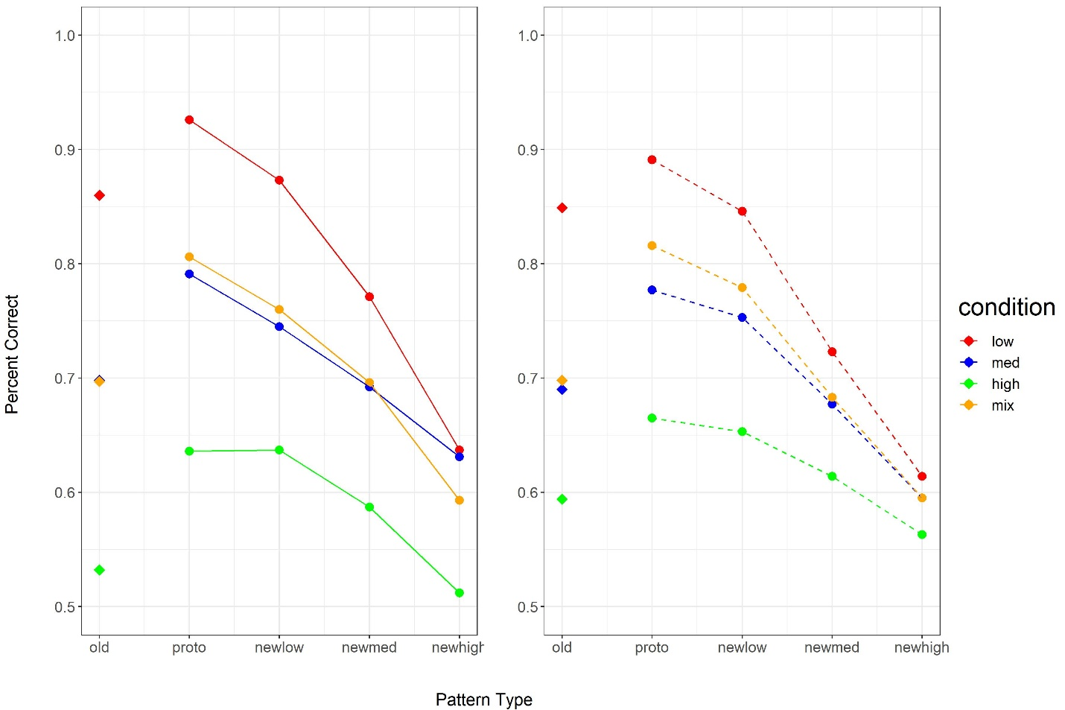

Figure 3

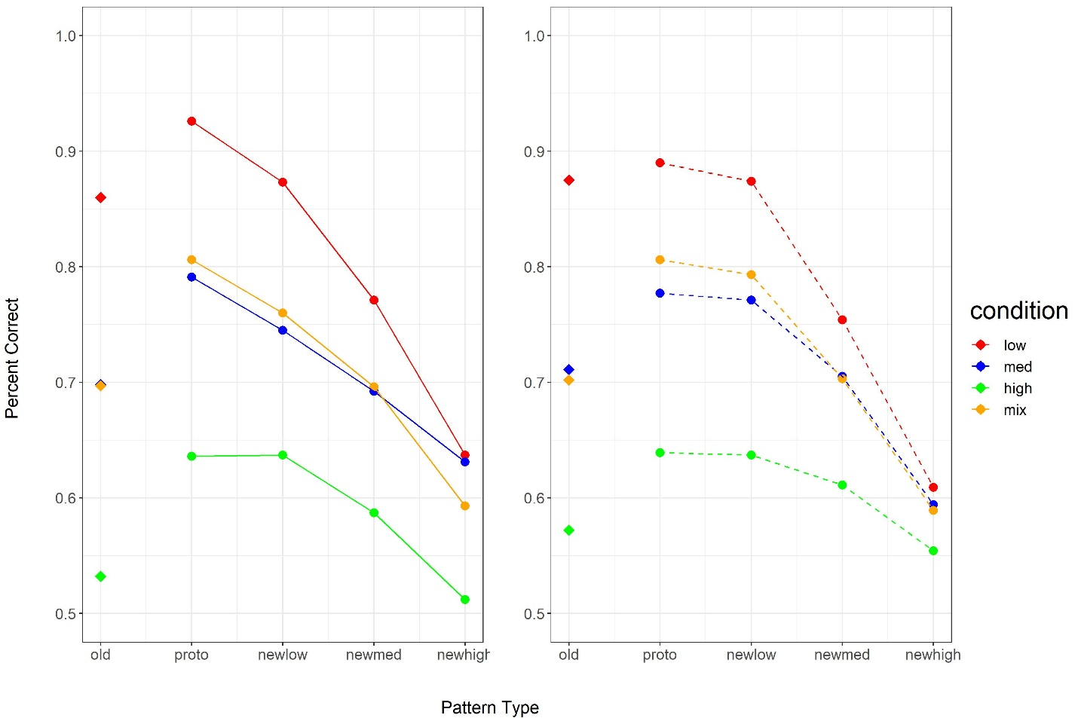

Figure 4

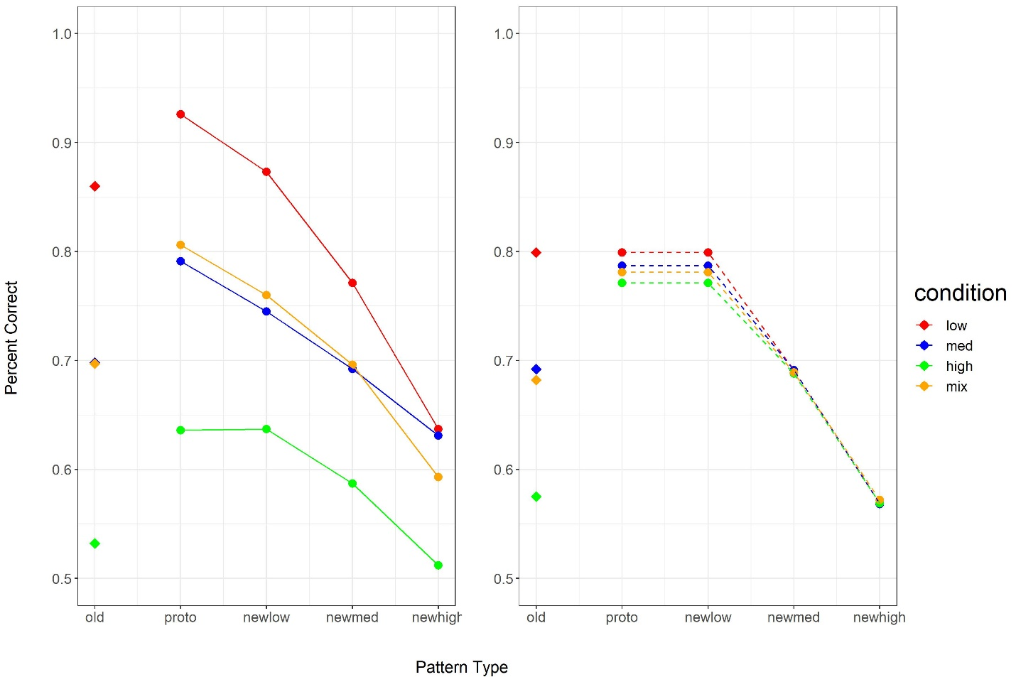

Figure 5