Table 1. Summary Fits of Models to the Classification Test Data in the medium-distortion condition

**Exemplar Models**

Model -lnL AIC BIC P

Average Similarity 5271.5 10555 10601 6

Dot Coordinates 5328.5 10661 10676 2

CNN Activation 5236.2 10476 10492 2

CNN_MDS_weighted 5163.2 10334 10365 4

**Prototype Models**

Model -lnL AIC BIC P

Average Similarity 5280.0 10568 10599 4

Dot Coordinates 5322.1 10646 10654 1

CNN Activation 5313.6 10629 10637 1

CNN_MDS_weighted_central 5185.5 10377 10400 3

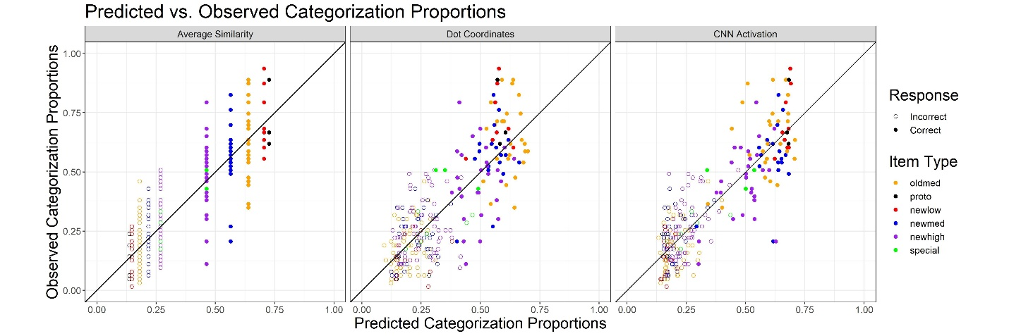

exemplar

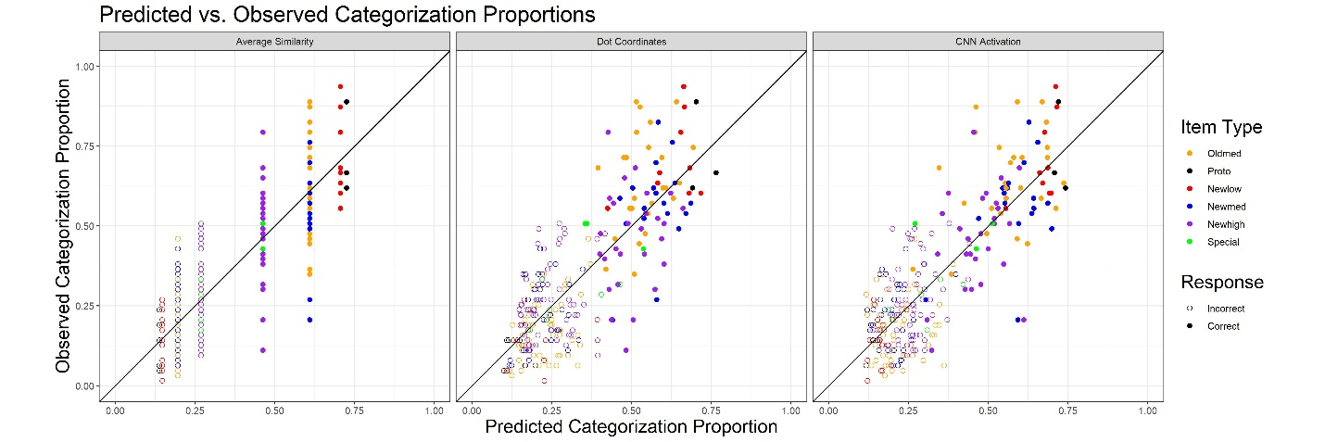

prototype

Table 2. Best-Fitting Free Parameters of Models with Alternative Methods of Stimulus Representation.

**Exemplar models**

Parameter Average Similarity Dot Coordinates CNN Activation

*Sp*  0.536 -- --

*Sl* 0.503 -- --

*Sm* 0.347 -- --

*Sh* 0.271 -- --

*Sc* 0.195 -- --

*c* -- 0.103 0.140

*γ* 1.651 1.000 1.000

**Prototype models**

Parameter Average Similarity Dot Coordinates CNN Activation

*Sp*  1.000* -- --

*Sl* 0.909 -- --

*Sm* 0.592 -- --

*Sh* 0.327 -- --

*Sc* 0.190 -- --

*c* -- 0.088 0.091

*γ\*\** 1.000 1.000 1.000

* Sp is set to 1 for self-match similarity

** γ is fixed at 1 as it cannot be estimated separately from c

Table 3. Best-Fitting Free Parameters of Models based on the Rotated CNN-MDS Solution

Parameter exemplar_CNN MDS prototype_CNN MDS

*w1*  0.547 0.575

*w2* 0.435 0.407

*w3*\* 0.018 0.018

*c* 0.221 0.191

*γ* 1.000 1.000

* w3 = 1 - w1 - w2

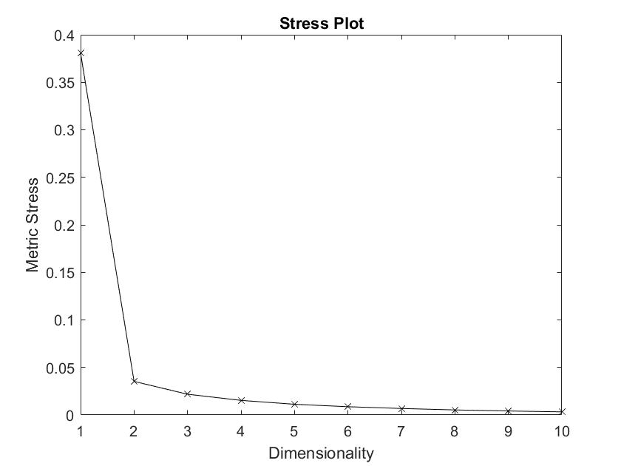

Table 3. correlation coefficients between the corresponding dimensions of the rotated MDS solution and the normative solution.

|  |  |
| --- | --- |
| Dimension | Correlation |
| 1.height-to-width ratio | 0.518 |
| 2.horizontal splitness | 0.767 |
| 3.dual centrality | 0.510 |

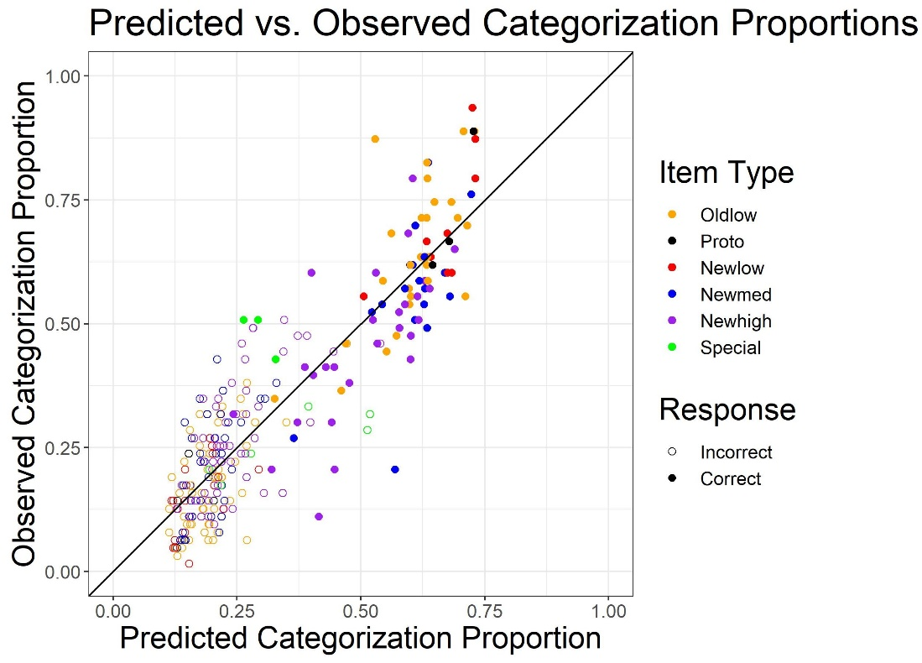

**Exemplar model**

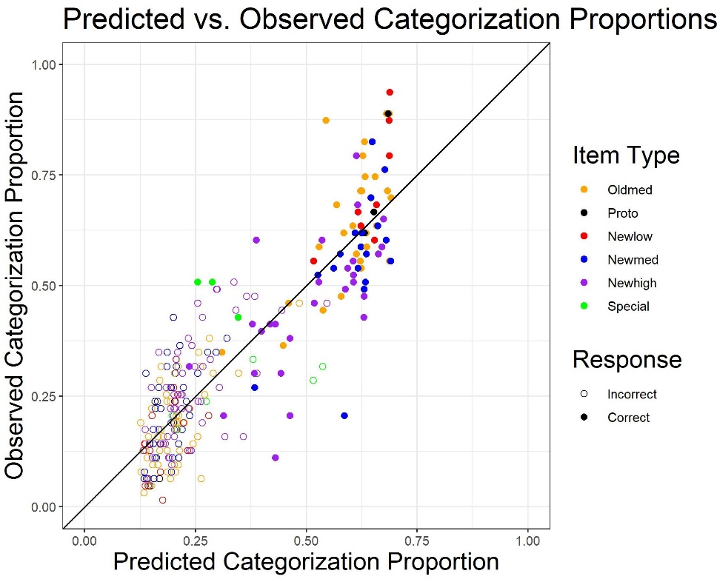

**Prototype Model**

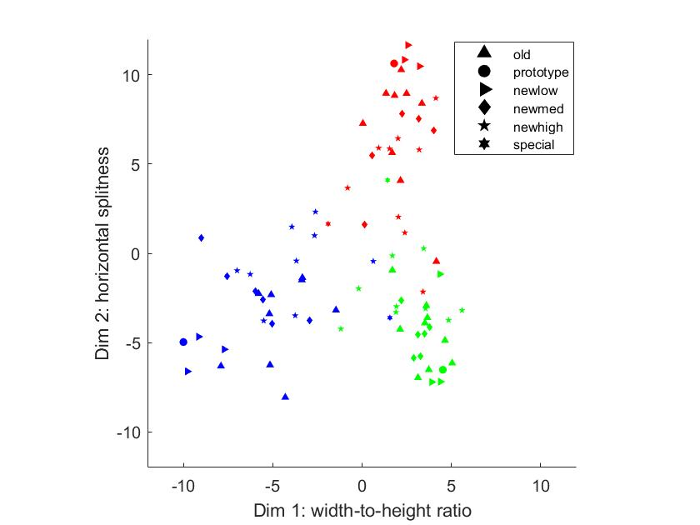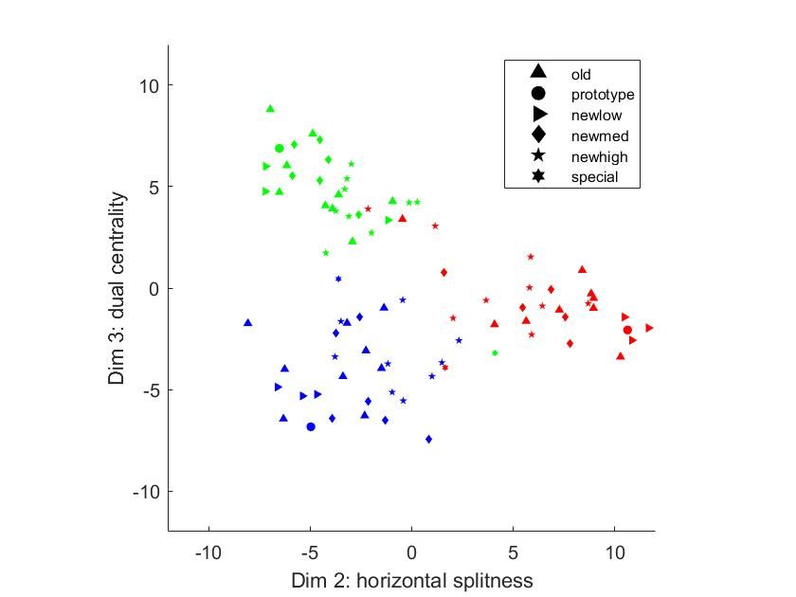

**Rotated CNN-MDS solution**