Table x. Summary Fits of Models to the Classification Test Data across training conditions

**Exemplar Models**

Model -lnL AIC BIC P

Fixed distortion 21435 21443 21476 4

Free distortion 21406 21418 21467 6

Table 2. Best-Fitting Free Parameters of Alternative Exemplar Models

Parameter Fixed distortion Free distortion

*low*  -- 0.020

*med* -- 0.329

*high* -- 0.757

within 0.149 --

between 2.057 2.610

*c* 1.158 0.699

*γ* 1.436 1.450

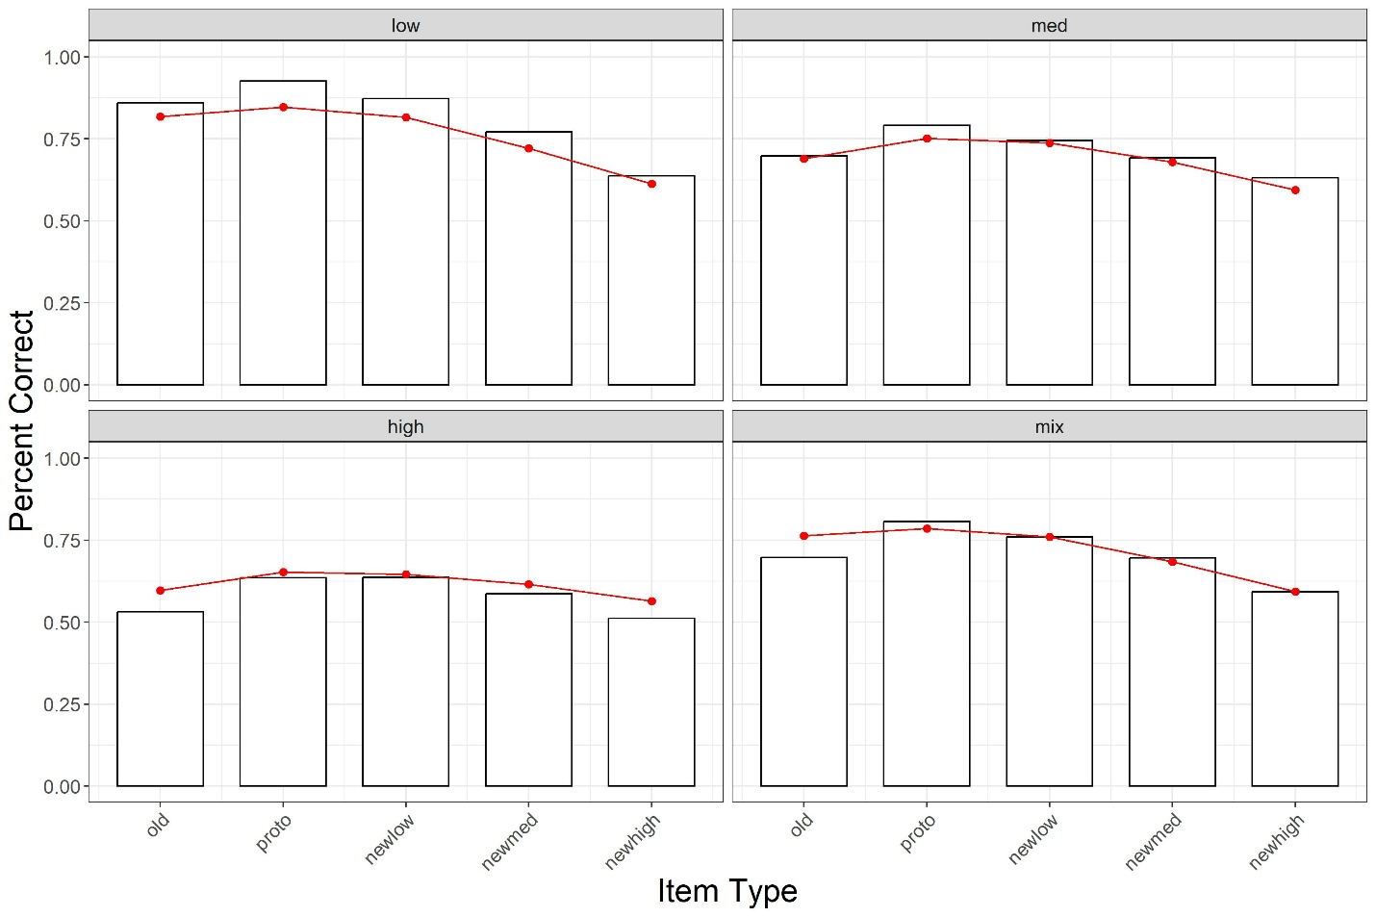

Classification Accuracy

Old Proto Newlow Newmed Newhigh

Training Condition

Low 0.818 0.847 0.816 0.722 0.613

Medium 0.690 0.752 0.737 0.679 0.594

High 0.597 0.653 0.646 0.615 0.564

Mixed 0.764 0.786 0.760 0.684 0.594

Classification Accuracy

Old Proto Newlow Newmed Newhigh

Training Condition

Low 0.818 0.847 0.816 0.722 0.613

0.860 0.926 0.873 0.771 0.637

Medium 0.690 0.752 0.737 0.679 0.594

0.698 0.791 0.745 0.692 0.631

High 0.597 0.653 0.646 0.615 0.564

0.532 0.636 0.637 0.587 0.512

Mixed 0.764 0.786 0.760 0.684 0.594

0.697 0.806 0.760 0.696 0.593