服务器信息：

安装测试环境--192.168.12.71 root/handdba

安装正式环境--192.168.12.75 root/handdba

# 1.连上vpn操作：

cd /u01/image --做好的qcow2格式的镜像，节省了大量的时间。

cp centos7_2_50g.qcow2 ../instance/test.qcow2 --测试下安装一台centos的虚拟机，其他的版本是一样安装，Ubuntu，oraclelinux

cd /u01/instance --将所有的虚拟机实例放在这个目录下方便后续的管理，比如要建一台名字为test的虚拟机

qemu-img resize test.qcow2 +70G --这个是扩容使用，因为做出来的镜像只有30g大小的硬盘，实际是无法满足需求的 +70g的空间达到100G /

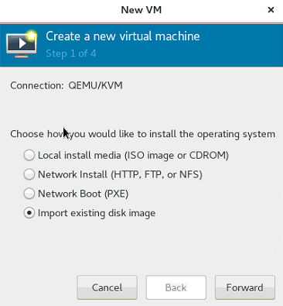

找到test.qcow2文件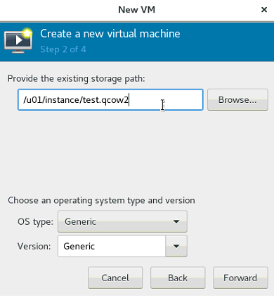

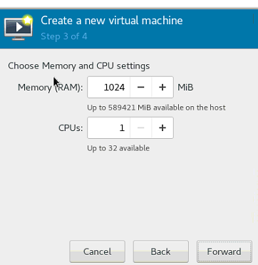

按照需求填写，一般cpu填4个就可以了

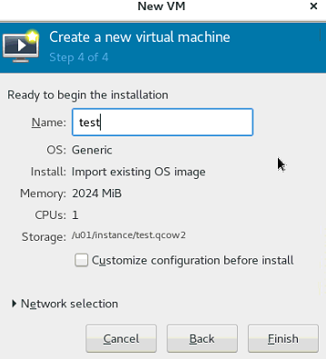

名字一定要根据要去填写，否则后续不方便管理

这样就ok了，很简单 root/handdba --统一的密码

后面就是改名字和配置ip ip按表格中的依次往后排。

最后就是扩容 使用lvm来配置

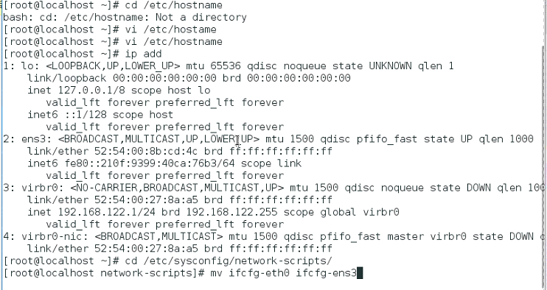

cat ifcfg-ens3

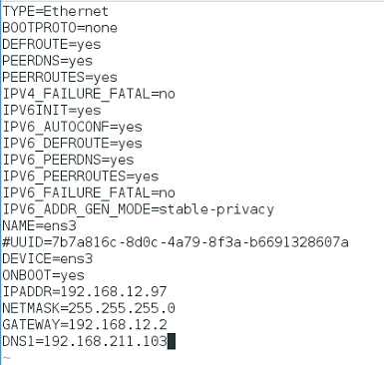

这里面每次只需要该IPADDR就可以了 其他的按照这个截图配置。

service network restart

systemctl stop firewalld.service 关闭防火墙

systemctl enable firewalld.service 开机防火墙不启动

**lvm的扩容 --参照这个扩容**

[root@Mysql01-213-66 ~]# df -h  
Filesystem Size Used Avail Use% Mounted on  
/dev/mapper/vg_mysql0121366-LogVol02 7.7G 2.6G 4.8G 36% /  
tmpfs 495M 0 495M 0% /dev/shm  
/dev/sda1 194M 29M 155M 16% /boot  
/dev/mapper/vg_mysql0121366-LogVol01 8.0G 3.1G 5.0G 38% /data

这里增加/data大小  
[root@Mysql01-213-66 ~]# fdisk -l /dev/sda

Disk /dev/sda: 40.8 GB, 40802189312 bytes  
255 heads, 63 sectors/track, 4960 cylinders  
Units = cylinders of 16065 * 512 = 8225280 bytes  
Sector size (logical/physical): 512 bytes / 512 bytes  
I/O size (minimum/optimal): 512 bytes / 512 bytes  
Disk identifier: 0x000eb81f

Device Boot Start End Blocks Id System  
/dev/sda1 * 1 26 204800 83 Linux  
Partition 1 does not end on cylinder boundary.  
/dev/sda2 26 2350 18668544 8e Linux LVM

进行分区  
[root@Mysql01-213-66 ~]# fdisk /dev/sda

WARNING: DOS-compatible mode is deprecated. It's strongly recommended to  
 switch off the mode (command 'c') and change display units to  
 sectors (command 'u').

Command (m for help): n  
Command action  
 e extended  
 p primary partition (1-4)  
p  
Partition number (1-4): 3  
First cylinder (2350-4960, default 2350):   
Using default value 2350  
Last cylinder, +cylinders or +size{K,M,G} (2350-4960, default 4960):   
Using default value 4960

Command (m for help): p

Disk /dev/sda: 40.8 GB, 40802189312 bytes  
255 heads, 63 sectors/track, 4960 cylinders  
Units = cylinders of 16065 * 512 = 8225280 bytes  
Sector size (logical/physical): 512 bytes / 512 bytes  
I/O size (minimum/optimal): 512 bytes / 512 bytes  
Disk identifier: 0x000eb81f

Device Boot Start End Blocks Id System  
/dev/sda1 * 1 26 204800 83 Linux  
Partition 1 does not end on cylinder boundary.  
/dev/sda2 26 2350 18668544 8e Linux LVM  
/dev/sda3 2350 4960 20966832 83 Linux

Command (m for help): t  
Partition number (1-4): 3  
Hex code (type L to list codes): 8e  
Changed system type of partition 3 to 8e (Linux LVM)

Command (m for help): w  
The partition table has been altered!

Calling ioctl() to re-read partition table.

WARNING: Re-reading the partition table failed with error 16: Device or resource busy.  
The kernel still uses the old table. The new table will be used at  
the next reboot or after you run partprobe(8) or kpartx(8)  
Syncing disks.

重启服务器或者　partprobe  
创建物理卷  
[root@Mysql01-213-66 ~]# pvcreate /dev/sda3  
 Physical volume "/dev/sda3" successfully created

使用vgscan查询物理卷  
[root@Mysql01-213-66 ~]# vgscan  
 Reading all physical volumes. This may take a while...  
 Found volume group "vg_mysql0121366" using metadata type lvm2

使用新增物理卷扩展vg  
[root@Mysql01-213-66 ~]# vgextend vg_mysql0121366 /dev/sda3  
 Volume group "vg_mysql0121366" successfully extended

[root@Mysql01-213-66 ~]# vgscan  
 Reading all physical volumes. This may take a while...  
 Found volume group "vg_mysql0121366" using metadata type lvm2

查询vg  
[root@Mysql01-213-66 ~]# vgdisplay   
 --- Volume group ---  
 VG Name vg_mysql0121366  
 System ID   
 Format lvm2  
 Metadata Areas 2  
 Metadata Sequence No 5  
 VG Access read/write  
 VG Status resizable  
 MAX LV 0  
 Cur LV 3  
 Open LV 3  
 Max PV 0  
 Cur PV 2  
 Act PV 2  
 VG Size 37.79 GiB  
 PE Size 4.00 MiB  
 Total PE 9675  
 Alloc PE / Size 4557 / 17.80 GiB  
 Free PE / Size 5118 / 19.99 GiB  
 VG UUID Zy2PVv-xSsx-NEAv-L6ba-G8Oy-tBBq-5zXKQm

查询lv  
[root@Mysql01-213-66 ~]# lvdisplay   
 --- Logical volume ---  
 LV Path /dev/vg_mysql0121366/LogVol01  
 LV Name LogVol01  
 VG Name vg_mysql0121366  
 LV UUID 5znkJ2-wdeZ-Y2o1-ECDS-gzzl-PqaS-qo2yZR  
 LV Write Access read/write  
 LV Creation host, time Mysql01-213-66, 2015-08-30 20:42:13 +0800  
 LV Status available  
 # open 1  
 LV Size 8.00 GiB  
 Current LE 2048  
 Segments 1  
 Allocation inherit  
 Read ahead sectors auto  
 - currently set to 256  
 Block device 253:2  
   
 --- Logical volume ---  
 LV Path /dev/vg_mysql0121366/LogVol00  
 LV Name LogVol00  
 VG Name vg_mysql0121366  
 LV UUID b1FV1n-iKyK-kZ23-glRO-opFh-gDRp-TzWNcL  
 LV Write Access read/write  
 LV Creation host, time Mysql01-213-66, 2015-08-30 20:42:14 +0800  
 LV Status available  
 # open 1  
 LV Size 2.00 GiB  
 Current LE 512  
 Segments 1  
 Allocation inherit  
 Read ahead sectors auto  
 - currently set to 256  
 Block device 253:0  
   
 --- Logical volume ---  
 LV Path /dev/vg_mysql0121366/LogVol02  
 LV Name LogVol02  
 VG Name vg_mysql0121366  
 LV UUID eoVdk3-cbcP-9PlI-kZBL-6pY2-Jpbl-1WI2uH  
 LV Write Access read/write  
 LV Creation host, time Mysql01-213-66, 2015-08-30 20:42:14 +0800  
 LV Status available  
 # open 1  
 LV Size 7.80 GiB  
 Current LE 1997  
 Segments 1  
 Allocation inherit  
 Read ahead sectors auto  
 - currently set to 256  
 Block device 253:1

[root@Mysql01-213-66 ~]# df -h  
Filesystem Size Used Avail Use% Mounted on  
/dev/mapper/vg_mysql0121366-LogVol02 7.7G 2.6G 4.8G 35% /  
tmpfs 495M 0 495M 0% /dev/shm  
/dev/sda1 194M 29M 155M 16% /boot  
/dev/mapper/vg_mysql0121366-LogVol01 8.0G 3.1G 5.0G 38% /data

扩展lv  
[root@Mysql01-213-66 ~]# lvextend -L +100%FREE /dev/mapper/vg_mysql0121366-LogVol01  
 Extending logical volume LogVol01 to 27.00 GiB  
 Logical volume LogVol01 successfully resized

[root@Mysql01-213-66 ~]# df -h  
Filesystem Size Used Avail Use% Mounted on  
/dev/mapper/vg_mysql0121366-LogVol02 7.7G 2.6G 4.8G 35% /  
tmpfs 495M 0 495M 0% /dev/shm  
/dev/sda1 194M 29M 155M 16% /boot  
/dev/mapper/vg_mysql0121366-LogVol01 8.0G 3.1G 5.0G 38% /data

若不是xfs我们可以用resize2fs，这里报错了  
[root@Mysql01-213-66 ~]# resize2fs -f /dev/mapper/vg_mysql0121366-LogVol01  
resize2fs 1.41.12 (17-May-2010)  
resize2fs: Bad magic number in super-block while trying to open /dev/mapper/vg_mysql0121366-LogVol01  
Couldn't find valid filesystem superblock.  
[root@Mysql01-213-66 ~]# df -h  
Filesystem Size Used Avail Use% Mounted on  
/dev/mapper/vg_mysql0121366-LogVol02 7.7G 2.6G 4.8G 35% /  
tmpfs 495M 0 495M 0% /dev/shm  
/dev/sda1 194M 29M 155M 16% /boot  
/dev/mapper/vg_mysql0121366-LogVol01 27G 3.1G 24G 12% /data

然后重启虚拟机就完成了