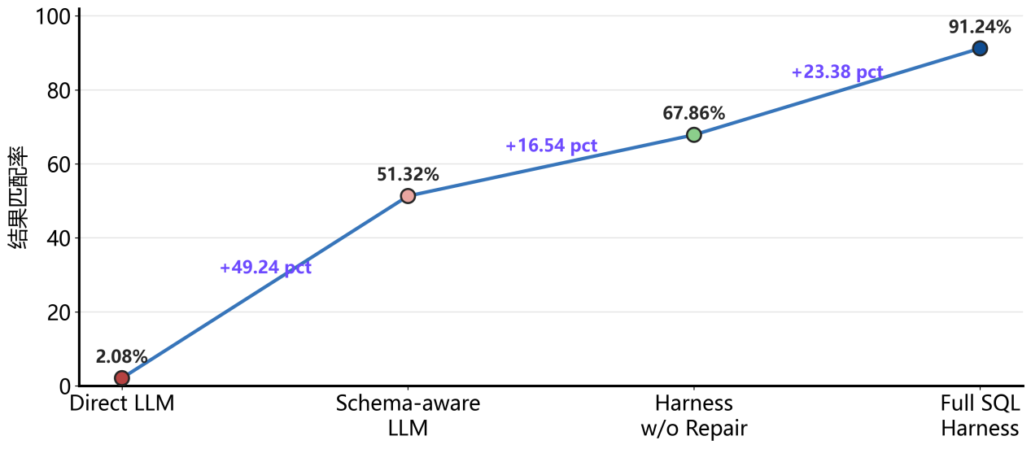
Direct LLM 0.0% Schema-aware LLM 35.0% Harness w/o Repair 50.0% Full SQL Harness 75.1%
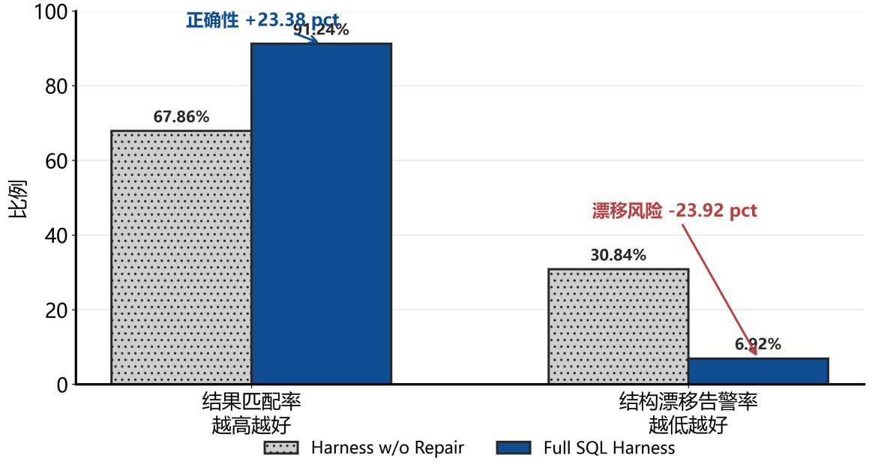
Harbess w/o Repair 50% 34.5% Full SQL Harness 75.1% 0.9%
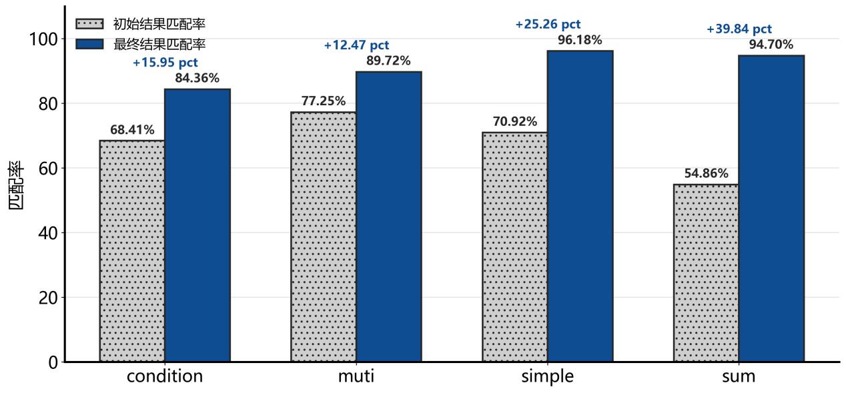
Condition 80% 80% muti 20% 39.6% simple 100% 100% sum 0% 80%

