TABLE OF CONTENTS

1.1 Background information 4
1.2 Objectives 4
1.3 Expectations 4
1.4 Requirements 5
2.1 IPO chart 5
2.2 Program development tool 6
2.3 System Flowchart 6
2.4 Features 7
2.4.1 Modularization 7
2.4.2 Outputting Methods 7
2.4.3 Constrained-Random Lesson Assignment: 7
2.4.4 Time Efficiency 7
2.4.5 Big O notation. 8
3.1 Library 9
3.2 Initializing the Data 9
4.1 Structure of the Main Function 14
4.2 Variables of different functions 15
4.2.1 Timetable 15
4.2.2 variables of get_available_teachers(subject) 15
4.2.3 Variables of assign_teacher_to_timetable(form, class_index, subject, lesson, assigned_teacher) 16
4.2.4 Variables of assign_teachers() 17
4.2.5 Variables of lessonfulled(classes, subject) 18
4.2.6 Variables of get_teacher(class_name, subject) 19
4.2.7 Variables of subjectassigningtoclass(classes) 19
4.2.8 Variables of assign(classesassigning) 20
4.3 Output 21
4.3.1 Displaying Class Timetable 21
4.3.2 Displaying Teacher Timetable 22
4.2.3 Displaying CSV File 23
5.1 Constraints for Data Validation Purpose 27
5.2 Generating Teachers’ Duty Data 29
5.2.1 Design of get_available_teachers(subject) 30
5.2.2 Design of assign_teacher_to_timetable function 30
5.3 Generating Teachers’ and Classes’ Timetable 33
5.3.1 Design of lessonfulled(classes, subject) function 34
5.3.2 Design of get_teacher(class_name, subject) function 35
5.3.3 Design of subjectassigningtoclass(classes) function 35
5.3.4 Design of assign(classesassigning) function 36
6.1 Encountered Bugs and Debugging 38
6.1.1 Wrongly assign the classes per form 38
6.1.2 Wrongly assign the iteration variable 39
6.1.3 Number of teachers 40
6.2 Feedbacks 41
6.3 Testing 42
6.3.1 Test data of the available_teachers() function 42
6.3.2 test data of the assign(classassigning) function 43
6.3.3 test data of the assign_teachers() 43
6.3.4 Test data of lessonfulled() 44
6.3.5 Test data of assign() 45
6.4 Integration tests 45
6.4.1 assigning subject teachers of each class 45
6.4.2 assigning lessons to teachers 45
7. Improvements based on reflections and testing 46
8. Further Improvements 49
8.1 Workload-based assignments 49
8.2 Flexibility of Timetable Size 49
9. Evaluation 50
9.1 Benefits and Limitations 50
9.2 Reflections 51
9.3 Presentation 52
10.Reference 52
10.1 Books 52
10.2 Websites 52
10.3 Essay 53
10.4 AI Tools 53

1.Problem Definition

1.1 Background information
Since school is suffering from frustrating timetabling experiences every year, A program that can ensure smooth operations, optimize resource utilization, and accommodate the needs of teachers, students, and classrooms is required.

1.2 Objectives
The system aims to reduce manual effort, minimize errors, and provide timely and accurate timetables by automating the scheduling process.

1.3 Expectations
Due to the complexity of school administration, different constraints have to be considered carefully to prevent conflict between timetables of teachers and classes.

Moreover,considering resource management, we hope that the program can create a timetable that can maximize the efficiency and effectiveness of teachers while maintaining a similar workload for every teacher for humane measures.

Furthermore,the program should have various humane measures that can minimize the pressure for every teacher. We sincerely believe that a reasonable timetable can further increase the teaching effectiveness and efficiency, which is beneficial for school and students.

1.4 Requirements
Some basic tools or specific devices will be needed for the system to be usable.
1. A computer operating system can execute a .exe file.
2. A computer with mouse and keyboard
3. An IDE (with compiler, editor, debugger) for developers

2 System Design

2.1 IPO chart

Input | Processing | Output
Initial data | 1. Assign teachers to subjects based on constraints. | Timetable with assigned teachers for each subject and class.
 | 2. Assign subjects to classes based on availability and constraints. | Timetable with subjects assigned to classes along with teachers.
 | 3. Generate teacher schedules based on assigned classes and subjects. | Formatted teacher schedules for each teacher.
Teacher timetable data | 4. Assign subjects to class timetables based on availability and constraints | Timetable with subjects and teachers scheduled for each class.

2.2 Program development tool
I use VS Code as it supports a wide range of programming languages and frameworks through its vast library of extensions, making it versatile for various development tasks.

2.3 System Flowchart
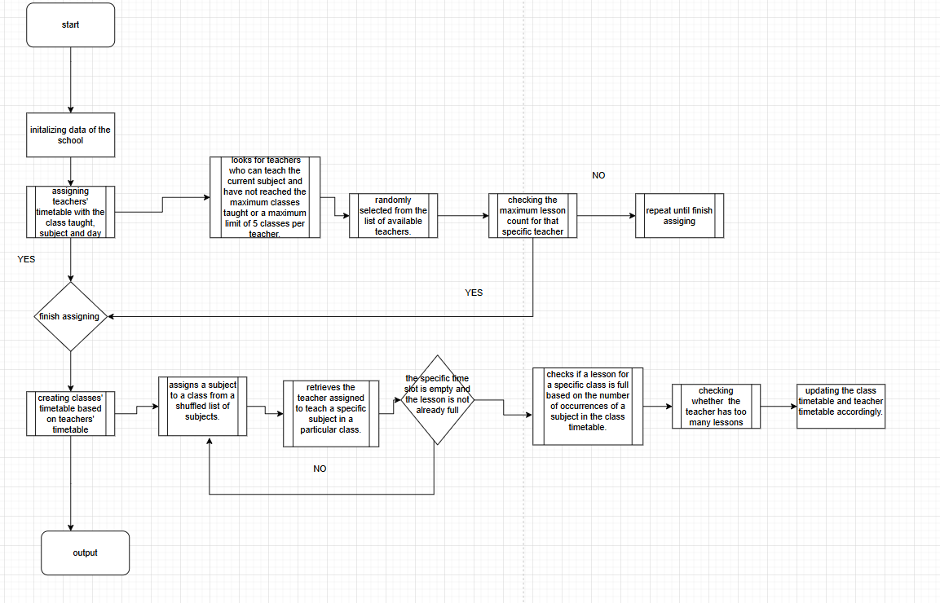

2.4 Features

2.4.1 Modularization
Modularization allows me to break down the scheduling system into smaller, manageable modules (e.g., teacher assignment, subject scheduling, conflict resolution). Each module can focus on a specific aspect of the system, making the codebase easier to navigate and maintain.

2.4.2 Outputting Methods
Implement a reporting feature that generates a summary of teacher workloads and classroom usage. This can be exported as a CSV file for further analysis, such as importing it in a database for data storage in the external server.

2.4.3 Constrained-Random Lesson Assignment:
Constraints provide a structured framework within which the random assignment of lessons occurs. They ensure that the generated timetable adheres to the school's educational policies and requirements.

2.4.4 Time Efficiency
To improve my code's efficiency, I need to consider both modularity and constraints.
Modularity involves breaking the code into smaller, self-contained functions or modules. This approach allows me to isolate different functionalities, making the code easier to read, maintain, and test. By organizing the code into modules, I can also reuse components for different tasks, which can further streamline the development process. For instance, creating separate functions for subject assignment, teacher selection, and timetable validation would enhance clarity and facilitate debugging.
Constraints refer to the limitations within which my code must operate, such as the maximum number of lessons per subject or the availability of teachers. Recognizing these constraints is crucial for designing an efficient scheduling system. I need to ensure that my code adheres to these limits while optimizing performance. For example, if a core subject can only be assigned a maximum of two lessons per week, my logic should enforce this constraint during subject assignment to avoid errors and inefficiencies.
By focusing on modularity and respecting constraints, I can create a more efficient, maintainable, and robust scheduling system. This approach not only enhances performance but also ensures that the code remains flexible and adaptable to future requirements.
Before optimization
After optimization
We can see a 57.4 % efficiency increase in terms of execution time, which can greatly reduce the system resources workload

2.4.5 Big O notation.
the time complexity for assigning teachers to all classes is O(12 * (num_subjects * num_forms * classes_per_form * T)), which simplifies to O(num_forms * classes_per_form * num_subjects * T).
the space complexity is approximately O(num_teachers + total_classes) where total_classes is proportional to num_forms * classes_per_form.

3 Implementation of Solution

3.1 Library
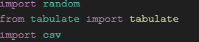
In summary, this code snippet is importing three different libraries:
- random: Provides random number generation capabilities.
- tabulate: Allows for the creation of formatted tables from Python data structures.
- csv: Enables reading and writing of CSV files.

3.2 Initializing the Data

# Number of classes per form
classes_per_form = 2
# Number of forms
num_forms = 6
# Total number of classes
total_classes = num_forms * classes_per_form
# Number of subjects
num_subjects = 7
# Number of days per cycle
num_days = 5
# Number of lessons per day
num_lessons_per_day = 4

subjects = ['Chinese Language', 'English Language', 'Mathematics', 'General Study', 'STREAM', 'Music', 'Visual Art']
num_lessons_per_day = len(subjects)
# Number of teachers
#-----------------------------------------------------------------------------------------------------------------------------
teachers = [
{'name': 'Chinese Language Teacher 1', 'subjects': ['Chinese Language', 'General Study'], 'classes_taught': 0},
{'name': 'Chinese Language Teacher 2', 'subjects': ['Chinese Language', 'General Study'], 'classes_taught': 0},
{'name': 'Chinese Language Teacher 3', 'subjects': ['Chinese Language', 'General Study'], 'classes_taught': 0},
{'name': 'Chinese Language Teacher 4', 'subjects': ['Chinese Language', 'General Study'], 'classes_taught': 0},
{'name': 'Chinese Language Teacher 5', 'subjects': ['Chinese Language', 'General Study'], 'classes_taught': 0},
#{'name': 'Chinese Language Teacher 6', 'subjects': ['Chinese Language', 'General Study'], 'classes_taught': 0},
#{'name': 'Chinese Language Teacher 7', 'subjects': ['Chinese Language', 'General Study'], 'classes_taught': 0},
{'name': 'English Language Teacher 1', 'subjects': ['English Language', 'Music', 'Visual Art'], 'classes_taught': 0},
{'name': 'English Language Teacher 2', 'subjects': ['English Language', 'Music', 'Visual Art'], 'classes_taught': 0},
{'name': 'English Language Teacher 3', 'subjects': ['English Language', 'Music', 'Visual Art'], 'classes_taught': 0},
{'name': 'English Language Teacher 4', 'subjects': ['English Language', 'Music', 'Visual Art'], 'classes_taught': 0},
{'name': 'English Language Teacher 5', 'subjects': ['English Language', 'Music', 'Visual Art'], 'classes_taught': 0},
#{'name': 'English Language Teacher 6', 'subjects': ['English Language', 'Music', 'Visual Art'], 'classes_taught': 0},
#{'name': 'English Language Teacher 7', 'subjects': ['English Language', 'Music', 'Visual Art'], 'classes_taught': 0},
{'name': 'Mathematics Teacher 1', 'subjects': ['Mathematics', 'STREAM'], 'classes_taught': 0},
{'name': 'Mathematics Teacher 2', 'subjects': ['Mathematics', 'STREAM'], 'classes_taught': 0},
{'name': 'Mathematics Teacher 3', 'subjects': ['Mathematics', 'STREAM'], 'classes_taught': 0},
{'name': 'Mathematics Teacher 4', 'subjects': ['Mathematics', 'STREAM'], 'classes_taught': 0},
#{'name': 'Mathematics Teacher 5', 'subjects': ['Mathematics', 'STREAM'], 'classes_taught': 0},
#{'name': 'Mathematics Teacher 6', 'subjects': ['Mathematics', 'STREAM'], 'classes_taught': 0},
{'name': 'General Study Teacher 1', 'subjects': ['General Study', 'Music'], 'classes_taught': 0},
{'name': 'General Study Teacher 2', 'subjects': ['General Study', 'Music'], 'classes_taught': 0},
#{'name': 'General Study Teacher 3', 'subjects': ['General Study', 'Music'], 'classes_taught': 0},
#{'name': 'General Study Teacher 4', 'subjects': ['General Study', 'Music'], 'classes_taught': 0},
{'name': 'STREAM Teacher 1', 'subjects': ['STREAM', 'Mathematics', 'Visual Art'], 'classes_taught': 0},
{'name': 'STREAM Teacher 2', 'subjects': ['STREAM', 'Mathematics', 'Visual Art'], 'classes_taught': 0},
{'name': 'STREAM Teacher 3', 'subjects': ['STREAM', 'Mathematics', 'Visual Art'], 'classes_taught': 0},
#{'name': 'STREAM Teacher 4', 'subjects': ['STREAM', 'Mathematics', 'Visual Art'], 'classes_taught': 0},
{'name': 'Music Teacher 1', 'subjects': ['Music', 'Visual Art'], 'classes_taught': 0},
#{'name': 'Music Teacher 2', 'subjects': ['Music', 'Visual Art'], 'classes_taught': 0},
]
#-----------------------------------------------------------------------
class_timetables = {
'1A': [[0 for x in range(5)] for y in range(4)],
'1B': [[0 for x in range(5)] for y in range(4)],
'2A': [[0 for x in range(5)] for y in range(4)],
'2B': [[0 for x in range(5)] for y in range(4)],
'3A': [[0 for x in range(5)] for y in range(4)],
'3B': [[0 for x in range(5)] for y in range(4)],
'4A': [[0 for x in range(5)] for y in range(4)],
'4B': [[0 for x in range(5)] for y in range(4)],
'5A': [[0 for x in range(5)] for y in range(4)],
'5B': [[0 for x in range(5)] for y in range(4)],
'6A': [[0 for x in range(5)] for y in range(4)],
'6B': [[0 for x in range(5)] for y in range(4)]
}

Name of variables | Data type | description | purpose
classes_per_form | int | This variable stores the number of classes per form, which is set to 2. | This value is used to calculate the total number of classes.
num_forms | int | This variable stores the number of forms, which is set to 6. | This value is used to calculate the total number of classes.
total_classes | int | This variable calculates the total number of classes by multiplying classes_per_form and num_forms. | This value represents the total number of classes in the school system.
num_subjects | int | This variable stores the number of subjects, which is set to 7. | This value is used to determine the number of lessons per day.
num_days | int | This variable stores the number of days per cycle, which is set to 5. | This value is used in the class timetable structure, for iteration.
num_lessons_per_day | int | This variable stores the number of lessons per day, which is set to 4. | This value is used in the class timetable structure, for iteration.
subjects | list of str | This is a list that stores the names of the subjects. | This list is used to associate subjects with teachers and classes.
teachers | list of dict | This is a list of dictionaries, where each dictionary represents a teacher. | This data structure stores information about each teacher, including their name, the subjects they teach, and the number of classes they have taught.
class_timetables | dict | This is a dictionary that stores the timetables for each class. | This data structure represents the class timetables, where each class (e.g., '1A', '1B', '2A', etc.) has a 2D list to store the assigned lessons for each time slot and day.
The well-structured variables and data structures provided in the code can significantly enhance the capabilities of my timetable scheduling program. The flexibility offered by configurable parameters, such as the number of classes per form, subjects, and lessons per day, allows your program to adapt to various school configurations

4. System Specification

4.1 Structure of the Main Function

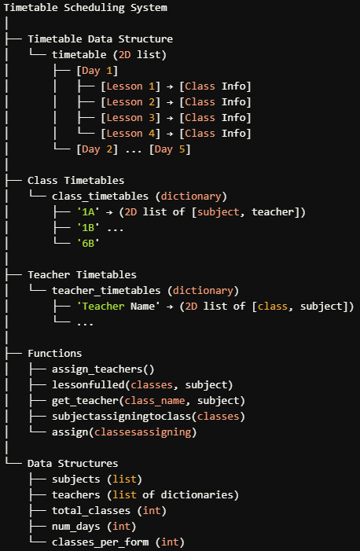

4.2 Variables of different functions

4.2.1 Timetable

variable | Data type | description
timetable | list of list of list (3D list)  The outer list represents the days, the middle list represents the lessons for each day, and the innermost list holds dictionaries that contain details about each lesson (class, subject, teacher). | The timetable structure is designed to store the schedule for classes over multiple days. Each entry in the timetable corresponds to a specific lesson for a specific day, allowing for easy access and modification as needed during the scheduling process.

4.2.2 variables of get_available_teachers(subject)
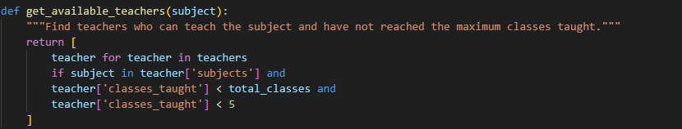

variable | Data type | description
subject | str | Represents the name of the subject for which we are finding available teachers.
teacher | dict | Represents an individual teacher from the teachers list being evaluated for availability to teach the specified subject.
Return Value | list of dict | Returns a list of teachers who can teach the specified subject and have not exceeded their teaching limits.

4.2.3 Variables of assign_teacher_to_timetable(form, class_index, subject, lesson, assigned_teacher)
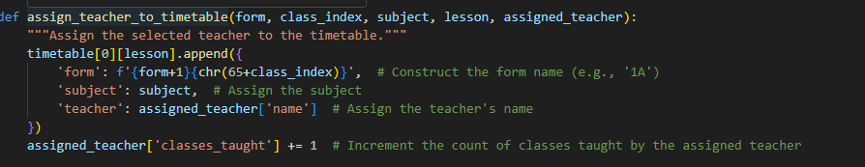

variable | Data type | description
form | int | Represents the current form (or class level) index being processed.
class_index | int | Represents the index of the specific class within the form being processed.
subject | str | Represents the name of the subject being assigned to the timetable for the current class.
lesson | int | Represents the index of the current lesson (timeslot) in the timetable for the day.
assigned_teacher | dict | Represents the teacher who has been randomly selected to teach the current subject and is being assigned to the timetable.

4.2.4 Variables of assign_teachers()
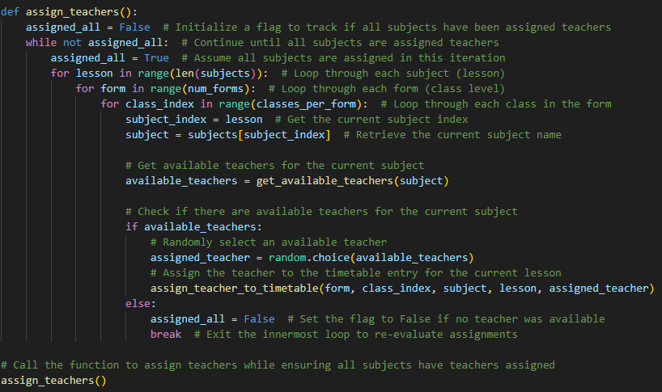

variable | Data type | description
assigned_all | bool | A flag to track whether all subjects have been successfully assigned teachers. It starts as False and is set to True if all subjects are assigned during an iteration.
lesson | int | Represents the index of the current subject (lesson) being processed within the loop that iterates over the subjects.
form | int | Represents the index of the current form (class level) being processed in the outer loop.
class_index | int | Represents the index of the specific class within the current form being processed.
subject_index | int | Holds the index of the current subject being processed, which is the same as the lesson.
subject | str | Represents the name of the current subject being processed, retrieved from the subjects list using subject_index.
available_teachers | list of dict | Contains a list of teachers who can teach the current subject and have not reached their maximum teaching limits. This is generated using a list comprehension.
assigned_teacher | dict | Represents the teacher selected from available_teachers to be assigned to the current subject for the class.

4.2.5 Variables of lessonfulled(classes, subject)
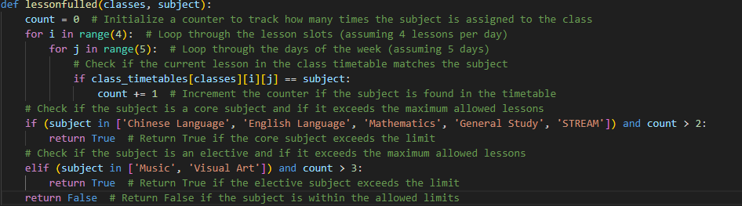

variable | Data type | description
count | int | Counts how many times the specified subject is assigned to the given class.
i | int | Index for iterating through lessons in the timetable.
j | int | Index for iterating through days in the timetable.

4.2.6 Variables of get_teacher(class_name, subject)
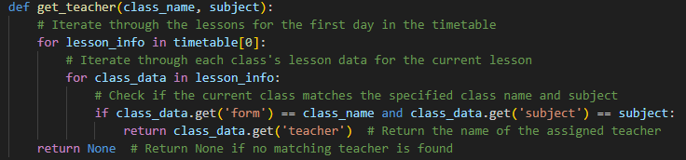

variable | Data type | description
lesson_info | list | Represents the lessons assigned for a particular day.
class_data | dict | Holds the information about each class's lesson (form, subject, teacher).

4.2.7 Variables of subjectassigningtoclass(classes)
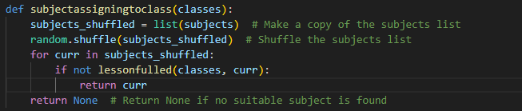

variable | Data type | description
subjects_shuffled | list | A shuffled copy of the subjects list to randomize subject assignment.
curr | str | Represents the current subject being evaluated for assignment.

4.2.8 Variables of assign(classesassigning)
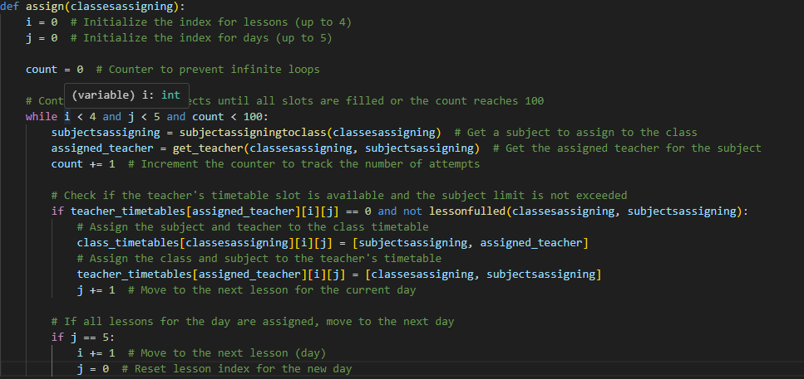

variable | Data type | description
i | int | Index for iterating through lessons in the class timetable.
j | int | Index for iterating through days in the class timetable.
count | int | A counter used to prevent infinite loops by limiting the number of iterations.
subjectassigning | str | Represents the subject assigned to the current time slot for the class.
assigned_teacher | str | Holds the name of the teacher assigned to the current subject for the class.

4.3 Output
We opt to output the class and teachers timetable in a CLI format first, and it will be outputted CSV format for further processing.

4.3.1 Displaying Class Timetable
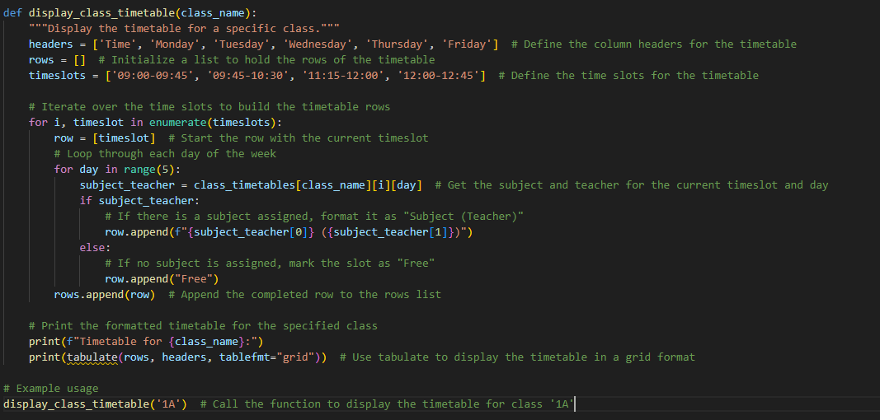
The display_class_timetable function is designed to show the schedule for a specific class in a clear and organized way. It starts by defining the headers for the timetable, including the days of the week and time slots. It then creates a list to hold the rows of the timetable. For each time slot, the function checks each day of the week to see if a subject and teacher are assigned. If a subject is assigned, it formats the entry as "Subject (Teacher)"; if not, it marks the slot as "Free." Finally, it uses the tabulate library to print the complete timetable in a visually appealing grid format. The tabulate library makes it easy to present data in structured tables, automatically aligning columns and supporting various output formats like plain text or HTML. This enhances readability, allowing users to quickly grasp the class schedule. You can use this function by calling it with a class name, like '1A', to see that class's schedule. The following is the output.
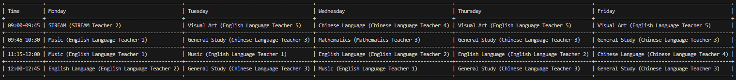

4.3.2 Displaying Teacher Timetable
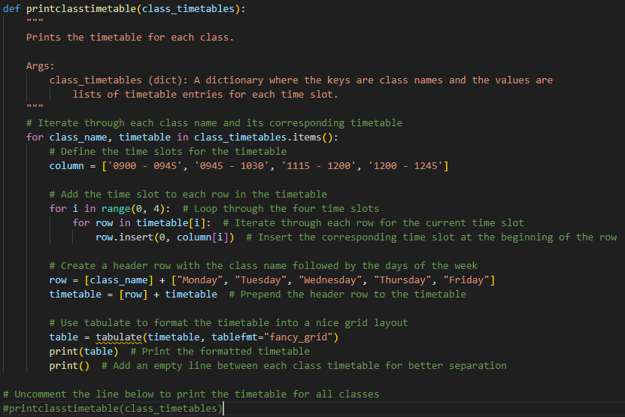
The printclasstimetable function prints the schedule for each class in a clear and organized format. It starts by defining the time slots for the day and then adds these time slots to each row of the timetable. For each class, it creates a header row that includes the class name and the days of the week. The function then uses the tabulate library to format the timetable into a visually appealing grid layout. This makes it easy to read and understand the class schedules at a glance. The tabulate library enhances the output by neatly aligning the data and providing various formatting options, so the final printed timetables look professional and are easy to follow. Each class's timetable is separated by an empty line for clarity, making the information even more accessible.The following is the output.
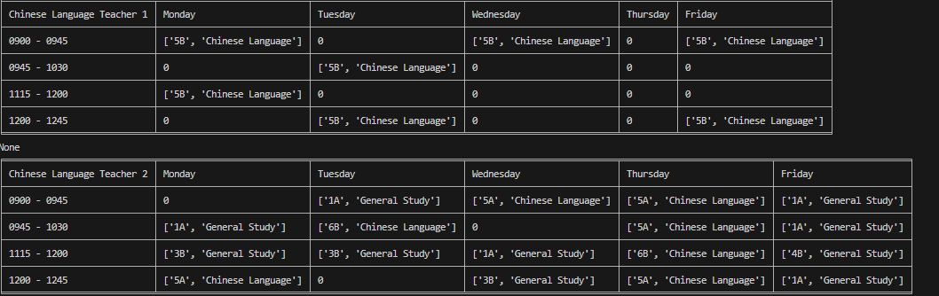

4.2.3 Displaying CSV File
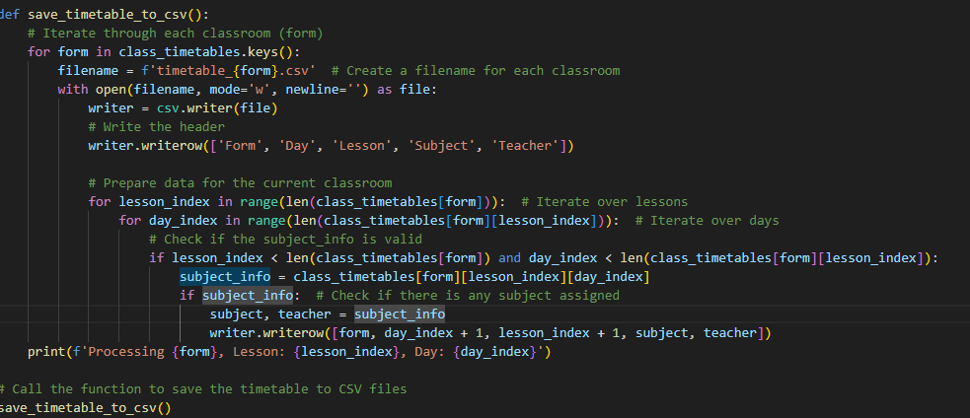

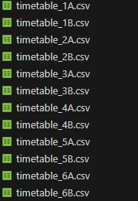
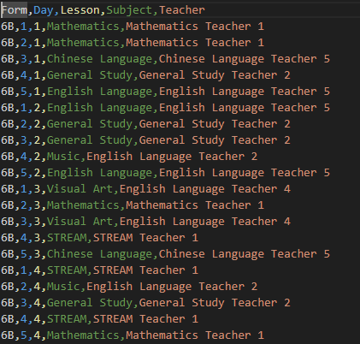

The provided Python program defines a function save_timetable_to_csv() that generates CSV files for each classroom's timetable. The function iterates over a dictionary called class_timetables, which contains timetables for various forms (classrooms). For each classroom, it creates a CSV file named after the form (e.g., timetable_1A.csv) and writes a header row with the columns "Form," "Day," "Lesson," "Subject," and "Teacher." It then loops through the lessons and days to collect the subject and teacher information for each lesson slot. If valid data is found in the timetable, it appends this information to the CSV file. After processing each form, it prints a message indicating the current form, lesson index, and day index being processed. Finally, the function is called to execute the CSV creation process, generating organized timetables for each classroom.
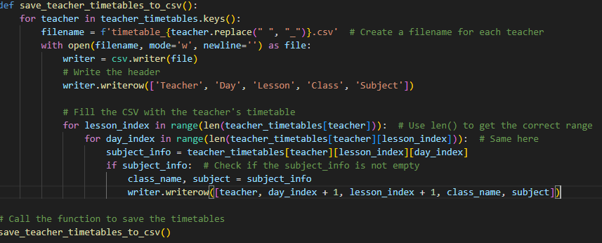
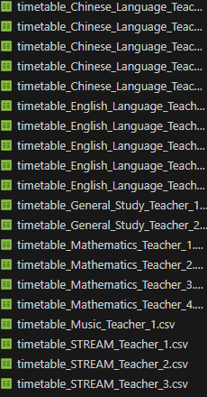
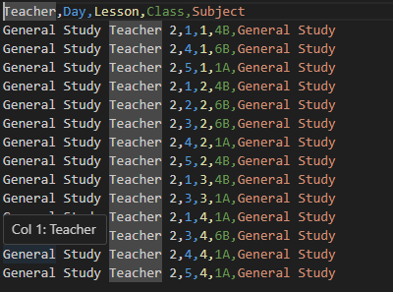
The save_teacher_timetables_to_csv() function is designed to generate CSV files for each teacher's timetable. It iterates through the teacher_timetables dictionary, where each key corresponds to a teacher and the associated value is a list of lists representing their schedule. For each teacher, the function creates a CSV file named after the teacher, with spaces replaced by underscores for compatibility. It begins by writing a header row that includes the columns "Teacher," "Day," "Lesson," "Class," and "Subject." The function then loops through the lessons and days within the teacher's timetable, checking for valid subject information. If a subject is assigned for a given lesson and day, it extracts the class name and subject and writes this data into the CSV file. Finally, the function is called to execute the CSV creation, resulting in organized timetables for each teacher, making it easier to view their schedules at a glance.

5 Algorithm design

5.1 Constraints for Data Validation Purpose
The constraints ensure data validation by establishing clear rules that the timetable must follow, which helps maintain organization, fairness, and functionality. By enforcing these rules, the system can check that the schedule is logically sound and meets the necessary requirements for both teachers and students. This validation process ensures that the timetable is practical and effective, preventing issues such as scheduling conflicts and ensuring equitable access to educational resources.

Constraint that we use | reason
including 6 forms where each form has 2 classes | ensures that the timetable is structured in a way that aligns with the specific organization of the school.
Number of subjects: 7 (Chinese Language, English Language, Mathematics, General Study, STREAM,  Music, Visual Art) | ensures the minimum subject is allocated a suitable number of timeslots throughout the timetable. This helps in achieving a balanced distribution of subjects, ensuring a suitable teaching hour for all classes.
20 teachers who specialized in various subject areas. | helps in achieving a balanced workload for teachers. It ensures a reasonable working timetable for all teachers, which can positively impact their performance and well-being. By distributing the workload evenly, the timetable will not pressurize teachers with an overwhelming schedule.
5 days / week (Monday-Friday) | Structured Learning Routine: The constraint ensures a structured learning routine for students, with classes scheduled consistently from Monday to Friday. This helps students establish a routine that is beneficial for their time management.
4 lessons / day, all in the morning, no lessons after lunch. | By scheduling all lessons in the morning, students can benefit from a concentrated period of focused learning. Research suggests that students are often more alert and receptive to new information in the morning, making it an ideal time for academic instruction.
All classes should have at least  (i) 3 Chinese Language, English Language, Mathematics, General Study and STREAM.  (ii) 2 Music, Visual Art. | Equity and Equality: Ensuring that all classes have an equal distribution of lessons for core subjects and arts subjects promotes equity and equality in education. It ensures that students across different classes have access to the same educational opportunities and resources.
No teacher should have 0 lessons per day. | Assigning each teacher at least one lesson per day ensures that the knowledge, skills, and expertise of teachers are effectively utilized. It maximizes the impact of their presence in the classroom and promotes a high-quality learning experience for students.
No teacher should attend 4 consecutive lessons in the same classroom. | Classroom Environment: By avoiding four consecutive lessons in the same classroom, the constraint helps in maintaining a fresh and dynamic learning environment. It allows for classroom setup adjustments, such as rearranging desks, materials, or technology, to suit different subjects or teaching methods.
No teacher or student should attend more than 1 lesson per timeslot. | Avoiding Scheduling Conflicts: By ensuring that no teacher or student is scheduled for more than 1 lesson per timeslot, the constraint minimizes scheduling conflicts. It allows teachers and students to fully engage and participate in each lesson without having to choose between conflicting classes.
The teacher will teach all the lessons on the specific subject for the specific class. | Consistent Instruction: Having the same teacher teach all the lessons on a specific subject ensures consistency in instruction. It helps in maintaining a cohesive curriculum, teaching style, and assessment approach throughout the course. This consistency can enhance student learning outcomes and foster a sense of continuity in their educational journey.

5.2 Generating Teachers’ Duty Data
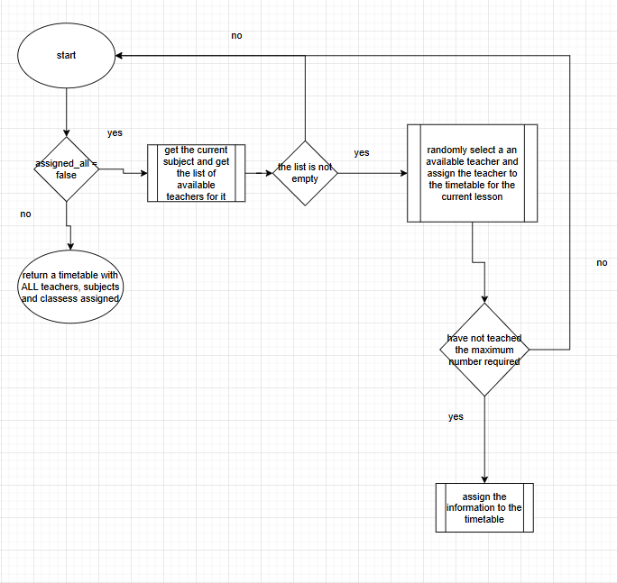

5.2.1 Design of get_available_teachers(subject)

def get_available_teachers(subject):
"""Find teachers who can teach the subject and have not reached the maximum classes taught."""
return [
teacher for teacher in teachers
if subject in teacher['subjects'] and
teacher['classes_taught'] < total_classes and
teacher['classes_taught'] < 5
]

The get_available_teachers function identifies teachers who are eligible to teach a specific subject. It takes the subject as an input and returns a list of teachers who meet certain criteria: they must be qualified to teach the subject (meaning it's included in their list of subjects), and they should not have exceeded their maximum allowed classes, which is defined by total_classes and capped at 5 classes taught. This function helps ensure that only teachers who are available and qualified are considered for teaching assignments.

5.2.2 Design of assign_teacher_to_timetable function

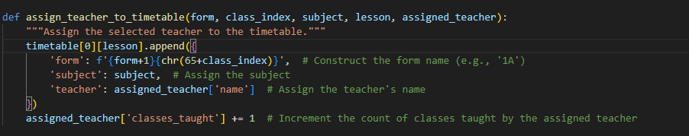
The assign_teacher_to_timetable function is responsible for adding a teacher's assignment to the timetable for a specific class and lesson. It takes parameters for the form, class index, subject, lesson, and the assigned teacher. The function constructs a name for the class (like '1A'), records the subject being taught, and logs the teacher's name. Additionally, it updates the count of classes taught by the assigned teacher to reflect this new assignment. This helps keep track of each teacher's workload while organizing the timetable effectively.

5.2.3 Design of assign_teachers() function

def assign_teachers():
assigned_all = False # Initialize a flag to track if all subjects have been assigned teachers
while not assigned_all: # Continue until all subjects are assigned teachers
assigned_all = True # Assume all subjects are assigned in this iteration
for lesson in range(len(subjects)): # Loop through each subject (lesson)
for form in range(num_forms): # Loop through each form (class level)
for class_index in range(classes_per_form): # Loop through each class in the form
subject_index = lesson # Get the current subject index
subject = subjects[subject_index] # Retrieve the current subject name

# Get available teachers for the current subject
available_teachers = get_available_teachers(subject)

# Check if there are available teachers for the current subject
if available_teachers:
# Randomly select an available teacher
assigned_teacher = random.choice(available_teachers)
# Assign the teacher to the timetable entry for the current lesson
assign_teacher_to_timetable(form, class_index, subject, lesson, assigned_teacher)
else:
assigned_all = False # Set the flag to False if no teacher was available
break # Exit the innermost loop to re-evaluate assignments

# Call the function to assign teachers while ensuring all subjects have teachers assigned
assign_teachers()

The assign_teachers function is designed to allocate teachers to subjects in a school timetable. It starts by setting a flag, assigned_all, to track whether all subjects have been successfully assigned teachers. The function enters a loop that continues until all subjects are assigned. Inside, it iterates through each subject, form, and class, retrieving the current subject and checking for available teachers. If there are teachers available, one is randomly selected and assigned to the timetable for that lesson. If no teachers are available for a subject, the function marks assigned_all as False, indicating that not all assignments could be made, and breaks out of the innermost loop to reevaluate. This process ensures that every subject is eventually taught by an available teacher.

{'1A': [[['STREAM', 'Mathematics Teacher 1'], ['English Language', 'English Language Teacher 2'], ['English Language', 'English Language Teacher 2'], ['English Language', 'English Language Teacher 2'], ['STREAM', 'Mathematics Teacher 1']], [['Chinese Language', 'Chinese Language Teacher 5'], ['STREAM', 'Mathematics Teacher 1'], ['Visual Art', 'English Language Teacher 3'], ['English Language', 'English Language Teacher 2'], ['Chinese Language', 'Chinese Language Teacher 5']], [['Chinese Language', 'Chinese Language Teacher 5'], ['STREAM', 'Mathematics Teacher 1'], ['STREAM', 'Mathematics Teacher 1'], ['General Study', 'Chinese Language Teacher 3'], ['Mathematics', 'Mathematics Teacher 1']], [['English Language', 'English Language Teacher 2'], ['Music', 'English Language Teacher 2'], ['General Study', 'Chinese Language Teacher 3'], ['Visual Art', 'English Language Teacher 3'], ['STREAM', 'Mathematics Teacher 1']]]
The sample output shows the final results of the functions combined. It shows the subject teacher of each class , which can be utilized later.

5.3 Generating Teachers’ and Classes’ Timetable
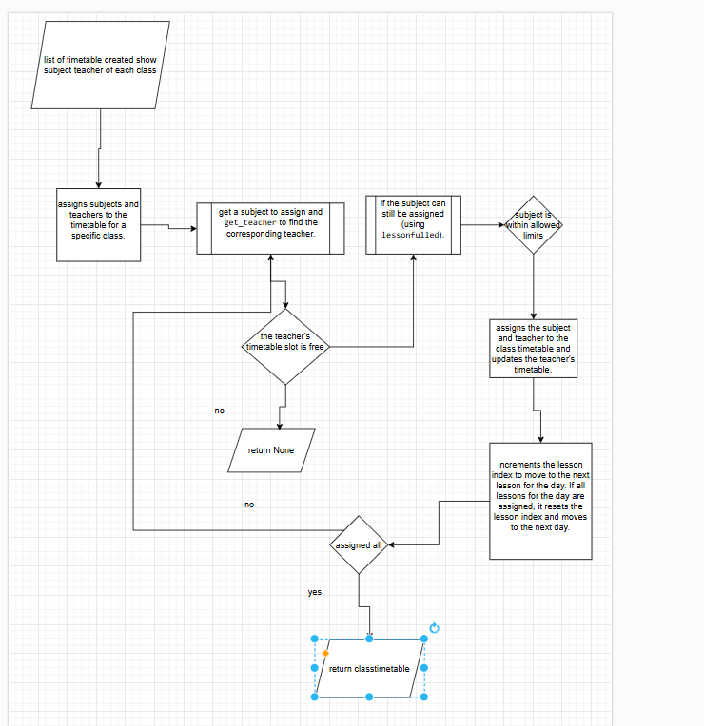
We first create the class timetable , then using the class timetable containing the subject teacher and their timeslots, deduce the teacher timetable.

5.3.1 Design of lessonfulled(classes, subject) function

def lessonfulled(classes, subject):
count = 0 # Initialize a counter to track how many times the subject is assigned to the class
for i in range(4): # Loop through the lesson slots (assuming 4 lessons per day)
for j in range(5): # Loop through the days of the week (assuming 5 days)
# Check if the current lesson in the class timetable matches the subject
if class_timetables[classes][i][j] == subject:
count += 1 # Increment the counter if the subject is found in the timetable
# Check if the subject is a core subject and if it exceeds the maximum allowed lessons
if (subject in ['Chinese Language', 'English Language', 'Mathematics', 'General Study', 'STREAM']) and count > 2:
return True # Return True if the core subject exceeds the limit
# Check if the subject is an elective and if it exceeds the maximum allowed lessons
elif (subject in ['Music', 'Visual Art']) and count > 3:
return True # Return True if the elective subject exceeds the limit
return False # Return False if the subject is within the allowed limits

The lessonfulled function checks how many times a specific subject has been assigned to a given class in the timetable. It counts occurrences of the subject across four lesson slots over five days. If the subject is a core subject (like Chinese Language or Mathematics) and is found more than twice, or if it’s an elective subject (like Music or Visual Art) found more than three times, the function returns True, indicating the subject has exceeded its allowed limit. If the subject is within the permissible limits, it returns False. This helps ensure a balanced distribution of subjects in the timetable.

5.3.2 Design of get_teacher(class_name, subject) function

def get_teacher(class_name, subject):
# Iterate through the lessons for the first day in the timetable
for lesson_info in timetable[0]:
# Iterate through each class's lesson data for the current lesson
for class_data in lesson_info:
# Check if the current class matches the specified class name and subject
if class_data.get('form') == class_name and class_data.get('subject') == subject:
return class_data.get('teacher') # Return the name of the assigned teacher
return None # Return None if no matching teacher is found

The get_teacher function retrieves the name of the teacher assigned to a specific class for a given subject. It iterates through the lessons for the first day in the timetable, checking each lesson entry. For each entry, it looks for a match between the specified class name and subject. If a match is found, the function returns the name of the assigned teacher. If no matching teacher is found after checking all entries, it returns None. This function helps identify which teacher is responsible for teaching a particular subject in a specific class.

5.3.3 Design of subjectassigningtoclass(classes) function

def subjectassigningtoclass(classes):
subjects_shuffled = list(subjects) # Make a copy of the subjects list
random.shuffle(subjects_shuffled) # Shuffle the subjects list
for curr in subjects_shuffled:
if not lessonfulled(classes, curr):
return curr
return None # Return None if no suitable subject is found

The subjectassigningtoclass function is designed to select a suitable subject for a given class. First, it creates a shuffled copy of the available subjects to ensure randomness in selection. It then iterates through this shuffled list and checks each subject to see if it can be assigned to the class without exceeding the allowed lesson limits, as determined by the lessonfulled function. If it finds a subject that meets the criteria, it returns that subject. If none of the subjects can be assigned without exceeding limits, the function returns None. This approach helps maintain a balanced distribution of subjects in the timetable.

5.3.4 Design of assign(classesassigning) function

def assign(classesassigning):
i = 0 # Initialize the index for lessons (up to 4)
j = 0 # Initialize the index for days (up to 5)

count = 0 # Counter to prevent infinite loops

# Continue assigning subjects until all slots are filled or the count reaches 100
while i < 4 and j < 5 and count < 100:
subjectsassigning = subjectassigningtoclass(classesassigning) # Get a subject to assign to the class
assigned_teacher = get_teacher(classesassigning, subjectsassigning) # Get the assigned teacher for the subject
count += 1 # Increment the counter to track the number of attempts

# Check if the teacher's timetable slot is available and the subject limit is not exceeded
if teacher_timetables[assigned_teacher][i][j] == 0 and not lessonfulled(classesassigning, subjectsassigning):
# Assign the subject and teacher to the class timetable
class_timetables[classesassigning][i][j] = [subjectsassigning, assigned_teacher]
# Assign the class and subject to the teacher's timetable
teacher_timetables[assigned_teacher][i][j] = [classesassigning, subjectsassigning]
j += 1 # Move to the next lesson for the current day

# If all lessons for the day are assigned, move to the next day
if j == 5:
i += 1 # Move to the next lesson (day)
j = 0 # Reset lesson index for the new day

The assign function fills a class timetable by assigning subjects and their respective teachers to specific lesson slots over five days. It uses a loop to attempt to assign subjects to each lesson, checking if a suitable subject can be assigned and if the assigned teacher is available for that time slot. If both conditions are met, it updates the timetable with the subject and teacher's information. The function continues this process until all lesson slots are filled or it reaches a limit of 100 attempts to prevent endless loops. This ensures that every class has a well-organized schedule while respecting subject limits and teacher availability.

The assign function not only fills a class timetable by assigning subjects and teachers to specific lesson slots but also simultaneously creates a teacher's timetable as a side product. Each time a subject and teacher are successfully assigned to a class, the function also updates the corresponding teacher's timetable to reflect the class and subject being taught in that lesson slot. This means that for every assignment made in the class timetable, the teacher's timetable is also populated with information about which class they are teaching and the subject. This dual updating ensures that both the class schedules and teacher schedules are organized and aligned, making it easier to manage teaching workloads and availability.

By formatting the timetable, we can create a conflict free timetable for both class and teacher.

6.Testing and Debugging

6.1 Encountered Bugs and Debugging
The timetable scheduling system can be highly complex, with many interdependent components. This complexity makes it difficult to identify and isolate bugs, which can lead to unexpected behavior that isn't easily concealed. The following are some bugs that I encountered and how I dealt with them.

6.1.1 Wrongly assign the classes per form

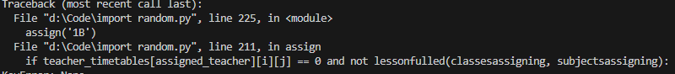
If classes_per_form is set to 1, it implies that there is only one class slot available for each form (or grade level) in your timetable. This limitation can lead to scheduling conflicts or unassigned lessons if multiple subjects or lessons need to be accommodated for the same form. For instance, if two different subjects are scheduled at the same time, one will be left out due to the lack of available slots.
Solving the problem, we can simply add 1 to the classes per form as classes_per_form = 2

6.1.2 Wrongly assign the iteration variable
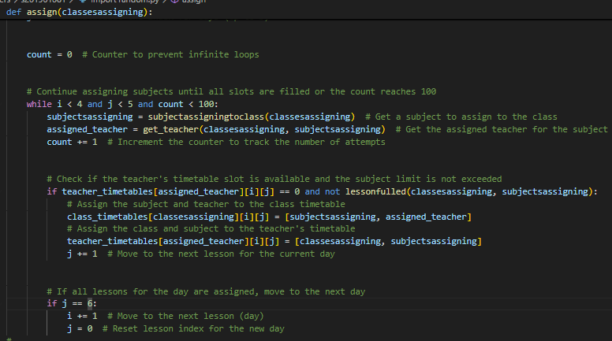
The condition if j == 6: cannot be met because j is intended to represent lesson slots for a single day, which are typically indexed from 0 to 4. This means that the maximum value j can take is 4; hence, it can never logically reach 6. In programming, indexing generally starts at 0, so having five lesson slots means they are represented by the indices 0, 1, 2, 3, and 4. As a result, the condition j == 6 will always evaluate to false during execution, preventing any associated code from running. This creates a significant issue where the logic meant to transition to the next day will not be triggered, hence the program only runs for the first day of the timetable. The example is as follows.
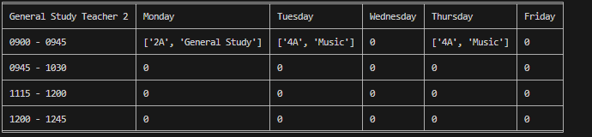
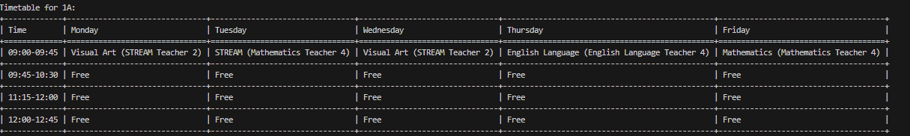
Using if j == 5: can effectively solve the problem by providing a proper condition to indicate when all lesson slots for a day have been filled. Since lesson slots are indexed from 0 to 4, reaching 5 signifies that the program has filled all available slots for that day. This condition allows the logic to increment the day counter (i) and reset the lesson counter (j) back to 0, facilitating the transition to the next day's slots. By correctly managing this transition, the condition j == 5 prevents the infinite loop scenario that occurs when the day transition condition is never satisfied. Ultimately, this adjustment ensures that the program can progress through the timetable efficiently, handling all lessons across multiple days as intended.

6.1.3 Number of teachers
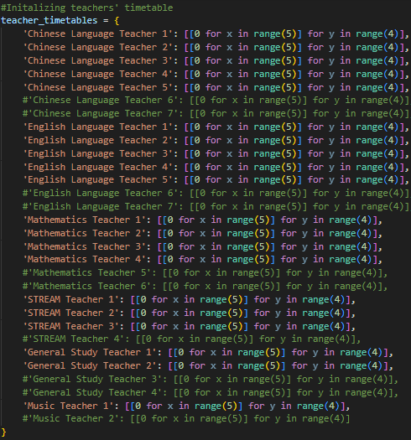
When i exclude some of the teachers in the list, i can find that the program efficiency and ability to run has dropped significantly. For example, if I exclude STREAM Teacher 3, I can only run once in a few times. The situation has worsened if I further exclude other teachers.
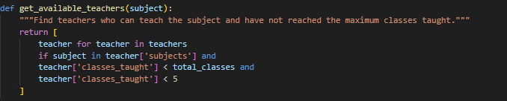
This sub function limits the amount of lessons that a teacher can teach. Hence, reducing the amount of teachers may lead to a run time error as the assigning process is random.
Solving this problem, we can simply include more teachers, but the resources of the school should also be considered. Hence the logic flow or workload of teachers should be refined. Such as assigning teachers based on their workload. This can further solve the problem of the difference of different teachers' workload, the following is the example.
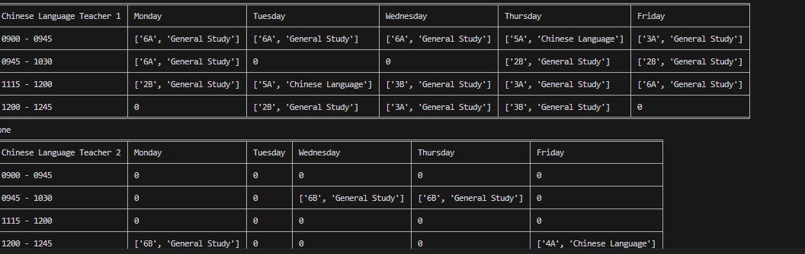
We can clearly see that Chinese Language teacher 1 and 2 have completely different workloads. Hence the program should be further refined for a more humane consideration

6.2 Feedbacks
A survey is conducted for the timetable system program to my classmates and teachers, here are the results

Items | Excellent | Good | Satisfactory | Fair | Poor
User-friendliness |  | ✔
Time efficiency | ✔
simplicity | ✔
usability | ✔
maintainability |  |  | ✔
Output | ✔

Comment:
- The assignment of lessons is unfair for some of the teachers.
- Sometimes there are run-time errors
- The output timetable is neat and tidy
- Unable to change the size of the timetable
It is excited that 100% of the students and teachers accept the functionality of the program, which successfully passes the user acceptance test

6.3 Testing

6.3.1 Test data of the available_teachers() function
Unit tests of the function

Data items | Test data | Methods of validation/verification | Expected results | Results
total_classes | -2  (✘invalid) | Range check | Users are reminded to the fact of list index out of range | Runtime error
 | ‘A’  (✘invalid) | Type check | Users are reminded that 'str' object cannot be interpreted as an integer | TypeError: '<' not supported between instances of 'int' and 'str'
subject | [‘Chemistry’,’Science’] | Presence check | Users are reminded that no such subject exists. | Runtime error
 | [1,2] | Data type check | Users are reminded that the subject should be in string form | Runtime error

6.3.2 test data of the assign(classassigning) function

Data items | Test data | Methods of validation/verification | Expected results | Results
form | 8  (✘invalid) | Range check | Users are reminded to the fact of list index out of range
 | ‘K’  (✘invalid) | Type check | Users are reminded that 'str' object cannot be interpreted as an integer
subject | [Physics’,’Science’]  (✘invalid) | Presence check | Users are reminded that no such subject exists.
 | [1,6]  (✘invalid) | Data type check | Users are reminded that the subject should be in string form

6.3.3 test data of the assign_teachers()

Data items | Test data | Methods of validation/verification | Expected results | Result
assign-all | True  (✘invalid) | Type check | Users are reminded that the loop starts with the assumption that all subjects are assigned, which has logic error | No values are assigned to the list timetable
 | False  (✔valid) | Type check | Able to run | /
subject | [Physics’,’Science’]  (✘invalid) | Presence check | Users are reminded that no such subject exists. | Runtime error
 | [1,6]  (✘invalid) | Data type check | Users are reminded that the subject should be in string form | Runtime error

6.3.4 Test data of lessonfulled()

Data items | Test data | Methods of validation/verification | Expected results | Results
count | -1 | range check | Users are reminded that the subject incorrectly passes the limit check because the counter will not reflect the true number of assignments. | The amount of lessons do not fit the constraints that the school has assigned
 | False | Type check | trying to perform arithmetic operations on a boolean will raise a TypeError. | There are no restrictions to the lessons assigned.
subject | [Physics’,’Science’]  (✘invalid) | Presence check | Users are reminded that no such subject exists. | Some teachers may have days without lessons
 | [1,6]  (✘invalid) | Data type check | Users are reminded that the subject should be in string form | Some teachers may have days without lessons

6.3.5 Test data of assign()

Data items | Test data | Methods of validation/verification | Expected results | Results
i | ‘K’ | Type check | Users are reminded that the iteration variables should be integer | TypeError: '<' not supported between instances of 'str' and 'int'
j | False | Type check | Users are reminded that the iteration variables should be integer | The class timetable may have free time slots.

6.4 Integration tests
There are mainly 2 parts of the program, assigning subject teachers of each class and assigning lessons to those teachers.

6.4.1 assigning subject teachers of each class
The coherence of the functions in my code centers on their interaction to efficiently assign teachers to a timetable. The assign_teachers() function orchestrates the entire process by iterating through subjects and classes, using get_available_teachers(subject) to find eligible teachers. This function acts as a filter, providing a list of teachers who can teach a specific subject and haven't exceeded their limits. Once a suitable teacher is identified, assign_teacher_to_timetable(form, class_index, subject, lesson, assigned_teacher) is invoked to handle the actual assignment, updating both the timetable and the teacher's workload. The loop in assign_teachers() continues until all subjects have been assigned teachers, ensuring that the process is thorough. Overall, the interaction among these functions creates a clear and efficient flow of data, making the assignment process straightforward and organized. This modular approach allows each function to focus on its specific role while contributing to the overall goal of effectively managing teacher assignments.

6.4.2 assigning lessons to teachers
The coherence of the functions in my code revolves around their interaction to effectively assign subjects and teachers to classes while adhering to specified rules. The lessonfulled(classes, subject) function checks how many times a given subject is assigned to a specific class, ensuring that it does not exceed the allowed limits for core or elective subjects. This function acts as a gatekeeper, providing essential validation for subject assignments.
Next, the get_teacher(class_name, subject) function retrieves the teacher assigned to a specific class and subject by searching through the timetable. This function is crucial for ensuring that the correct teacher is associated with each subject assignment, facilitating a seamless integration of teacher and subject data.
The subjectassigningtoclass(classes) function takes a shuffled list of subjects and checks each one against the lessonfulled() function to determine which subjects can be assigned to the class without exceeding limits. This function helps optimize the assignment process by ensuring that only eligible subjects are considered.
Finally, the assign(classesassigning) function orchestrates the overall process of assigning subjects and teachers to classes. It loops through lesson slots and days, attempting to assign subjects while ensuring that the teacher's timetable is available and that subject limits are respected. If a subject can be assigned, it updates both the class and teacher timetables accordingly.
In summary, these functions interact cohesively to manage the assignment of subjects and teachers, ensuring compliance with established rules and providing a structured approach to filling the timetable. Each function has a specific role, contributing to a smooth and organized assignment process, thereby enhancing the overall efficiency of the system.

7. Improvements based on reflections and testing
Based on the reflections about ‘Sometimes there are run-time errors’. We have found out that the code was lack of modularization
Before:
def assign_teachers():
assigned_all = False # Initialize a flag to track if all subjects have been assigned teachers
while not assigned_all: # Continue until all subjects are assigned teachers
assigned_all = True # Assume all subjects are assigned in this iteration
for lesson in range(len(subjects)): # Loop through each subject (lesson)
for form in range(num_forms): # Loop through each form (class level)
for class_index in range(classes_per_form): # Loop through each class in the form
subject_index = lesson # Get the current subject index
subject = subjects[subject_index] # Retrieve the current subject name
# Find teachers who can teach the subject and have not reached the maximum classes taught
available_teachers = [
teacher for teacher in teachers
if subject in teacher['subjects'] and
teacher['classes_taught'] < total_classes and
teacher['classes_taught'] < 5
]
# Check if there are available teachers for the current subject
if available_teachers:
# Randomly select an available teacher
assigned_teacher = random.choice(available_teachers)
# Assign the teacher to the timetable entry for the current lesson
timetable[0][lesson].append({
'form': f'{form+1}{chr(65+class_index)}', # Construct the form name (e.g., '1A')
'subject': subject, # Assign the subject
'teacher': assigned_teacher['name'] # Assign the teacher's name
})
# Increment the count of classes taught by the assigned teacher
assigned_teacher['classes_taught'] += 1
else:
assigned_all = False # Set the flag to False if no teacher was available
break # Exit the innermost loop to re-evaluate assignments

After:

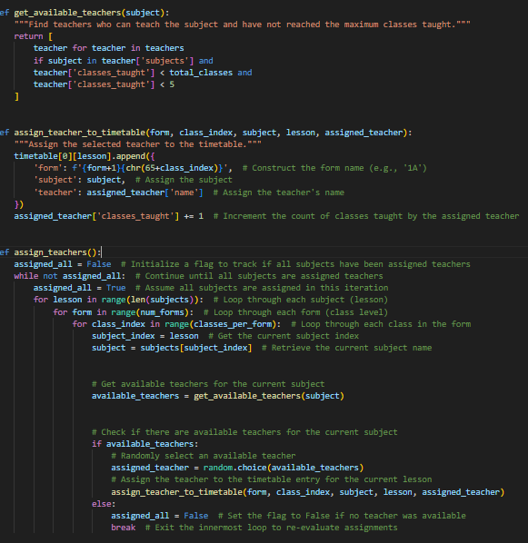

Before optimization
After optimization
Improving the efficiency of my program can significantly reduce the likelihood of run-time errors by simplifying logic and enhancing readability. When I keep functions concise and focused on specific tasks, it becomes easier to identify potential issues, making debugging more straightforward. Additionally, by following the "Don't Repeat Yourself" principle, I can minimize redundancy, which reduces the risk of introducing inconsistencies that can lead to errors. Efficient resource management is crucial; optimizing memory usage helps prevent exhaustion and memory leaks, both of which can result in crashes. Effective error handling, including proactive checks and graceful degradation, allows my program to respond to unexpected conditions without terminating abruptly. Furthermore, modular and efficient code is easier to test, leading to increased reliability and comprehensive coverage of various scenarios. Overall, focusing on efficiency not only enhances performance but also fosters a more robust and error-resistant application.

8. Further Improvements

8.1 Workload-based assignments
As mentioned above, the workload of teachers is completely random, sometimes it is fair but sometimes it is not. Therefore, a proper assigning logic should be further developed.
To enhance the fairness of teacher assignments in my code, I can implement a First-In-First-Out (FIFO) queue system that prioritizes teachers based on their workload. The FIFO concept ensures that teachers who have taught fewer lessons are assigned new classes first, promoting a more equitable distribution of work. This approach not only prevents any single teacher from becoming overburdened while others have lighter schedules, but also improves overall efficiency in resource management. By creating a sub-function that sorts teachers by their classes_taught count, I can dynamically update the list to reflect current workloads. When assigning subjects in the assign() function, instead of randomly selecting a teacher, I will use this FIFO queue to ensure that the teacher with the least workload is prioritized. This systematic approach not only enhances fairness in the assignment process but also contributes to a positive working environment, ultimately leading to improved job satisfaction among teachers. By adopting this strategy, I can create a more humane and effective management of teaching resources.

8.2 Flexibility of Timetable Size
When the size of the timetable cannot be changed, it can lead to several disadvantages that impact both teachers and students. A fixed timetable size limits the flexibility needed to accommodate varying class sizes, changes in subject demand, and unexpected events like teacher absences. This rigidity can result in overcrowded classes, which diminish the quality of education, as teachers may struggle to give individual attention to students. Additionally, if certain subjects are overrepresented while others are underutilized, it can create imbalances in workload among teachers, leading to burnout and dissatisfaction.

Solving this problem, incorporating advanced algorithms that analyze historical data can help predict trends in subject demand, enabling proactive adjustments to the timetable before issues arise.

9. Evaluation

9.1 Benefits and Limitations
The program offers several benefits by providing a simple user interface designed to output a conflict-free timetable without any sophisticated operations. This straightforward interface enhances user experience, making it accessible to teachers and administrators without requiring extensive training or technical knowledge. By focusing on essential features, the program minimizes complexity, reducing the risk of errors and confusion; users can quickly input their data and receive a clear timetable. Additionally, the simplicity of the interface allows for efficient time management, enabling users to generate timetables swiftly, which is crucial in educational settings. The design prioritizes conflict resolution, ensuring that no overlapping assignments or classes occur, thereby enhancing reliability. Furthermore, the elimination of sophisticated operations leads to faster execution times and less strain on system resources. By concentrating on core functionality, the program delivers consistent performance, making it dependable for scheduling needs. Maintenance and updates are also streamlined due to the simpler structure, allowing developers to focus on enhancing core features. Ultimately, the program outputs timetables in a clear format, making it easy for users to interpret and utilize the information effectively.

The program faces limitations, particularly in its lack of flexibility regarding changes to the variables of the timetable size and the potential for unfair assignment of lessons.
Firstly, the lack of flexibility in adjusting the timetable size can hinder its adaptability to different educational settings. For instance, if a school needs to accommodate a varying number of classes or a change in student enrollment, the rigid structure of the timetable may not allow for easy adjustments. This inflexibility can lead to inefficiencies, as educators might find themselves constrained by a one-size-fits-all approach that does not reflect the unique needs of their institution. Consequently, valuable time and resources may be wasted in attempts to fit the existing timetable to new requirements, rather than creating a responsive system that evolves alongside the educational environment.
Secondly, the potential for unfair assignment of lessons is a significant concern. If the program does not account for the specific qualifications or preferences of teachers, it may lead to an uneven distribution of workload among staff. For example, certain teachers may be assigned a disproportionate number of challenging classes or less desirable time slots, while others may receive easier or more favorable assignments. This imbalance can create dissatisfaction among educators, affecting morale and potentially impacting student learning outcomes. A system that does not fairly assign lessons may also overlook the importance of teacher specialties, leading to suboptimal learning experiences for students. Addressing these limitations is crucial for creating a more equitable and effective scheduling solution.

9.2 Reflections
Learning to use libraries like Tabulate and incorporating 2D dictionaries into my programming toolkit has significantly enriched my understanding of data manipulation and presentation.
Firstly, working with the Tabulate library has enhanced my ability to display data in a structured and visually appealing manner. This library simplifies the process of formatting tables, allowing me to present information clearly and effectively. As I learned to use various formatting options, I realized the importance of data visualization in enhancing comprehension and engagement. Being able to create well-organized tables not only makes my outputs more professional but also helps in conveying complex information in an easily digestible format. This skill is particularly valuable in educational settings, where presenting data clearly can facilitate discussions and decision-making.
Additionally, my experience with 2D dictionaries has deepened my understanding of data structures and their applications. By utilizing 2D dictionaries, I can organize related data in a more intuitive way, allowing for efficient access and manipulation. This approach has proven useful in various scenarios, such as storing and retrieving information related to timetables, student assignments, or course details. As I experimented with this data structure, I gained insights into how to optimize data retrieval processes and reduce complexity in my code. This experience has not only improved my programming skills but has also fostered a problem-solving mindset, encouraging me to think critically about how to best organize and manage information.
Overall, learning to use libraries like Tabulate and mastering 2D dictionaries has been a pivotal part of my learning process. These tools have equipped me with the skills to present data effectively and manage complex information structures, ultimately enhancing my programming capabilities and preparing me for more advanced projects in the future.

9.3 Presentation

https://www.canva.com/design/DAGaL9gmqtw/C0J6TCes8jT82dlNu1PsmA/edit

10.Reference
Throughout the development of the program, I have searched various sources of information to consolidate my knowledge and skills set for this task.

10.1 Books
Celestine Egbunik (2012) —Automated Timetable Scheduling System: The Design of an Automated Timetable Scheduling System for the Federal University of Technology, Yola (FUTY)

10.2 Websites
Ideas of output methods.

https://www.timetabler.com/book/

10.3 Essay
Paul Godwin Daniel (2018) — Paperless Master Timetable Scheduling System

10.4 AI Tools
AI Tools used: ChatGPT
A short description of output: I inputted how to create 2d dictionary in python
Summary of output:ChatGPT provided some examples to initialize a 2d dictionaries and provide the usage of it
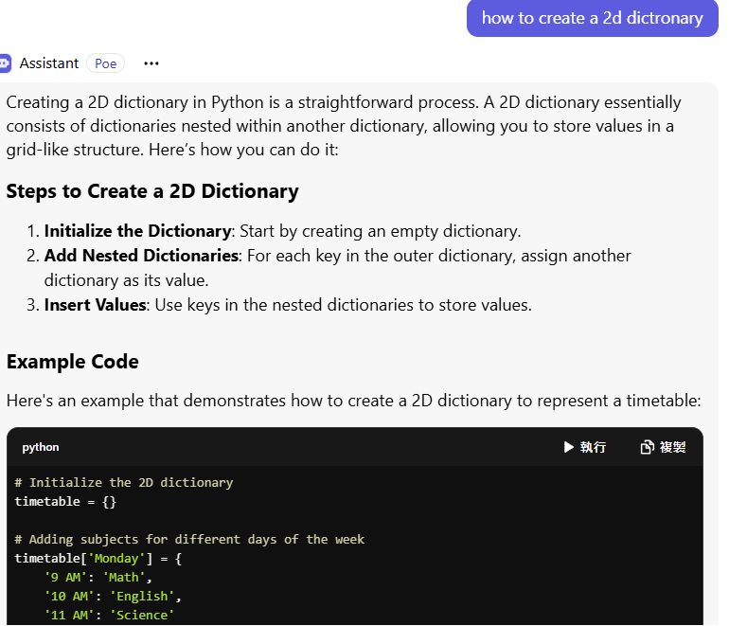
AI Tools used: ChatGPT
A short description of actions: I imputed how different programming languages affect my program to consider which programming language I should use to create the timetable scheduling system.
Summary of output: ChatGPT provided different pros and cons of different programming languages for my consideration

