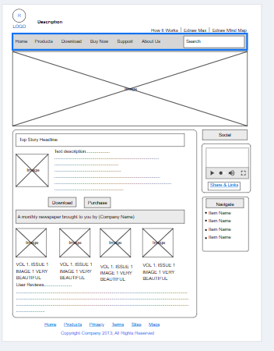

Task 2

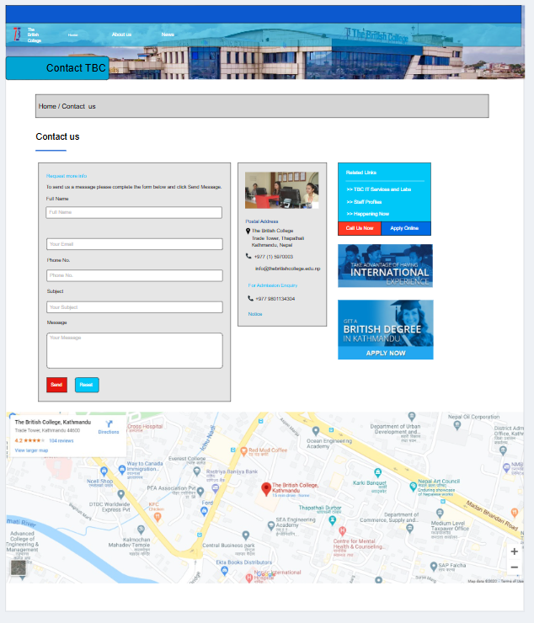

Task 3 Link: https://app.moqups.com/wg49ZRV0NeYEjWjNKpsVwHdC5XMysVHW/view/page/aabaf25fb

Link:https://app.moqups.com/wg49ZRV0NeYEjWjNKpsVwHdC5XMysVHW/view/page/ab88a800d