15-112 Design Documents

Project Overview

This project includes two classic casino games, Black Jack and Texas Poker. For each of the game, you bet with the computer. You start the game with certain amount of money, and try to get more while gambling with the computer AI. The major two parts of this project is to implement the computer artificial intelligence system that are the rival of you, as well as the graphic works. When running this game, the user is expected to get some sensing of playing in a real casino.

Techniques

Firstly, the major approaches of Black Jack is just to implement exactly the rule of Black Jack. For this game, the computer is like a dealer in the real casino, and therefore has very fixed rules of playing. When the cards sum reach 17, it must stop, and when it exceeds 21, dealer lose. This part, the project just try to implement this process, and have some functions to find the sum of cards for both the player and the dealer. One difficult part here needs to be overcome is the special case for card Ace. Since Ace can either be counted as 1 or 11, we need some special functions to solve this issue. Other than that, when get the sum of both side, we just need to find the winner by simple comparison.

As for the Texas Poker, the operations here is much more complicated than the Black Jack. To begin with, we implemented the functions to hand out each round’s cards correctly. Then, we need to have the function that can tell the largest hand at this time, and also the probabilities of each hand for next rounds. In order to test the current round hand, several helper functions are implemented to the Texas Poker class. This include functions like (isFlushing(), isStraight(), isPair()……..). The general approach here I used is to have two dictionary, one for the rank of cards and one for the suit of cards. For the rank dictionary, it stores the number of cards corresponding to each rank, and for the suit dictionary, it stores the number of cards corresponding to each suit. By looking at the information from this two dictionary, the highest hand at each time is easy to tell.

Then, the probability forecast function is the crucial part of this game. Since the computer needs to battle with you, it should make some decisions, either clever or not, based on some results. Here, one good way for the AI to make correct decision is to look at what his highest hand right now, and what is the probability to get each hands in the future. For my project, the way to get the probability of each hand in next rounds is to simulate the game with large trials. This is really similar to Monte Carlo method. And based on the simulation result, the AI made some decisions. I implemented four AI levels, including easy, medium, hard and expert. The easy mode just matches the player for no reason. The medium AI make some random decision based on the current hand. The hard AI make decisions based on the current hand, as well as combine with the probability of future rounds, but it only look at its own cards but ignore the player’s probability. For the expert AI, it has the information of both itself and the player’s probability. It will combine the information together, and try to evaluate all the situations, and make a more sophisticated decision. In general, the hard AI is more aggressive, while the expert is cleverer.

Now, with reliable operational control, the next challenge of this project is to make a very good User Interface design. For this, I firstly looked at some current online version, and did a competitive analysis. Something they did well is that the game flow and algorithms are really smooth, without crashing. But for the graphic, I think there graphic not really give me a sense of casino, or it is too general and not fancy enough. Below is an example from <http://www.thepokerpractice.com/>.

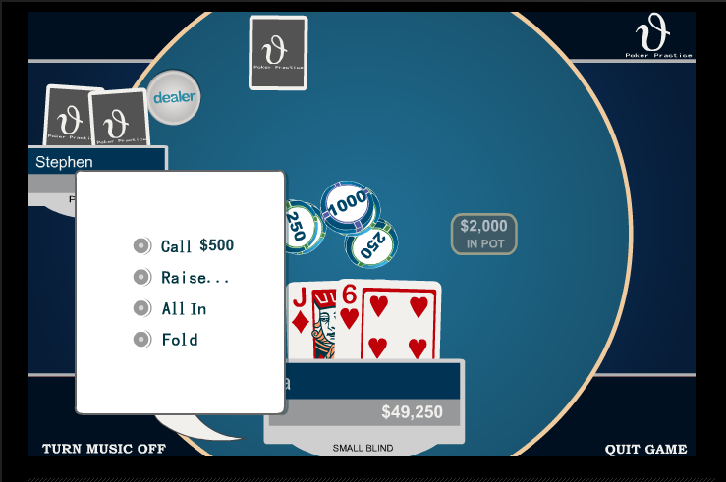

The user interface of this is good, but the background theme and color is not satisfactory. Also, I do not like the arrangement of the player position and cards. I would prefer to make the cards occupy most of the space, and not use a 3D table. One main drawback of this games is that if the player is not familiar with the Texas poker rule, the get no idea what he or she should do at certain situation. For this issue, some dynamic instruction main help.

For my UI design, I tried to resolve all the problem I mentioned above.