### KIỂM TRA PROGRESS TEST FER202

### DURATION: 85 minutes

You need to create a product management application using **JSON Server**, **ReactJS**, **Hooks**, **React Router**, and **React Bootstrap**. The application should include the following functionalities:

1. **Create a ReactJS Application.** (0.5 mark)

* Initialize a new ReactJS project, named the react is test01

1. **Create and configure JSON Server** (0.5 mark)**:**

* Create a db.json file in the root folder to initialize a mock server with the product and user account data as given file.

1. **Create a Login Form.** (3 marks)

* Create a login form with 2 input fields: **Username**, **Password**.

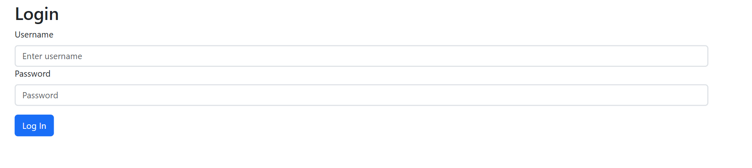

* + Check the validity of the login credentials.
  + If the user enters the correct **username** and **password**, the message 'Welcome, <username> login Successful!' is displayed, the redirect to Product Management Form.
  + If the username or password is incorrect, an **alert** should appear with the message **"Invalid username or password!"**.

1. **Create Laptop Management Form (4 marks)**

Display product List (1 mark):

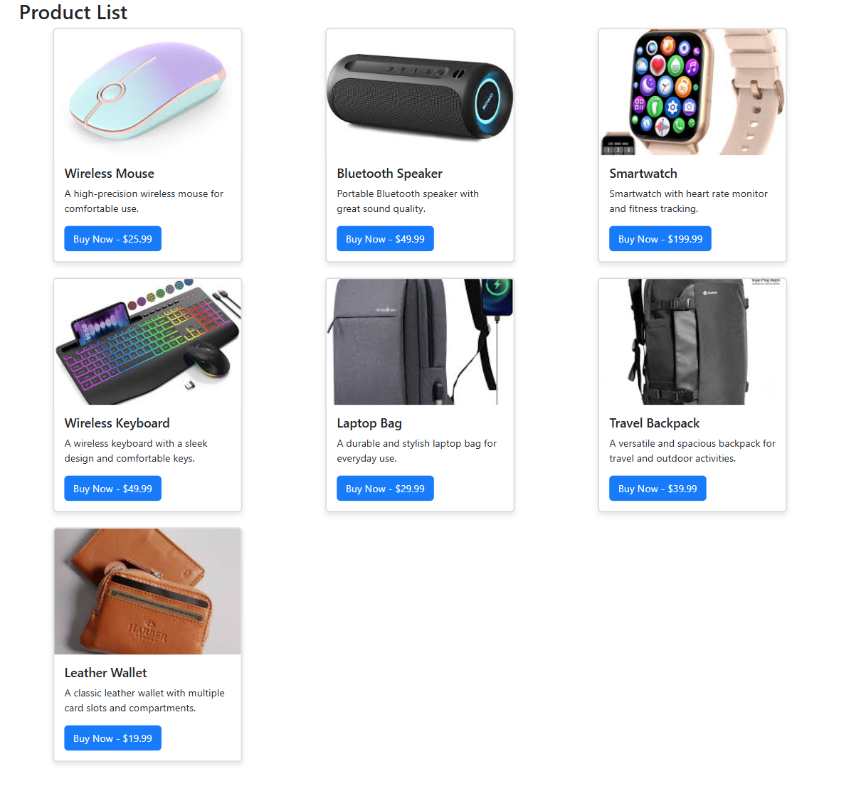

Nâng cao:

* + - Thêm chức năng View Details, chuyển hướng đến trang xem chi tiết 1 sản phẩm.
    - Sau khi xem chi tiết sản phẩm, hãy điều hướng đến trang Danh sách sản phẩm.

Yêu cầu: sử dụng React Router, axios để lấy dữ liệu từ server, validate dữ liệu, …