# 79_HO2+H->H2+O2

**Review**

|  |  |  |  |  |  |  |
| --- | --- | --- | --- | --- | --- | --- |
| **type** | **ID** | **Temperature range/K** | **A/cm3mol-1s-1** | **n** | **(E/R)/K** | **Ref.** |
|  | **Baulch, 2005** | 250-1000 | 1.05E+14 |  | 1030 | [1] |
|  | **Konnov, 2008** | 250-1000 | 1.05E+14 |  | 1030 | [2] |
|  | **Hong, 2011** |  | 3.66E+06 | 2.09 | –730 | [3] |
|  | **Burke, 2012** |  | 2.75E+06 | 2.09 | –730 | [4] |
| reverse | **Kéromnès, 2013** |  | 1.09E+07 | 1.92 | –334 | [5] |
|  | **Varga, 2015** | 800-2300 | 1.14E+10 | 1.083 | 278.7 | [6] |
|  | **2016VAR/OLM407-422** | 800-2500 | 2.17e+06 | 2.11 | -817.50 | [7] |
|  | **2004ATK/BAU1461-1738** | 245-300 | 3.33E+12 |  |  | [8] |
|  | 2004ATK/BAU1461-1738 | 298 | 3.38E+12 |  |  | [8] |
|  | **1997ATK/BAU1329-1499** | 245-300 | 3.38E+12 |  |  | [9] |
|  | **1992BAU/COB411-429** | 300-1000 | 4.29E+13 |  | 709.301 | [10] |
|  | **1992ATK/BAU1125-1568** | 245-300 | 3.38E+12 |  |  | [11] |
|  | **1989ATK/BAU881-1097** | 245-300 | 3.38E+12 |  |  | [12] |
|  | 1986TSA/HAM1087 | 300-2500 | 6.62E+13 |  | 1069.96 | [13] |
|  | **1984WAR197C** | 300-1000 | 2.49E+13 |  | 348.640 | [14] |
|  | 1983PRA/WOO2597 | 231-246 | 1.02E+12 |  | -199.57 | [15] |
|  | **1974LLO169-228** | 300-100 | 2.49E+13 |  | 352.25 | [16] |

**Experiments**

|  |  |  |  |  |  |  |
| --- | --- | --- | --- | --- | --- | --- |
| **type** | **ID** | **Temperature range/K** | **A/cm3mol-1s-1** | **n** | **(E/R)/K** | **Ref.** |
|  | **1982SRI/QIU4569\*** | 296 | 4.04E+12 |  | 0 | [17] |
| reverse | **2000MIC/SUT1471-1478\*** | 1662-2097 | 3.07E+13 | -0.297 | -4797.0 | [18] |
| reverse | 1989KOI2480-2484 | 1000-1400 | 2.35E+16 | -0.066 | 6482.23 | [19] |

**Theory**

|  |  |  |  |  |  |  |
| --- | --- | --- | --- | --- | --- | --- |
| **type** | **ID** | **Temperature range/K** | **A/cm3mol-1s-1** | **n** | **(E/R)/K** | **Ref.** |
|  | **2007MOU/SAH1901-1913\*** | 200-3000 | 1.859E+08 | 1.72 | -581.86 | [20] |
|  | **2007MOU/SAH1901-1913\*** | 200-3000 | 6.689E+07 | 1.77 | -286.12 | [20] |
|  | **1999KAR/OSH11918-11927\*** | 298-1000 | 6.168E+11 | 0.47 | 229.621 | [21] |
|  | 1979BAL/WAL525 | 773 | 2.801E+13 |  |  | [22] |
|  | 1979BAL/WAL140 | 370-773 | 2.801E+13 |  |  | [22] |
|  | **1977SHA929\*** | 250-2000 | 1.142E+11 | 0.75 |  | [23] |
| reverse | **2000MIC/SUT1471-1478\*** | 400-2300 | 3.311E+06 | 2.11 | -558.48 | [18] |
| reverse | **1999KAR/OSH11918-11927\*** | 298-1000 | 8.070E+12 | 0.13 | 354.353 | [21] |
| reverse | 1972SKI/LIF3853 | 1000-2500 | 4.000E+14 | -0.46 | 4401.96 | [24] |
| reverse | 1968MAY/SCH2628-2631 | 300-1000 | 1.193E+13 | -0.06 | 1803.42 | [25] |

**Reverse direction of reaction (H2 + O2** → **HO2 + H)**

**Review**

|  |  |  |  |  |  |  |
| --- | --- | --- | --- | --- | --- | --- |
| **type** | **ID** | **Temperature range/K** | **A/cm3mol-1s-1** | **n** | **(E/R)/K** | **Ref.** |
|  | Kéromnès, 2013 |  | 5.18E+05 | 2.43 | 26923 | [5] |

**Experiments**

|  |  |  |  |  |  |  |
| --- | --- | --- | --- | --- | --- | --- |
| **type** | **ID** | **Temperature range/K** | **A/cm3mol-1s-1** | **n** | **(E/R)/K** | **Ref.** |
|  | **2000MIC/SUT1471-1478** | 1662-2097 | 9.03E+12 |  | 22852 | [18] |
|  | 1989KOI2480-2484 | 1000-1400 | 4.10E+16 | -0.066 | 34278 | [19] |

**Theory**

|  |  |  |  |  |  |  |
| --- | --- | --- | --- | --- | --- | --- |
| **type** | **ID** | **Temperature range/K** | **A/cm3mol-1s-1** | **n** | **(E/R)/K** | **Ref.** |
|  | **2000MIC/SUT1471-1478** | 400-2300 | 7.40E+05 | 2.43 | 26941 | [18] |
|  | **1999KAR/OSH11918-11927** | 298-1000 | 1.44E+13 | 0.17 | 28023 | [21] |
|  | 1972SKI/LIF3853 | 1000-2500 | 3.00+E13 |  | 31752 | [24] |
|  | 1968MAY/SCH2628-2631 | 300-1000 | 1.91E+13 |  | 29467 | [25] |

**Compare**

|  |  |  |  |  |  |  |
| --- | --- | --- | --- | --- | --- | --- |
| **type** | **Name** | **Temperature range/K** | **A/cm3mol-1s-1** | **n** | **(E/R)/K** | **Ref.** |
|  | **NPU** | 300-2500 | 3.521E+08 | 1.564 | -329.30 |  |
|  | **Hong, 2011** | 300-2500 | 3.660E+06 | 2.09 | -730 | [3] |
|  | **TaoTao** | 300-2500 | 1.140E+10 | 1.0827 | 278.70 | [26] |
|  | **Henry** | 300-2500 | 2.800E+06 | 2.09 | -730.25 | [27] |

**The tabulated values of the uncertainty parameter *f* for** **reaction HO2+H->H2+O2**

The fitted Arrhenius expression is based on experiment and theory, lines labelled with * ID.

***A*= 3.55382E+08cm3mol-1s-1 *n*=1.56 *Ea/R*=-328.1448K Temperature range/K: 300-2500**

**Assumed probability distribution: Normal**

|  |  |
| --- | --- |
| ***Ti*/K** | ***foriginal*(*Ti*)** |
| 300 | 0.6130 |
| 400 | 0.5702 |
| 500 | 0.5366 |
| 600 | 0.5089 |
| 700 | 0.4854 |
| 800 | 0.4650 |
| 900 | 0.4469 |
| 1000 | 0.4307 |
| 1100 | 0.4161 |
| 1200 | 0.4026 |
| 1300 | 0.3903 |
| 1400 | 0.3788 |
| 1500 | 0.3682 |
| 1600 | 0.3582 |
| 1700 | 0.3488 |
| 1800 | 0.3400 |
| 1900 | 0.3316 |
| 2000 | 0.3236 |
| 2100 | 0.3161 |
| 2200 | 0.3088 |
| 2300 | 0.3043 |
| 2400 | 0.3053 |
| 2500 | 0.3063 |

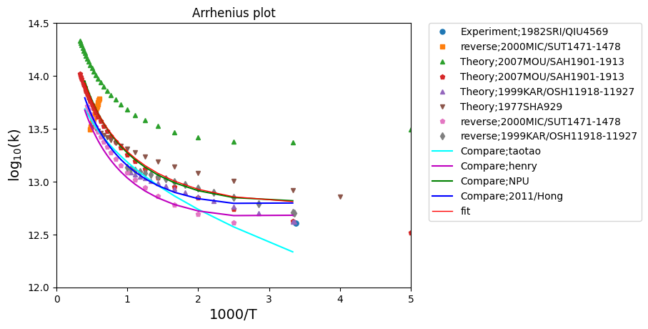

**Figure 1a.** Arrhenius plots for all data fitted Arrhenius expression, which is based on experiment and theory, and compared with someone recommend value from NPU、Nagy、taotao、Henry for reaction HO2+H->H2+O2



**Figure 1b.** Arrhenius plots for all data calcuate uncertainty factor, and compared with someone recommend value from NPU、Nagy、taotao、Henry for reaction HO2+H->H2+O2



**Figure 1c.** The *T*–*f*original values, and the *f*extreme and *f*prior curves for reaction HO2+H->H2+O2



**Figure 1d.** Arrhenius plots, and the upper and lower uncertainty limits for reaction HO2+H->H2+O2

|  |  |  |  |  |  |  |  |  |
| --- | --- | --- | --- | --- | --- | --- | --- | --- |
|  | *σa* | *σn* | *σε* | *σan* | *σaε* | *σnε* | *T* range (K) | *f* range |
| HO2+H->H2+O2 | 2.05154 | 0.24225 | 125.43 | -0.993 | 0.581 | -0.4814 | **300-2500** | **0.3043-0.613** |

# 143_CH3+O->CH2O+H

**Review**

|  |  |  |  |  |  |  |
| --- | --- | --- | --- | --- | --- | --- |
| **type** | **ID** | **Temperature range/K** | **A/cm3mol-1s-1** | **n** | **(E/R)/K** | **Ref.** |
|  | **1992BAU/COB411-429** | 300-2500 | 8.43E+13 |  |  | [10] |
|  | **1992ATK/BAU1125-1568** | 200-900 | 8.43E+13 |  |  | [11] |
|  | **1989ATK/BAU881-1097** | 200-900 | 8.43E+13 |  |  | [12] |
|  | **1988HER967** | 300-2000 | 8.37E+13 |  |  | [28] |
|  | **1986TSA/HAM1087** | 300-2500 | 7.82E+13 |  |  | [13] |
|  | **1984WAR197C** | 300-2500 | 6.98E+13 |  |  | [29] |

**Experiments**

|  |  |  |  |  |  |  |
| --- | --- | --- | --- | --- | --- | --- |
| **type** | **ID** | **Temperature range/K** | **A/cm3mol-1s-1** | **n** | **(E/R)/K** | **Ref.** |
|  | 1992SEA/LEO4478-4485 | 298 | 5.66E+13 |  |  | [30] |
|  | **1988ZEL/HAR549\*** | 298 | 6.62E+13 |  |  | [31] |
|  | **1987SLA/SAR4375\*** | 294 | 8.43E+13 |  |  | [32] |
|  | **1987DEA/WES207\*** | 300 | 8.93E+13 | -0.03 | 18.0331 | [33] |
|  | **1982PLU/RYA861\*** | 295 | 6.86E+13 |  |  | [34] |
|  | **1980WAS1665\*** | 298 | 8.31E+13 |  |  | [35] |
|  | **1980BHA/FRA503\*** | 1700-2300 | 8.49E+13 |  |  | [36] |
|  | **1979WAS271\*** | 298 | 8.31E+13 |  |  | [35] |
|  | **1976WAS/BAY777\*** | 259-341 | 6.02E+13 |  |  | [37] |
|  | **1976BIO/LAZ57\*** | 1550-1750 | 8.19E+13 |  |  | [38] |
|  | 1975BOW869 | 1900-2400 | 9.99E+13 |  |  | [39] |
|  | 1975BIO/LAZ917 | 1550-1720 | 1.04E+14 |  |  | [40] |
|  | 1974SLA/PRU111 | 300 | 1.10E+14 |  |  | [41] |
|  | **1973WAS/BAY373\*** | 297 | 7.40E+13 |  |  | [42] |
|  | 1973PEE/MAH133 | 1100-1900 | 1.30E+14 |  | 1009.853 | [43] |
|  | 1973MOR/NIK47 | 298 | 1.81E+13 |  |  | [44] |
|  | **1971DEA/KIS1718\*** | 1750-2580 | 6.02E+13 |  |  | [45] |
|  | 1971CLA/IZO4644 | 1350 | 2.52E+13 |  |  | [46] |
|  | **1970DEA/KIS1718-1725\*** | 1750-2580 | 6.02E+13 |  |  | [45] |
|  | 1969NIK/DAB277-288 | 300 | 1.81E+14 |  |  | [47] |

**Theory**

|  |  |  |  |  |  |  |
| --- | --- | --- | --- | --- | --- | --- |
| **type** | **ID** | **Temperature range/K** | **A/cm3mol-1s-1** | **n** | **(E/R)/K** | **Ref.** |
|  | **1976TSU159\*** | 1500-2000 | 6.02E+13 |  |  | [48] |
|  | 1968NIK/DAB5729-5730 | 300 | 1.81E+13 |  |  | [49] |

**Compare**

|  |  |  |  |  |  |  |
| --- | --- | --- | --- | --- | --- | --- |
| **type** | **Name** | **Temperature range/K** | **A/cm3mol-1s-1** | **n** | **(E/R)/K** | **Ref.** |
|  | **NPU** | 300-2500 | 1.029E+15 | -0.345 | 207.09 |  |
|  | **TaoTao** | 300-2500 | 5.54E+13 | 0.05 | -68.445 | [26] |
|  | **Henry** | 300-2500 | 5.54E+13 | 0.05 | -68.445 | [27] |

**The tabulated values of the uncertainty parameter *f* for reaction CH3+O->CH2O+H**

The fitted Arrhenius expression is based on experiment and theory, lines labelled with * ID.

***A*= 1.089E+15cm3mol-1s-1 *n*=-0.35 *Ea/R*=212.012K Temperature range/K: 300-2500**

**Assumed probability distribution: Normal**

|  |  |
| --- | --- |
| *Ti*/K | *foriginal*(*Ti*) |
| 300 | 0.0832 |
| 400 | 0.0518 |
| 500 | 0.0639 |
| 600 | 0.0669 |
| 700 | 0.0654 |
| 800 | 0.0615 |
| 900 | 0.0564 |
| 1000 | 0.0506 |
| 1100 | 0.0445 |
| 1200 | 0.0434 |
| 1300 | 0.0497 |
| 1400 | 0.0559 |
| 1500 | 0.0627 |
| 1600 | 0.0691 |
| 1700 | 0.0752 |
| 1800 | 0.081 |
| 1900 | 0.0864 |
| 2000 | 0.0917 |
| 2100 | 0.0966 |
| 2200 | 0.1014 |
| 2300 | 0.106 |
| 2400 | 0.1104 |
| 2500 | 0.1151 |

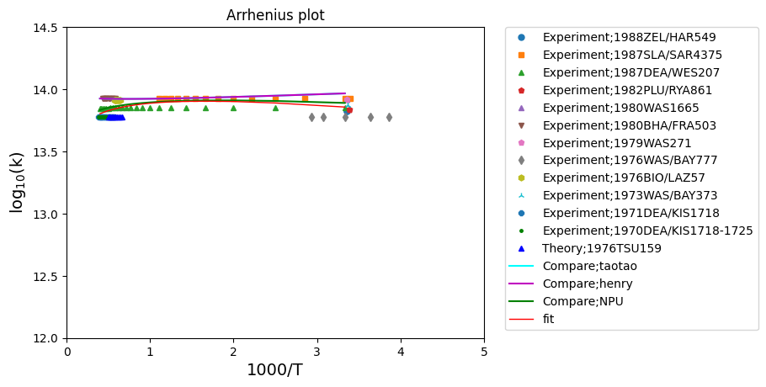

**Figure 2a.** Arrhenius plots for all data fitted Arrhenius expression, which is based on experiment and theory, and compared with someone recommend value from NPU、taotao、Henry for reaction **CH3+O->CH2O+H**



**Figure 2b.** Arrhenius plots for all data calcuate uncertainty factor, and compared with someone recommend value from NPU、taotao、Henry for reaction **CH3+O->CH2O+H**



**Figure 2c.** The *T*–*f*original values, and the *f*extreme and *f*prior curves for reaction **CH3+O->CH2O+H**



**Figure 2d.** Arrhenius plots, and the upper and lower uncertainty limits for reaction **CH3+O->CH2O+H**

|  |  |  |  |  |  |  |  |  |
| --- | --- | --- | --- | --- | --- | --- | --- | --- |
|  | *σa* | *σn* | *σε* | *σan* | *σaε* | *σnε* | *T* range (K) | *f* range |
| CH3+O->CH2O+H | 1.325 | 0.174 | 110.72 | -0.999 | 0.998 | -0.9994 | **300-2500** | **0.0434-0.1151** |

# 99_CH3+HO2_CH4+O2

**Review**

|  |  |  |  |  |  |  |
| --- | --- | --- | --- | --- | --- | --- |
| **type** | **ID** | **Temperature range/K** | **A/cm3mol-1s-1** | **n** | **(E/R)/K** | **Ref.** |
|  | **1986TSA/HAM1087** | 300-2500 | 3.61E+12 |  |  | [13] |
| reverse | **1992BAU/COB411-429** | 500-2000 | 1.23E+11 | 0.1677 | 95.7725 | [10] |
| reverse | **1986TSA/HAM1087** | 300-2500 | 1.24E+12 | -0.114 | 397.4836 | [13] |

**Experiments**

|  |  |  |  |  |  |  |
| --- | --- | --- | --- | --- | --- | --- |
| **type** | **ID** | **Temperature range/K** | **A/cm3mol-1s-1** | **n** | **(E/R)/K** | **Ref.** |
|  | **2012HON/DAV3007-3013\*** | 1072-1139 | 4.40E+12 |  |  | [50] |
| reverse | **2017RYU/SHI228-236\*** | 1609-1812 | 5.43E+05 | 1.797 | -4874.9 | [51] |

**Theory**

|  |  |  |  |  |  |  |
| --- | --- | --- | --- | --- | --- | --- |
| **type** | **ID** | **Temperature range/K** | **A/cm3mol-1s-1** | **n** | **(E/R)/K** | **Ref.** |
| reverse | **1978SHA1179\*** | 300-2500 | 2.62E+05 | 1.886 | -2007.2 | [52] |
| reverse | **1972SKI/LIF3853\*** | 1000-2500 | 8.28E+08 | 0.865 | -1270.1 | [24] |
| reverse | 1968MAY/SCH2628-2631 | 300-1000 | 1.09E+14 | -0.720 | 1663.06 | [53] |

**Reverse direction of reaction (CH4+O2** → **CH3+HO2)**

**Review**

|  |  |  |  |  |  |  |
| --- | --- | --- | --- | --- | --- | --- |
| **type** | **ID** | **Temperature range/K** | **A/cm3mol-1s-1** | **n** | **(E/R)/K** | **Ref.** |
|  | **1992BAU/COB411-429** | 500-2000 | 3.96916e+13 |  | 28612.5062 | [10] |
|  | **1986TSA/HAM1087** | 300-2500 | 4.04143e+13 |  | 28612.5062 | [13] |

**Experiments**

|  |  |  |  |  |  |  |
| --- | --- | --- | --- | --- | --- | --- |
| **type** | **ID** | **Temperature range/K** | **A/cm3mol-1s-1** | **n** | **(E/R)/K** | **Ref.** |
|  | **2017RYU/SHI228-236** | 1609-1812 | 1.45757e+14 |  | 26208.0939 | [51] |

**Theory**

|  |  |  |  |  |  |  |
| --- | --- | --- | --- | --- | --- | --- |
| **type** | **ID** | **Temperature range/K** | **A/cm3mol-1s-1** | **n** | **(E/R)/K** | **Ref.** |
|  | **1978SHA1179** | 300-2500 | 8.54576e+06 | 2.0 | 26208.0939 | [52] |
|  | **1972SKI/LIF3853** | 1000-2500 | 8.01059e+13 |  | 28131.6237 | [24] |
|  | 1968MAY/SCH2628-2631 | 300-1000 | 4.31849e+13 |  | 29574.2711 | [53] |

**Compare**

|  |  |  |  |  |  |  |
| --- | --- | --- | --- | --- | --- | --- |
| **type** | **Name** | **Temperature range/K** | **A/cm3mol-1s-1** | **n** | **(E/R)/K** | **Ref.** |
|  | NPU | 300-2500 | 5.70E+09 | 0.701 | -867.53 |  |
|  | TaoTao | 300-2500 | 2.32E+05 | 2.23 | -1521 | [26] |
|  | Henry | 300-2500 | 1.82E+03 | 2.83 | -1877.2 | [27] |

**The tabulated values of the uncertainty parameter *f* for reaction CH3+O->CH2O+H**

The fitted Arrhenius expression is based on experiment and theory, lines labelled with * ID.

***A*= 5.8203E+09cm3mol-1s-1 *n*=0.7 *Ea/R*=-864.8769K Temperature range/K: 300-2500**

**Assumed probability distribution: Normal**

|  |  |
| --- | --- |
| ***Ti*/K** | ***foriginal*(*Ti*)** |
| 300 | 0.2457 |
| 400 | 0.0318 |
| 500 | 0.1526 |
| 600 | 0.2241 |
| 700 | 0.2641 |
| 800 | 0.2906 |
| 900 | 0.307 |
| 1000 | 0.3167 |
| 1100 | 0.322 |
| 1200 | 0.3239 |
| 1300 | 0.3236 |
| 1400 | 0.3217 |
| 1500 | 0.3186 |
| 1600 | 0.3147 |
| 1700 | 0.3101 |
| 1800 | 0.305 |
| 1900 | 0.2995 |
| 2000 | 0.2938 |
| 2100 | 0.2879 |
| 2200 | 0.2819 |
| 2300 | 0.2758 |
| 2400 | 0.2696 |
| 2500 | 0.2635 |

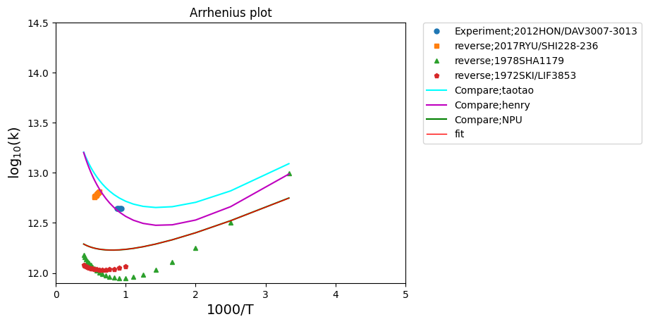

**Figure 3a.** Arrhenius plots for all data fitted Arrhenius expression, which is based on experiment and theory, and compared with someone recommend value from NPU、taotao、Henry for reaction **CH3+HO2_CH4+O2**



**Figure 3b.** Arrhenius plots for all data calcuate uncertainty factor, and compared with someone recommend value from NPU、taotao、Henry for reaction **CH3+HO2_CH4+O2**



**Figure 3c.** The *T*–*f*original values, and the *f*extreme and *f*prior curves for reaction **CH3+HO2_CH4+O2**



**Figure 3d.** Arrhenius plots, and the upper and lower uncertainty limits for reaction **CH3+HO2_CH4+O2**

|  |  |  |  |  |  |  |  |  |
| --- | --- | --- | --- | --- | --- | --- | --- | --- |
|  | *σa* | *σn* | *σε* | *σan* | *σaε* | *σnε* | *T* range (K) | *f* range |
| CH3+O->CH2O+H | 2.641 | 0.303 | 333.57 | -0.997 | 0.993 | -0.983 | **300-2500** | **0.0318-0.3239** |

# 254_CH3+CH3+M->C2H6+M

**Third body M=Ar**

**Reviews**

|  |  |  |  |  |  |  |
| --- | --- | --- | --- | --- | --- | --- |
| **type** | **ID** | **Temperature range/K** | **A/cm6mol-1s-1** | **n** | **(E/R)/K** | **Ref.** |
|  | **1994BAU/COB847-1033** | 300 - 2000 | 1.27189e+41 | -7.0 | 1389.7503 | [54] |
|  | **1992BAU/COB411-429** | 300 - 2000 | 1.27189e+41 | -7.0 | 1389.7503 | [55] |
| reverse | 1994BAU/COB847-1033 | 300 - 2000 | 2.98E+19 | -7.64 | 1.59E+03 | [54] |
| reverse | **1992BAU/COB411-429** | 300 - 2000 | 1.80E+43 | -7.65 | 1.59E+03 | [10] |
| reverse | **1984WAR197C** | 800 - 2500 | 4.28E+08 | 1.978 | -1.27E+04 | [29] |

**Experiments**

|  |  |  |  |  |  |  |
| --- | --- | --- | --- | --- | --- | --- |
| **type** | **ID** | **Temperature range/K** | **A/cm6mol-1s-1** | **n** | **(E/R)/K** | **Ref.** |
|  | **1996DU/HES974-983\*** | 296 - 1800 | 6.23E+42 | -7.25 | 2.17E+03 | [56] |
|  | **1988WAG/WAR2462-2471\*** | 296 - 2000 | 3.20E+41 | -7.03 | 1.39E+03 | [57] |
|  | **1988SLA/GUT2455-2462\*** | 296 - 906 | 3.20E+41 | -7.03 | 1.39E+03 | [58] |
|  | **1983MAC/PIL430\*** | 296 - 577 | 2.18E+19 |  | -1.68E+03 | [59] |
| reverse | **1971IZO/KIS4425\*** | 1400-2200 | 1.12E+10 | 2.242 | -3.14E+03 | [60] |

**Theory**

|  |  |  |  |  |  |  |
| --- | --- | --- | --- | --- | --- | --- |
| **type** | **ID** | **Temperature range/K** | **A/cm6mol-1s-1** | **n** | **(E/R)/K** | **Ref.** |
|  | **1976VAN201\*** | 450 - 1350 | 8.67E+17 | 0 | -3.55E+03 | [61] |

**Third body M=He**

**Theory**

|  |  |  |  |  |  |  |
| --- | --- | --- | --- | --- | --- | --- |
| **type** | **ID** | **Temperature range/K** | **A/cm6mol-1s-1** | **n** | **(E/R)/K** | **Ref.** |
|  | **1976VAN201\*** | 450 - 1350 | 1.72E+18 | 0 | -3.76E+03 | [61] |

**Third body M=N2**

**Reviews**

|  |  |  |  |  |  |  |
| --- | --- | --- | --- | --- | --- | --- |
| **type** | **ID** | **Temperature range/K** | **A/cm6mol-1s-1** | **n** | **(E/R)/K** | **Ref.** |
| reverse | 1994BAU/COB847-1033 | 300-2000 | 1.796E+43 | -7.64 | 1588.4751 | [54] |

**Experiments**

|  |  |  |  |  |  |  |
| --- | --- | --- | --- | --- | --- | --- |
| **type** | **ID** | **Temperature range/K** | **A/cm6mol-1s-1** | **n** | **(E/R)/K** | **Ref.** |
| reverse | 1960BRO/KAL4443 | 1040-1160 | 2.217E-08 | 5.22 | -9286.05 | [62] |

**Reverse direction of reaction (C2H6+M** → **CH3+CH3+M)**

**Reviews**

|  |  |  |  |  |  |  |
| --- | --- | --- | --- | --- | --- | --- |
| **type** | **ID** | **Temperature range/K** | **A/cm3mol-1s-1** | **n** | **(E/R)/K** | **Ref.** |
|  | 1994BAU/COB847-1033 | 300-2000 | 1.10113e+25 | -8.24 | 47126.4807 | [54] |
|  | **1992BAU/COB411-429** | 300-2000 | 6.64497e+48 | -8.24 | 47126.4807 | [10] |
|  | **1984WAR197C** | 800-2500 | 9.99818e+18 |  | 34262.875 | [29] |
|  | 1994BAU/COB847-1033 | 300-2000 | 6.64497e+48 | -8.24 | 47126.4807 | [54] |

**Experiments**

|  |  |  |  |  |  |  |
| --- | --- | --- | --- | --- | --- | --- |
| **type** | **ID** | **Temperature range/K** | **A/cm3mol-1s-1** | **n** | **(E/R)/K** | **Ref.** |
|  | **1971IZO/KIS4425** | 1400-2200 | 2.40920e+21 |  | 44241.186 | [60] |
|  | 1960BRO/KAL4443 | 1040-1160 | 9.99818e+13 |  | 41235.6706 | [62] |

**Compare**

|  |  |  |  |  |  |  |
| --- | --- | --- | --- | --- | --- | --- |
| **type** | **Name** | **Temperature range/K** | **A/cm3mol-1s-1** | **n** | **(E/R)/K** | **Ref.** |
|  | TaoTao | 300-2500 | 1.26900e+41 | -7.0 | 1390.035 | [26] |
|  | Henry | 300-2500 | 3.74000e+50 | -9.93 | 3718.671 | [27] |

**The tabulated values of the uncertainty parameter *f* for reaction CH3+O->CH2O+H**

The fitted Arrhenius expression is based on experiment and theory, lines labelled with * ID.

***A*= 9.01600E+39cm3mol-1s-1 *n*=** **-6.502 *Ea/R*=** **1272.65K Temperature range/K: 300-2500**

**Assumed probability distribution: Normal**

|  |  |  |  |  |  |  |
| --- | --- | --- | --- | --- | --- | --- |
|  | m(H2O) | m(H2) | **m(Ar)** | **m(He)** | m(CO) | m(CO2) |
| **used here** |  |  | 0.7 | 0.7 |  |  |
| **Baulch** | 6 | 2 | 0.7 | 0.7 | 1.5 | 2 |
| **Henry** | 5 | 2 | - | - | 2 | 3 |
| **WANG** | 5 | - | - | - | 2 | 3 |

The 3rd-body collision efficiency proposed by Baulch is used in Taotao's mechanism.

The 3rd-body collision efficiency proposed by WANG is used in Co-optima's mechanism.

|  |  |
| --- | --- |
| ***Ti*/K** | ***foriginal*(*Ti*)** |
| 300 | 0.2273 |
| 400 | 0.2944 |
| 500 | 0.312 |
| 600 | 0.3086 |
| 700 | 0.3402 |
| 800 | 0.3493 |
| 900 | 0.345 |
| 1000 | 0.3325 |
| 1100 | 0.3149 |
| 1200 | 0.294 |
| 1300 | 0.271 |
| 1400 | 0.2469 |
| 1500 | 0.2221 |
| 1600 | 0.197 |
| 1700 | 0.1719 |
| 1800 | 0.1469 |
| 1900 | 0.1221 |
| 2000 | 0.0977 |
| 2100 | 0.0736 |
| 2200 | 0.05 |
| 2300 | 0.0268 |
| 2400 | 0.0202 |
| 2500 | 0.0434 |

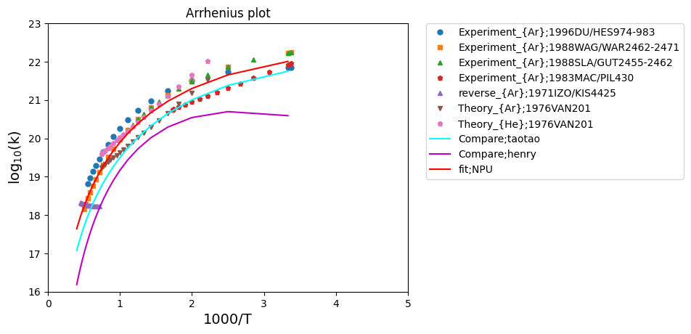

**Figure 4a.** Arrhenius plots for all data fitted Arrhenius expression, which is based on experiment and theory, and compared with someone recommend value from taotao、Henry for reaction **CH3+CH3+M->C2H6+M**



**Figure 4b.** Arrhenius plots for all data calcuate uncertainty factor, and compared with someone recommend value from taotao、Henry for reaction **CH3+CH3+M->C2H6+M**



**Figure 4c.** The *T*–*f*original values, and the *f*extreme and *f*prior curves for reaction **CH3+CH3+M->C2H6+M**



**Figure 4d.** Arrhenius plots, and the upper and lower uncertainty limits for reaction **CH3+CH3+M->C2H6+M**

|  |  |  |  |  |  |  |  |  |
| --- | --- | --- | --- | --- | --- | --- | --- | --- |
|  | *σa* | *σn* | *σε* | *σan* | *σaε* | *σnε* | *T* range (K) | *f* range |
| CH3+O->CH2O+H | 3.266 | 0.402 | 247.57 | -1.00 | 0.999 | -0.999 | **300-2500** | **0.1001-0. 3673** |

# 56_O2+H->O+OH

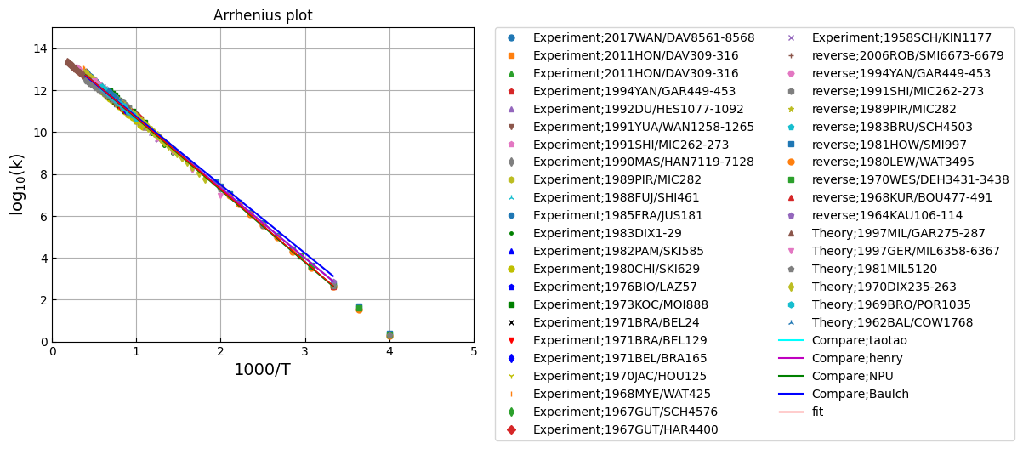

**Figure 5a.** Arrhenius plots for all data fitted Arrhenius expression, which is based on experiment and theory, and compared with someone recommend value from taotao、Henry 、Baulch for reaction **O2+H->O+OH**

**all**





|  |  |
| --- | --- |
| ***Ti*/K** | ***foriginal*(*Ti*)** |
| 300 | 0.2416 |
| 400 | 0.1425 |
| 500 | 0.1707 |
| 600 | 0.1714 |
| 700 | 0.159 |
| 800 | 0.1401 |
| 900 | 0.1178 |
| 1000 | 0.127 |
| 1100 | 0.133 |
| 1200 | 0.1367 |
| 1300 | 0.1387 |
| 1400 | 0.1394 |
| 1500 | 0.1393 |
| 1600 | 0.1384 |
| 1700 | 0.1382 |
| 1800 | 0.1432 |
| 1900 | 0.1557 |
| 2000 | 0.1677 |
| 2100 | 0.1793 |
| 2200 | 0.1905 |
| 2300 | 0.2013 |
| 2400 | 0.2118 |
| 2500 | 0.2219 |

|  |  |  |  |  |  |  |  |  |
| --- | --- | --- | --- | --- | --- | --- | --- | --- |
|  | *σa* | *σn* | *σε* | *σan* | *σaε* | *σnε* | *T* range (K) | *f* range |
| O2+H->O+OH | 2.63 | 0.343 | 240.46 | -0.999 | 0.996 | -0.998 | **300-2500** | **0.1178-0. 2416** |

# References

[1] D.L. Baulch, C.T. Bowman, C.J. Cobos, R.A. Cox, Th. Just, J.A. Kerr, M.J. Pilling, D. Stocker, J. Troe, W. Tsang, R.W. Walker, J. Warnatz, Evaluated Kinetic Data for Combustion Modeling: Supplement II, Journal of Physical and Chemical Reference Data. 34 (2005) 757–1397. https://doi.org/10.1063/1.1748524.

[2] A.A. Konnov, Remaining uncertainties in the kinetic mechanism of hydrogen combustion, Combustion and Flame. 152 (2008) 507–528. https://doi.org/10.1016/j.combustflame.2007.10.024.

[3] Z. Hong, D.F. Davidson, R.K. Hanson, An improved H2/O2 mechanism based on recent shock tube/laser absorption measurements, Combustion and Flame. 158 (2011) 633–644.

[4] M.P. Burke, M. Chaos, Y. Ju, F.L. Dryer, S.J. Klippenstein, Comprehensive H2/O2 kinetic model for high-pressure combustion, International Journal of Chemical Kinetics. 44 (2012) 444–474.

[5] A. Kéromnès, W.K. Metcalfe, K.A. Heufer, N. Donohoe, A.K. Das, C.-J. Sung, J. Herzler, C. Naumann, P. Griebel, O. Mathieu, M.C. Krejci, E.L. Petersen, W.J. Pitz, H.J. Curran, An experimental and detailed chemical kinetic modeling study of hydrogen and syngas mixture oxidation at elevated pressures, Combustion and Flame. 160 (2013) 995–1011. https://doi.org/10.1016/j.combustflame.2013.01.001.

[6] T. Varga, T. Nagy, C. Olm, I.Gy. Zsély, R. Pálvölgyi, É. Valkó, G. Vincze, M. Cserháti, H.J. Curran, T. Turányi, Optimization of a hydrogen combustion mechanism using both direct and indirect measurements, Proceedings of the Combustion Institute. 35 (2015) 589–596. https://doi.org/10.1016/j.proci.2014.06.071.

[7] T. Varga, C. Olm, T. Nagy, I.Gy. Zsély, É. Valkó, R. Pálvölgyi, Henry.J. Curran, T. Turányi, Development of a Joint Hydrogen and Syngas Combustion Mechanism Based on an Optimization Approach, International Journal of Chemical Kinetics. 48 (2016) 407–422. https://doi.org/10.1002/kin.21006.

[8] R. Atkinson, D.L. Baulch, R.A. Cox, J.N. Crowley, R.F. Hampson, R.G. Hynes, M.E. Jenkin, M.J. Rossi, J. Troe, Evaluated kinetic and photochemical data for atmospheric chemistry: Volume I - gas phase reactions of Ox, HOx, NOx and SOx species, Atmospheric Chemistry and Physics. 4 (2004) 1461–1738. https://doi.org/10.5194/acp-4-1461-2004.

[9] R. Atkinson, D.L. Baulch, R.A. Cox, R.F. Hampson Jr., J.A. Kerr, M.J. Rossi, J. Troe, Evaluated Kinetic and Photochemical Data for Atmospheric Chemistry: Supplement VI. IUPAC Subcommittee on Gas Kinetic Data Evaluation for Atmospheric Chemistry, Journal of Physical and Chemical Reference Data. 26 (1997) 1329–1499. https://doi.org/10.1063/1.556010.

[10] D.L. Baulch, C.J. Cobos, R.A. Cox, C. Esser, P. Frank, Th. Just, J.A. Kerr, M.J. Pilling, J. Troe, R.W. Walker, J. Warnatz, Evaluated Kinetic Data for Combustion Modelling, Journal of Physical and Chemical Reference Data. 21 (1992) 411–734. https://doi.org/10.1063/1.555908.

[11] R. Atkinson, D.L. Baulch, R.A. Cox, R.F. Hampson Jr., J.A. Kerr, J. Troe, Evaluated Kinetic and Photochemical Data for Atmospheric Chemistry: Supplement IV. IUPAC Subcommittee on Gas Kinetic Data Evaluation for Atmospheric Chemistry, Journal of Physical and Chemical Reference Data. 21 (1992) 1125–1568. https://doi.org/10.1063/1.555918.

[12] R. Atkinson, D.L. Baulch, R.A. Cox, R.F. Hampson Jr., J.A. Kerr (Chairman), J. Troe, Evaluated Kinetic and Photochemical Data for Atmospheric Chemistry: Supplement III. IUPAC Subcommittee on Gas Kinetic Data Evaluation for Atmospheric Chemistry, Journal of Physical and Chemical Reference Data. 18 (1989) 881–1097. https://doi.org/10.1063/1.555832.

[13] W. Tsang, R.F. Hampson, Chemical Kinetic Data Base for Combustion Chemistry. Part I. Methane and Related Compounds, Journal of Physical and Chemical Reference Data. 15 (1986) 1087–1279. https://doi.org/10.1063/1.555759.

[14] J. Warnatz, Rate Coefficients in the C/H/O System, in: W.C. Gardiner (Ed.), Springer New York, New York, NY, 1984: pp. 197–360. https://doi.org/10.1007/978-1-4684-0186-8_5.

[15] G.L. Pratt, S.W. Wood, Stoichiometry and rate of reaction of hydrogen atoms with oxygen, J. Chem. Soc., Faraday Trans. 1. 79 (1983) 2597–2604. https://doi.org/10.1039/F19837902597.

[16] A.C. Lloyd, Evaluated and estimated kinetic data for phase reactions of the hydroperoxyl radical, International Journal of Chemical Kinetics. 6 (1974) 169–228. https://doi.org/10.1002/kin.550060202.

[17] U.C. Sridharan, L.X. Qiu, F. Kaufman, Kinetics and product channels of the reactions of perhydroxyl with oxygen and hydrogen atoms at 296 K, J. Phys. Chem. 86 (1982) 4569–4574. https://doi.org/10.1021/j100220a023.

[18] J.V. Michael, J.W. Sutherland, L.B. Harding, A.F. Wagner, Initiation in H2/O2: Rate constants for H2+O2→H+HO2 at high temperature, Proceedings of the Combustion Institute. 28 (2000) 1471–1478. https://doi.org/10.1016/S0082-0784(00)80543-3.

[19] T. Koike, Shock Tube Studies of the H2–O2 Reaction by Atomic Resonance Absorption Spectroscopy, BCSJ. 62 (1989) 2480–2484. https://doi.org/10.1246/bcsj.62.2480.

[20] S.H. Mousavipour, V. Saheb, Theoretical Study on the Kinetic and Mechanism of H+HO2 Reaction, BCSJ. 80 (2007) 1901–1913. https://doi.org/10.1246/bcsj.80.1901.

[21] S.P. Karkach, V.I. Osherov, Ab initio analysis of the transition states on the lowest triplet H2O2 potential surface, The Journal of Chemical Physics. 110 (1999) 11918–11927. https://doi.org/10.1063/1.479131.

[22] R.R. Baldwin, R.W. Walker, Rate constants for reactions of HO2 radicals with alkanes, aldehydes, and related compounds, Symposium (International) on Combustion. 17 (1979) 525–533. https://doi.org/10.1016/S0082-0784(79)80053-3.

[23] R. Shaw, Estimation of rate constants as a function of temperature for the reactions W + XYZ = WX + YZ, where W, X, Y, and Z are H or O atoms, International Journal of Chemical Kinetics. 9 (1977) 929–941. https://doi.org/10.1002/kin.550090608.

[24] G.B. Skinner, A. Lifshitz, K. Scheller, A. Burcat, Kinetics of Methane Oxidation, The Journal of Chemical Physics. 56 (2003) 3853–3861. https://doi.org/10.1063/1.1677790.

[25] S.W. Mayer, L. Schieler, Activation energies and rate constants computed for reactions of oxygen with hydrocarbons, ACS Publications. (2002). https://doi.org/10.1021/j100853a066.

[26] T. Tao, S. Kang, W. Sun, J. Wang, H. Liao, K. Moshammer, N. Hansen, C.K. Law, B. Yang, A further experimental and modeling study of acetaldehyde combustion kinetics, Combustion and Flame. 196 (2018) 337–350. https://doi.org/10.1016/j.combustflame.2018.06.007.

[27] S. Dong, S.W. Wagnon, L. Pratali Maffei, G. Kukkadapu, A. Nobili, Q. Mao, M. Pelucchi, L. Cai, K. Zhang, M. Raju, T. Chatterjee, W.J. Pitz, T. Faravelli, H. Pitsch, P.K. Senecal, H.J. Curran, A new detailed kinetic model for surrogate fuels: C3MechV3.3, Applications in Energy and Combustion Science. 9 (2022) 100043. https://doi.org/10.1016/j.jaecs.2021.100043.

[28] J.T. Herron, Evaluated Chemical Kinetic Data for the Reactions of Atomic Oxygen O(3P) with Saturated Organic Compounds in the Gas Phase, Journal of Physical and Chemical Reference Data. 17 (1988) 967–1026. https://doi.org/10.1063/1.555810.

[29] Rate Coefficients in the C/H/O System | SpringerLink, (n.d.). https://link.springer.com/chapter/10.1007/978-1-4684-0186-8_5 (accessed May 21, 2023).

[30] P.W. Seakins, S.R. Leone, A laser flash photolysis/time-resolved FTIR emission study of a new channel in the reaction of methyl + oxygen atom: production of carbon monoxide(v), J. Phys. Chem. 96 (1992) 4478–4485. https://doi.org/10.1021/j100190a065.

[31] R. Zellner, D. Hartmann, J. Karthäuser, D. Rhäsa, G. Weibring, A laser photolysis/LIF study of the reactions of O(3P) atoms with CH3 and CH3O2 radicals, J. Chem. Soc., Faraday Trans. 2. 84 (1988) 549–568. https://doi.org/10.1039/F29888400549.

[32] Kinetics of the reaction between methyl radicals and oxygen atoms between 294 and 900 K | The Journal of Physical Chemistry, (n.d.). https://pubs.acs.org/doi/pdf/10.1021/j100300a032 (accessed May 19, 2023).

[33] Bimolecular QRRK analysis of methyl radical reactions - Dean - 1987 - International Journal of Chemical Kinetics - Wiley Online Library, (n.d.). https://onlinelibrary.wiley.com/doi/abs/10.1002/kin.550190305 (accessed May 19, 2023).

[34] Kinetics of the reactions of CH3 with O(3P) and O2 at 295 K - Plumb - 1982 - International Journal of Chemical Kinetics - Wiley Online Library, (n.d.). https://onlinelibrary.wiley.com/doi/abs/10.1002/kin.550140806 (accessed May 19, 2023).

[35] N. Washida, Reaction of methyl radicals with O(3P), O2 and NO, The Journal of Chemical Physics. 73 (2008) 1665–1672. https://doi.org/10.1063/1.440348.

[36] K.A. Bhaskaran, P. Frank, T. Just, High temperature methyl radical reactions with atomic and molecular oxygen, Shock Tubes and Waves. (1980) 503–513.

[37] N. Washida, K.D. Bayes, The reactions of methyl radicals with atomic and molecular oxygen, International Journal of Chemical Kinetics. 8 (1976) 777–794. https://doi.org/10.1002/kin.550080512.

[38] J.C. Biordi, C.P. Lazzara, J.F. Papp, Molecular beam mass spectrometry applied to determining the kinetics of reactions in flames II. A critique of rate coefficient determinations, Combustion and Flame. 26 (1976) 57–76. https://doi.org/10.1016/0010-2180(76)90057-2.

[39] C.T. Bowman, Non-equilibrium radical concentrations in shock-initiated methane oxidation, Symposium (International) on Combustion. 15 (1975) 869–882. https://doi.org/10.1016/S0082-0784(75)80354-7.

[40] J.C. Biordi, C.P. Lazzara, J.F. Papp, Flame structure studies of CF3Br-Inhibited methane flames: II. Kinetics and mechanisms, Symposium (International) on Combustion. 15 (1975) 917–932. https://doi.org/10.1016/S0082-0784(75)80358-4.

[41] Kinetics into the steady state. I. study of the reaction of oxygen atoms with methyl radicals - Slagle - 1974 - International Journal of Chemical Kinetics - Wiley Online Library, (n.d.). https://onlinelibrary.wiley.com/doi/abs/10.1002/kin.550060111 (accessed May 19, 2023).

[42] N. Washida, K.D. Bayes, The rate of reaction of methyl radicals with atomic oxygen, Chemical Physics Letters. 23 (1973) 373–375. https://doi.org/10.1016/0009-2614(73)85101-2.

[43] J. Peeters, G. Mahnen, Reaction mechanisms and rate constants ofelementary steps in methane-oxygen flames, Symposium (International) on Combustion. 14 (1973) 133–146. https://doi.org/10.1016/S0082-0784(73)80015-3.

[44] E.D. Morris, H. Niki, Reaction of methyl radicals with atomic oxygen, Int. J. Chem. Kinet. 5 (1973) 47–53. https://doi.org/10.1002/kin.550050105.

[45] A.M. Dean, G.B. Kistiakowsky, Oxidation of Carbon Monoxide/Methane Mixtures in Shock Waves, The Journal of Chemical Physics. 54 (2003) 1718–1725. https://doi.org/10.1063/1.1675077.

[46] T.C. Clark, T.P.J. Izod, S. Matsuda, Oxidation of Methyl Radicals Studied in Reflected Shock Waves using the Time-of-Flight Mass Spectrometer, The Journal of Chemical Physics. 55 (2003) 4644–4647. https://doi.org/10.1063/1.1676803.

[47] H. Niki, E.E. Daby, B. Weinstock, Mass spectrometric study of the kinetics and mechanism of the ethylene-atomic oxygen reaction by the discharge-flow technique at 300°K, Symposium (International) on Combustion. 12 (1969) 277–288. https://doi.org/10.1016/S0082-0784(69)80410-8.

[48] T. Tsuboi, Mechanism for the Homogeneous Thermal Oxidation of Methane in the Gasphase, Jpn. J. Appl. Phys. 15 (1976) 159. https://doi.org/10.1143/JJAP.15.159.

[49] H.N. Eric, E. Daby, B. Weinstock, Reaction of Atomic Oxygen with Methyl Radicals, The Journal of Chemical Physics. 48 (2003) 5729–5730. https://doi.org/10.1063/1.1668664.

[50] Z. Hong, D.F. Davidson, K.-Y. Lam, R.K. Hanson, A shock tube study of the rate constants of HO2 and CH3 reactions, Combustion and Flame. 159 (2012) 3007–3013. https://doi.org/10.1016/j.combustflame.2012.04.009.

[51] S.-O. Ryu, K.S. Shin, S.M. Hwang, Determination of the Rate Coefficients of the CH4 + O2 → HO2 + CH3 and HCO + O2 → HO2 + CO Reactions at High Temperatures, Bulletin of the Korean Chemical Society. 38 (2017) 228–236. https://doi.org/10.1002/bkcs.11070.

[52] R. Shaw, Semi‐empirical extrapolation and estimation of rate constants for abstraction of H from methane by H, O, HO, and O2, Journal of Physical and Chemical Reference Data. 7 (1978) 1179–1190. https://doi.org/10.1063/1.555577.

[53] Activation energies and rate constants computed for reactions of oxygen with hydrocarbons | The Journal of Physical Chemistry, (n.d.). https://pubs.acs.org/doi/10.1021/j100853a066 (accessed May 19, 2023).

[54] D.L. Baulch, C.J. Cobos, R.A. Cox, P. Frank, G. Hayman, Th. Just, J.A. Kerr, T. Murrells, M.J. Pilling, J. Troe, R.W. Walker, J. Warnatz, Evaluated Kinetic Data for Combustion Modeling. Supplement I, Journal of Physical and Chemical Reference Data. 23 (1994) 847–848. https://doi.org/10.1063/1.555953.

[55] Evaluated Kinetic Data for Combustion Modelling | Journal of Physical and Chemical Reference Data | AIP Publishing, (n.d.). https://pubs.aip.org/aip/jpr/article/21/3/411/241441/Evaluated-Kinetic-Data-for-Combustion-Modelling (accessed May 21, 2023).

[56] Recombination of Methyl Radicals. 1. New Data between 1175 and 1750 K in the Falloff Region | The Journal of Physical Chemistry, (n.d.). https://pubs.acs.org/doi/10.1021/jp951217w (accessed May 21, 2023).

[57] A.F. Wagner, D.M. Wardlaw, Study of the recombination reaction methyl + methyl .fwdarw. ethane. 2. Theory, J. Phys. Chem. 92 (1988) 2462–2471. https://doi.org/10.1021/j100320a016.

[58] I.R. Slagle, D. Gutman, J.W. Davies, M.J. Pilling, Study of the recombination reaction methyl + methyl .fwdarw. ethane. 1. Experiment, J. Phys. Chem. 92 (1988) 2455–2462. https://doi.org/10.1021/j100320a015.

[59] M.T. Macpherson, M.J. Pilling, M.J.C. Smith, The pressure and temperature dependence of the rate constant for methyl radical recombination over the temperature range 296–577 K, Chemical Physics Letters. 94 (1983) 430–433. https://doi.org/10.1016/0009-2614(83)80761-1.

[60] T.P.J. Izod, G.B. Kistiakowsky, S. Matsuda, Oxidation of Carbon Monoxide Mixtures with Added Ethane or Azomethane Studied in Incident Shock Waves, The Journal of Chemical Physics. 55 (2003) 4425–4432. https://doi.org/10.1063/1.1676769.

[61] H.E. van den Bergh, The recombination of methyl radicals in the low pressure limit, Chemical Physics Letters. 43 (1976) 201–204. https://doi.org/10.1016/0009-2614(76)85285-2.

[62] A.M. Brodsky, R.A. Kalinenko, K.P. Lavrovsky, 863. The principles governing high-temperature ethane cracking, J. Chem. Soc. (1960) 4443–4454. https://doi.org/10.1039/JR9600004443.