Name: MingQing Zhu

Access link: <https://github.com/mingqingzhu/CS-49J-assignment-3.git>

Exercise 1:

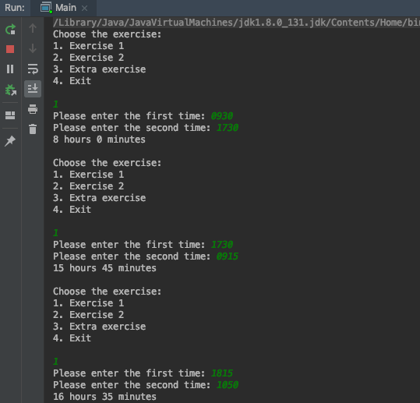

Exercise 2:

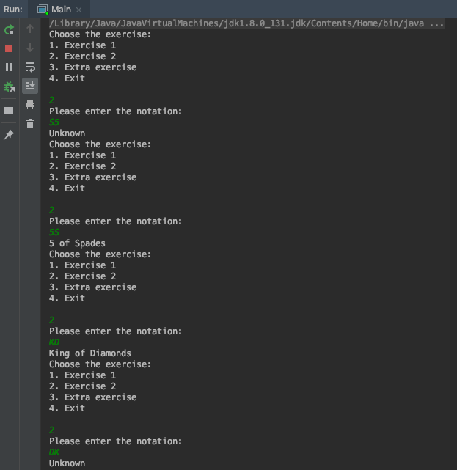

Extra exercise:

