BrainNet Viewer User Manual
  - MATLAB Python Desktop and Docker Web Editions
Version 2.0.0
Mingrui Xia
National Key Laboratory of Cognitive Neuroscience and Learning
Beijing Key Laboratory of Brain Imaging and Connectomics
IDG/McGovern Institute for Brain Research
Beijing Normal University, Beijing, China

Contents
This manual describes how to load data, display surfaces, nodes, connections, volumes and ROIs, inspect a view, save Scenes and export figures. It also explains mesh tools, camera animation, command-line rendering and troubleshooting. The scientific workflows are shared, with separate installation instructions and notes where MATLAB, Python Desktop and Docker/Web differ. Screenshots show MATLAB unless stated otherwise. Control tables describe MATLAB defaults; edition notes and the shared tutorials explain Python and Web behavior. Check coordinates and statistical meaning before interpreting a figure.
- 1 Installation and launch 3
- 2 Workspace and first visualization 6
- 3 Data formats and coordinates 7
- 4 Scenes and presets 11
- 5 Layout and camera controls 13
- 6 Global appearance and rendering 16
- 7 Surface appearance and maps 19
- 8 Nodes 22
- 9 Edges 24
- 10 Volume mapping and statistics 27
- 11 ROI drawing 31
- 12 Colormaps and presets 33
- 13 Figure export 35
- 14 Camera animation 37
- 15 Surface formats and mesh tools 39
- 16 Command line rendering and provenance 41
- 17 Migration and troubleshooting 44
- Appendix References and acknowledgments 48
- Appendix Shared tutorials 49

1 Installation and launch
BrainNet Viewer displays brain surfaces, networks, volume maps and ROIs in MATLAB Desktop, Python Desktop and Docker/Web. This manual covers their common workflow and explains installation and behavior where the editions differ.
BrainNet Viewer code is licensed under GPL-3.0-or-later. Bundled resources retain their accompanying notices and citations.

MATLAB installation
MATLAB Desktop requires an installed, activated MATLAB and a graphics-capable session. Windows R2024b/R2025a and macOS R2024a are supported starting environments; consult the installation guide for version-specific requirements. Independent NIfTI/GIfTI readers do not require SPM. Optional numerical GPU acceleration can require MATLAB toolboxes and compatible hardware. MATLAB Runtime-only installation and a standalone executable are not supplied.
Set MATLAB Current Folder to the installed software root, the directory containing the top-level BrainNetViewer.m, then run:
app = BrainNetViewer;
The launcher adds src/matlab/BrainNetViewer to the path. To launch from another directory, first add only the software root. Avoid addpath(genpath(...)) and paths to multiple BrainNet Viewer installations. Use which BrainNetViewer -all to find conflicting copies. The application starts directly from its software directory.

Python installation
Python 3.11 or newer is required. Download the matching wheel and verify its version and SHA-256. Create a new virtual environment; do not reuse or upgrade a Python 3.10 environment in place. Retain the pinned dependencies. The Windows example uses PowerShell; replace the wheel path with your downloaded file's location:
py -3.11 -m venv .venv-bnv
$bnvPython = (Resolve-Path .venv-bnv/Scripts/python.exe).Path
& $bnvPython -m pip install --upgrade pip
$bnvWheel = (Resolve-Path brainnet_viewer-2.0.0-py3-none-any.whl).Path
$bnvWheelUrl = & $bnvPython -c "from pathlib import Path; import sys; print(Path(sys.argv[1]).resolve().as_uri())" $bnvWheel
& $bnvPython -m pip install "brainnet-viewer[desktop] @ $bnvWheelUrl"
& $bnvPython -m pip check
& $bnvPython -m brainnet_viewer
On macOS, select the Python version appropriate for the installation notes and run:
python3.11 -m venv .venv-bnv
source .venv-bnv/bin/activate
python -m pip install --upgrade pip
BNV_WHEEL="/path/to/brainnet_viewer-2.0.0-py3-none-any.whl"
BNV_WHEEL_URL="$(python -c 'from pathlib import Path; import sys; print(Path(sys.argv[1]).resolve().as_uri())' "$BNV_WHEEL")"
python -m pip install "brainnet-viewer[desktop] @ $BNV_WHEEL_URL"
python -m pip check
brainnet-viewer
Use the supplied brainnet_viewer-2.0.0 wheel and install its desktop extra in a fresh environment. Dependency downloads require network access unless supplied separately. If installation fails, retain the complete error rather than changing fixed version constraints; the installation guide includes proxy troubleshooting. Launch with the environment interpreter or graphical launcher.

Docker Web on this computer
Install and start Docker Desktop on Windows/macOS, or Docker Engine with Compose on Linux. Windows uses the WSL 2 backend and Linux containers. No MATLAB licence or local Python environment is required.
Download and extract BrainNet-Viewer-Web-2.0.0.zip. With Docker running in Linux-container mode, open a terminal in the extracted folder. Obtain the versioned image, then use the supplied launcher:
docker compose -f compose.web.release.yml pull
Windows: powershell -File start_web.ps1 -Action Start
Linux/macOS: sh start_web.sh
Open http://127.0.0.1:1031/index.html and keep Docker running. Auto tests an actual GPU render at startup and uses CPU if GPU allocation or rendering fails; explicit GPU mode stops on failure. Compose does not allocate a GPU by default. Apple Silicon Docker uses CPU without Metal access. Use docker logs --tail 80 brainnet-web for startup errors. Chapter 17 explains resource quotas and server sessions.
Add Files uploads local inputs; bundled resources are also selectable. Export Figure downloads the image and provenance JSON separately. Save Scene downloads a portable ZIP, which Open Scene and Apply restore. Save the Scene before stopping or updating Docker; unsaved working data is temporary. See docs/web/en/INSTALLATION.md for platform instructions, stopping, updates and troubleshooting.

Docker Web on a LAN
Server mode lets a team use BrainNet Viewer through a Linux server's IP address. Each signed-in browser session has its own application process, uploads, settings and cameras, even when clients share an IP. Tabs in the same browser profile share one workspace. Use the server recipe below for LAN access.
On the Linux server, extract the matching Web package. Beside compose.web.server.release.yml, create .server-secrets/ containing server.crt, server.key and access_password.txt. Obtain a certificate trusted by the clients and valid for the server IP. Use a random team password; keep the private key and password out of shared files and readable only by the administrator and container UID 10001. Restrict incoming TCP port 1031 to the team's LAN.
Create a .env file beside the Compose file with the public address below, replacing the IP with the server's address:
BNV_SERVER_ORIGIN=https://192.168.1.10:1031
From that folder, start the server in the background:
docker compose -f compose.web.server.release.yml pull
docker compose -f compose.web.server.release.yml up -d
docker compose -f compose.web.server.release.yml ps
On each client, open https://192.168.1.10:1031/index.html and enter the team password. The configured address, certificate and browser URL must agree. Keep Docker running on the server; clients need only a browser. Save a Scene ZIP before ending a session: inactive sessions expire after 30 minutes. For immediate sign-out, open /_bnv/session on the same server and select Sign out and end session.
The default limit is four sessions. CPU and memory limits apply to the whole container. The server recipe uses CPU unless GPU device access is configured; Auto cannot allocate a GPU. See docs/web/en/SERVER_DEPLOYMENT.md for permissions, GPU access, changing ports and maintenance. The .server-secrets folder may stay beside the Compose file; a separate external directory is optional.

Find the resource library
The MATLAB distribution supplies Data/SurfTemplate, Data/ExampleFiles and Data/Tutorials inside its software tree. AtlasNetworks holds matched node/edge files. AAL90 auxiliary inputs are in resources/atlases/AAL90 from the archive root; Python and Docker provide them under atlases/AAL90 in the package resource library. Web exposes bundled inputs in library selectors. To locate Python resources:
python -c "from pathlib import Path; import brainnet_viewer; print(Path(brainnet_viewer.__file__).parent / 'resources')"
File pickers open the relevant bundled library where configured. Copy examples into a working folder before editing them, leaving the installed resources unchanged. Check the resource notices for credits, citations and redistribution terms.

2 Workspace and first visualization

What should appear
The English main window contains Data Sources, a render canvas and Visualization Settings. Select inputs with Add Files or the individual file controls, then click Validate and Load. Adjust the settings and click Apply to commit them and render. Render Scene redraws the current Scene. Web uses uploaded local files or files from the bundled library.
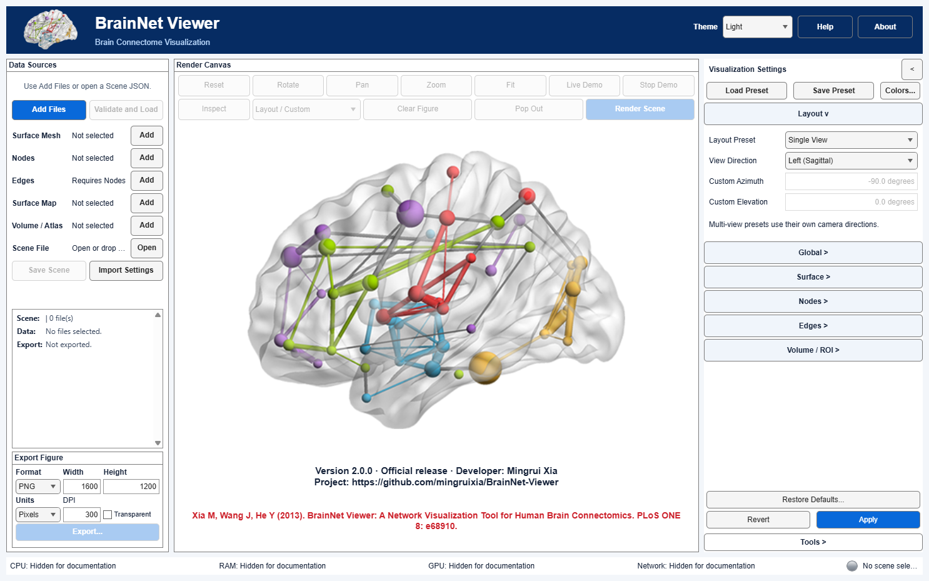
Figure 1. The English startup window identifies the data, render and settings areas before files are loaded. MATLAB illustration.
Start with the ICBM152 surface exercise. Chapter 3 explains file roles, coordinates and the data root; Chapter 4 explains how to save and reopen a visualization.

First surface workflow
1. Click Surface Mesh Add and select Data/SurfTemplate/BrainMesh_ICBM152.nv. 2. Click Validate and Load, then check the path and mesh counts. 3. Choose a layout and set the surface to an opaque gray Uniform color. 4. Click Apply to render. 5. Explore the selected view and export the figure.
Collapse Visualization Settings to enlarge the drawing area. The Tools panel starts collapsed in all three editions; click its heading to expand or collapse it. Python opens one settings section at a time without forcing it to the top. Rotate, Pan and Zoom target the selected subplot. Light/Dark changes the interface, not the scientific canvas background.

Sharing figures and data
Check the installed version and resource credits. Figure provenance may include private file paths or titles; review it before sharing. Save a Scene before stopping the Web container because uploads and unsaved session data are temporary.

3 Data formats and coordinates
Select the role that matches the file's contents. Add Files can classify inputs; use the individual Data Sources controls if the role is ambiguous. Click Validate and Load to check the selected files before rendering. In MATLAB, paths resolve against the configured data root, which defaults to src/matlab/BrainNetViewer, rather than against the Scene JSON directory.
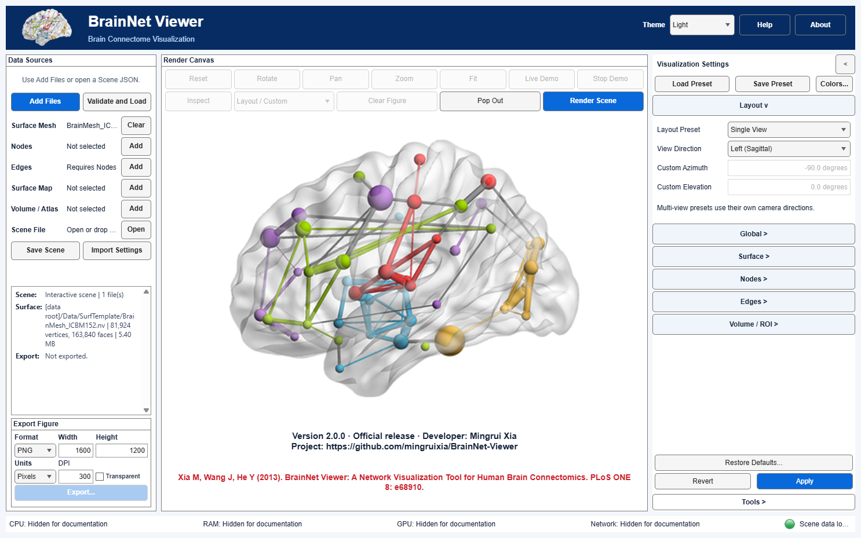
Figure 2. Surface Mesh input after validation and loading. MATLAB illustration.
Role in Data Sources | Typical input | Key correspondence rule
Surface Mesh | .nv, .gii/.gii.gz, .pial, .mesh, .g, MNI/BIC .obj, .mz3/.mz3.gz | Geometry contains XYZ coordinates and faces. Check its coordinate space before combining it with other data. See Chapter 15.
Nodes | BrainNet .node | Each row specifies a marker's coordinates and display fields. Preserve row order when pairing nodes with an edge matrix, and define what the display columns represent. See Chapter 8.
Edges | BrainNet .edge | Matrix rows/columns must correspond to node rows; directedness and threshold semantics depend on settings. See Chapter 9.
Surface Map | Original-order per-vertex scalar text | Supply one scalar per mesh vertex in the original vertex order. Matching lengths alone do not establish correspondence. See Chapter 7.
Volume | NIfTI-1/2 .nii/.nii.gz or supported paired .hdr/.img | Header/affine and statistic metadata matter. A readable volume need not be registered to a separate surface; see Chapter 10 and Chapter 11.
Scene File | Modern .scene.json | Stores references to the analysis inputs and settings. Paths resolve under the configured data root. See Chapter 4.

Choose a useful input combination
You do not need to load every role for every figure. A surface alone shows geometry; nodes alone show spatial markers; adding an edge matrix to nodes shows a network without an anatomical mesh. Combining a surface with nodes or with nodes and edges places those elements over anatomy. A scalar surface map or a volume-derived surface map requires a matching surface. The resulting map can also be shown with nodes and edges. To draw atlas or statistical ROIs, load a suitable volume and choose the ROI Volume Type; a surface makes their anatomical context easier to judge. An edge file without its matching nodes cannot establish endpoint locations.
The nine examples below illustrate the different input combinations. For an analysis, start with the fewest data roles needed and add one file at a time. After each addition, inspect the Scene Summary and check that the layers are spatially consistent. Colors and camera positions can be adjusted independently of the input data.
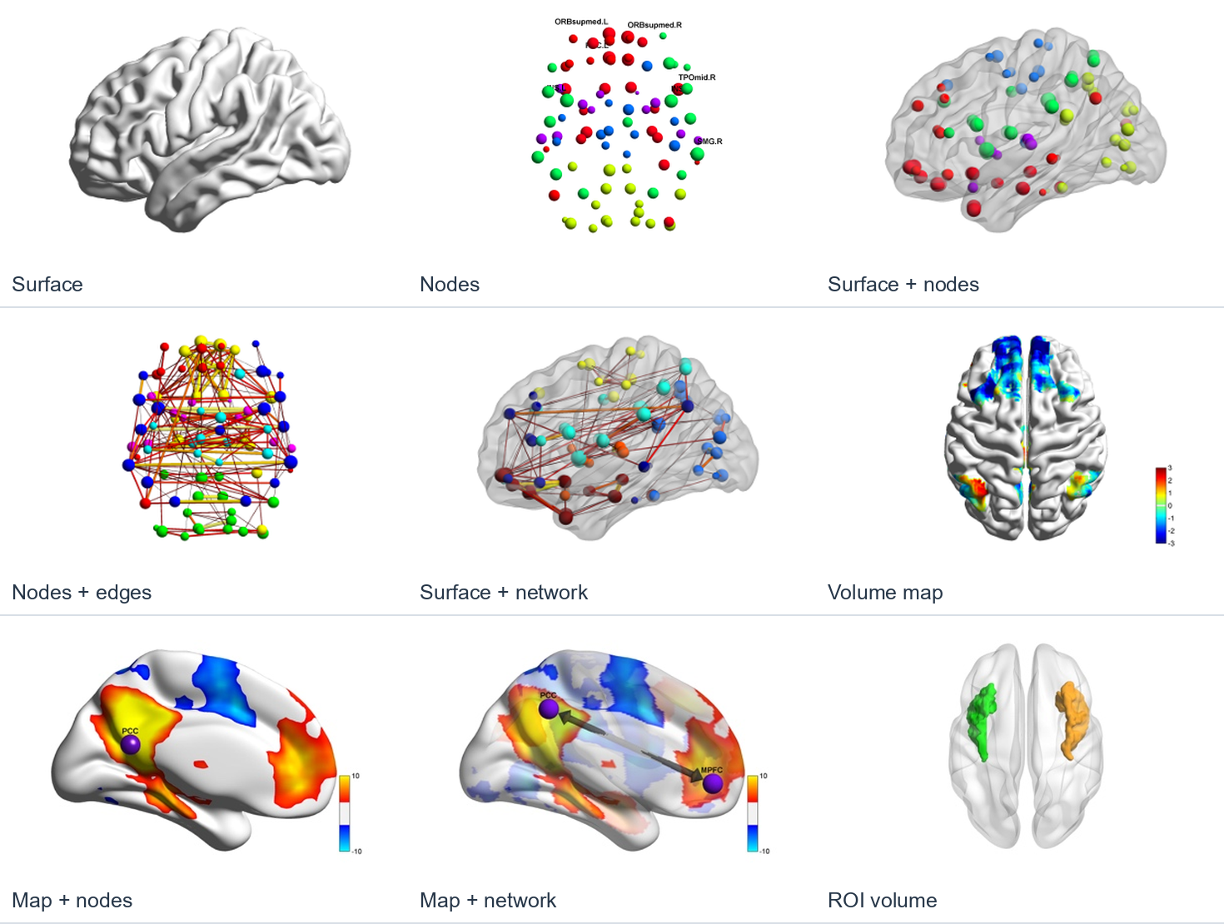
Figure 3. Data-role combinations for surface, node, edge and volume visualization. MATLAB illustration.

Prepare text-based inputs
The BrainNet .nv format begins with an integer vertex count, then that many XYZ coordinate triplets, an integer triangle count, and that many triplets of one-based vertex indices. The number of coordinates and faces must agree with the declared counts. A # comment may document provenance, but it does not change coordinates or supply a registration transform. Mesh utilities in Chapter 15 can create a new .nv from supported formats after a review step.
A .node file has one node per line: X Y Z color_or_module size label. The first five fields must be finite numbers; the final label may contain spaces. A label consisting of - means no visible label. Column 4 may encode a continuous color value or a discrete module ID, depending on the Nodes color setting; column 5 controls mapped or raw radius. The following three rows are a format example only, not atlas coordinates:
0 0 0 1 2 Region_A
10 0 0 2 3 Region_B
0 10 0 2 1 Region_C
The matching .edge file is a whitespace-delimited 3×3 numeric matrix in precisely the same node order. For example, the first row below describes values from Region_A to Regions A, B and C:
0 0.4 0
0.4 0 -0.2
0 -0.2 0
Zero denotes an absent edge. In undirected mode, only eligible upper-triangle entries are drawn; in directed mode, ordered off-diagonal entries can be drawn separately. A file may contain # comments. Do not treat this illustrative matrix as a real functional-connectivity estimate. For a per-vertex text Surface Map, provide exactly one scalar (finite values; Python also accepts NaN as missing) per vertex in the mesh's original vertex order; a matching count without a trustworthy vertex correspondence is insufficient.
Pair node and edge files from the same atlas, keeping their original row order. Check node counts, atlas version and coordinate space. Atlas IDs identify categories; their numerical order does not represent effect size.
The independent modern NIfTI/GIfTI readers do not require SPM. Plain Analyze 7.5 .hdr/.img lacking NIfTI magic is not accepted. GIfTI external binary arrays are supported within the reader's validation rules; keep companions together when moving data. For surface formats, .obj means MNI/BIC, not Wavefront; .mesh means the supported BrainVISA encoding, not arbitrary Medit data. FreeSurfer .pial geometry is kept in stored surface coordinates; it is not automatically scanner-RAS or MNI. BrainVISA geometry is kept as stored rather than applying the old implicit XYZ inversion. GIfTI transforms/metadata may be recorded without applying registration. Format support does not imply that embedded MZ3 scalars/RGBA are automatically used for display. Consult the detailed matrix and Chapter 15 for explicit rejections.

Local files and portable Scenes
MATLAB reads selected local files directly, without an import confirmation or automatic copies. Ordinary Save Scene JSON stores references and hashes; keep the original files at their recorded locations. For migration, choose Portable Scene with data (*.zip) in the save dialog. The ZIP collects the inputs and supported paired or external data files. Open Scene reads JSON or ZIP. Opening a ZIP automatically verifies and caches its contents; the archive is unchanged. Older root-relative Scenes remain readable. Local references are intended for the same computer; use a ZIP when data paths will change.

Python data and Scene portability
Python saves a Scene JSON with companion assets beside it. Keep the JSON and assets together when moving the Scene. The Python CLI defaults to the JSON directory as its data root; MATLAB uses its configured root. File counts and hashes establish identity, while anatomical correspondence requires a separate spatial check.
AtlasNetworks contains AAL90 and fourteen matched GroupFC pairs: AAL116, AAL3v2, Brodmann82, Brainnetome246, Dos160, Fair34, Glasser360, HOA112, Power264, Shen278 and Schaefer100/200/400/1000Yeo7. GroupFC node sizes encode absolute connection strength; colors encode Yeo modules for Schaefer or data-derived communities otherwise. Edges are group-level resting-state examples from healthy adults, not normative estimates. Match filenames and row order. AAL90 retains its supplied binary/weighted examples; its IDs differ from AAL3v2.

Scientific alignment check
Before combining data, check the subject or template, XYZ convention, handedness, physical units, surface vertex order, volume affine and atlas or statistic definition. Volume mapping uses the NIfTI affine for sampling but does not register the datasets. Inspect queries AAL/Brodmann in a compatible MNI-like frame without an affine registration. Hashes identify files; they do not verify alignment, statistical validity or redistribution rights. Resolve uncertain spatial relationships before interpreting anatomy. The AAL vertex-map and T-map tutorials describe the required file combinations.

4 Scenes and presets

Choose the right file
Need | Use | What it contains
Reopen a complete visualization | Scene JSON | Input references and hashes, applied visualization settings, and supported camera/export session state; not the data bytes
Reuse a look on different data | Visualization Preset | Display settings only; no input files, camera or export destination
Recover a trusted old project | Legacy configuration import | Translates supported legacy fields for review before saving a modern Scene.

Save and reopen a Scene
MATLAB: Load and validate the inputs, configure the scene and select Apply. Save Scene writes ordinary JSON references to the original files without copying the data. It preserves applied settings and compatible camera/export state, and verifies input hashes. For another computer, select Portable Scene with data (*.zip) in the save dialog, transfer the ZIP and open it with Open Scene. Supported companion files are included. Ordinary JSON requires the recorded data paths to remain available; saving references does not move the inputs.
When reopening a Scene, check the resolved paths, hashes, file roles and rendered result. Investigate missing or changed inputs rather than bypassing validation. Compatible camera and export preferences can be restored; older Scenes may not contain every current option. See Scene Workflows for schema, path and command-line details.
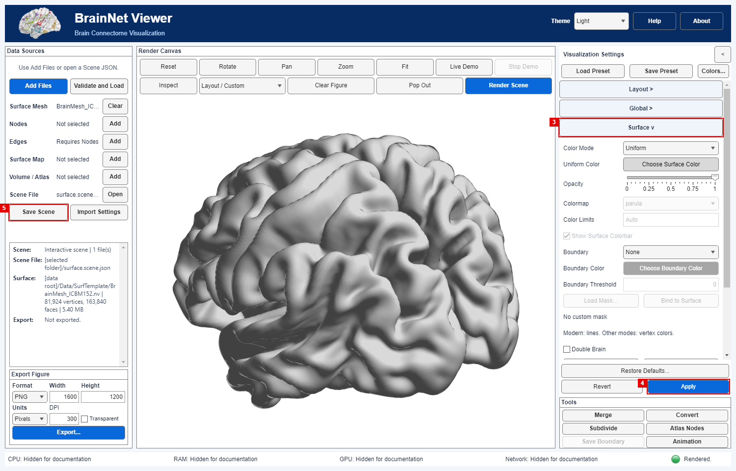
Figure 4. A saved Scene reopened with an opaque gray surface. Step 3 opens Surface settings, step 4 applies and renders, and step 5 saves a Scene. MATLAB illustration.

Apply a visualization preset
MATLAB: Choose a preset after loading the intended data. Preset load replaces the visualization settings sections; it does not bring in files or preserve pending edits and camera state. Review the resulting controls, then use Render Scene for a visible redraw. Save a new Scene JSON if the input-plus-display combination should be reproducible. See Visualization Presets for the supported fields and reset behavior.

Python Scenes and presets
Python saves a Scene JSON with copied companion assets beside it; keep both. Docker/Web Save Scene downloads a portable ZIP containing the Scene and its assets. Reopen the ZIP with Open Scene and Apply. A preset contains appearance settings, not data bytes or the session camera. Python/Web Save Preset can capture pending panel edits; Apply first to save the intended rendered configuration.
Before transferring a Scene or preset between editions, check its schema, paths and edition-specific metadata. Matching filenames are insufficient. MATLAB supports import of trusted EC MAT configurations; this is not a general Python MAT import route.

Import a legacy configuration
Import a legacy MAT configuration only from a trusted source. The converter translates supported fields and reports settings requiring review. Check paths, file roles, layout, thresholds, colors and export options, then compare a representative figure before adopting the configuration. See Migration and troubleshooting for limitations.

Batch and provenance
Use BrainNetRender with a checked Scene for repeatable non-interactive rendering. Retain the Scene, data origin, atlas version, coordinate convention, software build and any manual choices alongside the figure's provenance. Chapter 16 explains batch use. Before sharing a Scene or sidecar, remove private information and check whether the input data may be redistributed.

5 Layout and camera controls
Use Visualization Settings → Layout to choose a view arrangement and initial camera direction. The shared Apply commits changes and renders; Revert discards pending edits. Saved Scenes and presets retain applied layout settings, but presets do not carry the current camera.
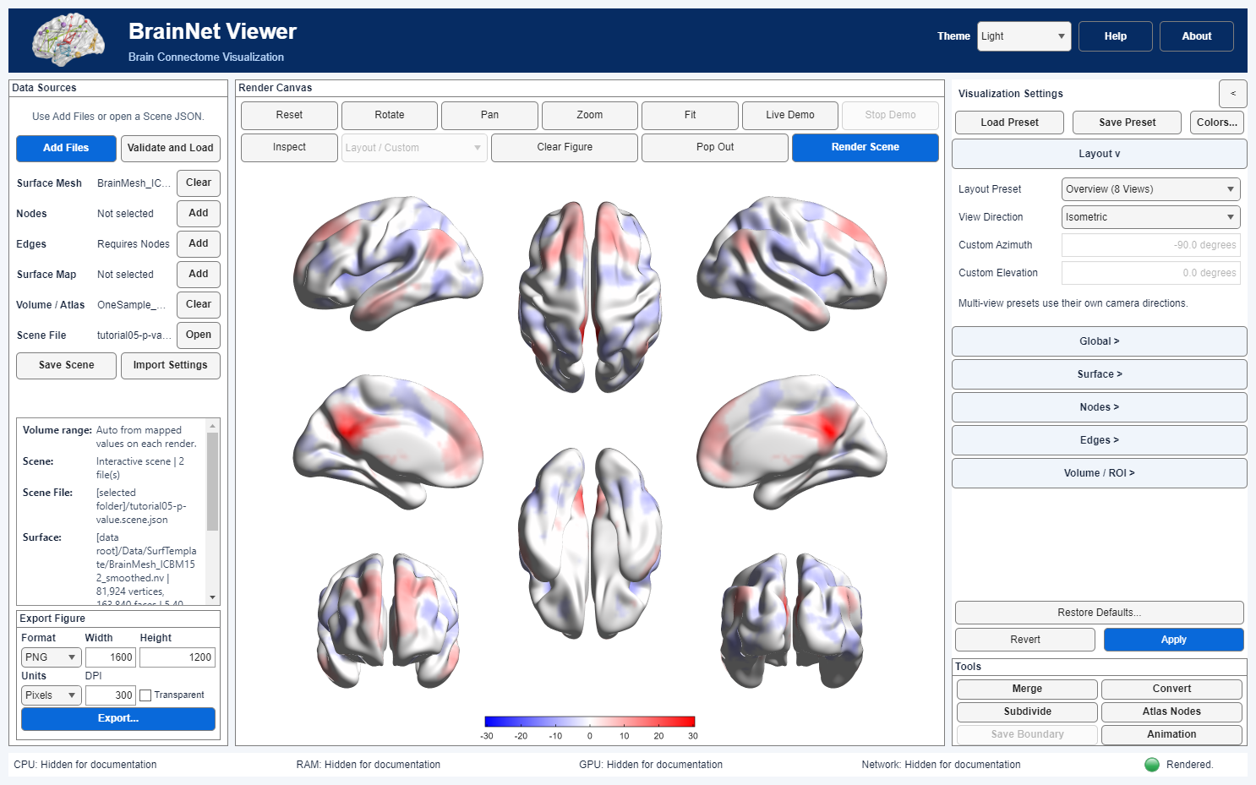
Figure 5. Overview with eight views for a surface that can be split into hemispheres. MATLAB illustration.
Control | New-settings default | Effect and when to use it
Layout Preset | Single View | Five choices: Single View; Overview (6 / 8 Views); Lateral / Medial; Lateral / Medial / Ventral; Lateral / Medial / Dorsal. Multi-view presets set their own pane directions and use a shared scale; they are not independent copies of the single-view direction control.
View Direction | Left (Sagittal) | Single-view directions: Left, Superior, Anterior, Custom, Right, Inferior, Posterior, Isometric. In multi-view, the preset's own directions take precedence. A named view is a camera orientation, not proof of anatomical L/R.
Custom Azimuth | no explicit value | Enabled for Custom direction; numeric degrees, −360 to 360. Save and replay the applied value in Scene/preset.
Custom Elevation | no explicit value | Enabled for Custom direction; numeric degrees, −90 to 90.

Read a multi-view figure
Use Single View to adjust one camera or inspect a point. Lateral / Medial shows the outside and inside of each separable hemisphere in four panes. Ventral adds inferior views; Dorsal adds a superior overview. Overview (6 / 8 Views) uses eight panes for a safely separable two-hemisphere mesh and six complete views for a single or inseparable surface. Each pane shows the same Scene from a different camera.
The layout gallery illustrates the available viewing arrangements. Verify the dataset coordinate convention before interpreting orientation labels. At the intended export size, check that labels and thin edges remain legible in the smaller panes.
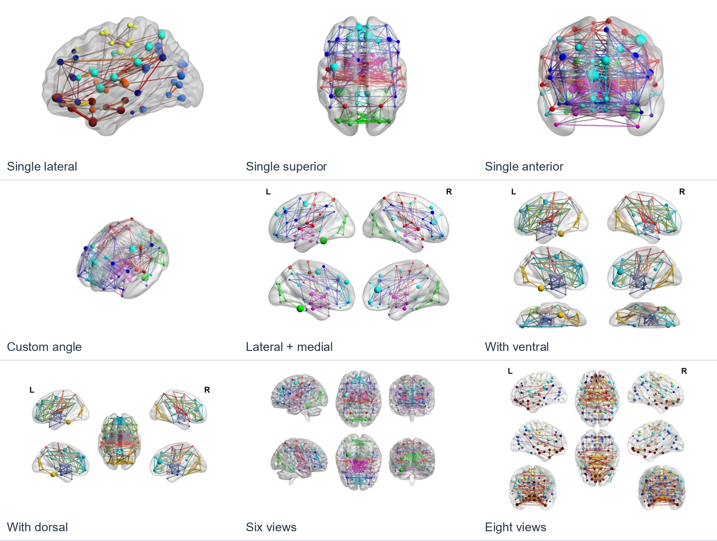
Figure 6. Viewing arrangements and relative positions of the brain panes. MATLAB illustration.
Overview (6 / 8 Views) uses eight split views when the mesh has nonempty, vertex-disjoint X-side groups. Otherwise it displays six complete views. This rule checks whether the geometry can be split; it does not identify anatomical hemispheres or verify registration. If reopening changes the layout between six and eight views, the saved camera is reset with a notice. See Layout 2.
After rendering, use the canvas controls to Rotate, Pan, Zoom, Fit, or Reset. Fit recenters and frames visible geometry without changing input coordinates; Reset restores the selected layout's initial camera. Resizing preserves the current camera rather than silently fitting it. MATLAB Pop Out opens an independent inspection copy; later movement there does not replace the main canvas camera. Save Scene records a valid modern main-canvas camera; Save Preset does not. See camera/replay details and window sizing.
Double Brain (described in Chapter 7) is a separate single-view display option, not a sixth layout. It is restricted to Left, Superior or Anterior direction with a surface and no scalar-map/volume input. The pane badges governed by Show Orientation Labels are described in Chapter 6; they identify coordinate halves unless an input-bound anatomical declaration has been explicitly verified.
Multi-view readability depends on mesh shape, labels and display scaling. Check the final figure at its intended export size.

Python view behavior
Python Pop Out moves the original canvas into a separate window and returns it when that window closes; it is not an independent inspection copy. Multi-view interaction affects only the selected brain. View Direction is disabled for multi-view layouts. Reset restores layout cameras; Fit frames geometry without changing input coordinates.

6 Global appearance and rendering
Use Visualization Settings → Global to adjust the canvas background, shading, lighting and render detail, then click Apply. The table lists defaults for new settings. Loaded Scenes and presets retain their saved values until you change them.
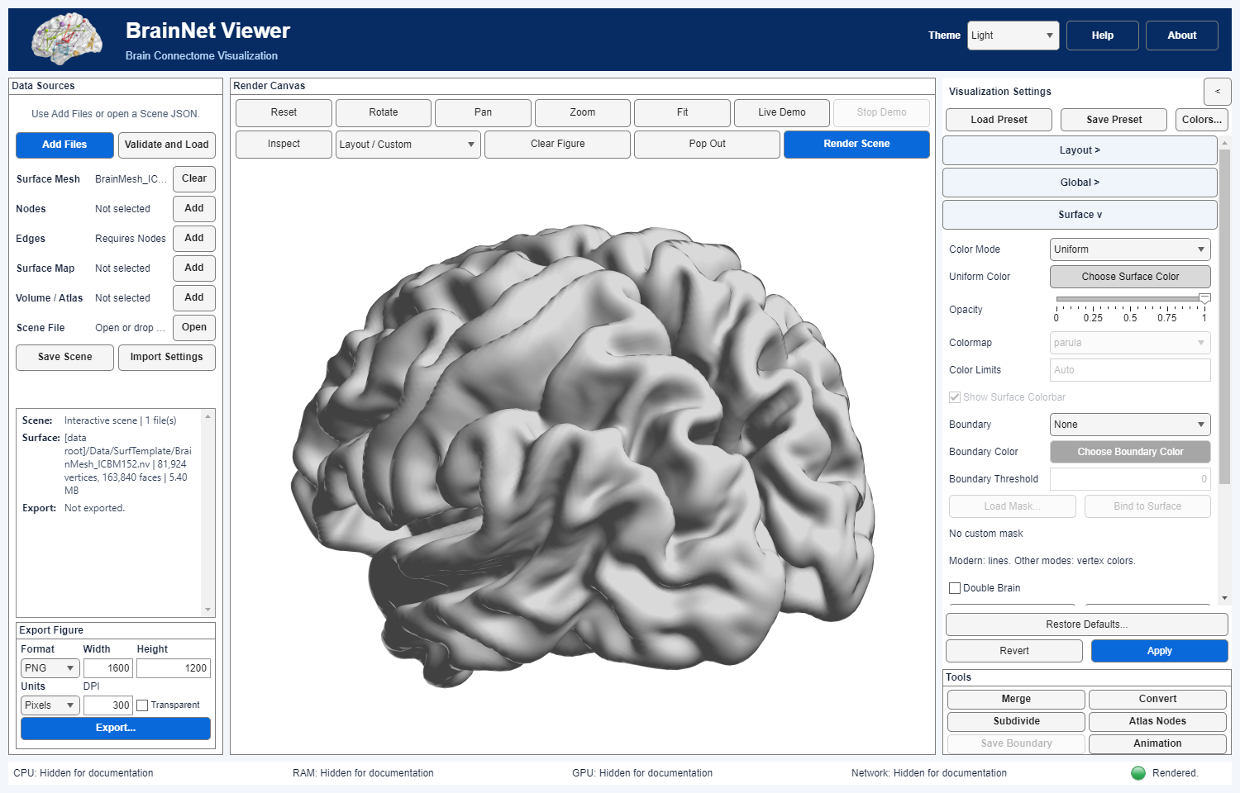
Figure 7. An opaque gray ICBM152 surface with Surface settings visible. MATLAB illustration.
Control | New-settings default | Meaning / constraints
Background Color → Choose Color | white [1 1 1] | Sets the scientific canvas background, not the Light/Dark interface theme. App export set to current follows the rendered canvas color.
Surface Shading | Interpolated | Flat, Faceted or Interpolated surface face/vertex shading. Faceted draws black mesh outlines and may cost more on dense meshes. This is display shading, not mesh smoothing.
Lighting Model | Phong | None, Flat, Gouraud or Phong lighting for shaded geometry. Appearance depends on material, view and graphics backend.
Light Direction | Right | Headlight, Right or Left. Camera/light behavior should be inspected after manual rotation; the choice does not change data coordinates.
Surface Material | Dull | Dull, Shiny, Metal or Custom. Custom enables the three strength fields below; presets follow MATLAB's material behavior.
Ambient / Diffuse / Specular Strength | [0.5 0.5 0.5] stored | Each accepts 0–1 and is editable for Custom material. Values affect lighting response, not underlying scalar data.
Render Detail | Adaptive (modern) | Adaptive uses load-aware renderer policy. Legacy Low/Moderate/High use node sphere detail 10/50/100 and edge-cylinder sides 5/10/20; High can be costly. The surface topology is unchanged.
Show Orientation Labels | off | Multi-view pane badges are X<=0 / X>0 unless the Scene has an explicit, input-bound anatomical-X declaration; only then can they say L/R. They label panes, not the screen's left/right edge. Single View and six complete-data Overview have no half-space badges.

Compare appearance settings
Material changes the balance of ambient, diffuse and specular reflections. Dull gives a relatively subdued shape; Shiny and Metal emphasize highlights. A Custom material lets you adjust the three strengths rather than replacing the input mesh. Surface Shading controls whether neighboring vertex colors are interpolated and whether triangle boundaries are visible; use Faceted to inspect mesh edges, not to infer an anatomical boundary. The Lighting Model controls how illumination is calculated, while Light Direction chooses where it comes from. These are separate decisions: an interpolated color map can still look flat under weak lighting, and changing illumination never changes a statistic in the source map.
The appearance gallery compares material, shading and light direction on one geometry. Set the palette and statistical range first, choose lighting and material, then check legibility at the intended export size. Use Render Detail conservatively on dense networks: higher sphere and cylinder tessellation increases geometry without adding measurements or changing surface topology.
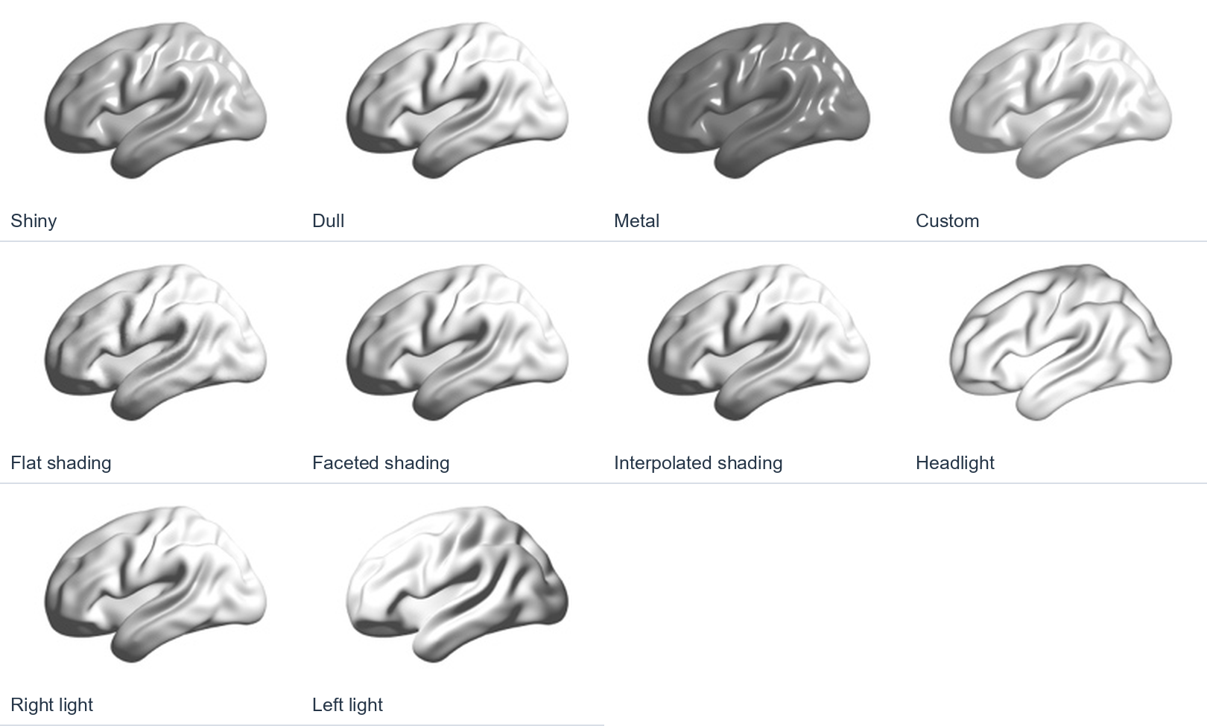
Figure 8. Surface material, shading and light-direction examples. MATLAB illustration.
Theme in the top bar changes UI colors only. For export, current preserves the actual scientific canvas background; transparent raster requests may be rejected rather than silently flattened. See backgrounds. Lighting/material specifics and the exact legacy geometry table are in Material Settings and Render Detail.
MATLAB orientation labels: The App does not infer anatomy from a filename or species. To show anatomical L/R, first verify coordinate units, shared registration, the X=0 midline and positive-X direction, then attach the declaration to hashed Scene inputs using the documented Scene/API workflow. Merely ticking Show Orientation Labels without that declaration shows coordinate halves. Check label contrast on the display and in the exported figure.
Restore Defaults resets display settings while keeping the current canvas visible. Click Apply or Render Scene to redraw; export is paused until the retained preview is replaced. It does not return to the welcome page.

Titles and supported characters
In Python Desktop and Web, bundled fonts provide supported Chinese and Unicode annotations. Missing glyphs produce an error rather than disappearing. If a new title cannot fit, Apply keeps the previous canvas. If resizing leaves too little room, the title is temporarily hidden with a warning; enlarge the canvas to restore it. The saved title retains every character. Check the complete title and its spacing from colorbars at the intended figure size.

Edition specific appearance
Python displays graphics with VTK, so material and lighting settings may produce a different appearance from MATLAB. Interpret pane labels using the known input coordinates; orientation labels do not register data. Python numerical preparation uses CPU paths. A GPU listed in the status bar does not indicate that a numerical operation uses it.

7 Surface appearance and maps
Use Visualization Settings → Surface to set the surface color, opacity, boundaries and vertex colors. Apply commits and renders. A loaded Scene or preset keeps its explicit values unless you edit them.
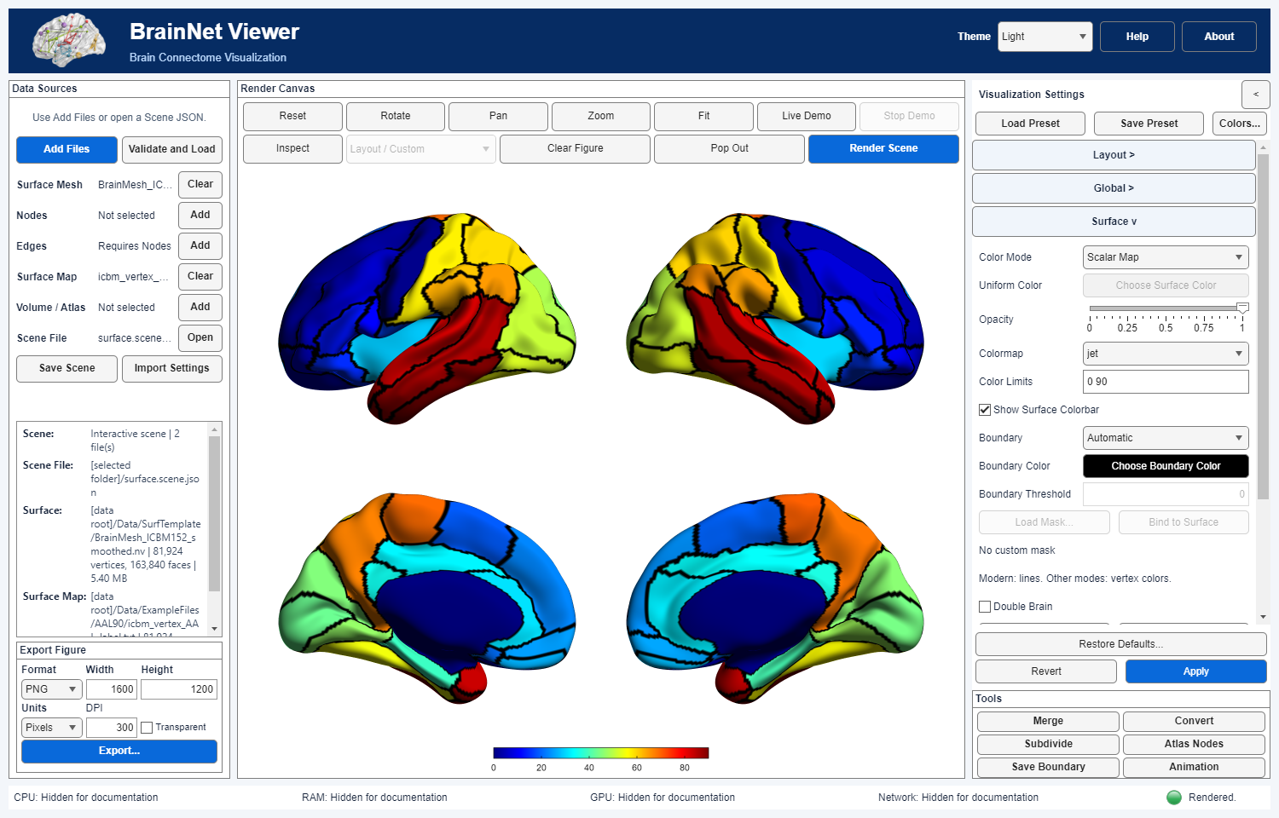
Figure 9. AAL vertex labels with automatic boundaries in four lateral and medial views. MATLAB illustration.
Control | New-settings default | Meaning / enabling rule
Color Mode | Uniform | Uniform applies one RGB color; Scalar Map colors vertices from a loaded map or a volume-to-surface mapping; Vertex RGB uses a bound RGB table in original vertex order. Choose the mode that matches your input data.
Uniform Color | [0.95 0.95 0.95] | Active only for Uniform; Choose Surface Color changes the single color.
Opacity | Settings default 0.3 | Slider range 0 (transparent) to 1 (opaque). A new surface-only or surface-plus-map/volume Scene instead starts at 1; explicit Scene/preset values are preserved. This display opacity does not change input values.
Colormap | Parula | Active for a loaded scalar surface map. Choose a named palette or Custom (Colors...). Volume-to-surface coloring uses the Volume panel's separate colormap; Vertex RGB bypasses scalar palettes.
Color Limits | Auto | For Scalar Map, enter Auto or two numeric endpoints (for example -2 2). Fixed limits control color scaling, not vertex-value filtering. Recheck them when switching datasets.
Show Surface Colorbar | on | Shows one continuous colorbar when a scalar surface map or volume-to-surface map is displayed; Uniform and Vertex RGB have no scalar bar. Existing Scenes/presets retain an explicit off setting. Atlas ROI ID legends are separate categorical keys.
Boundary | None | Automatic draws class-transition lines; Threshold marks vertices at a strict value threshold; Custom Mask uses an original-order binary mask. Boundary operations need the relevant map except Custom Mask.
Boundary Color | black [0 0 0] | Active when a boundary mode is selected; changes display color only.
Boundary Threshold | 0 | Numeric field used only by Threshold; its classification is value > threshold, not >=.
Load Mask... / Bind to Surface | no mask | Available for Custom Mask. Import or bind a binary table only after verifying original vertex order; a matching count alone cannot prove anatomical correspondence. The status line reports binding state.
Double Brain | off | Displays a second copy of one surface in Single View, Left/Superior/Anterior only; optional node/edge data follow explicit row ordering. No surface-map/volume input. This is not arbitrary two-subject composition.
Load RGB... / Bind RGB | no RGB table | Text is N×3 finite RGB in [0,1] for one brain, or 2N×3 for Double Brain, in original surface vertex order. Binding is required; it does not independently verify initial correspondence. The status line reports binding state.

Double Brain and boundary examples
Double Brain copies one surface for a side-by-side network comparison. If a node file contains N rows, rows 1 through floor(N/2) belong to the first display and the remaining rows to the second. For example, a 180-row file may place 90 matched regions in each copy. Its edge file is then 180×180: the upper-left and lower-right 90×90 blocks describe within-copy connections, and the two off-diagonal blocks describe connections between copies. The program does not discover which rows correspond to the same regions or verify a longitudinal, group or subject interpretation. Prepare and review the ordering before turning on Double Brain; an ordinary 90×90 edge matrix is not the paired network for a 180-row node file.
The boundary gallery compares Double Brain, categorical atlas outlines and continuous mapped color. A region outline is a display boundary, not a new ROI volume. Continuous colors require a scale and must not be interpreted as category IDs. Automatic, Threshold and Custom Mask boundaries follow the rules above. Recheck visibility when changing surface opacity, map range or export resolution.
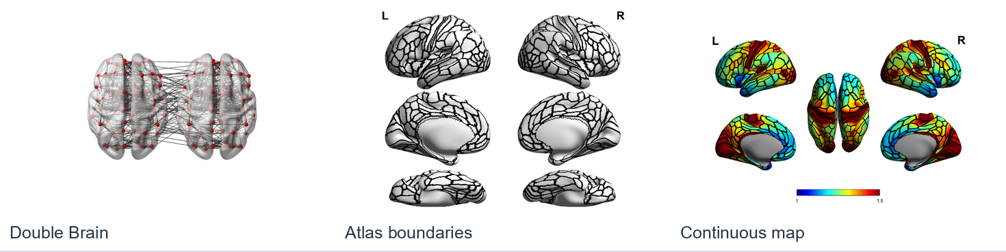
Figure 10. Double Brain, atlas boundaries and continuous surface coloring. MATLAB illustration.
Automatic in the current panel is the modern line-style boundary option; an older Legacy Automatic setting can be read for compatibility but is not a separate current panel choice. Threshold and Custom Mask use vertex colors rather than geometric isolines. See boundary algorithms and mask safety. Vertex RGB preserves the original mesh while active and can cost more for large surfaces; it is not a scalar map or statistical threshold. See RGB format/binding and Double Brain ordering.
The Volume section controls volume sampling, sign display, thresholding and ROI drawing; Chapter 10 explains these settings. Its palette is separate from the Surface scalar-map palette. Check the volume and surface coordinate spaces before interpreting mapped locations, even if the overlay looks plausible.
Shared tutorial 05 explains AAL vertex labels, Automatic boundaries and binary-mask export. Atlas IDs are categories rather than effect sizes. Use the mesh specified for your edition and retain the resource credits.

Inspect on the rendered canvas
MATLAB: Click Inspect, then pick a displayed surface vertex or node. The on-canvas label reports source index, available value/module, assumed-MNI XYZ, Brodmann Area and AAL region. Another pick replaces it; clicking Inspect again clears it. Edges, arrows, ROI meshes and fibers are not pick targets. Surface picks use the nearest displayed source vertex rather than interpolating the mouse-hit position.

Python Inspect
Click Inspect and pick a displayed surface vertex. Python reports the source vertex/value, assumed-MNI XYZ and Brodmann Area/AAL region in a compact annotation above the canvas. Another pick replaces it; clicking Inspect again clears it. Python node, edge and ROI picking are not supplied by this surface Inspect route. Neither edition registers or affinely transforms inputs for this lookup.
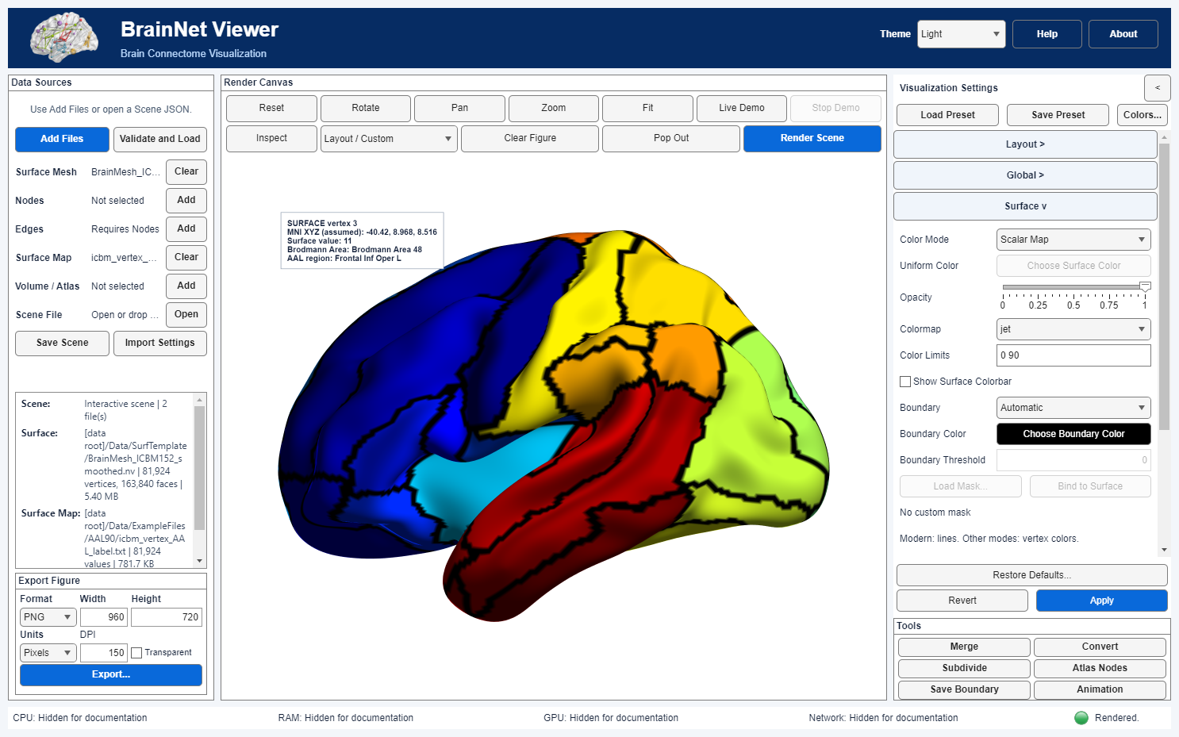
Figure 11. An Inspect label on the rendered surface reports Brodmann and AAL regions. MATLAB illustration.
Inspect assumes coordinates are already in the relevant MNI space. It does not register data or apply transforms. Native-space, animal or unregistered inputs may give plausible but incorrect labels. Verify coordinates before anatomical interpretation; see Inspect limits.
The AAL vertex-map exercise demonstrates this lookup with the bundled AAL/Brodmann resources. A successful lookup does not prove spatial registration.

8 Nodes
Use Visualization Settings → Nodes to control marker visibility, labels, size and color. In a .node row, columns 1–3 are XYZ coordinates, column 4 supplies module/color values, column 5 supplies node-size values, and column 6 is a label. Verify units and anatomical space rather than inferring them from the extension. The shared Apply commits and renders; Revert discards pending edits.
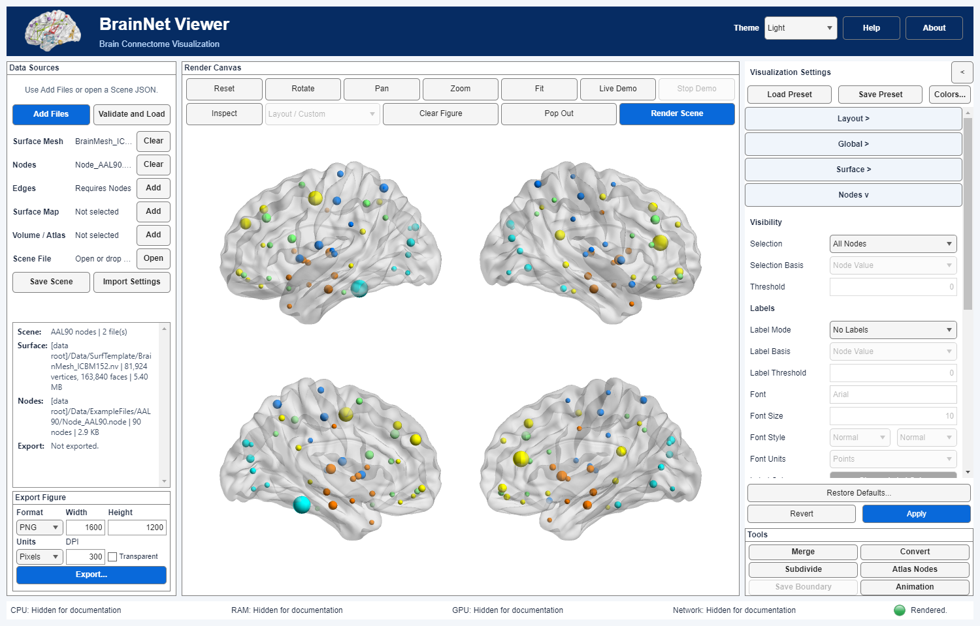
Figure 12. The bundled AAL90 nodes on ICBM152 in four views; colors use node column 4 and mapped sizes use column 5. MATLAB illustration.

Visibility and labels
Control | New-settings default | Current rule
Selection | All Nodes | Threshold keeps nodes with original Selection Basis > Threshold; equality is excluded. Connected Nodes keeps either endpoint of an edge retained after edge filtering; no selected edges means no Connected nodes.
Selection Basis / Threshold | Node Value / 0 | Enabled for Threshold. Node Value reads column 5; Module reads column 4. Module still uses a numeric > comparison, not equality to a chosen ID. Mapped radii and Scale do not affect this test.
Label Mode | No Labels | All Labels, No Labels, or Threshold. Labels appear only on visible nodes with nonzero rendered radius; a label exactly - is suppressed, but a hyphenated name remains valid.
Label Basis / Label Threshold | Node Value / 0 | Enabled for Threshold labels. Uses the original column 5 or 4 value with strict >; independent of node-selection threshold.
Font / Font Size | Arial / 10 | Font name and a positive numeric size (editor limit >0 to 100). Font Units defaults to Points; other offered units are Pixels, Normalized, Inches and Centimeters.
Font Style / Label Color / Keep Labels in Front | Normal + Normal / black / off | Weight is Normal or Bold; angle Normal or Italic. The front option changes display order, not data coordinates; it cannot guarantee collision-free dense labels.

Node size
Control | New-settings default | Current rule
Size Mode | Mapped | Uniform uses Base Size; Mapped normalizes source values to radii; Raw uses unnormalized source values; Threshold uses either Mapped or Raw radius rules then replaces radii strictly below Size Threshold with 1. Equality remains.
Size Source | Node Value | Column 5 by default, or Module/column 4 as a modern extension. Inactive in Uniform. This choice does not alter color mode.
Base Size / Scale | 3 / 1 | Base Size matters in Uniform; positive Scale multiplies the resulting radius exactly once in all modes. Radius is in input-coordinate units, not screen pixels.
Size Threshold: Mapped/Raw, value | Mapped / 0 | Enabled only for Threshold. Comparison occurs before Scale; a below-threshold radius becomes 1 before scaling. This threshold changes size, not visibility.

MATLAB numeric size rules: Mapped sizes follow the legacy normalization (including its log compression for large ranges); constant input gives radius 4 before Scale. Raw negative/invalid final radii are rejected rather than silently made positive. A zero final radius omits that sphere and its label but does not delete the input node or its edges. See numeric size rules.

Node color
Control | New-settings default | Current rule
Color Mode | Uniform | Uniform uses one Color; Mapped samples a palette from column 4; Modules assigns colors by sorted unique column-4 module IDs; Threshold uses two colors split by column 4. Column 5 is not the default color source.
Color / Colormap / Color Limits | RGB [37 89 152]/255 / Jet / Auto | Color button is active in Uniform. Palette is active for Mapped or Modules and can be custom through Colors...; fixed low high limits apply to Mapped, clamping outside values. Auto uses the full input column-4 range, not just visible nodes.
Color Threshold / Low (<=) / High (>) | 0 / [37 89 152]/255 / red | In Threshold, column-4 values <= threshold use Low, values > use High. Mapped limits/palette do not change these two fixed colors.

Modules assigns colors through the Nodes colormap. Same-module edges can inherit these colors when Edges → Node Module is selected. A custom module palette differs from the geometry-bound Vertex RGB surface table. See the node color, selection and label guides for details.
Dense labels can overlap even when Keep Labels in Front is enabled. Inspect their placement at the intended export size and simplify labels or the view when necessary.

9 Edges
Use Visualization Settings → Edges to control connectivity selection, direction, size, color and opacity. An .edge matrix must follow the loaded .node row order. Values, coordinate distances and directed relationships have meaning only in that input's declared scientific context; neither edge lengths nor arrowheads imply white-matter tracts. The shared Apply commits and renders; Revert discards pending edits.
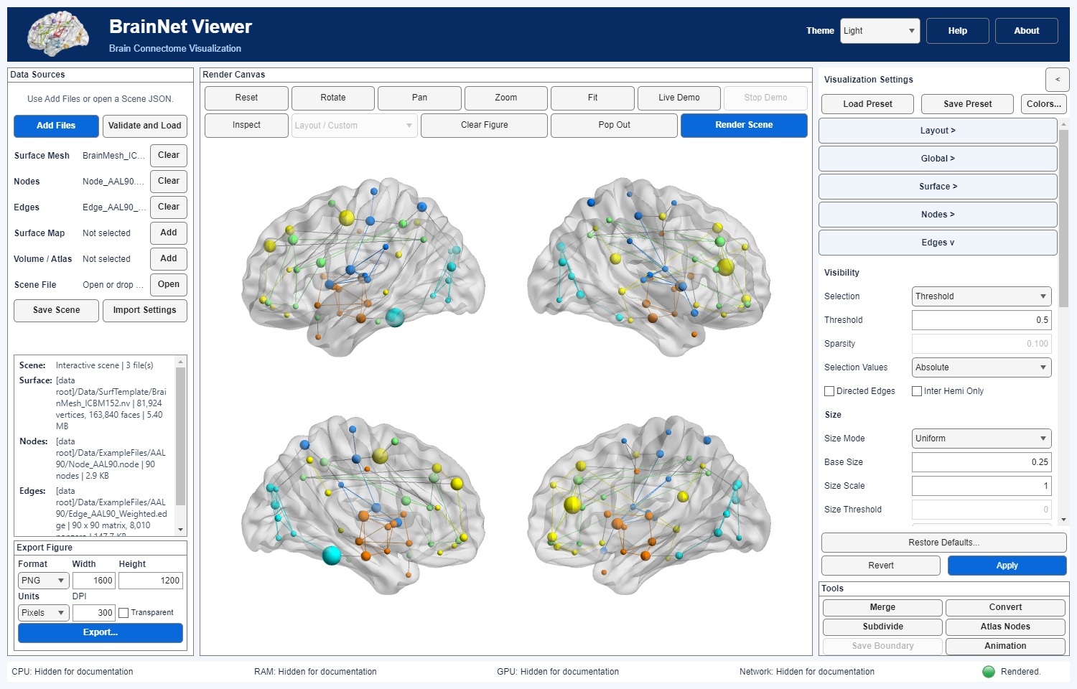
Figure 13. The bundled AAL90 weighted network in four views, showing undirected connections at threshold 0.5. MATLAB illustration.

Visibility and direction
Control | New-settings default | Current rule
Selection | All Edges | All keeps nonzero eligible off-diagonal edges. Threshold keeps selection values >= Threshold. Sparsity (Top Count) ranks nonzero eligible candidates and retains a deterministic count.
Threshold / Sparsity | 0 / 0.1 | Threshold is used only in Threshold mode. Sparsity fraction is 0–1 for Top Count; 0 selects no edges. Selection does not rewrite source weights.
Selection Values | Absolute | Signed or Absolute changes ranking/thresholding only; source weights are not rewritten. Other size/color/opacity signs have separate controls.
Directed Edges | off | Off uses nonzero upper-triangle candidates; on uses nonzero off-diagonal ordered pairs and draws arrowheads. The matrix is not automatically symmetrized.
Inter Hemi Only | off | After selection, retains opposite-X-side or midline endpoints by node X=0. This is a coordinate rule, not anatomical hemisphere detection.

Sparsity (Top Count) selects a deterministic count of eligible nonzero edges. The current UI provides All, Threshold and Sparsity (Top Count), not a separate Legacy Threshold mode. Connected Nodes in Chapter 8 follows the finally selected edge pairs. Review tie handling when comparing editions.

Size and arrowheads
Control | New-settings default | Current rule
Size Mode | Mapped | Uniform uses Base Size; Mapped maps retained weights to radii 0.4–6 (constant set: 2); Raw clamps to 0.2–6; Threshold first tests original sign-adjusted weights >= Size Threshold, then sizes qualifying edges by Mapped or Raw basis. Below threshold uses radius 0.4, not removal.
Base Size / Size Scale | 1 / 0.7 | Base Size is used in Uniform. Positive Size Scale multiplies radii once in all modes. These are radii in input-coordinate units, not pixel widths.
Size Threshold / Threshold Basis | 0 / Mapped | Enabled only in Threshold. Basis is Mapped or Raw; the threshold comparison precedes normalization and scaling.
Size Values | Absolute | Signed or Absolute is independent of Selection Values and color/opacity signs. Negative invalid final radii are rejected rather than silently made positive.
Arrowhead Shape: Length / Width | 1 / 0.7 | Enabled for Directed Edges. Multipliers are 0.25–3; length is capped at 35% of edge length. The edge tube ends at the arrowhead base to avoid overlap. These settings change geometry, not matrix direction or weight.

Threshold+Raw has a different lower-radius rule from ordinary Raw; see full radius calculation. A zero-radius edge may be absent from geometry without changing its selection/Connected semantics.

Color and opacity
Control | New-settings default | Current rule
Color Mode | Uniform | Uniform uses one Color. Mapped uses a 64-entry palette. Threshold uses Low when value <= Color Threshold and High when >; Length uses Short when original-node Euclidean distance < Length Threshold and Long at >=. Node Module compares both endpoints; Custom Matrix uses an explicitly bound node-order color-index matrix.
Color / Colormap / Color Limits | [1 0.9 0.73] / Jet / Auto | The Color button is for Uniform. Mapped/Custom Matrix use the selected named colormap or Custom (Colors...); fixed low high limits apply only to Mapped. Auto uses retained color weights after selected sign handling. Equal limits use the last palette color.
Color Threshold / Length Threshold | 0 / 75 | Threshold coloring uses original edge weights with its own sign choice; equality is Low. Length uses input XYZ coordinate units, not tract/geodesic length; equality is Long.
Threshold Values / Mapped Values | Absolute / Absolute | Separate Signed/Absolute choices for their respective color modes. They do not change Selection Values, radii or opacity.
Low / High colors; Inter-module Color | gray [.38 .38 .38] / [1 .9 .73]; gray [.5 .5 .5] | Low/High are used for Threshold or Length (buttons become Short/Long). Node Module uses the Nodes module palette for same-module edges and Inter-module Color for different modules. Select Nodes → Modules to make visible node colors match.
Load Colors... / Bind to Nodes | no matrix | Custom Matrix only. Confirm matrix dimensions and original node order; the binding cannot independently establish scientific correspondence.
Opacity Mode / Value / Range | Uniform / 0.7 / [0.1 0.9] | Uniform uses one 0–1 opacity. Mapped maps selected weights to two output opacity endpoints in [0,1]; constant weights use the upper endpoint. A transparent edge is not deselected.
Opacity Values | Absolute | Signed/Absolute for Mapped opacity only, independent of selection, size and color.

The Node Module palette is derived from the Nodes colormap; the Edges colormap selector does not override it. In MATLAB, this mode supports at most 20 distinct modules and rejects excess categories rather than recycling colors. Custom Matrix colors require explicit binding and file-format review. Color threshold/length endpoints are detailed in Edge Colors; mapped opacity in Edge Opacity. Changing a visual option does not rewrite the .edge file or establish registration.
Before publishing, check dense or directed networks at the intended export size; an edge that is selected may still be hard to see because of its radius, opacity or overlap. Graphics backends need not produce identical pixels.

10 Volume mapping and statistics
Use Visualization Settings → Volume to map a 3-D NIfTI onto a surface. Mapping uses the volume affine to locate samples; it does not register the surface and volume. Check their coordinate spaces and units first. Apply commits settings and renders, while Revert discards pending changes.
In the Volume panel, Threshold Mode, Statistical Threshold, P Value, Cluster Size and Voxel Connectivity appear above the Surface Mapping section because they also govern statistical ROIs. Controls enable according to Volume Type and Threshold Mode; ROI P Value uses Cluster Size, while Surface Map P Value does not.
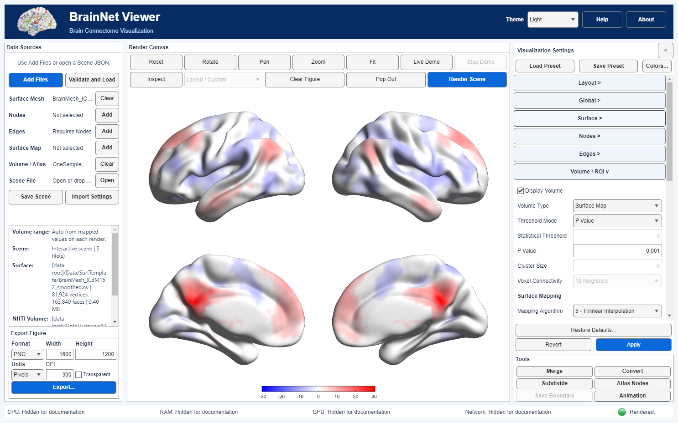
Figure 14. A signed statistical map displayed on four surface views with the P-value controls visible. MATLAB illustration.
Control | New-settings default | Current rule
Display Volume | off | Enables the chosen Volume Type. A newly loaded file does not by itself establish scientific suitability.
Volume Type | Surface Map | Surface Map maps a 3-D volume onto a loaded surface; ROIs (Atlas / Statistical) extracts labelled meshes and uses the Chapter 11 controls.
Mapping Algorithm | 2 | Used for Surface Map only. The eight algorithms below have different numerical meanings, not a simple low/high-quality order.
Threshold Mode | None | None keeps values; Value keeps finite values with abs(value) >= abs(Statistical Threshold); Cluster adds a minimum connected-component size. P Value converts supported NIfTI statistical metadata into a voxelwise cutoff. In ROI mode it also applies Cluster Size; see Chapter 11.
Statistical Threshold / P Value / Cluster Size / Voxel Connectivity | 0 / 0.05 / 0 / 18 neighbors | Value and Cluster use the numeric threshold; Cluster also uses voxel count and 6/18/26 connectivity. P Value requires 0 < P < 1 and valid statistic metadata. The original volume is not rewritten.

For Value/Cluster, zero is background, nonfinite voxels are excluded, equality at the absolute-value threshold is retained, and Cluster removes components smaller than Cluster Size. The 6/18/26 selection defines statistical connectivity; it is not the separate 26-connected safety check used in ROI smoothing. Cluster filtering can change the values available for later mapping and the resulting color range. See statistical ROI rules.
For P Value, the reader uses the NIfTI description from SPM, REST or DPABI (SPM{T_[20]}, REST{F_[3,20]}, DPABI{R_[20]}, or a Z token); a standard NIfTI CORREL/TTEST/FTEST/ZSCORE intent and its parameters are a fallback. Missing or invalid degrees of freedom cause an error, never a silent numeric-threshold fallback. T, R and Z use two-sided uncorrected P; F uses the upper tail and excludes negative F values. The resulting statistic cutoff, degrees of freedom, tail and metadata source are recorded in render preparation/provenance. P filtering occurs before mapping; interpolation or neighborhood smoothing can subsequently change vertex values, so a displayed vertex value is not itself a voxelwise P-value test. There is no family-wise/FDR correction or spatial registration.

Mapping algorithm (Surface Map)
No. / menu label | Calculation and boundary caution
1 · Nearest Voxel | Round the transformed surface position and sample that voxel. Invalid/out-of-volume positions receive zero.
2 · Average Surface Neighbors | Take algorithm 1 values first, then average each vertex with its surface-mesh neighbors and itself. This is a surface-adjacency average, not a 3×3×3 voxel mean; mesh topology affects the result.
3 · Average 3-by-3 Voxel Neighborhood | Apply a 3×3×3 mean filter to the volume, then nearest-voxel sample it. Volume boundary handling follows the filter implementation.
4 · Gaussian Voxel Smoothing | Smooth the volume with a Gaussian kernel, then nearest-voxel sample it. MATLAB uses smooth3; Python uses its numerical implementation. Kernel/boundary details are edition-specific, and nearby labels or signs can mix.
5 · Trilinear Interpolation | Interpolate the eight enclosing voxel values at an interior position; outside the supported interior returns zero.
6 · Maximum 3-by-3 Voxel Neighborhood | At a valid interior rounded position, take the maximum of 27 voxels.
7 · Minimum 3-by-3 Voxel Neighborhood | At a valid interior rounded position, take the minimum of 27 voxels.
8 · Extremum 3-by-3 Voxel Neighborhood | Choose the 27-voxel sample with greatest absolute magnitude and retain its original sign.

The gallery shows the eight algorithms applied to the same input. For a discrete atlas, begin with Nearest Voxel because averaging or interpolation can create values absent from the label image. For continuous statistics, algorithms 2 and 5 can produce smoother displays by averaging mesh-neighbor samples or interpolating the volume. Record the method and compare the display with the source map before interpreting locations.
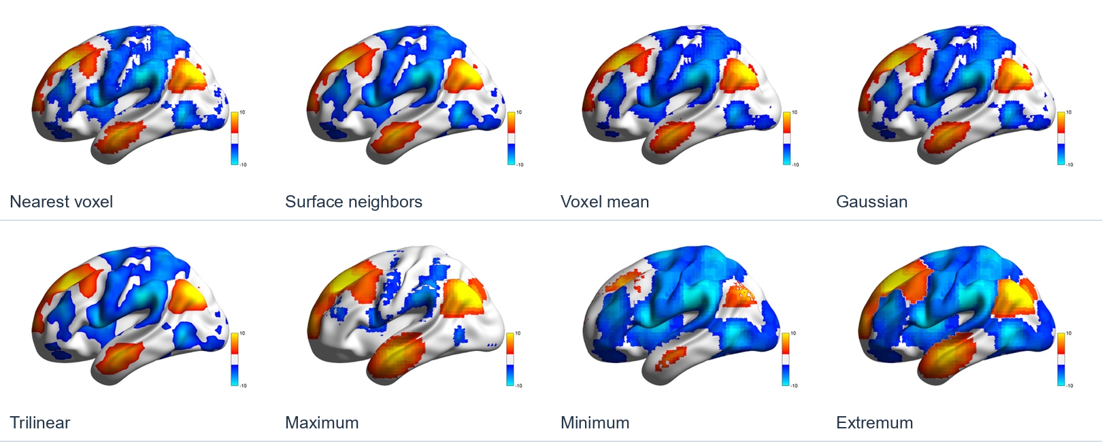
Figure 15. Eight volume-to-surface mapping algorithms applied to the same input. MATLAB illustration.
For sign and color-range choices, Display Values changes the signed color axis but does not remove negative or positive vertex values. If a map contains values from −3 to +6, Both mode uses a symmetric −6 to +6 axis; a +3 and a −3 therefore have comparable distance from the center even though +6 is the observed positive maximum. Positive Only or Negative Only uses the corresponding half of the palette. Change the relevant bounds only after checking the actual sampled value distribution and the displayed colorbar; do not interpret white/null color as a formal nonsignificant voxel unless the thresholding and adjustment rules warrant that interpretation.
MATLAB CPU mapping supports all eight algorithms. The GPU path supports algorithms 1 and 5; requests for other algorithms use the CPU and record the reason. Auto chooses GPU for algorithm 5 on sufficiently large surfaces when supported hardware is available, otherwise CPU. Setup and transfer costs can outweigh the benefit on small inputs. Python numerical mapping uses the CPU and displays graphics with VTK. Check edition-specific kernels and boundary handling before comparing sampled values.

Ranges and sign display
Control | New-settings default | Current rule
Positive Range / Negative Range | Auto / Auto | Enter Auto or minimum and maximum (either endpoint may be Auto). Manual bounds persist when the volume file changes and are identified in Scene Summary; recheck them for each new dataset. Auto Ranges only resets the pending fields—click Apply to commit and render.
Colormap | Blue-White-Red | One 256-entry palette: its lower half represents negative values and upper half positive values. A custom RGB palette can be set with Colors.... The Surface panel's scalar-map palette is separate.
Display Values | Positive & Negative | Both, Positive Only or Negative Only changes the color axis, not which vertex values exist. Both uses a symmetric [-M,+M] axis around zero even when the data extrema differ; one-sided modes use the respective palette half. Values outside a chosen range clamp to endpoint colors.
Adjust for Null / Null Color | on / [0.95 0.95 0.95] | When on, the null-side palette region receives Null Color; when off, finite values use the continuous palette. Null Color is editable only when adjustment is on. This changes display, not sampled values.

Both uses a symmetric color axis, which can reduce contrast on the smaller-magnitude side. Check the values and colorbar rather than inferring an absent effect from pale colors. The illustrated map comes from a published resting-state study; its alignment to a selected surface still requires a spatial check. See signed-axis details.
Multiple-comparison correction is not available. Check the source map's statistic, degrees of freedom, coordinate alignment and your analysis-specific inference policy before interpretation.

11 ROI drawing
Set Display Volume on and choose Volume Type → ROIs (Atlas / Statistical) to draw atlas or statistical regions. Apply commits and renders; Revert discards pending edits. ROI identifiers are labels, not continuous quantitative values.
The shared threshold controls are above Surface Mapping in the Volume panel, not inside that surface-only section. In ROI mode, P Value and Cluster Size are enabled together; Statistical Threshold is used by Value/Cluster instead.

ROI controls
Control | New-settings default | Current rule
Threshold Mode | None | None preserves positive integer atlas IDs. Value and Cluster construct connected regions with abs(value) >= abs(Statistical Threshold); Cluster also removes components smaller than Cluster Size. P Value converts supported NIfTI T/F/R/Z metadata into a statistic cutoff, then applies Cluster Size before assigning ROI IDs.
Statistical Threshold / P Value / Cluster Size / Voxel Connectivity | 0 / 0.05 / 0 / 18 neighbors | Value/Cluster use the numeric threshold; P Value requires 0 < P < 1 and valid statistic metadata. T/R/Z are two-sided; F is upper-tail only. P Value and Cluster use Cluster Size in voxels, not mm³. Zero and nonfinite voxels are excluded; choose 6, 18 or 26 connectivity.
Draw All ROIs | on | Draws every valid positive ID. While on, ROI Selection is disabled.
ROI Selection | empty | Turn Draw All off to enter positive IDs separated by spaces or commas. Typing a nonempty list also turns Draw All off. Atlas mode uses source IDs; statistical Value/Cluster/P Value modes use newly assigned, consecutive component IDs, which can change with thresholds, Cluster Size or connectivity.
ROI Color Mode | Label Index | Uniform uses one ROI Color; Label Index cycles the selected categorical ROI Palette by ID; Custom requires an explicit ROI_ID R G B table. Color modes do not redefine region membership.
ROI Palette | HSV | Label Index can choose any named palette, including Viridis, Plasma, Inferno, Magma and Cividis. Its 256 colors cycle by positive ROI ID; this is categorical indexing, not a continuous quantitative colorbar. HSV and Lines generally separate categories better than sequential gradients.
Show ROI ID Legend | off | Optional ROI ID/color key in the first rendered view; at most 16 entries are shown, with an overflow count. It is not a value colorbar.
ROI Color / Load ROI Colors... / Custom table | [0.8 0.2 0.2] / no table | ROI Color applies in Uniform. For Custom, enter or load rows ROI_ID R G B, unique positive integer IDs and finite RGB in [0,1]. Every selected ID present in the volume needs a color; missing rows cause an error rather than a fallback.
ROI Smoothing / Smoothing Kernel | Gaussian / 3 | None, Box or Gaussian. Kernel is in voxels; 1 disables smoothing, and larger effective odd kernels soften boundaries. This is display mesh smoothing, not a change to the stored volume or scientific cluster IDs.

ROI P Value uses this sequence: convert P to a statistic cutoff, discard subthreshold/nonfinite voxels, remove components smaller than Cluster Size, then number surviving components. Positive and negative T/R/Z voxels in contact can form one ROI; F excludes negative values. The cutoff, degrees of freedom, metadata source, removed clusters and resulting IDs are recorded in preparation provenance. Missing/contradictory metadata raises an error. This is an uncorrected voxelwise threshold; Cluster Size does not by itself establish cluster-level significance, and no multiple-comparison correction or registration is performed. An atlas should normally use None, not P Value.
ROI meshes use a 0.5 isosurface and a virtual zero halo to close regions touching volume borders. Smoothing checks each original 26-connected component and conservatively falls back to the whole original ROI if one would disappear. This does not guarantee volume, thin-branch or full topology preservation. In MATLAB, active smoothing with kernel >1 requires Image Processing Toolbox (bwconncomp); without it choose None or kernel 1. See ROI geometry, custom colors and statistical numbering. Recheck a Custom table whenever statistical filtering changes IDs. Automatic atlas/statistic classification is not provided.
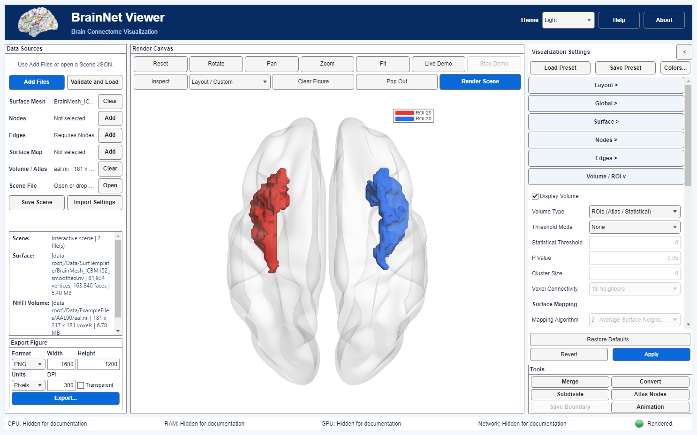
Figure 16. Bilateral AAL insula regions displayed above a translucent surface. MATLAB illustration.

Python ROI and null display
Python ROI processing uses Python numerical libraries rather than MATLAB Image Processing Toolbox. Smoothing changes the displayed mesh; component safeguards do not preserve every aspect of topology or volume. With a hemisphere-only surface, only corresponding ROIs are displayed. Statistical component IDs may change with the threshold, cluster size or connectivity.
Adjust for Null in Python uses the original surface color for null/zero mapped values. MATLAB retains an editable Null Color control for volume mapping. Zero/missing values in vertex scalar maps also retain the original surface color; a null color is a display convention, not by itself statistical significance.

12 Colormaps and presets
Custom colormaps specify display colors; presets save display settings for reuse on other datasets. Neither changes numerical values, thresholds or registration, and presets do not contain input files.

Custom RGB colormaps
Open Colors... below Load Preset / Save Preset in the right-hand Visualization Settings panel. The editor has four independent Target choices: Surface, Nodes, Edges and Volume. Volume uses one signed colormap, not separate positive and negative palettes. Named choices now include Viridis, Plasma, Inferno, Magma and Cividis; these are also available directly from each target's colormap selector. Choose a named Preset and Count (2–4096 rows), then Generate; Resample interpolates the current table to Count, and Reverse reverses its row order. The Red/Green/Blue table accepts finite components in [0,1]; a valid edit updates the preview. Import... reads RGB TXT/JSON; Export... writes the current target's table only, without applying it. Existing export files require an overwrite decision.
Use in Settings stages the four maps in the right-hand panel and closes the editor. Cancel/closing discards editor changes. A merely viewed named map stays named; modifying it produces an embedded numeric map. Choose a display mode that consumes that target's colormap, then press the single panel-bottom Apply: it commits settings and renders. Revert discards pending panel edits. A separate Render Scene click is unnecessary after a successful Apply.
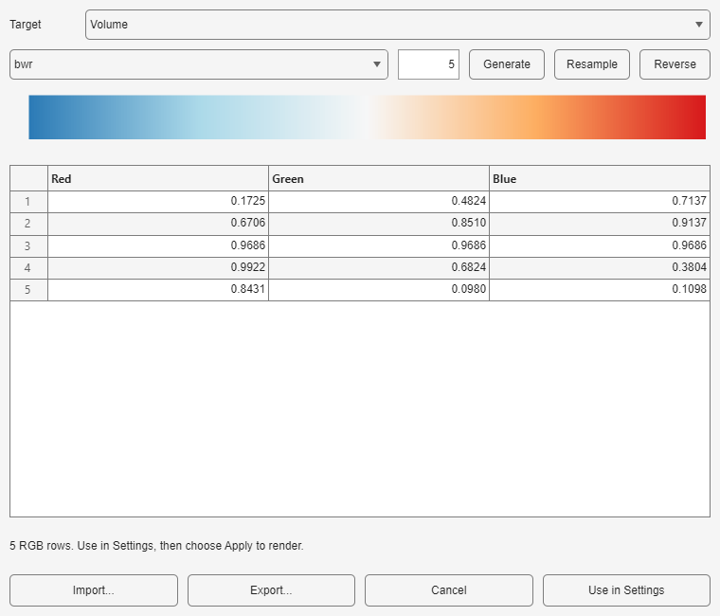
Figure 17. The custom Volume colormap editor before the colors are applied to the scene. MATLAB illustration.
Surface Scalar, Node Mapped/Modules, Edge Mapped, and Volume Surface Map are examples of applicable consumers. In Edge Node Module mode, same-module edges inherit the Node module palette, not the Edge colormap. Node and Edge fixed threshold colors do not use the continuous palette. For Volume Display Values = Positive & Negative, the one map is split at its midpoint between negative and positive values; review the resulting signed colorbar and limits. The ROI Label Index palette is a separate categorical selector in Volume settings, not an editor target. Numeric palettes are RGB-interpolated, not guaranteed perceptually uniform or accessible. See the node, edge, volume and ROI chapters before interpreting colors scientifically.
MATLAB RGB JSON uses kind brainnet-colormap, schema 1.0 and a colors array. Python exports a plain RGB array and accepts supported rgb/colors objects; the edition schemas are not assumed identical. A reviewed three-column RGB text table is a simpler exchange route. RGB components must be finite and in [0,1]; importing a table changes colors, not scientific data. Treat legacy EC MAT configuration as trusted input.

Save and load a display preset
- Load a dataset and edit Visualization Settings. Press Apply to commit and render.
- MATLAB Save Preset captures applied settings. Python Save Preset can capture current panel values including pending edits. Apply first to save the intended rendered configuration. Neither preset packages input files, session camera or export-panel preferences.
- With another dataset, select Load Preset and review the resulting controls. MATLAB confirmation replaces pending display settings and clears the old render/camera; Python stages normalized settings for review. Apply commits and renders. Recheck data-specific ranges and thresholds.
- Before exporting, check color limits, thresholds, units, selected ROI IDs and spatial correspondence for the current data. A file-role compatibility check does not establish registration or statistical validity.
Save Scene is different: it records one Scene's input references, settings and (when saved from the modern App) session camera/export preferences; MATLAB inputs are referenced, whereas Python saves companion assets beside the JSON. Invalid, unknown-version or explicitly input/camera-bearing preset JSON is rejected. Cancellation and failed validation do not replace the current settings. Fiber rendering remains unavailable; Surface Map and statistical ROI P-value presets require supported statistic metadata in the selected NIfTI. Preset names/titles may contain private text; review before sharing.
The real-data illustrated exercise shows custom Volume RGB staging, Apply and preset replay. Check the resulting colorbar and limits against the loaded data before reusing a preset in a figure.

13 Figure export
Export Figure requires a rendered Scene. It saves the figure without changing input data or applied settings.
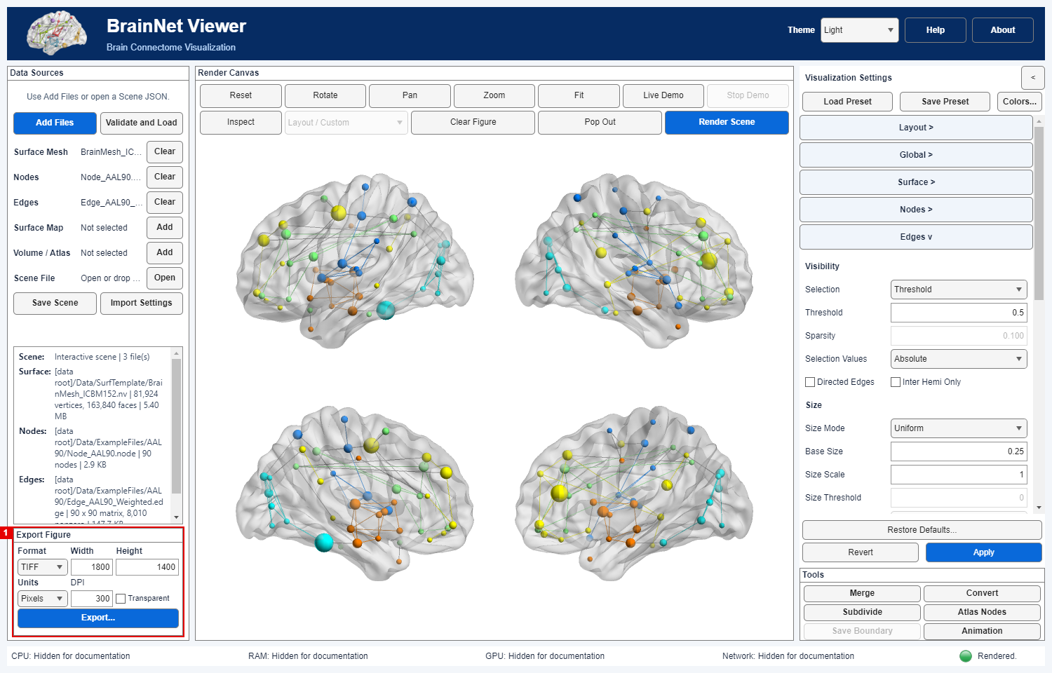
Figure 18. The red frame identifies Export Figure settings, including output format, dimensions and resolution. MATLAB illustration.

Export a still figure
After rendering, use Export Figure below Data Sources. Select format, dimensions, units, DPI and Transparent. Desktop opens a destination chooser. Web downloads the image and provenance JSON separately to the browser download location; allow multiple downloads if prompted. The compact panel has no separate Export Background or Size Mode selector.
Control | Current choices and meaning
Format | PNG, JPEG, TIFF, BMP, PDF or SVG. Raster formats produce pixels; PDF/SVG do not guarantee editable vector 3-D content.
DPI, Width, Height, Units | Positive DPI and dimensions; units include Pixels, Millimeters/Millimetres, Centimeters/Centimetres, Inches and Points. Physical size is converted using DPI.
Content handling | No separate Content control in the compact main panel. PDF/SVG can include rasterized 3-D geometry; Python transparent PDF/SVG rasterizes the complete scene and annotations.
Transparent | Transparent requests supported alpha output. With it off, use the canvas background. JPEG/BMP cannot be transparent; review actual output alpha rather than assuming it.

The file chooser may replace the selected output; choose a new path if an existing file must be preserved. A successful export writes the figure and a neighboring .provenance.json sidecar with Scene/renderer/export information. Review that JSON and any absolute input paths or titles before sharing. Output preferences are part of an App-saved Scene session, but loading a display preset does not change them. The interface Light/Dark theme is not the figure background.

Python export and recovery
Both editions offer pixel and physical sizes including millimetres; MATLAB labels use Millimeters/Centimeters and Python uses Millimetres/Centimetres. Pixel export uses the requested dimensions; physical dimensions convert using DPI. A Python request is limited to 16–16000 pixels per dimension, 64 million pixels and integer DPI 1–2400.
Python opaque PDF/SVG contains raster brain geometry with supported vector annotations. In opaque PDF, annotations using bundled fallback fonts are glyph outlines and cannot be searched or copied as text; SVG text can also be outlines. Transparent PDF/SVG uses a full RGBA raster. These files are not pure-vector editable brain meshes. JPEG/BMP cannot be transparent. Review saved dimensions, alpha, labels and the provenance sidecar.
Python Desktop and Web use point sizes for global export annotations: the title starts at 12 pt and may shrink to 6 pt to fit; scalar-bar text is 8 pt. Other global legend text uses the same scale with a 6 pt minimum. Node labels retain their selected units and sizes. Export fits the complete title to the requested output size and is rejected if it still cannot fit. Success or failure restores the screen camera, typography, DPI and title visibility. The provenance sidecar records effective annotation sizes.
After export or an error, check that the window, camera, DPI and colorbar fonts have returned to their normal screen settings. Close Figure Saved to resume work. Use a new filename when an existing image or provenance record must be retained.

14 Camera animation
Render first and adjust the canvas camera, then choose Export Animation in Tools. The animation dialog exports the current static scene into a new folder; it does not animate changing connectivity or edit the main canvas/camera. Its defaults are 960 × 720 pixels, 5 seconds, 24 fps, world Z axis, 0°→360°, and Safe Fit on. Available formats are MP4 when the edition's encoder is available, Motion JPEG AVI, and PNG frame sequence. Choose Export... and a new folder name under an existing parent; existing bundle paths are never overwritten.
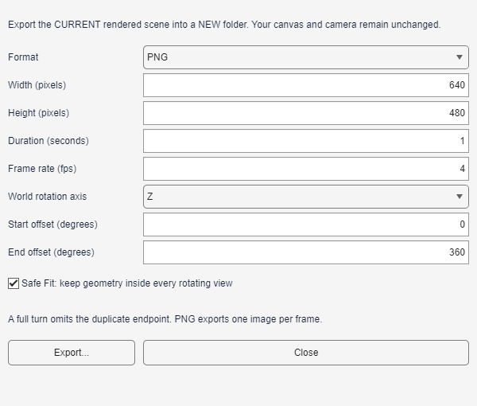
Figure 19. Camera-animation controls for a PNG frame-sequence example. MATLAB illustration.
Safe Fit centers and orthographically frames geometry across the orbit on a private rendering copy; disable it only if preserving current framing matters more than possible cropping. Angles are offsets from the current camera around the chosen world X/Y/Z axis. A full turn omits its duplicated endpoint. Frame count is round(duration × fps), so effective duration may differ slightly. Export speed is not playback speed; no GPU video-encoder claim is made. The dialog's Cancel Export takes effect after the current frame/codec operation; partial output is cleaned up.
The new folder contains movie.mp4 or movie.avi, or frame-000001.png etc., plus preview.png and provenance.json. The latter can contain Scene references, input metadata, cameras and per-frame records; source inputs are not copied. Limits: 128–3840 pixels per dimension, 1–60 fps, 2–1800 frames, at most 120 requested seconds, one billion total frame-pixels, and a nonzero orbit no greater than 360°. Video dimensions must be even; there is no transparent movie or audio. Codec availability and pixel-identical results across platforms are not guaranteed. See the animation guide for API and verification details.

Animation encoding by edition
MATLAB encodes video through VideoWriter; Python uses FFmpeg with the available libx264 or MJPEG encoders, supplied through the documented imageio-ffmpeg dependency. Use PNG frames if a video encoder is unavailable. Encoding speed depends on the codec and platform. The animation shows a static Scene from a moving camera.

15 Surface formats and mesh tools
Surface readers preserve geometry as stored. Before combining meshes with other data, check registration, units and handedness. Check the resource terms separately before redistributing a mesh.

Load and review a surface
In Data Sources → Surface Mesh, select a supported mesh; then Validate and Load, configure the display, and Apply to render. The same independent readers serve the desktop, Scene JSON and BrainNetRender. Surface support includes .nv, FreeSurfer .pial, BrainVISA .mesh, BYU/MOVIE.BYU .g, MNI/BIC .obj, MZ3 .mz3/.mz3.gz, and GIfTI .gii/.gii.gz, within each reader's restrictions. .obj means the MNI/BIC polygon format here, not generic Wavefront OBJ. .mesh does not imply Medit format. .pial is the advertised FreeSurfer desktop suffix; do not assume arbitrary FreeSurfer suffixes or compressed .pial.gz work. See the FreeSurfer, BrainVISA, BYU, MNI/BIC and MZ3 guides for exact encodings and rejection rules.
Coordinates and face winding are kept as returned by each reader; disk indices become one-based internally. BrainVISA .mesh does not receive the original BrainNet's implicit XYZ inversion. FreeSurfer surface RAS is not automatically scanner RAS/MNI. GIfTI transform metadata is recorded, not automatically applied by the mesh utilities. MZ3 embedded RGBA/scalars are validated but not automatically promoted to display settings or Surface Map. Verify space and geometry alignment before combining a mesh with nodes, volume, atlases or other surfaces. A single unsplittable mesh should use applicable full-surface layouts; two-hemisphere layouts cannot be assumed from its filename.
Expand the Tools panel to access these utilities; its heading also collapses the panel when the tools are no longer needed.

Tools that write new data
Tool in Tools | Inputs and operation | Output / caution
Merge Surfaces | Automatically review 2–64 meshes, order, bounds, counts and SHA-256. Space, units and note are optional; no verification checkbox is required. | Concatenates coordinates/faces into a new ASCII .nv; does not register, weld, smooth, repair or transfer color/scalar attributes.
Convert Surface to NV | Review one supported mesh and optional space/unit declarations. | New .nv preserving reader-returned geometry; no implicit legacy .mesh coordinate inversion or attribute transfer.
Subdivide Surface to NV | Review one mesh; choose 1–3 linear midpoint levels (4× faces per level). | New denser .nv; no smoothing, curvature preservation or automatic node/map correspondence.
Generate Nodes from Atlas | Review a discrete integer NIfTI label atlas, selected region IDs, affine and declared space/units. | New .node; each region uses its unweighted voxel-centre centroid, which need not lie within a concave/disconnected region. No registration or name lookup.

Each tool has a review step, checks source/dependency fingerprints again before publication, writes a new destination without replacing an existing one, and leaves the active Scene unchanged. Mesh utilities use default combined limits of five million vertices and ten million triangles; read/allocation may still require substantial RAM. The .nv/.node output includes a # JSON provenance comment, potentially with absolute source paths. Do not publish it without inspecting privacy and licensing. Declarations in comments do not assign a Scene coordinate space or perform transforms. Load the new file explicitly through Data Sources; for a portable Scene, place it within the configured data root or use an appropriate root. See merge, convert, subdivide, and atlas nodes for exact review fields, formats and limits.
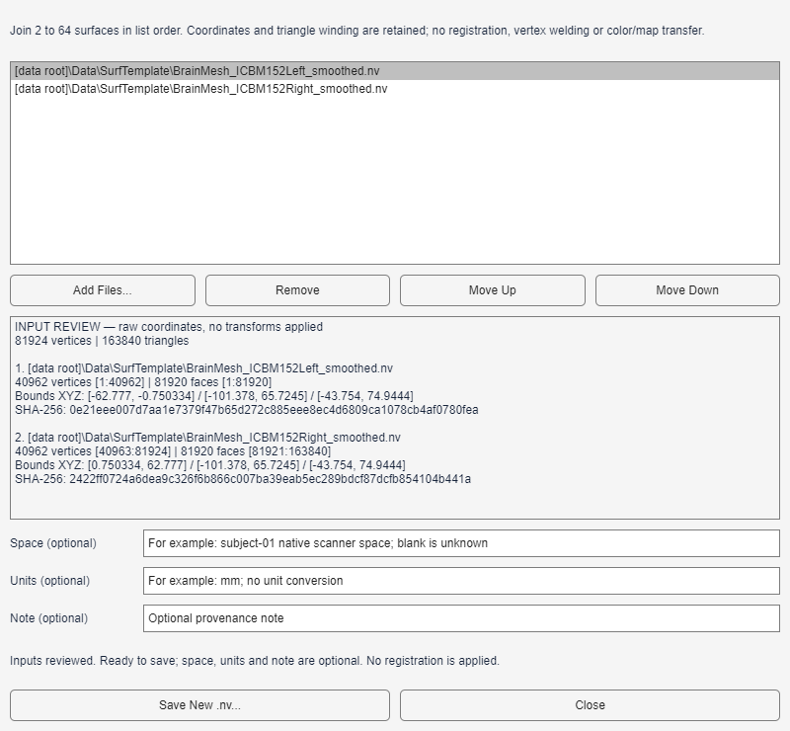
Figure 20. Merge Surfaces automatically reviews the selected inputs. Space, units and note are optional. MATLAB illustration.
These geometry operations are not a scientifically validated surface-registration pipeline. Verify anatomy and resource permissions for each dataset before using or distributing derived files.

Python tools and declarations
Python Merge and Convert do not require the optional space/unit/note declaration fields shown in the MATLAB Merge illustration. Add inputs to trigger review, check geometry and write a new destination. This optional mesh metadata rule does not apply to Python Generate Nodes from Atlas: confirm known coordinate space and units before publishing atlas nodes.
Atlas nodes use unweighted voxel-center centroids transformed by the atlas affine. They are not guaranteed to lie inside concave or disconnected parcels. The tool does not compute FC, assign measured connection strength or perform modularity analysis; constant module/size fields are user choices, not measured network quantities. Tool provenance comments can contain source paths in either edition.

16 Command line rendering and provenance
MATLAB command-line rendering uses BrainNetRender without opening the App; a MATLAB license and working graphics environment are required. Python uses brainnet-render with off-screen VTK graphics support. Docker/Web provides a separate browser workflow; it does not require these commands for normal use.

Prepare a reproducible Scene
MATLAB Scene preparation: Select local files, Validate and Load, configure Visualization Settings and Apply. Save Scene JSON records applied settings, input references and hashes, coordinate/redistribution metadata and optional camera/export state. Local files remain in place. Older relative paths still resolve against the configured DataRoot, while explicit local references identify files elsewhere on the same computer. For migration, choose Portable Scene with data (*.zip); both JSON and ZIP can be passed to BrainNetRender. The Scene does not perform registration, capture unapplied edits or grant sharing rights.
To render one image without opening the App:
record = BrainNetRender("D:/results/scene.json", "D:/results/figure.png", ...
DataRoot="D:/project-data", ComputeBackend="cpu", ...
PerformanceMode="quality", Width=2000, Height=1500, ...
Resolution=300, Overwrite=false);
The command reads and validates input files, prepares data, renders a hidden modern figure and writes the image plus figure.png.provenance.json. Output extensions are PNG, JPEG, TIFF, BMP, PDF or SVG; complex PDF/SVG scenes may contain rasterized 3-D content. The output file and sidecar are protected from overwrite by default. Use a distinct output name for every run or explicitly choose Overwrite=true after checking the targets. A simple MATLAB loop may call BrainNetRender over different Scene/output paths; there is no claim of an independent job scheduler or automatic dataset discovery.
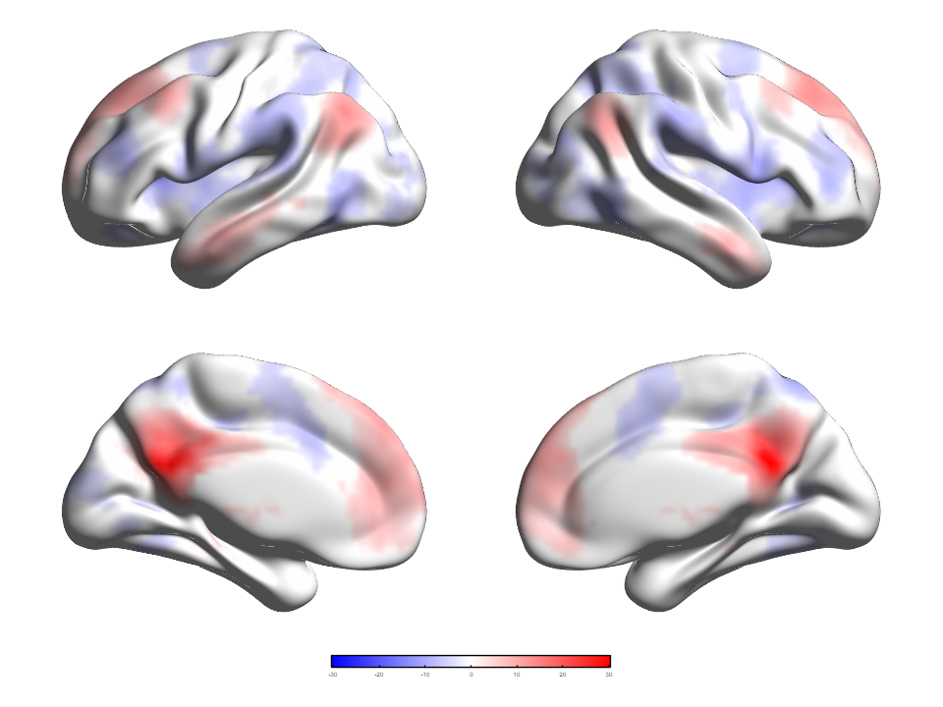
Figure 21. A four-view figure rendered by BrainNetRender from a real-data Scene JSON. MATLAB illustration.

Options to review per run
Option | Current behavior
DataRoot | Defaults to the installed BrainNetViewer folder; set it explicitly for portable project data.
ComputeBackend | auto (default), cpu, gpu; GPU applies only where individual operations support it.
PerformanceMode | quality (default), interactive, auto. For publication runs, explicitly request quality.
Width, Height, Resolution, Units | Specify both dimensions or neither. Otherwise saved App export preferences are used, falling back to Scene image defaults. Explicit dimensions without Units use pixels. DPI and physical units are interpreted by the exporter.
BackgroundColor, ContentType | Explicit choices override saved preferences. JPEG/BMP cannot use transparent none; raster formats reject vector content. Auto/PDF/SVG do not promise pure vectors.
LegacyConfig | Optional trusted legacy EC MAT conversion before rendering; not a full old-GUI replay or a sandbox for untrusted MAT objects.
Planner | Optional reusable brainnet.render.RenderPlanner object; within one MATLAB process it can reuse preparation work when keys match. It does not prove GPU speedup or identical pixels.

Scene loading checks input identities and hashes. Restore or investigate a missing or changed file before rendering. A saved camera is restored only when its content signature is compatible; otherwise the layout camera is used. For comparisons across machines, retain the settings, numeric fingerprints, renderer version and camera record. Graphics drivers may produce different image pixels. Review local paths, titles and other sensitive metadata in the sidecar before sharing it. Nothing is uploaded automatically. To reuse appearance without input paths, save a preset; see Chapter 12.
Shared tutorial 10 uses your own same-edition Scene and explicit output settings. Review sidecar privacy and cross-platform rendering differences. For Docker deployment, follow the installation chapter and the separate Docker/Web installation guide.

Python command line rendering
Activate the installed Python environment. Create the output parent directory beforehand. Relative Scene assets resolve against --data-root, defaulting to the Scene directory. Supply units explicitly: Python can retain saved physical units when dimensions are supplied without --units, unlike the MATLAB explicit-dimension pixel fallback.
brainnet-render --scene "D:/project-data/scene.json" `
--data-root "D:/project-data" --output "D:/results/figure.png" `
--width 800 --height 600 --units Pixels --dpi 200 --transparent
Use --opaque instead of --transparent for an opaque figure. --overwrite explicitly replaces the image and sidecar; without it outputs are protected. --reset-view ignores the saved camera while retaining settings. Units are Pixels, Millimetres, Centimetres, Inches or Points. There is no ComputeBackend option in this Python entry point.
Successful rendering prints a JSON result. Handled failures print BrainNet render failed to stderr and return status 1. Read the warnings and camera-restoration status. If the saved camera is incompatible or unsupported, the layout camera is used. To process several inputs, call the CLI from a loop; it does not discover datasets or perform preprocessing.
Python CLI provenance records the Scene filename and hash rather than its absolute path. Other input or tool metadata may still contain private information, so review the full record before sharing. Keep the settings, input hashes and graphics-environment details for comparisons between machines.

17 Migration and troubleshooting
BrainNet Viewer provides MATLAB Desktop, Python Desktop and Docker/Web workflows. A MATLAB Runtime-only package is not supplied. This chapter explains configuration migration, interaction controls and troubleshooting.

Moving from BrainNet Viewer 1.7/1.8
Older workflow | Current route | What to check
GUIDE main window / Load File | BrainNetViewer; Data Sources → Validate and Load | Use the project launcher. Local files are read directly; JSON saves their references. Choose a portable ZIP when the data must travel with the Scene.
BrainNet_Option.fig and OK/Apply | Right-hand Visualization Settings → shared Apply | Apply commits and renders. Revert drops pending edits; canvas Reset changes only the camera; Restore Defaults replaces display settings after confirmation.
Save/Load Option MAT | Save/Load Preset for display reuse; Import Settings for trusted EC MAT | Presets omit inputs/camera/export-panel preferences. An EC import is a reviewed conversion, not guaranteed lossless reproduction; retain the original MAT and inspect fields_requiring_review.
Save or reopen an analysis | Save Scene / Open Scene | Scene records input references/hashes and applied settings, with optional modern camera/export state. Keep the corresponding data-root structure; verify hashes and spatial alignment.
Redraw / Clear Figure | Render Scene for explicit redraw; Clear Figure for view-only clearing | Clearing the figure preserves inputs/settings; a per-role Clear removes that input.
Get position | In-canvas Inspect | Queries AAL/Brodmann using assumed MNI-like coordinates; it does not register or transform the input. Verify provenance before citing regions.
Merge Mesh / generate coordinates | Merge Surfaces, Convert Surface to NV, Subdivide Surface to NV, Generate Nodes from Atlas | New reviewed files, no silent source overwrite or registration. Conversion is geometry-only; the old .mesh implicit coordinate inversion is not retained.
Movie / print / script | Export Animation, Export Figure, BrainNetRender | Animation is a static-scene camera orbit. Print from an exported image/PDF externally; the modern CLI is not a drop-in BrainNet_MapCfg replacement.

Locate familiar menus and interaction tools
The desktop follows one sequence: load files, configure, render, interact and export. Data Sources selects and validates the inputs; Visualization Settings controls appearance; the central canvas displays the result. Help and About are in the header. Separate tool windows provide mesh and atlas-node operations.
After rendering, use the canvas Rotate, Pan and Zoom tools to adjust individual views. Fit frames the visible geometry; Reset returns to the layout's initial camera. View Direction supplies Left, Superior, Anterior and opposite/other directions for Single View; select the desired direction and render again. MATLAB Inspect replaces the old Get Position datatip workflow and clears its compact on-canvas label when clicked again. Live Demo and Stop Demo control an on-screen camera orbit, while Export Animation makes a separately configured movie or PNG frame sequence.
Native printing and MATLAB Plot Edit are not provided. Export at the required pixel/physical size, then print or annotate in an external application. Use a visualization preset for reusable appearance or a Scene for reproducible inputs and applied settings. BrainNetRender is the MATLAB Scene-based command. Previous 1.x releases remain separately available; do not mix their paths or configuration formats with the 2.0 installation.
Modern Settings schema is 1.22.0. Older Scene/preset/EC values may migrate, but their appearance can change because node/edge threshold endpoints, modules, signed volume color handling, ROI numbering/smoothing and other semantics were clarified or repaired. Recheck science-critical settings with a small dataset that independently varies .node columns 4 and 5 and includes values exactly at thresholds. Do not use visual similarity alone as proof of parity. For source-specific rules see Nodes, Edges, Volume, ROI/Inspect and Colormaps.
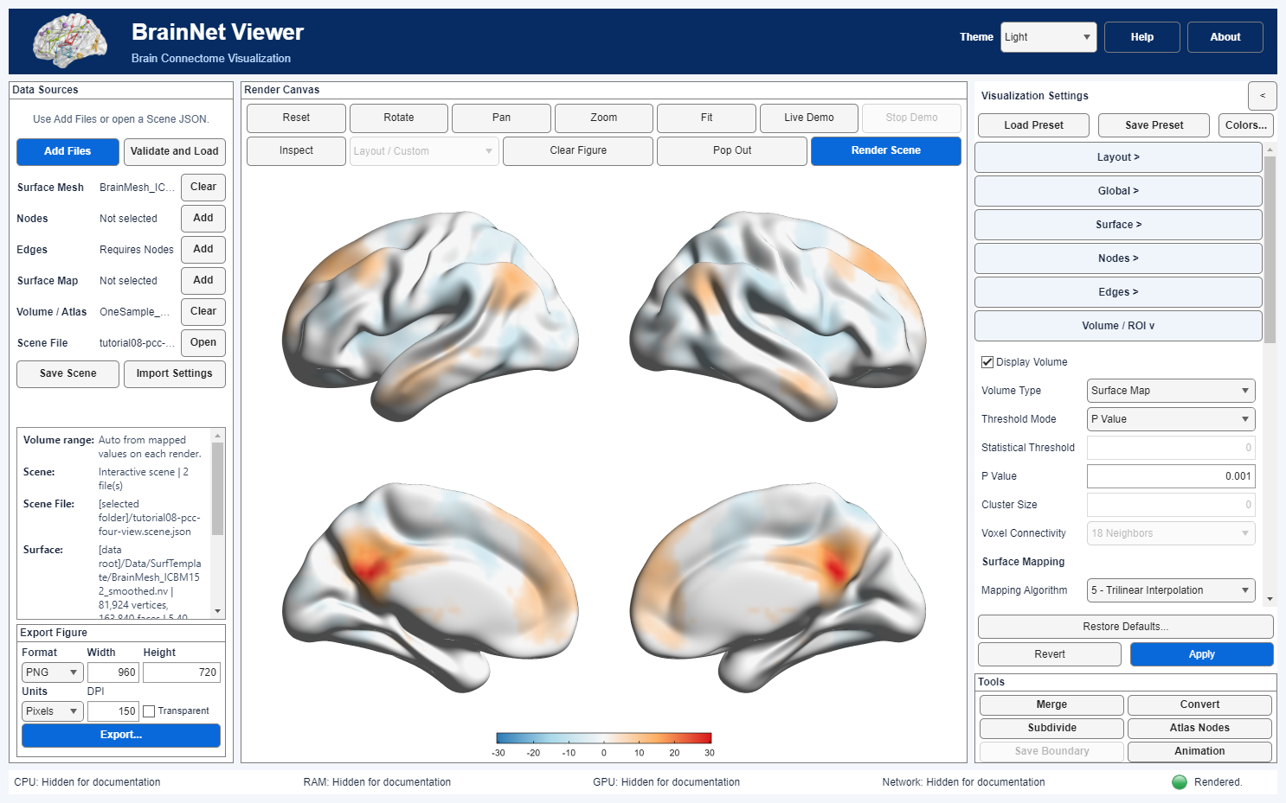
Figure 22. The current main window brings Data Sources, render controls, Visualization Settings and export into one workspace. MATLAB illustration.

Capabilities and limitations
- The independent NIfTI reader supports NIfTI-1/2 single files and paired headers/images, including supported gzip variants; pure Analyze 7.5 without NIfTI magic is rejected. MNI/BIC .obj is not Wavefront OBJ. FreeSurfer .pial, BrainVISA .mesh, MZ3 and GIfTI have narrower reader-specific rules. Loading a geometry does not establish coordinate registration.
- ROI P Value converts supported statistical NIfTI metadata but does not infer the input's role, correct multiple comparisons or prove cluster-level significance. Fiber rendering, arbitrary Plot Edit, GIF/EPS/EMF export, native print and Runtime-only packaging are not supplied. Local Docker/Web shares one workspace; Linux server mode provides authenticated browser sessions with separate processes. Working uploads are temporary. GPU use requires device access and a successful render probe; startup falls back to CPU when unavailable.
- Follow edition-specific installation and compatibility requirements. Python Desktop runs in an independent environment; Docker requires a Linux container engine with the matching processor architecture. Untested desktop configurations, including Intel Mac, Linux and additional monitor/scaling combinations, can require further validation. Save portable Scenes and exported files before changing environments.
- GPU acceleration applies only to supported operations. Rendering and video encoding have separate requirements. Complex PDF/SVG figures may contain rasterized geometry, and JPEG/BMP cannot have transparent backgrounds. Verify alpha in PNG/TIFF exports. Hashes and provenance identify files and settings; spatial validity and redistribution rights require separate checks.

Docker resources and server sessions
The supplied launchers default to the smaller of eight and the Docker engine's available CPUs. Override this with BNV_CPUS or the launcher CPU option, within the engine's limit. Compose defaults to one CPU. The quota covers the whole container, not each session. Startup fallback does not guarantee recovery from a driver failure during use.
The local service shares one workspace. Linux server mode uses compose.web.server.release.yml with the matching image, or a source build, and requires HTTPS and an access password. Separate browser profiles have independent application processes even at the same IP; tabs sharing the session cookie share one workspace. Save the Scene ZIP before stopping or updating; working uploads are temporary.
For a beta upgrade, keep the old files, image and saved Scenes. Identify the old service before stopping it. Running both versions requires a different container name and a free port. Do not perform a global Docker cleanup. Follow docs/web/en/RELEASE_INSTALLATION.md for upgrade and CPU/GPU options, and docs/web/en/SERVER_DEPLOYMENT.md for server preparation.

If something goes wrong
Symptom | First check / safe action
The launcher is not found or a different BrainNet starts | Use the current project root containing BrainNetViewer.m, add that root to the MATLAB path if necessary, and remove conflicting path entries from the session; do not alter the original software folder. See getting started.
Move a Scene to another computer | Select Portable Scene with data (*.zip), transfer the ZIP and use Open Scene on the destination computer. Ordinary JSON references the original files; moving JSON alone does not include those data.
Scene/preset JSON fails to open, or files/hashes do not match | Use Open Scene for Scene files and Load Preset for *.preset.json; these schemas are not interchangeable. Check version/required fields, data-root-relative paths, companion files and the original hashes. Do not suppress validation by changing a hash.
New file selected but the old image remains / nothing exports | Validate and Load, then Apply or explicit Render Scene. Export requires a current render. Review loaded preset settings and retained volume limits; follow the edition-specific preset behavior in Chapter 12.
Wrong side, scale, or atlas region / empty split view | Check the actual coordinate frame, orientation, units, surface-volume alignment and hemisphere separability. The App does not register data. Use a supported whole-surface layout for an inseparable mesh; treat Inspect's AAL/Brodmann result as provisional.
ROI P Value metadata error, unsupported file, or custom color error | Verify NIfTI statistic type/degrees of freedom; do not treat an atlas as a statistic map. Otherwise choose a compatible reader/file or provide every selected ROI ID in the custom color table; see ROI rules.
GPU, transparency or animation export fails | Try the documented CPU backend where relevant; verify output format, real alpha support, video codec availability, even video dimensions, frame/size limits and a new animation folder. Do not overwrite or publish partial output.

For an unresolved reproducible failure, record the edition/build and MATLAB or Python version, data roles and non-sensitive dimensions, exact error, minimal steps, compute backend and output format. Keep participant data and absolute provenance paths out of public reports unless authorized. Verify limitations against the actual package before sharing results.

Python installation and reporting failures
Check the Python executable, version and package import path in the intended virtual environment, then run pip check. Retain pinned dependencies and resolve installation errors rather than hiding them with a source PYTHONPATH. When reporting a problem, include the complete error and steps to reproduce it.
Check Scene versus preset, asset companions, root and hashes for reopening failures. Check graphic drivers for off-screen rendering errors. Report operating system, edition/build, interpreter or MATLAB version, GPU, monitor resolution/scaling, format and a complete-window screenshot when relevant. Do not publish sensitive inputs, credentials or local paths.

Appendix References and acknowledgments
The references below identify the principal software and atlas sources. Cite the actual atlas release, derivative and analysis method used in your study, rather than treating this general list as a substitute for dataset-specific attribution. The 2013 article is the primary software reference for BrainNet Viewer.

Software and atlas references
- Xia M, Wang J, He Y (2013). BrainNet Viewer: A Network Visualization Tool for Human Brain Connectomics. PLoS ONE 8: e68910.
- Brodmann K (1909). Vergleichende Lokalisationslehre der Großhirnrinde. Barth, Leipzig.
- Dosenbach NUF, Nardos B, Cohen AL, et al. (2010). Prediction of individual brain maturity using fMRI. Science 329: 1358–1361.
- Fair DA, Cohen AL, Power JD, et al. (2009). Functional brain networks develop from a local to distributed organization. PLoS Computational Biology 5: e1000381.
- Power JD, Cohen AL, Nelson SM, et al. (2011). Functional network organization of the human brain. Neuron 72: 665–678.
- Shattuck DW, Mirza M, Adisetiyo V, et al. (2008). Construction of a 3D probabilistic atlas of human cortical structures. NeuroImage 39: 1064–1080.
- Smith SM, Jenkinson M, Woolrich MW, et al. (2004). Advances in functional and structural MR image analysis and implementation as FSL. NeuroImage 23 Suppl 1: S208–S219.
- Tzourio-Mazoyer N, Landeau B, Papathanassiou D, et al. (2002). Automated anatomical labeling of activations in SPM using a macroscopic anatomical parcellation of the MNI MRI single-subject brain. NeuroImage 15: 273–289.

Distributed atlas example sources
- AAL3v2: https://www.gin.cnrs.fr/fr/outils/aal/
- Glasser360: https://afni.nimh.nih.gov/pub/dist/atlases/MNI_HCP/MNI_Glasser_HCP_2019_v1.0/
- Power264: https://github.com/brainspaces/power264
- Shen278: https://www.nitrc.org/frs/download.php/5785/shenetal_neuroimage2013_funcatlas.zip
- Schaefer100/200/400Yeo7: https://github.com/ThomasYeoLab/CBIG/tree/master/stable_projects/brain_parcellation/Schaefer2018_LocalGlobal/Parcellations/MNI
Use the paired example files with their unchanged node order. Cite the actual atlas source and derivative used; example connectivity is for visualization, not a normative connectivity reference.

Acknowledgments
We acknowledge Prof. Alan C. Evans for the ICBM152 surface and the BrainVISA contributors for Colin27 geometry. Distributed templates, atlases, examples and derivatives retain their file-specific provider credits and notices.
BrainNet Viewer acknowledges assistance from Gaolang Gong, Ni Shu, Zhilei Xu, Jiaying Zhang, Yapei Xie, Alan C. Evans, Xindi Wang, Jinhui Wang, Chaogan Yan, Zhengjia Dai, Teng Xie, Qixiang Lin, Miao Cao and Jin Liu.
Contact Mingrui Xia at mxia@bnu.edu.cn or mingruixia@gmail.com.

Appendix Shared tutorials
These thirteen tutorials combine MATLAB, Python Desktop and Docker/Web workflows. Follow the edition-labelled instructions for installation, inputs, settings and output. Links are relative to this manual: retain the repository documentation structure when moving the file.
Shared tutorial index
MATLAB and Python topic coverage
01 Installation and first launch
02 First surface visualization
03 Scenes and presets
04 Nodes modules and connectivity
05 Vertex maps boundaries and Inspect
06 Statistical volume to surface mapping
07 Bilateral AAL insula ROIs
08 Layouts and figure export
09 Custom colors and presets
10 Command line Scene replay
11 Surface and atlas tools
12 Camera animation
13 Performance and reproducibility
Illustrations identify their edition; the shared lessons use the same scientific inputs with edition-specific controls. No prebuilt Scene files are supplied. Save your own Scene during the exercises.

