[How to calculate the dominant wavelengths of a stratigraphic series?](https://acycle.org/docs/123.CalculateWavelength.pdf)

By Mingsong Li (msli@pku.edu.cn), Peking University, Feb. 5, 2021

Step 1: Load the example data: “Example-WayaoCarnianGR0.txt”.

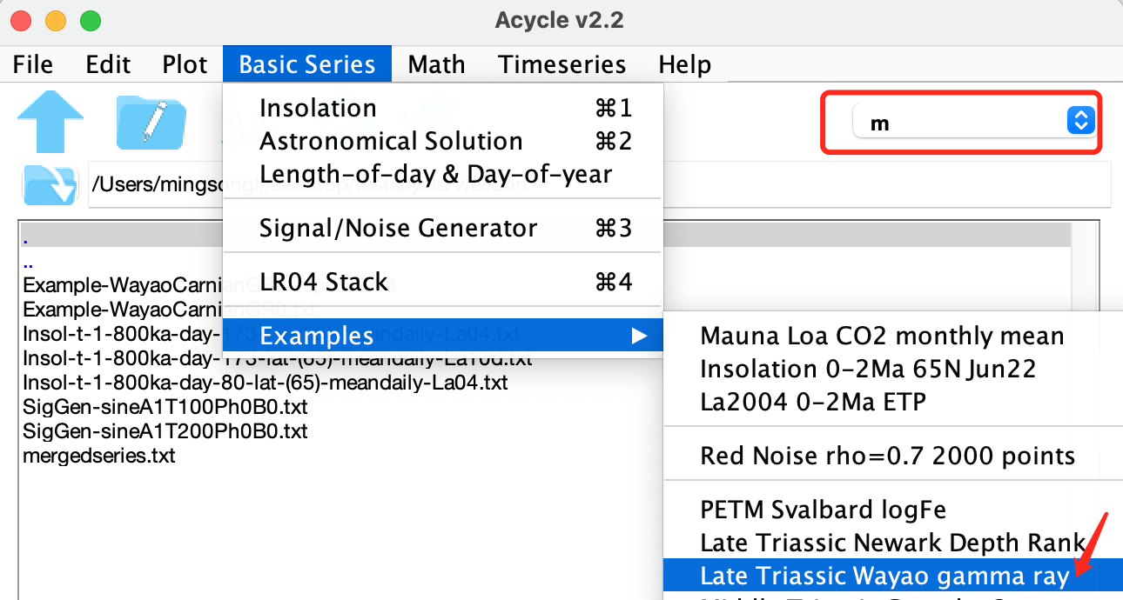

Step 2: Run the interpolation for the selected data.

Select the loaded data, choose the “Interpolation” tool. Here I use a 0.33 m as the new sampling rate for interpolation.

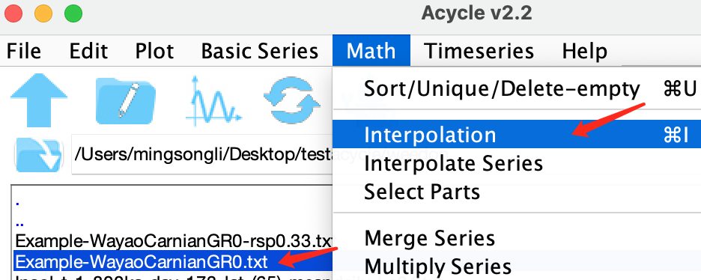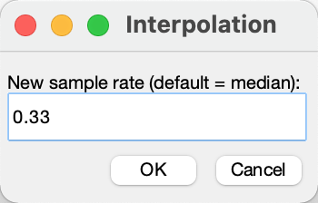

Step 4: Remove the long-term trend. See below as an example.

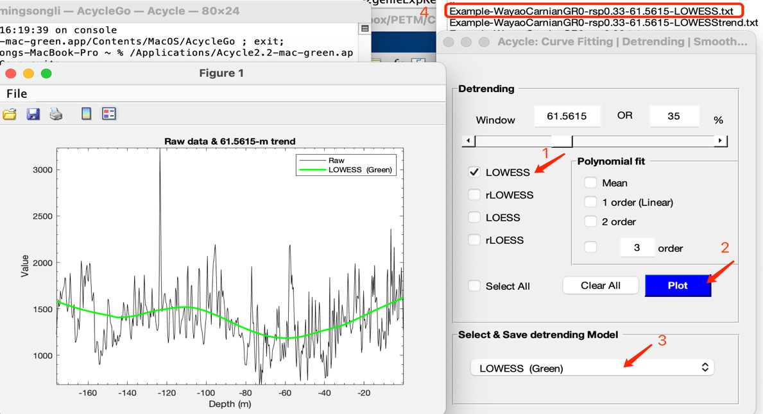

Step 3: Select the interpolated, detrended data, and then the toolbox named “power spectral analysis”. Using the following settings (right panel), you will have a power spectrum (left panel). Clicking the peaks, the period in m and power will pop-up. The result means a 2-pi MTM power spectrum indicates dominated peaks at 35.2 m, 9.68 m, 6.78 m, and ca. 2.67 m (and more if you keep on clicking).

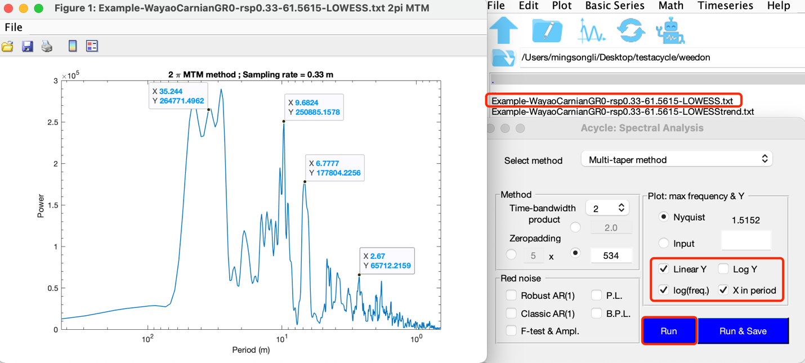

If one unselects “log(freq.)” and “X in period” in the right panel above, the power spectrum will be shown as x-axis in frequency (here, cycle/m), that is 1/period. You will need to click the frequency peaks and calculate using a simple equation: Period (m) = 1/frequency. For example, 1/[0.028374 cycle/m] = 35.244 m.

