|  |  |  |  |
| --- | --- | --- | --- |
|  |  |  |  |
|  |  |  |  |
|  |  |  |  |
|  |  |  |  |
|  |  |  |  |
|  |  |  |  |
|  |  |  |  |
|  |  |  |  |
|  |  |  |  |
|  |  |  |  |
|  |  |  |  |
|  |  |  |  |

**Resume** 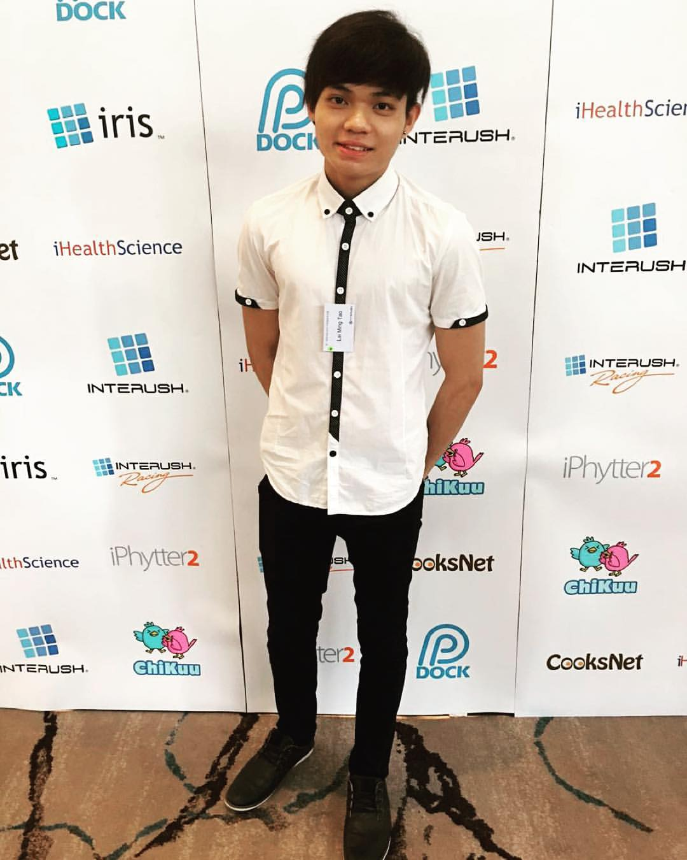

**Personal Particulars**

|  |  |
| --- | --- |
| Name | : Lai Ming Tao |
| NRIC | : S9572398E |
| Date of Birth | : 23 May 1995 |
| Citizenship | : Singapore PR (Malaysian) |
| Race | : Male |
| Marital status | : Single |
| Address | : BLK 5 Punggol Filed Walk #04-10 Flo Residence 828742 |
| Email | : [Johnnylai0523@gmail.com](mailto:Johnnylai0523@gmail.com) or [15038122@myrp.edu.sg](mailto:15038122@myrp.edu.sg) |
| Tel Number | : +65 9671 5260 |

**Education Background**

|  |  |
| --- | --- |
| 2015 – Current | : Republic Polytechnic (Diploma in Interactive Digital Media) |
| 2010 – 2014 | : Punggol Secondary School |

**Achievements**

|  |  |
| --- | --- |
| 2016 | : Director’s Roll Of honor (Academic Year 2016 & 2017 Semester 1)  Gives due recognition to students who have performed |
| 2015 | : Director’s Roll Of honor (Academic Year 2015 & 2016 Semester 1 & 2) |
| 2014 | : School Co-Curricular leadership award |
| 2014 | : T.Net Youth got talent 2nd runner (Band Group) |
| 2013 | : School Most improved award in academic (Secondary 3) |
|  |  |
|  |  |
|  |  |

**Skill and Knowledge**

|  |  |
| --- | --- |
| Programming | : PHP, JavaScript, J-query, HTML, CSS, Bootstrap, Python, C#, MySQL |
| Office Suite | : MS-Word, MS-Excel, MS-PowerPoint |
| Media editing | : Adobe Photoshop, In design, Illustrator, Premium Pro, After effect |

**Academic Results** Republic Polytechnic Diploma in Interactive Digital Media

|  |  |
| --- | --- |
| **Module Name** | **Grade** |
| Mathematics | A |
| Introduction to Programming (Python) | B+ |
| Processes and Problem solving | B |
| Effective Communication | B |
| Web Application Development in PHP | B+ |
| Multimedia Programming (Python) | A |
| Database system (My SQL) | DIST |
| Interactive Web Design and Development (HTML,CSS) | A |
| Digital Audio and Video (Adobe software) | B+ |
| 3D Graphics and Animation (MAYA) | B |
| 2D Game Design and Development (Unity C#) | A |
| Digital Illustration and imaging (Adobe software) | B |
| Digital Media Technologies | B+ |
| Advance Web Application Development (Javascript,bootstrap) | B+ |
| Cumulative GPA | 3.26 |

**Academic Results** Punggol Secondary School O Level’s

|  |  |
| --- | --- |
| **Subject Name** | **Grade** |
| Mathematics | 3 |
| Advance Mathematics | 3 |
| Chinese | 1 |
| English | 7 |
| Combine Humanities | 8 |
| Combine Science | 2 |
| **L1R5** | **16** |

**Co-Curricular Activities (CCA) & Awards** Punggol Secondary School – Band

I am a percussionist in Punggol Secondary School band. 4 years’ experience in learning music and building up set skill in Drum Set, Electric guitars, and piano. In addition, I was a team leader among the percussion session, this has built my organize and leadership skill.

|  |  |
| --- | --- |
| **Competition** | **Award** |
| SYF 2013 music festival Singapore | Silver |
| SYF 2014 music festival Singapore | Silver |
| Hong Kong Disney Youth Band music festival | Silver |
| T-Net Youth Band Singing Competition | 3rd |

**FYP – Final Year Project (current )**

Project title: Course kit for Trainer Video [IDM]

Project details / objective:

To make a video that comprises audio, text and animated contents. Integration of audio and animated contents are the main scope for the project. The animation video is to provide trainers the reference for reviewing or ascertaining the pertinent steps in conducting the lessons and tests of the course. The video will be posted on their learning portal to ensure the course is conducted in a consistent manner as designed among the trainers.

Example of the deliverable: (Motion graphic animation)



**Work Experience**

|  |  |
| --- | --- |
| **Company** | **Position and Responsibilities** |
| AJISEN Ramen Restaurant (2012 - 2013) | Server:  Serve customer and make suggestion, answer and present the menu.  Take orders and send them to kitchen staff though the POS system.  Ensuring the working area is clean. |
| Kim Gary Hong Kong Restaurant  (2013 - 2014) | Bartender:  Preparing beverages for bar and restaurant patrons. Interacting with customer, taking orders and serving snack and drinks. Assessing customer’s needs and preferences and making recommendations. |
| McAfee Anti-virus  (Event Job Flexible timing) | Promoter:  Demonstrating and providing information on promoted products.  Distributing product samples, brochures and flyer to source new sales opportunities. |
| Starbucks  (2014 - 2016) | Part-time Shift Supervisor:  Perform all POS duties. Establishes effective and positive communication among all team members. Assists store manager in maintaining proper coverage and schedules. Handing procedures and running shift. |
| Bee Choo Origin  (2016 - current) | IT Technician and consultant:  With my knowledge and programming skill from school, I was employed by this company Bee Choo origin as an IT software technician and consultant. To Manage the Database of customers and data analysis together with their marketing department. |