**Onetech Asia Project Management Tools Cross-platform Application**

**Tran Truong Minh Toan - 000123456**

**Supervisor: Vo Thanh Duy**

**Contextual Report**

**COMP1682 Final Year Project**

**BSc Computing**

**Due date: November 30th 2020**

**Word count:**

**Abstract**

This project is a research about how to create a project management tools applications which can be deploy to web and both mobile platform of IOS and Android, under the point of view of a quality control engineer as known as a tester, with limited coding skill but understood the problems when operating the quickly scalable projects. The outcomes should be a detail research report about mentioned topic and a prototype application that enough to represent the research result.

**Acknowledgement**

Sincerely thank to my family and my parents for creating the motivation and conditions for me to complete this project. I also would like to express my gratitude to the teachers and University of Greenwich Vietnam for creating the best conditions and helping me in times of need, having dedicated to teaching and transmitting knowledge and experience to my academic and mature.

Although there are many efforts in the learning process, as well as in the process of making the graduation project, it is inevitable shortcomings.

I am looking forward to the valuable suggestions of all reviewers; you let my results be more complete.

Once again, I sincerely thank!

Tran Truong Minh Toan

# Table of Contents

1 Table of Contents 2

2 Introduction 3

2.1 Background 3

2.2 Aims and objectives 3

2.3 Approach 3

3 Literature Review 3

3.1 Approach to literature searching 3

3.2 Identifying the problem 3

3.3 Another Section 3

3.4 Yet Another Section 3

3.5 Conclusions 3

4 Product Research 4

5 Requirements 4

5.1 Analysis of requirements 4

5.2 Comparison of systems 4

5.3 Requirements elicitation 4

5.4 Functional requirements 4

5.5 Non-functional requirements 4

6 Design 4

7 Prototype 4

7.1 Review of technology 5

8 Reflection 5

9 Bibliography 5

# Introduction

## Background

After 6 months of working as a QC (Quality Control) engineer at Onetech Asia, I have realized that there are lots of deficiency issues in our current usage project management tools and task management functions are limited. It is required a high cost and long-term subscription in order to activate all the necessary features and reach the highest performance. Moreover, the back-end service for those tools and application are often setup in another country such as Singapore, Malaysia, Philippines, etc. that make the internet connection become one of the problems that affect our projects business performance. It also put our security at risk of unexpected data leaking, mining or scrapping. For all of those reason, I decide to process my own research to figure out how to create an effective and high-performance project management application that my company can fully control the features and host the back-end server and database on our own with using any third-party tools or applications.

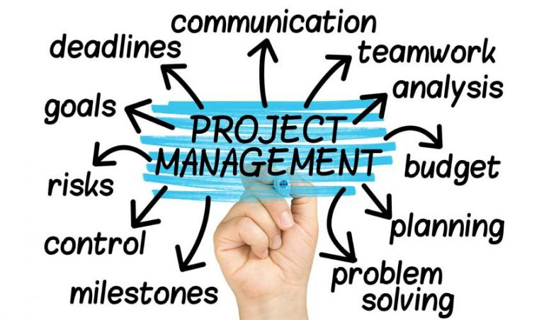

## Aims and objectives

For this topic, I am about to research about how to create a project management system in both technical and business aspect. To be more clearly, the aims and objectives of this research should be separated into 4 main ideas:

**First, study about project management,** what users need from a management tool or application, what should be required and what are the improvements?

**Second, research about infrastructure design,** what are an enterprise level system needs? Which technologies should be used? Which design pattern should be applied? And, how to combine all of those selections.

**Third, research about what is a cross-platform application?** What framework and technologies should be used? And create a project management application that can satisfy the business requirement at the First idea.

**Fourth, apply the knowledges from the Second research** in order to create a back-end server system for the applications.

Thus, the four idea should the objective for this research, I will specifically follow them to avoid losing my way in this journey!

## Approach

For more clearly, as mentioned before, I have been working as a QC engineer and my career path is more management orientation than architect orientation, so, my approach for this project shall a little bit lean to the side of research and compare the management system to figure out the good, the bad and the improvement that should be apply. However, this is a project of Computing programme, so technology is also a very important aspect that should be considered to described carefully and especially detail. Moreover, despite that I have a reasonable time to experience the project operating process and environment, but an undergraduate student as I am still lack of the knowledge about project management, so study from specific cases should increase my speed of researching really much. For all of those reason, the Case Studies Research Method would be my dominant research methodology of this project.

# Literature Review

## Approach to literature searching

Before finally decide to choose this topic about develop a project management application, beside my current experience in project operation environment, I have briefly done some research two main question: what are the business requirements for this application and how to create a cross-platform application include server and client side. So far, those researches led me to divide the two common questions in four details problems that suitable with the defined above objectives.

Therefore, in this section of literature review, I will continuously go through that four problems to find out what researches or investigations should be done in order to build the application system that satisfy our objectives.

## Identifying the problem

As mentioned above, this report topic is separated in four main problems that help keeping me align with the beginning and do not become lost too far from the main road. So, I will briefly introduce about those problems as following:

One, the very first question, the root core of my topic, what is project management? What are the aspects that should be considered to study about in the field of project management? And, finally, when a project management process started to require a tools or application?

Two, what are the project management tools or application definition? What make a good project management application?

Three, this management system infrastructure design. How to design the overall system? How to create a good back-end data API server?

Four, cross-platform application development? What technologies and frameworks to used? How to consist the UI/UX and guarantee the performance?

## Project management - The common definitions and aspects

### Project definition

Before go straight into the concept of project management, I will quickly summary about the project definition. Project is a temporary effort that taken to create a specific product, service or any other types of result. A project is definitely unique in which does not include not just a routine operation, but unique collection of operations created to achieve a singular goal. So, a team of project usually includes member that seldom working with each other ever before, sometimes they might from different company, organizations or across country borders and separated by geographies. Some easily found example for project such as development of software, a business process improvement, a building construction, a charity programme or a marketing campaign are all project and all must be especially managed to delivery on time, within given budget of cost and resource of the organizations.

Project management, then, can be quickly defined as the application of skills, tools, experiences, knowledges and specify techniques to the project operation that lead it to the point of requirement meet.

### Project management definition

### Five stages of project management

## What is project management tool application? - Requirement for a good management tool

### Project management tool application

### What Makes A Good Project Management Tool?

## REST data API and overall system infrastructure

## Create a cross-platform application (Android, IOS and Web)

## Conclusions

What are you taking forward from this? How is this going to influence what you are going to do next?

# Product Research

## Celoxis

## Trello

## Redmine

## Backlog

## Conclusion

# Requirements

## Analysis of requirements

In this project there are of….

## Comparison of systems

For some projects there may be similar existing systems. This would be a good place to identify these, compare them and elicit requirements from them.

## Functional requirements

A clear statement of functional requirements is the starting point for your design. Without this you will look foolish.

## Non-functional requirements

Clear statement of non-functional requirements. It may be an idea here to refer back to your earlier LSEPi section as compliance is likely to (and should) be an important aspect here.

# Design

## Use cases diagrams

## Database model design

## System infrastructure design

## User interfaces

# Prototype

## Relational database with PostgreSQL

## Database migration by GORM (Go-ORM)

## REST data API with Golang

## React-native cross-platform application

# Reflection

## Reflection on research result

## Reflection on outcomes prototype

## Reflection on my knowledge achievement