**Mini-project 2 Report**

**Members:**

Mingwei Li

Shuyang Li

Xuanyi Wu

1. **A general overview:**

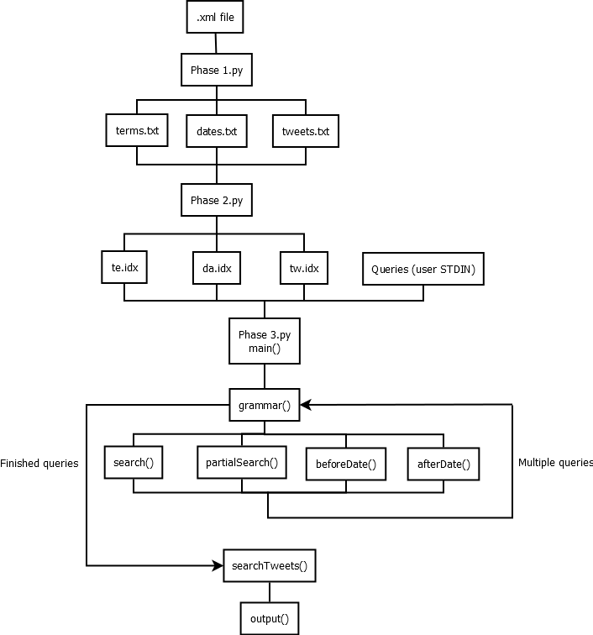

We divide the whole program into 3 parts, one part for each phase, and write each part in Python 3.

phase1.py:

1.Read the files;

2.handle each term by using regular expression;

3.ignore special characters and terms with length less than or equal to 2;

4.save the qualified data to terms.txt, dates.txt, tweets.txt respectively.

pahse2.py:

1.Use Linux sort command ‘sort –u… ’ to sort the three txt files generated in phase1 without duplicate key-data pairs; 2.

2.use ‘perl break.pl …’to get the ideal format for db_load;

3.use ‘db_load -c duplicates=1…’ command to get the .idx files (allow duplicate keys).

4.use ‘db_dump’ to check the correctness of db_load

phase3.py:

provide a query interface and return the results

**User Guide**:

Format 1, user enter __:__

This query returns exact match results

The previous blank can be filled in with: text or name or location or date; the second blank is the keyword(format year/month/date for the search of date). The program searches terms in text, name, location, date respectively.

Format 2: user enter __:__%

This query returns partial match results

The previous blank can be filled in with: text or name or location; the second blank is the keyword. The program searches terms in text, name, location, respectively.

Format 3: user enter __

The blank can be filled in with any keyword, and the program returns exact match results by searching terms in text, name and location

Format 4: user enter __%

The blank can be filled in with any keyword, and the program returns partial match results by searching terms in text, name and location

Format 5: user enter date>__

It is a range search, the blank can be filled in with any date with format year/month/date, and returns the tweets posted after that date.

Format 6: user enter date<__

It is a range search, similar with format 5 but returns the tweets posted before that date.

Format 7: user enter (query 1) (query 2) … (query n)

Multiple search, user can enter any combination of the previous 6 queries separated by blank. It returns the tweets satisfy all queries.

**(b) A description of your algorithm for evaluating queries**

1. load the three .idx files to database

2. use split(‘ ‘) to split the queries (in grammar function)

3. for each query, decide it is what kind of search (in grammar function)

4. exact search : (call search(termPrefix, term) function)

for Format 1: termPerfix is ‘-t’ or ’-n’ or ’-l’ or empty for date

for Format 3: termPerfix is ‘-t’ and ’-n’ and ’-l’ and union all results

4.1. encode the termPerfix+term into the key

4.2 use curs.get(key, db.DB_SET) to get the first qualified record

4.3 recursively use curs.get(key, db.DB_NEXT_DUP) to get all qualified records

4.4 if the id is not in the result query, append it into the result query

5.partial search(wild cards): (call partialSearch(termPrefix, term) function)

for Format 2: termPerfix is ‘-t’ or ’-n’ or ’-l’

for Format 4: termPerfix is ‘-t’ and ’-n’ and ’-l’ and union all results

5.1. encode the termPerfix+term into the key

5.2 use curs.get(key, db.DB_RANGE) to get the first candidate record

5.3 recursively use curs.get(key, db.DB_NEXT_DUP) to get all candidate records

5.4 for each candidate, use result[0].startswith(key) to check whether it is a perfix

5.5 if it is and the id is not in the result query, append it into the result query

6.range search:

6.1 encode the date; search in da.idx

6.2 use daCurs.get(date, db.DB_SET_RANGE) get the first candidate record

6.3 for Format 5 (call afterDate(date) function)

when the date != the date we entered, use daCurs.get(date, db.DB_NEXT) recursively to get all records after that date (we can do that since the the file ins sorted)

6.4 for Format 5 (call beforeDate(date) function )

when the date != the date we entered, use daCurs.get(date, db.DB_PREV) recursively to get all records before that date (we can do that since the the file ins sorted)

6.5 append the ids to the result list

7.multiple search:

since for each query we get a result list, we intersect all the result lists to get the result for multiple search (i.e. every time we get a new result list, we do tids=list(set(tids).intersection(newTids)) )

8. get the full record (call searchTweets(tids function )

8.1 traverse list tids(a list with all qualified tids);search the ids in tw.idx

8.2 append the matching records in the result list

9. make it readable (call output(line) function)

use regular expression again to get the readable format and print them.

**An analysis of the efficiency of your algorithm**:

The time efficiency of search algorithm depends on two parts: the efficiency of B+ tree and the efficiency of hash. We first search each query in B+ tree (te.idx and da.idx) which costs $O\left(\log_{f}N\right)$ ($f$ is fan-out, $N$ is the number of leaf pages). Then we use the results from last step to find intersection of them (final result tids), and use each final result to search in the hash (tw.idx) which costs $O(1)$. Therefore, the time efficiency is:

$$C*O\left(\log_{f}N\right)+R*O\left(1\right)=O\left(\log_{f}N\right)$$

where $C$ is the number of queries, $R$ is the number of result.

The space efficiency also depends on the space efficiency of B+ trees and the hash. We assume in te.idx, da.idx, and tw.idx, the largest number of records is $n$. Therefore, the space efficiency is:

$$3*O\left(n\right)$$

**(c) Testing Strategies**

On phase 1, we run our code with 1k.txt and use diff to compare our result with the correct result offered in spec. Then we analyze the difference and revise our code.

On phase 2, we use db_dump –p to export our result in readable file. Then we use diff to compare the index file with the sorted and file which is processed by break.pl to make sure every record is in the index file.

On phase 3, we test our code by input some critical queries, such as finding records before a non-existing date. We also imported the .xml file into Excel as a table, and compare the query result with the excel filter result which can improve our testing efficiency.

**(d) Group Work Break-down Strategy**

For this project, we didn’t have too much code to write, so we emphasized on discussing how to implement the project and test several simple cases to make sure this method does work.

We discussed several ways for phase 1 breaking the .xml file down to 3 .txt files. Finally, we choose to use regex which is the easiest and fastest way, and Shuyang Li individually spent some time to figure out how to write correct regex.

We discussed about phase 2 together and searched some ways to run Unix command in python and implement it in a short time.

For phase 3, we discussed how to analyze the grammar of query. Mingwei Li wrote some parts of the code, and then Shuyang Li and Xuanyi Wu finished the rest part.

We tested the code separately and reported the bug we found to each other via email and IM software.

Work time:

Mingwei: 12 hours

Shuyang Li: 12 hours

Xuanyi Wu: 11 hours