

SELECT empno,empname

FROM employee

WHERE empname like '%刘%'

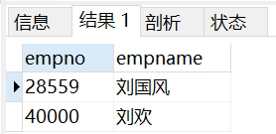

Select empni,empname from employee where empname llike ‘刘%’



SELECT empno,empname

FROM workson natural join project natural join department natural join employee

WHERE enterdate<'1999-01-01 00:00:00' AND projectname='网络布线'

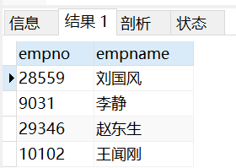

Select employee.empno,employee.empname from employee natural join workson natural join project where projectname=’网络布线’ AND enterdate<’1999-01-01’

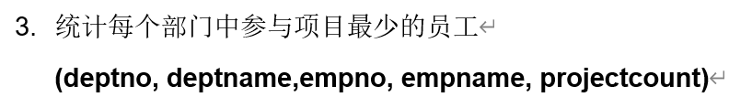

SELECT d1.deptno,d1.deptname,empno,empname,count(projectno) as projectcount

FROM workson natural join employee natural join department d1

GROUP BY empno

HAVING count(projectno)<=ALL(

SELECT count(projectno)

FROM workson natural join department d2 natural join employee

WHERE d1.deptno=d2.deptno

GROUP BY empno

)

select e1.depid,depname,e1.empid,e1.empname,count(distinct workson.proid) as count from workson natural join project natural join employee e1 natural join department group by e1.empid having count(distinct workson.proid)<=all(select count(\*) as count from employee e2 natural join workson natural join project where e1.depid=e2.depid group by e2.empid) order by depid;

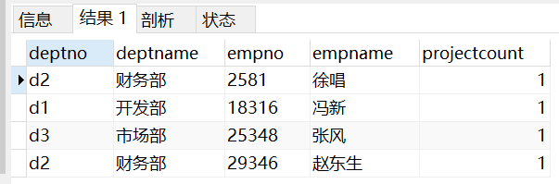

查询每个部门在同一个项目中参与人数最多的项目名称以及该项目的总参与人数



SELECT projectno,projectname

FROM(

SELECT distinct projectno

FROM workson

WHERE job IS NULL

) as son1 NATURAL JOIN project

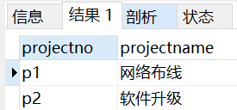



SELECT depid,depname,location

FROM department natural join(

SELECT deptno

FROM employee

GROUP BY depid

HAVING count(\*)< ANY (

SELECT count(\*)

FROM employee

GROUP BY depid

)

) as son1

WHERE location<>'广东'

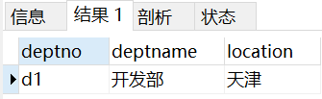



SELECT empno,empname

FROM employee natural join workson

GROUP by empno

HAVING count(projectno)>=2

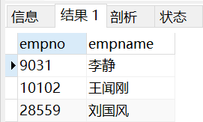

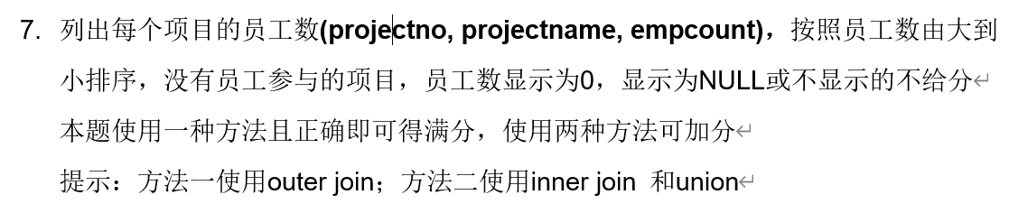

SELECT project.projectno,projectname,count(empno)as empcount

FROM workson RIGHT OUTER JOIN project on workson.projectno=project.projectno

GROUP BY project.projectno

ORDER BY empcount desc

(

SELECT projectno,projectname,count(empno) as 'empcount'

FROM workson natural join project

GROUP BY projectno

ORDER BY empcount DESC)

union

(

SELECT projectno,projectname,0 as 'empcount'

FROM project

WHERE projectno not in(

SELECT projectno

FROM workson natural join project

GROUP BY projectno

HAVING count(empno)>0

)

)

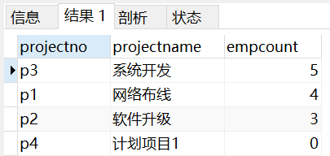

select project.proid,projectname,count(distinct empid) as empcount from employee natural join workson natural join project group by project.proid union select project.proid,projectname,0 as empcount from project where proid not in (select proid from workson) order by empcount desc;

select project.proid,projectname,count(distinct empid) as empcount from project left outer join workson on project.proid=workson.proid group by proid order by empcount desc;



SELECT projectid,empid

FROM workson w1 natural join employee

WHERE w1.enterdate<=ALL(

SELECT enterdate

FROM workson w2

WHERE w1.proid=w2.proid

)

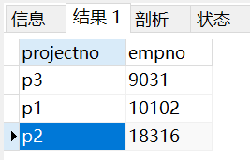



SELECT projectno,budget

FROM project

WHERE budget>(

SELECT AVG(budget)

FROM project)

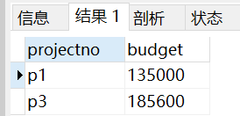

1. 找出除财务部外 所有部门都参与了的项目

select project.proid,projectname from project natural join department natural join workson natural join employee group by proid having count(distinct depid)>=(select count(\*)-1 from department) and proid not in(select proid from project natural join workson natural join employee natural join department where depname='财务部');