

SELECT empno,empname

FROM employee

WHERE empno in(

SELECT empno

FROM workson natural join project

WHERE projectname='网络布线'

)

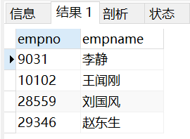



select employee.empid,empname from employee natural join workson group by empid having count(distinct proid)=1;

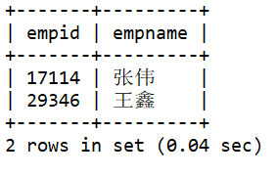



SELECT proid,projectname,count(\*) as '职员人数'

FROM(

SELECT \*

FROM workson NATURAL JOIN project

WHERE job='职员'

) as son1

GROUP BY proid

HAVING count(\*)>= ALL(

SELECT count(\*)

FROM(

SELECT \*

FROM workson NATURAL JOIN project

WHERE job='职员'

) as son2

GROUP BY projectno

);

select project.proid,projectname,count(\*) as '职员人数' from project natural join workson where job='职员' group by proid having count(\*)>=all(select count(\*) from workson where job='职员' group by proid);

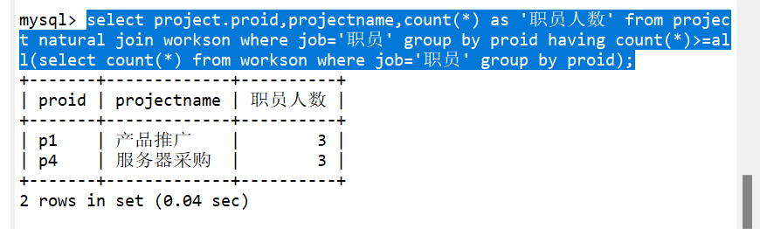



select location,count(\*) from employee natural join department group by depid;

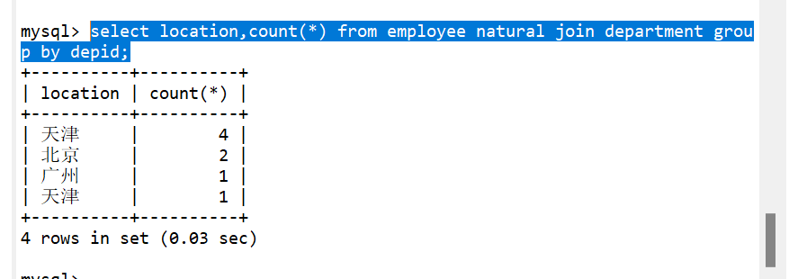



elect proid,budget\*0.1/count(\*) as bouns from project natural join workson group by workson.proid;

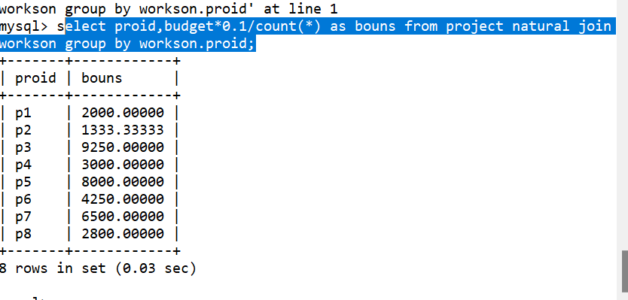



select employee.empid,empname from employee natural join workson natural join project where projectname='产品推广' and enterdate>='1998-01-01 00:00:00:00';

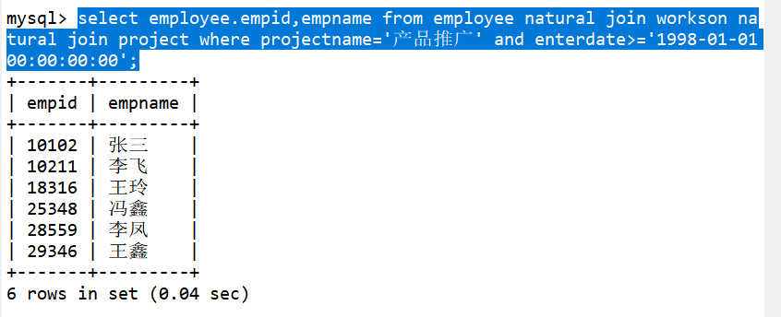



select project.proid,w1.empid,empname from workson w1 natural join project natural join employee where enterdate>=all(select enterdate from workson w2 where w2.proid=w1.proid);

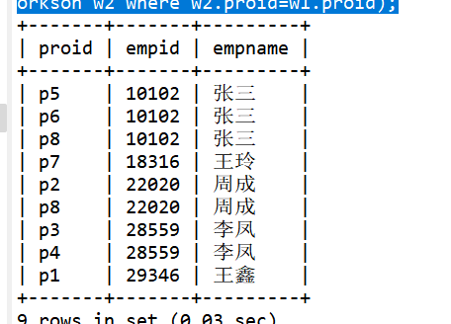



select department.depid,depname,count(distinct proid) from department left outer join employee on department.depid=employee.depid left outer join workson on workson.empid=employee.empid group by department.depid;

