

SELECT bookid as '图书编号',price as '价格'

FROM book

WHERE bookname='DB2数据库性能调整和优化'

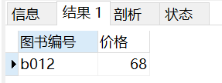



SELECT bookid,bookname,author,price

FROM book

WHERE catid='c1'

ORDER BY price DESC limit 2

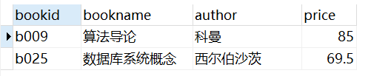



SELECT department as '学院',count(\*) as '人数'

FROM student natural join major

GROUP BY department

ORDER BY 人数 DESC limit 1





SELECT stuid,bookid,bookname,borrowdate

FROM borrow natural join book

WHERE borrowdate>= '2010-10-09 00:00:00' AND borrowdate<= '2010-10-13 23:59:59' AND bookname like '%数据库%'

ORDER BY borrowdate ASC

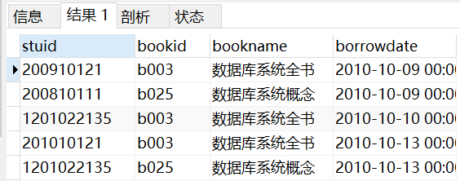



SELECT stuid,stuname,count(\*) AS 'borrownum'

FROM borrow natural join student

WHERE borrowdate>= '2010-10-10 00:00:00'

GROUP BY stuid

HAVING count(\*) >= all(

SELECT count(\*)

FROM borrow natural join student

WHERE borrowdate>= '2010-10-10 00:00:00'

GROUP BY stuid

)

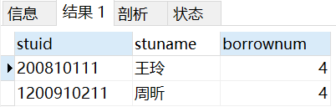



SELECT bookid,bookname,author

FROM book

WHERE bookid not in(

SELECT bookid

FROM borrow natural join student natural join major

WHERE degree='本科生' AND department='计算机与控制工程学院'

)

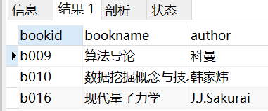



(SELECT majorid,majorname,count(\*) AS 'borrowcount'

FROM borrow NATURAL JOIN student NATURAL JOIN major NATURAL JOIN book NATURAL JOIN category

WHERE catid='c2'

GROUP BY majorid

)

UNION

(

SELECT distinct majorid,majorname,0 AS 'borrowcount'

FROM borrow NATURAL JOIN student NATURAL JOIN major NATURAL JOIN book NATURAL JOIN category

WHERE majorid NOT IN(

SELECT majorid

FROM(

SELECT majorid,majorname,count(\*) AS 'borrowcount'

FROM borrow NATURAL JOIN student NATURAL JOIN major NATURAL JOIN book NATURAL JOIN category

WHERE catid='c2'

GROUP BY majorid

) as son1

)

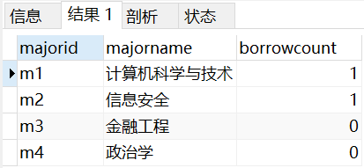



SELECT bookname,author

FROM book

WHERE bookid in(

SELECT bookid

FROM(

SELECT bookid,count(\*) as cnt

FROM borrow NATURAL JOIN student

WHERE degree='本科生'

GROUP BY bookid

) as son1

WHERE cnt=(

select count(distinct stuid)

FROM student

WHERE degree='本科生'

)

)

SELECT bookname,author

FROM book

WHERE not exists(

SELECT stuid FROM student WHERE degree='本科生' AND stuid not in(

SELECT stuid

FROM student natural join borrow

WHERE borrow.bookid=book.bookid

)

)





我没有写这个



SELECT catid,catname,count(\*) as 'borrowcount'

FROM borrow NATURAL JOIN book NATURAL JOIN category

WHERE stuid='200910121'

GROUP BY catid

HAVING count(\*) >= ALL(

SELECT count(\*) as 'borrowcount'

FROM borrow NATURAL JOIN book NATURAL JOIN category

WHERE stuid='200910121'

GROUP BY catid

)