“数据库系统原理”练习题

姓名 学号 专业

**Major**

**Book**

**Category**

**Student**

**Borrow**

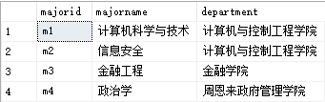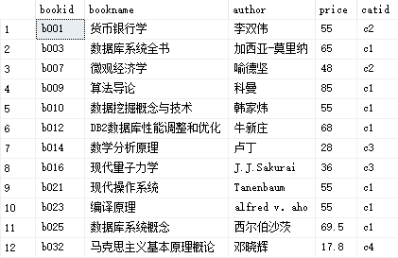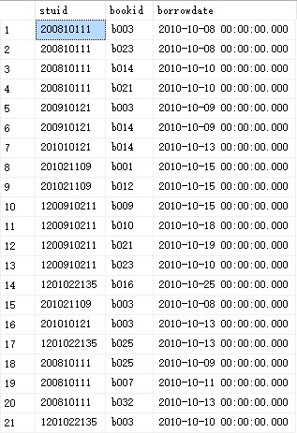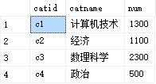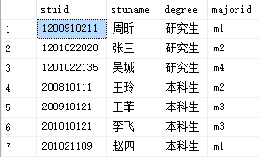

答案以Word文件的方式提交，文件名为“学号_姓名.docx”。每个题目的SQL语句都必须在查询分析器中调试，运行无误后提交查询的SQL语句（文字）和查询结果（截图），注意：查询结果集中的列名必须采用查询需求中给出的列名。

数据库模式如下：

图书类别（类别编号，类别名， 藏书数目）

图书（图书编号，书名，作者，价格，类别编号）

学生（学号，姓名， 学生类别）

借书情况（学号，图书编号，借书日期）

专业（专业编号，专业名称，学院名称）

注：上面数据仅供参考，具体的SQL语句不应该和具体的数据有关

1. 给出"DB2数据库性能调整和优化"这本书的图书编号和价格(图书编号,价格)

select bookid,price from book where bookname='DB2数据库性能调整和优化';

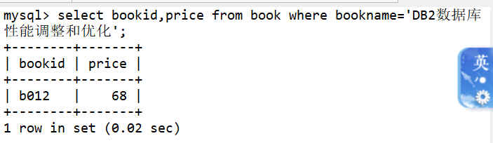

2、给出图书类别编号为"c1"且图书价格最贵的**两**本书(bookid,bookname,author,price)

select bookid,bookname,author,price from book order by price desc limit 2;

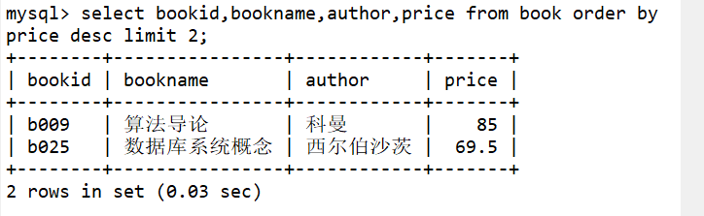

3、哪个学院的人数最多，共有多少人？（学院，人数）

select majorname,count(*) as number from major join student where major.majorid=student.majorid group by(major.majorid) having number>=max(number);

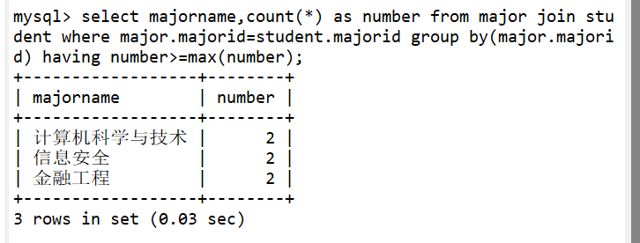

4、请列出在2010年10月9日和13日之间与数据库有关的图书（书名包含“数据库”的图书）的借阅信息，并且按照借书时间从小到大排列(stuid, bookid, bookname，borrowdate)

select borrow.stuid,borrow.bookid,book.bookname,borrowdate from borrow join book on borrow.bookid=book.bookid where borrowdate>='2010-10-9' and borrowdate<='2010-10-13' and book.bookname LIKE '%数据库%' order by borrowdate asc;

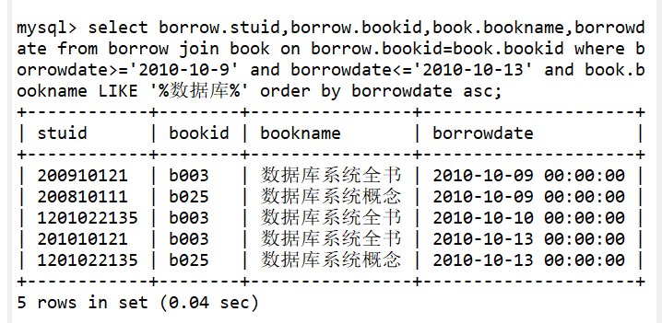

5、在2010-10-10以后（包括2010-10-10），谁借的书最多（stuid，stuname，borrownum）

select borrow.stuid,student.stuname,count(*) as borrownum from borrow join student on student.stuid=borrow.stuid group by (borrow.stuid) having borrow.stuid in (select stuid from borrow where borrowdate >='2010-10-10') order by borrownum desc limit 1;

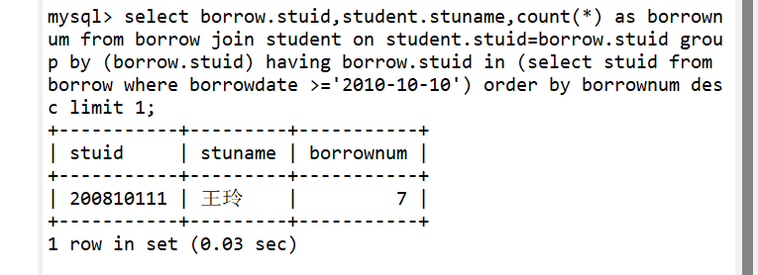

6、哪些书没有被“计算机与控制工程学院”的本科生借阅过（bookid，bookname，author）

select bookid,bookname,author from book where bookid not in (select book.bookid from book join borrow on book.bookid=borrow.bookid join student on borrow.stuid=student.stuid where student.majorid='m1' or student.majorid='m2');

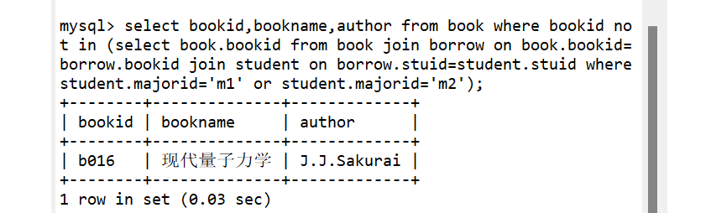

7、给出每个专业借阅的“c2”类的图书总数，没有借阅的次数显示为0（majorid，majorname，borrowcount）

select student.majorid,major.majorname,count(*) as borrowcount from borrow join student on borrow.stuid=student.stuid join major on major.majorid=student.majorid join book on borrow.bookid=book.bookid and book.catid='c2' group by major.majorid;

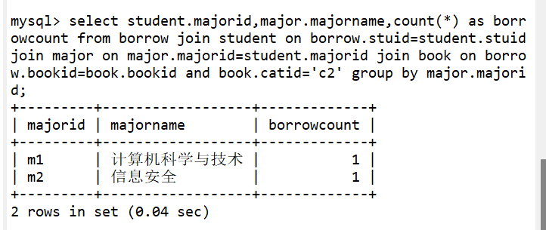

没有借阅的次数显示0没有实现 如果想实现 需要用left outer join或者用以下语句：

select student.majorid,major.majorname,count(*) as borrowcount from borrow join student on borrow.stuid=student.stuid join major on major.majorid=student.majorid join book on borrow.bookid=book.bookid and book.catid='c2' group by major.majorid union select student.majorid,major.majorname,0 as borrowcount from borrow join student on borrow.stuid=student.stuid join major on major.majorid=student.majorid join book on borrow.bookid=book.bookid where student.majorid not in ( select distinct student.majorid as borrowcount from borrow join student on borrow.stuid=student.stuid join major on major.majorid=student.majorid join book on borrow.bookid=book.bookid where book.catid='c2');

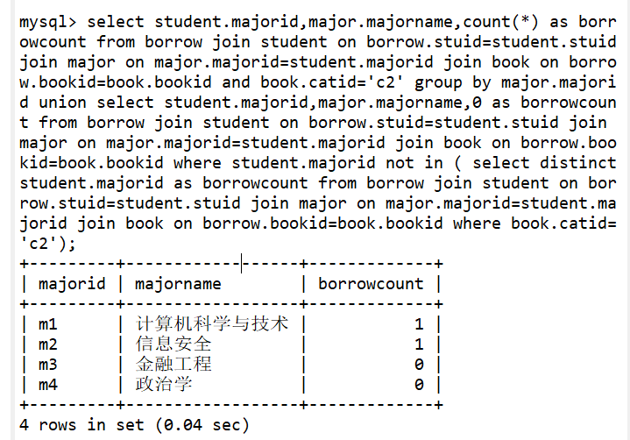

1. 给出被所有本科生都借阅过的图书(bookname,author)

select count(distinct borrow.stuid) as count,bookname,author from book join borrow on book.bookid=borrow.bookid join student on student.stuid=borrow.stuid where student.degree='本科生' group by book.bookid having count(distinct borrow.stuid)=(select count(*) from student where degree='本科生');

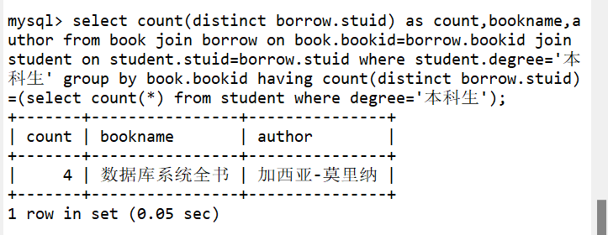

1. 已知每本图书最多可借阅30天，“计算机技术”类图书每超出一天需交费0.8元，其它类图书每超出一天需交费0.5元，假设王玲在2010-10-11后（包括2010-10-11）所借的书都未归还，问王玲在2010-11-20那天需向图书馆交纳多少钱？（从1月1号到1月2号视为借阅了1天）。（stuname, priceSum）

不会 查资料得到：

select student.stuname,student.stuid,sum(case when category.catname='计算机技术' then datediff('2010-11-20',borrow.borrowdate)*0.8 else datediff('2010-11-20',borrow.borrowdate)*0.5 end) as pricesum from student join borrow on student.stuid=borrow.stuid join book on borrow.bookid=book.bookid join category on book.catid=category.catid where student.stuname='王玲' group by student.stuname;

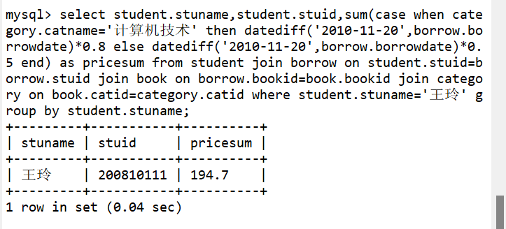

1. 给出被学号为'200910121'的学生借阅次数最多的图书类别（catid, catname, borrowcount）

select book.catid,catname,count(*) as borrowcount from book join category on book.catid=category.catid join borrow on borrow.bookid=book.bookid where borrow.stuid='200910121' group by book.catid having borrowcount>=all(select count(*) from borrow join book on book.bookid=borrow.bookid where stuid='200910121' group by book.catid);

