select b_number,b_type from bank_card;

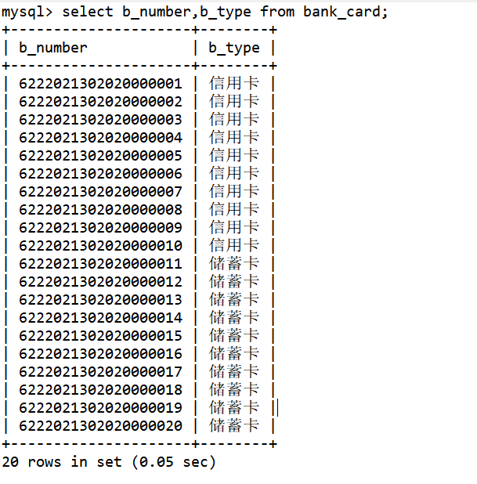

select * from property where pro_status = '可用';

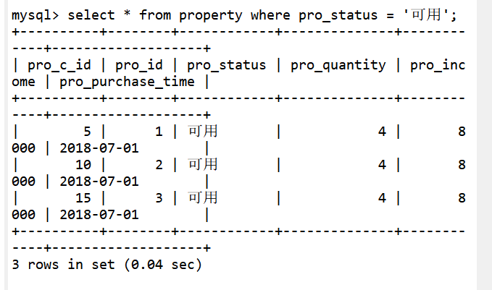

select count(c_id) from client;

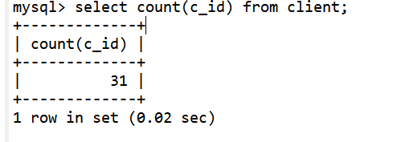

select b_type,count(*) as count from bank_card group by b_type;

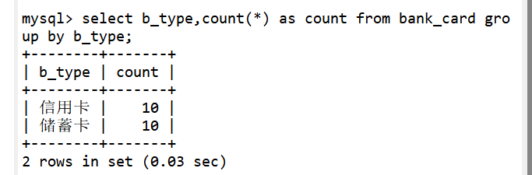

select avg(i_amount) from insurance;

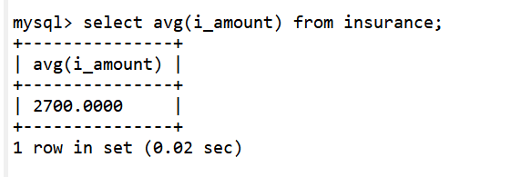

select i_name,i_amount from insurance where i_amount>=all(select i_amount from insurance) or i_amount <=all(select i_amount from insurance);

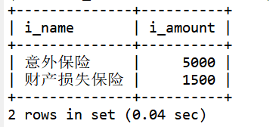

select c_id,c_name,c_id_card from client join bank_card on bank_card.b_c_id=client.c_id group by c_id;

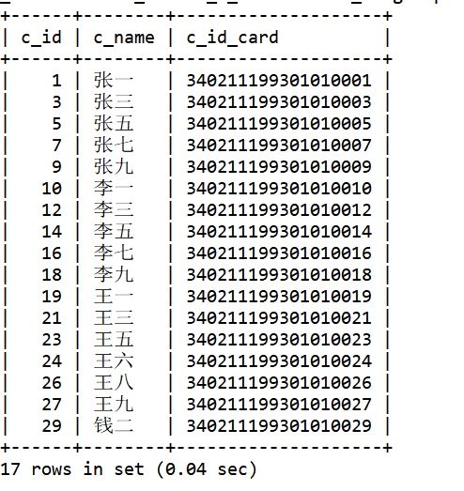

select c_id,c_name,c_id_card from client where c_id not in( select b_c_id from bank_card where b_number LIKE '622202130202000001_');

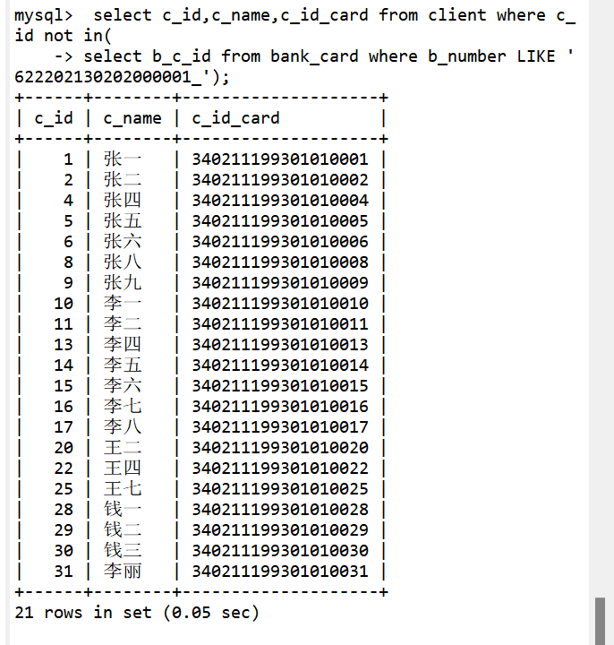

select i_name,i_amount,i_person from insurance where i_amount>=(select avg(i_amount) from insurance);



select i_name,i_amount,i_person from insurance where i_id>2 order by i_amount desc;

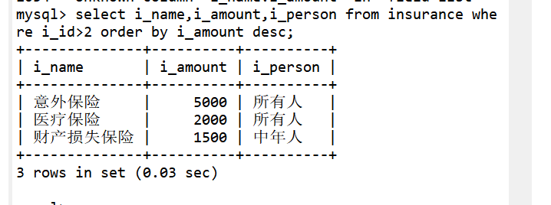

select p_year,count(*) as insurance_information from finances_product group by p_year;

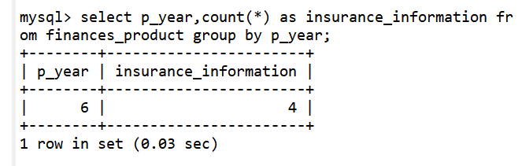

select i_person,count(*) from insurance group by i_id having count(i_amount)=2;

