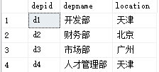 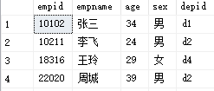

Department Employee

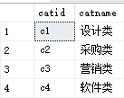 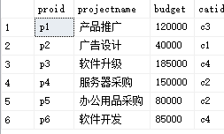 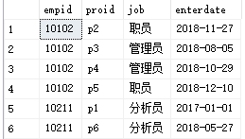

Category Project Workson

数据库模式如下（分别为Department，Employee，Category，Project，Workson）：

部门（部门号，部门名称，位置）

员工（员工号，姓名，年龄，性别，所在部门号）

项目种类（项目种类号，项目种类名）

项目（项目号，项目名称，预算，项目种类号）

员工工作情况（员工号，项目号，职责，开始日期）

注：上面数据仅供参考，具体的SQL语句不应该和具体的数据有关。

1. 给出职工中所有男性的所有信息（empid,empname,age,sex,edpid）

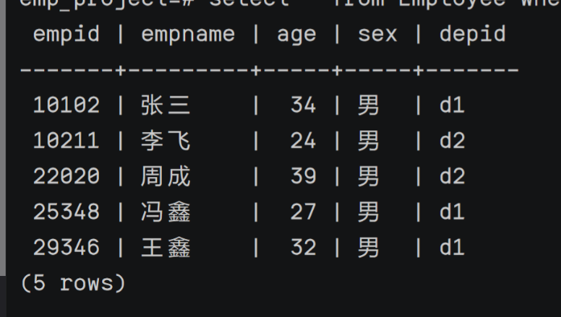

select \* from employee where sex='男';

2. 统计“李”性职工信息，按年龄降序排序。（empid,empname,age,location）

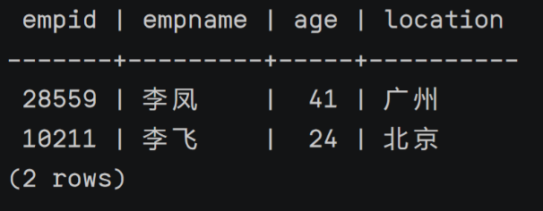

select empid,empname,age,location from employee natural join department where empname LIKE '李%' order by age desc;

3. 给出每位职员参与项目的最高预算和最低预算（empname，highestbudget，lowestbudget）

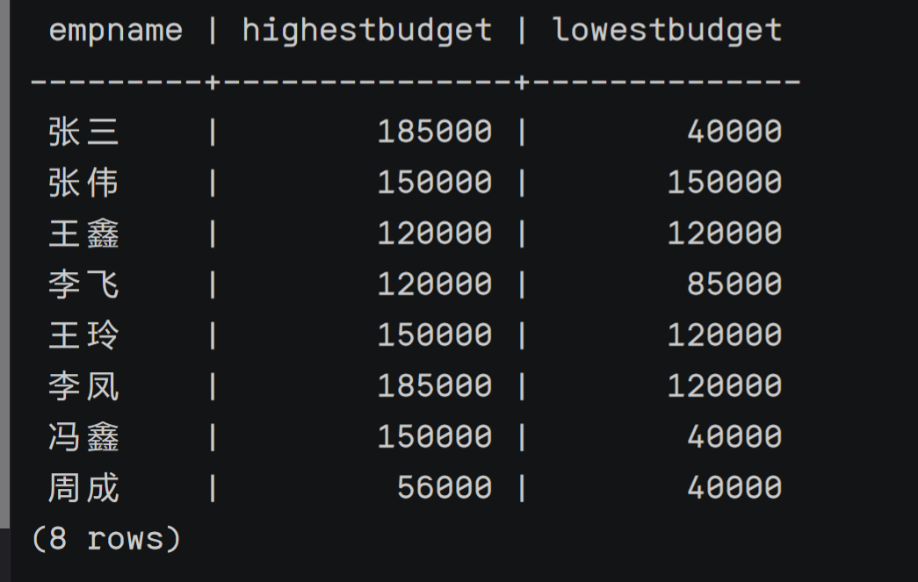

select empname,max(budget) as highestbudget,min(budget) as lowestbudget from project natural join workson natural join employee group by empname;

4. 给出所有项目超过一个的员工的id和参加的项目个数（empid, num）

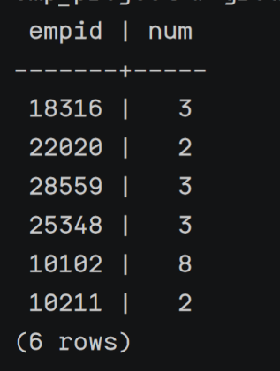

select employee.empid,count(distinct proid) as num from workson natural join employee group by empid having num>1;

5. 给出项目种类号为“c2”且预算最多的项目。（proid，projectname，budget）

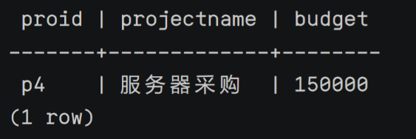

select project.proid,projectname,budget from project where project.catid='c2' and budget>=all(select budget from project where catid='c2');

6. 给出参加“产品推广”项目，但不担任职位的员工的信息，（empid,empname，age,sex.depid）

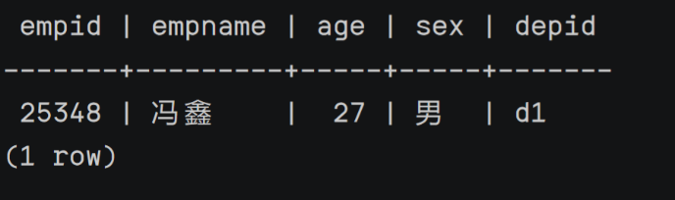

select job,project.proid,employee.empid,empname,age,sex,depid from employee join workson on employee.empid=workson.empid join project on project.proid=workson.proid where projectname='产品推广' and job is null;

7. 给出工号为“10102”的员工每类项目的参加总数，若没有参加过某类项目，则参加项目总数显示为0（catid，proNum）

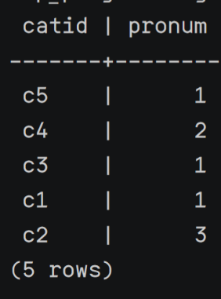

select project.catid,count(catid) as pronum from employee left outer join workson on employee.empid=workson.empid and employee.empid='10102' left outer join project on project.proid=workson.proid where catid is not null group by catid;

8. 给出没有参与“软件类”项目女性职工的信息（empid,empname, age,sex,depid)

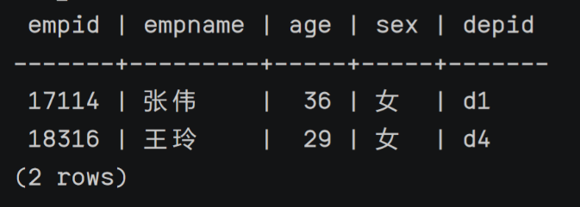

select distinct employee.empid,empname, age,sex,depid from employee natural join workson natural join project where employee.empid not in(select empid from workson natural join project natural join category where catname='软件类') and sex='女';

9. 给出有30岁以上男性员工的地点名称和该地男员工最大年龄，结果按最大年龄升序排序

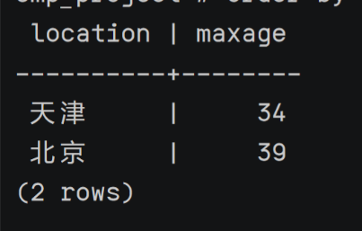

select location,max(age) as maxage from department natural join employee where location in (select location from department natural join employee where age>30 and sex='男') and sex='男' group by department.location order by maxage asc;

10. 给出在广州工作的、参加“'产品推广'”项目的职员id、姓名及他们参加的项目个数（empid, empname, procnt）

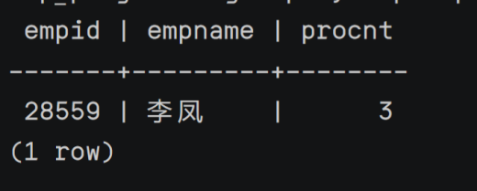

select employee.empid,empname,count(distinct proid) as procnt from employee natural join department natural join workson natural join project natual join category where employee.empid in(select employee.empid from employee natural join workson natural join department natural join project where location='广州' and projectname='产品推广' )group by empid;