Appendix The Nonlinear Effect between Race/Poverty and Grant Volume
To explain the unexpected relationship between the proportion of nonwhite or poor residents in the nonprofits’ zip code and the size of the grant received by recipients, we ran additional models that included the squared term for the proportion of nonwhite residents and poverty rates in recipient zip codes.
We identified a nonlinear relationship between the poverty rate in recipients’ communities and the size of grants received. Our results confirm an inverted U-shaped relationship between poverty rates and grant size. As shown in Table A1, the coefficient for the poverty rate is positive and significant, while the coefficient for the squared term is negative and significant in Model (2). This indicates that as poverty rates increase, grant size initially increases, but this positive effect diminishes and eventually reverses.
Table A1: The Hierarchical Linear Modeling (HLM) of place-based class stigma_nonlinear effect: Amount of grants received by recipients
Dependent Variables | $ grant received by recipients
 | (1) | (2)
Level 1 recipient variables
Poverty rate (Rec) (proportion) | 0.259** | 0.605**
 | (0.022) | (0.051)
Squared_Poverty rate (Rec) (proportion) |  | -0.568**
 |  | (0.076)
Nonwhite population (Rec) (proportion) | 0.005 | -0.020
 | (0.015) | (0.015)
Total population (Rec) (log) | -0.015** | -0.019**
 | (0.002) | (0.002)
Assets (Rec) (log) | 0.041** | 0.041**
 | (0.002) | (0.002)
Age (Rec) (log) | -0.066** | -0.067**
 | (0.003) | (0.003)
Program service revenue (Rec) (log) | -0.004** | -0.004**
 | (0.0004) | (0.0004)
Total revenue (Rec) (log) | 0.041** | 0.042**
 | (0.002) | (0.002)
Field of activity (Rec) (1=human services) | -0.025** | -0.025**
 | (0.005) | (0.005)
Level 2 grant maker variables
Population above poverty level (GM) (proportion) | 0.184* | 0.195*
 | (0.088) | (0.088)
Nonwhite population (GM) (proportion) | -0.146* | -0.135*
 | (0.064) | (0.064)
Total population (GM) (log) | -0.022* | -0.021*
 | (0.010) | (0.010)
Assets (GM) (log) | -0.042** | -0.042**
 | (0.010) | (0.010)
Age (GM) (log) | -0.021 | -0.022
 | (0.022) | (0.022)
Total amount of grants (GM) (log) | 0.184** | 0.184**
 | (0.009) | (0.009)
Grants from DAFs (GM) (log) | -0.010** | -0.010**
 | (0.002) | (0.002)
Region (GM) (1=South) | 0.017 | 0.016
 | (0.028) | (0.027)
Level 1 X Level 2 (cross-level)
Co-location of GM & Rec | 0.369** | 0.368**
 | (0.005) | (0.005)
Interactions
Above poverty (GM) * Poverty rate (Rec)
Above poverty (GM) * Co-location
Poverty rate (Rec) * Co-location
Above poverty (GM) * Poverty rate (Rec) * Co-location
Constant | -24.615** | -24.553**
 | (3.528) | (3.527)
Observations | 232,517 | 232,517
Conditional R² | 0.140 | 0.140
Log Likelihood | -340,799.600 | -340,773.200
Akaike Inf. Crit. | 681,641.200 | 681,590.400
Bayesian Inf. Crit. | 681,858.600 | 681,818.200
Note: Unstandardized coefficients in the table; Standard deviation in the parentheses.
Years have been controlled for in this analysis.
GM = grant maker; Rec = recipient.
Independent variables are bolded in the table.

*p<0.05; **p<0.01

To visualize this nonlinear relationship, Figure A1 plots the predicted grant size against varying poverty rates while holding other variables at their means. The inverted U-shaped curve illustrates how grant size increases with poverty rates up to the approximately 50% threshold, after which additional increases in poverty are associated with decreasing grant sizes.
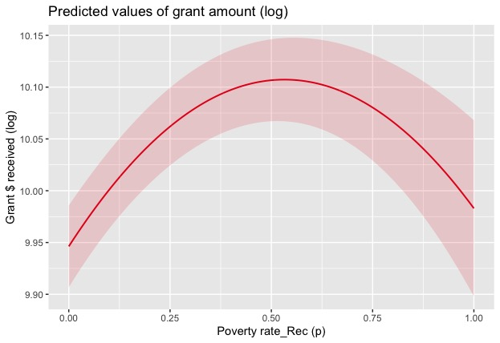
Figure A1: Predicted values of amount of grant to proportion above poverty level in the grant maker’s zip code

In contrast, our analysis found no evidence of a nonlinear relationship between the proportion of nonwhite residents and grant size (as shown in Table A2). The squared term for the proportion of nonwhite residents was not statistically significant, confirming that this relationship remains linear throughout the observed range.
Table A2: The Hierarchical Linear Modeling (HLM) of place-based race stigma_nonlinear effect: Amount of grants received by recipients
Dependent Variables | $ grant received by recipients
 | (1) | (2)
Level 1 recipient variables
Nonwhite population (Rec) (proportion) | 0.005 | 0.016
 | (0.015) | (0.041)
Squared_Nonwhite population (Rec) (proportion) |  | -0.014
 |  | (0.046)
Poverty rate (Rec) (proportion) | 0.259** | 0.258**
 | (0.023) | (0.023)
Total population (Rec) (log) | -0.015** | -0.015**
 | (0.002) | (0.002)
Assets (Rec) (log) | 0.041** | 0.041**
 | (0.002) | (0.002)
Age (Rec) (log) | -0.066** | -0.066**
 | (0.003) | (0.003)
Program service revenue (Rec) (log) | -0.004** | -0.004**
 | (0.0004) | (0.0004)
Total revenue (Rec) (log) | 0.041** | 0.041**
 | (0.002) | (0.002)
Field of activity (Rec) (1=human services) | -0.025** | -0.025**
 | (0.005) | (0.005)
Level 2 grant maker variables
White population (GM) (proportion) | 0.146* | 0.147*
 | (0.064) | (0.064)
Population below poverty level (GM) (proportion) | 0.184* | 0.184*
 | (0.088) | (0.088)
Total population (GM) (log) | -0.022* | -0.022*
 | (0.010) | (0.010)
Assets (GM) (log) | -0.042** | -0.042**
 | (0.010) | (0.010)
Age (GM) (log) | -0.021 | -0.021
 | (0.022) | (0.022)
Total amount of grants (GM) (log) | 0.184** | 0.184**
 | (0.009) | (0.009)
Grants from DAFs (GM) (log) | -0.010** | -0.010**
 | (0.002) | (0.002)
Region (GM) (1=South) | 0.017 | 0.017
 | (0.028) | (0.028)
Level 1 X Level 2 (cross-level)
Co-location of GM & Rec | 0.369** | 0.369**
 | (0.005) | (0.005)
Interactions
White population (GM) * Nonwhite population (Rec)
White population (GM) * Co-location
Nonwhite population (Rec) * Co-location
White population (GM) * Nonwhite population (Rec) * Co-location
Constant | -24.577** | -24.517**
 | (3.525) | (3.525)
Observations | 232,517 | 232,517
Conditional R² | 0.140 | 0.141
Log Likelihood | -340,799.600 | -340,801.700
Akaike Inf. Crit. | 681,641.200 | 681,647.400
Bayesian Inf. Crit. | 681,858.600 | 681,875.200
Note: Unstandardized coefficients in the table; Standard deviation in the parentheses.
Years have been controlled for in this analysis.
GM = grant maker; Rec = recipient.
Independent variables are bolded in the table.

*p<0.05; **p<0.01

