House Price Prediction from Exterior Images with a ResNet Ensemble
Mingyang Sun (1657392) and Yikai Qian (1722421)
COMP90086 Computer Vision, Semester 2, 2026
Abstract
We perform the task of house price prediction from single exterior images via transfer learning. With a fixed 7000/1000 training-validation split, we compare frozen features of ResNet-50, regression heads, input image size, partial fine-tuning and augmentation. The chosen submission_ensemble consists of three fine-tuned ResNet-50 models. The exported validation predictions have an MSE of 95852.00 and MAE of 226.42 in USD 1000 for prices. Kaggle reported MSE is 96958.98 which is 15.06% less than the frozen features Ridge. Interestingly, 53.14% of the squared error comes from the top 10% of validation houses and the ensemble results in increasing MSE of this group although the overall MSE is better. We explore why the improvements are not balanced for the groups and confound in the experiment, as well as reuse of validation data, and report controlled improvements without blaming the unexplained error.
Keywords—house price prediction, transfer learning, ResNet-50, regression, ensemble, error analysis

I. Introduction
An image of the exterior may provide information about the style of the building, its visible size, and state, yet the price also depends on some information that cannot be extracted from the image. Hence, the task of the course project is to evaluate the pros and cons of visual price prediction without fully estimating the value of the property. We consider only the provided subset of images of Southern California listings and allowed labels.
We employ an ImageNet pre-trained ResNet-50 [1], where the residual shortcuts help to learn corrections to identity mappings, thus enabling optimisation of deep features. Transfer learning [2] provides a good initial representation in case of limited labelled data for the task; the effectiveness of the transferred features depends on their specificity and task distance. We evaluate the impact of improved readouts, more pixels, final residual module adaptation, and augmentation on top of frozen features. Our contribution is a practical submission of three models along with a replicable quantitative evaluation of when the total gain of our submission succeeds and does not.

II. Data and Evaluation Protocol
The dataset [4] has 8000 labeled observations and 3000 test IDs. The task is to classify the exterior images of real-estate listings of Southern California from 2019. The prices of labeled observations vary from 195 to 2000 with mean of 720.65 and median of 639.90. Prices are given in USD 1,000, therefore, 700 corresponds to USD 700,000. Mean is greater than median and the distribution has a wide upper tail, hence, the analysis of prices is important.
We use the 7000/1000 split with price decile stratification and seed 42. Stratification is to ensure that the distribution of prices is represented; however, it does not guarantee visual and geographical diversity. Training and validation scores are 720.98 and 718.32 respectively. The metadata validation includes checking for unique IDs, disjoint partitions and matching validation labels and prediction export. This does not guarantee there are no duplicate images or multiple properties with different IDs.
Scaling of features, target statistics and clipping bounds are learned on the training partition. Validation is used to select the configurations and checkpoints, and test labels are not available and not used.
MSE = (1/N) Σᵢ (ŷᵢ − yᵢ)²
Furthermore, we provide MAE, RMSE, R² and signed residuals e = ŷ − y. The units of MSE are (USD 1000)² while the units of MAE, RMSE and bias are USD 1000. The comparison is conducted using the same validation IDs saved, with imageid instead of row number. The trained models keep the 7000-row training split and do not refit on all 8000 labels in the submitted results.

III. Method and Design Choices

Frozen Feature Baselines
B0: Training mean is predicted by B0. B1 removes the ImageNet classifier of ResNet-50 and performs global average pooling (GAP) [3] to generate a 2048-dimensional feature. The features are standardised on the training set and then Ridge regression is fitted. RidgeCV chooses from 25 logarithmic penalties from 10⁻² to 10⁴ on the training split only. Regularisation gives a cheap indication of whether the learned visual features are useful for price prediction or not.
B2: Features are used with 256 units ReLU layer, dropout of 0.2 and linear output. Adam with 10⁻³, batch size of 64, capped at 200 epochs and with early stopping on validation with patience of 15 is used; 19 epochs is run in the recorded experiment. The worse performance indicates that this specific non-linear readout is not good, rather than indicating that price is linear in the features.

B. Partial Fine Tuning
All the components have ResNet-50 with GAP, then Dropout(0.2), Dense(256, ReLU) and Dense(1). The last residual block (conv5) and head are trained while other blocks are frozen. Thus, the later features are adapted while earlier features are kept. Still, there are 15.50 million out of 24.11 million parameters that are trainable, hence, there is still a concern of having insufficient data and overfitting. The backbone is called in inference mode to keep the BatchNorm statistics running while the weights selected are trainable.
Adam with learning rate of 10⁻⁴ and batch size of 32 is used. The published code has capped the number of epochs to 15 and tracks the validation loss and restores the best checkpoint. 15 epochs were executed and best epochs 12/14 according to the logs of original E2/E4. Both of these logs do not show the patience value although currently the default patience is 4. Best epoch for E3 according to the experiment log is 10.
These can be used to describe the training without using the current defaults to indicate all the past values.
z = (y − μ)/σ, pₘ = clip(σẑₘ + μ, 195, 2000)
Original-unit MSE prior to clipping is σ² × standardised-target MSE, and this maintains the competition objective to a constant factor, unlike log-price training. Clipping is a range prior based on the training data, and it does not necessarily aid in cases where the actual prices go outside of this range.

C. Resolution and Augmentation
The image is decoded in RGB, then square resized, and processed by ResNet (RGB-to-BGR and channel-mean). E2 has 224 × 224 as input size, E3 has 320 × 320, and E4 has 224 × 224 with augmentation. Larger resolution allows retaining more small-scale information; however, square resizing can affect the geometry. GAP restricts the descriptor size and is sensitive to the location of features, yet it does not explicitly provide translation invariance of the whole network.
For E4, horizontal flip, translation 0.1, zoom 0.1, and brightness and contrast 0.15 are performed before backbone processing. Such augmentation helps to make the model more robust to framing and lighting conditions with the approximate label preservation. It can also change the useful information. The augmentation is only used during training. For validation and test inference, the policy is deterministic. There is no test-time augmentation.

D. Final Ensemble
The chosen submission_ensemble is the equal mean of E2, E3 and E4. Each component prediction after inverse transform and clipping is exported with one decimal digit:
ŷ = R₀.₁((R₀.₁(p₂) + R₀.₁(p₃) + R₀.₁(p₄))/3)
In this case, R₀.₁ is rounded to one decimal. Three runs provide partially different predictions due to different resolution and augmentation. Same weights do not prevent selection of a subset based on validation. Average does not necessarily lead to better results than the best component or in all price groups. Additionally, three model evaluations are needed, the latency of which was not measured.

IV. Experiments and Results

A. Experimental Progression
Table I shows baseline, frozen sweep and final family. B0 and E2-E5 are calculated from committed predictions/labels. All other rows are historical runs as their validation predictions are not stored in the repository. All have the same split; they are single-seed runs.
TABLE I. VALIDATION COMPARISON IN ORIGINAL PRICE UNITS
Configuration | MSE ↓ | MAE ↓ | R² ↑
B0 Mean | 154,431.7 | 295.9 | ≈0
B1 Ridge 224* | 114,853.7 | 249.0 | 0.256
B2 MLP 224* | 133,378.6 | 270.8 | 0.136
E1 Ridge 320* | 111,822.5 | 246.2 | 0.276
E1 Ridge 400* | 112,219.7 | 242.0 | 0.273
E1 MLP 320* | 133,046.0 | 267.4 | 0.138
E1 MLP 400* | 126,795.1 | 265.8 | 0.179
E2 Fine tune 224 | 102,746.2 | 235.7 | 0.335
E3 Fine tune 320 | 99,051.2 | 229.8 | 0.359
E4 Augmented 224 | 108,784.2 | 246.3 | 0.296
E5 Ensemble | 95,852.0 | 226.4 | 0.379
* Historical reported metrics. Other rows are recalculated; component predictions are already rounded. E5 uses the final one-decimal convention. MSE: (USD 1,000)²; MAE: USD 1,000.
Ridge is better than frozen MLP. At 320 pixels, Ridge is better by 2.64% in E1; at 400 pixels, it has lower MAE, but higher MSE. Therefore, the best resolution varies by metric and head. E2 has 10.54% better MSE than B1, however, it also uses different regression head and optimisation: this is not an ablation of unfreezing only. E3 is 3.60% better than E2, indicating some benefit from resolution after training.
E4 is worse than E2 by 5.88% even though it has later best epoch. This indicates a negative outcome for the augmentation policy combination within the budget as recorded. The augmented and non-augmented training loss represents different input distributions, hence cannot be used to indicate slower learning and later better performance with more training. Effects of individual augmentations and variation of seed are not evaluated.

B. Selection and Supplementary Trials
E5 has 16.54% less validation MSE than historical B1 and 3.23% less than E3. MSE of 95,850.62 is obtained for the mean of the components before final rounding; exported ensemble has MSE of 95,852.00. This difference accounts for 95,850.6 value and it is not a new model. Exported ensemble also has RMSE of 309.60, R² of 0.3793 and signed bias of +6.91.
Additional ConvNeXt experiments with different backbone and aspect ratio preserving resize are mentioned in the repository. Values for V3 columns can be quantified; however, it is not confirmed that they correspond to the same checkpoints. They have MSE of 110,013.04 at 224 pixels and 109,155.39 at 320. Four-way equal average of E2, E3, E4 and V3-320 is approximately 95,538.9 before final rounding, which is a 0.33% improvement. We choose the three model submission as the small improvement is not supported by repeat run and needs a new model. Thus, E5 is chosen as the core solution, not the minimum value over all evaluated options. V2 has varied parameters and does not have the same run evidence archived; hence, it is not possible to evaluate the effect of backbone.
Kaggle MSE recorded is 96,958.98 compared to 114,147.16 for B1 and 101,594.15 for E3, with 15.06% and 4.56% improvement respectively. These are historical Kaggle results and not calculated from test labels. Kaggle error for E5 is higher by approximately 1.16% than its validation error. CSV file has 3000 finite predictions with imageid and price columns and the values are exactly the rounded mean of three test exports stored.

V. Error Analysis and Critical Discussion

A. Successes and Failures Across Prices
As shown in Figure 1, E5 has a narrower prediction range than indicated by the labels; however, its average bias is small due to the presence of counteracting biases. The 30% lowest prices are, on average, predicted higher by 222.03, while the highest decile is predicted lower by 648.48. The highest decile accounts for 53.14% of the total squared error (Table II). Decile thresholds are based on validation prices quantiles with ties in prices aggregated, hence the number of counts does not have to be 100.
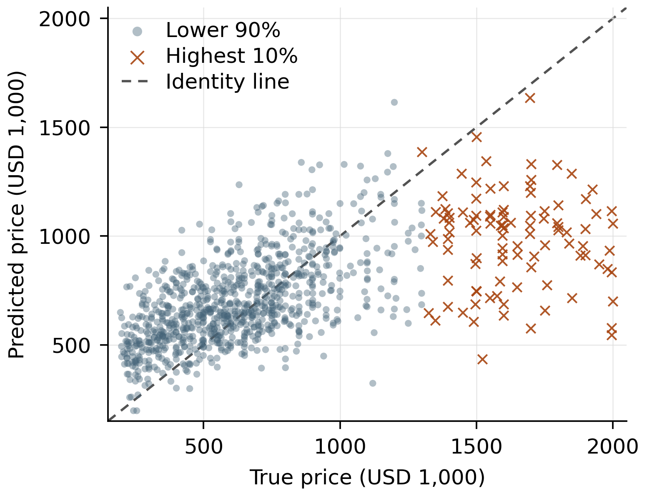
Fig. 1. E5 predictions for all 1,000 validation images. The dashed identity line denotes perfect prediction; orange marks the highest-price decile. Both axes use USD 1,000.
TABLE II. E5 ERRORS BY TRUE PRICE GROUP
Price group | n | MAE | Bias | SSE %
Lowest 30% | 300 | 227.86 | +222.03 | 21.19
Middle 50% | 500 | 139.21 | +46.27 | 16.81
Ninth decile | 100 | 234.39 | −179.81 | 8.86
Highest 10% | 100 | 650.21 | −648.48 | 53.14
Bias = predicted minus true price. SSE % is the share of total squared error. Group boundaries are approximately 480, 941 and 1,300 (USD 1,000).
The 50% central decile has MAE of 139.21 and MSE reduced by 20.73% compared to E3. However, MSE of the highest decile increases from 488,255.36 to 509,349.70 (increase of 4.32%). E5 has reduced absolute error for 515 images and increased absolute error for 485 images; median absolute error also slightly increased from 170.15 to 173.60. Hence, the overall improvement is beneficial but not uniform.
Deterministic examples of close prediction are 751.jpg (true value 759.0, predicted value 758.2), largest overprediction is 3947.jpg (true value 420.0, predicted value 1,026.7), and largest underprediction is 1977.jpg (true value 1,995.0, predicted value 545.9). These examples provide information about the amount of error, but not how often it occurs in general cases. They do not indicate visually why such errors occurred without looking at the pictures.

B. What the Evidence Can Explain
The residual correlation obtained from the new calculation is 0.925 for E2/E3, 0.888 for E2/E4 and 0.860 for E3/E4. The runs are somewhat different but highly correlated, hence they do not provide independent errors. The high correlation can be explained by partially complementary predictions and large common errors. Conditional mean is the best predictor under the expected squared loss, however, the central tendency of price does not indicate lack of information, skew of the target, limitations of representation or choice of fit as the only reason for it.
E3’s historical training and validation losses of 0.0684 and 0.6309 at the best epoch indicate that there is a gap in generalisation. It is not an ensemble training curve or inference mode tested on both splits simultaneously. Moreover, same validation set is used during multiple checkpoint, configuration and subset selection. A new descriptive paired bootstrap for fixed E3/E5 predictions (10,000 resamples, seed = 42) provides a 95% percentile range of −278 to 6,729 for E3 MSE − E5 MSE. This range contains zero and does not take into account selection reuse, training differences and dependence on the property. Hence, the improvement does not indicate statistical significance.

C. Limitations and Future Improvements
In addition, assess stability on different seeds and different held-out splits, grouped by property/region if grouping metadata is available. Then assess augmentation parts and compare schedules with given compute budget. Compare square resizing and aspect-ratio preserved input at same effective resolution and spatial pooling preserving useful layout. Lastly, assess given cost-aware sampling/loss strategy and provide both overall MSE and tail errors. Log-target/robust losses alter the optimisation function and thus need to be evaluated in original price units.
While source, split ID and predictions stored can be used for numeric verification, they are not sufficient to re-create the trained models. Original E2/E4 checkpoints’ hash and metadata have been saved, but checkpoint to prediction execution was not verified by checking the archive. To fully re-create the run, original model/normalisation artifacts, resolved dependencies and inference checks are required. In our case, we have used general ImageNet pretrained models, without task pretrained models, source dataset metadata or pretrained MLLMs. The uncertainty in our case is about generalisation and completeness of the run, rather than the calculations in the resulting CSV.

VI. Conclusion and Contributions
The chosen ResNet model improves upon the frozen features baseline and the best core individual model, but the main drawback of it is that it has expensive tail. The usefulness of it is justified by the obtained aggregate improvement. More claims regarding causal improvement and reliable dominance would require further controlled assessments. Mingyang Sun was responsible for data, metadata, augmentation, model comparison and ensemble error verification. Yikai Qian was responsible for model implementation/training, providing original artifacts and Phase 4 executed. The report combines these different aspects and the phase plan as revised based on the feedback.

References
[1] K. He, X. Zhang, S. Ren, and J. Sun, “Deep residual learning for image recognition,” in Proc. IEEE Conf. Computer Vision and Pattern Recognition (CVPR), 2016, pp. 770–778.
[2] J. Yosinski, J. Clune, Y. Bengio, and H. Lipson, “How transferable are features in deep neural networks?” in Advances in Neural Information Processing Systems (NeurIPS), 2014, pp. 3320–3328.
[3] M. Lin, Q. Chen, and S. Yan, “Network in network,” in Proc. Int. Conf. Learning Representations (ICLR), 2014.
[4] T. Dogan, “House Prices and Images -- SoCal,” Kaggle, 2019. [Online]. Available: https://www.kaggle.com/datasets/ted8080/house-prices-and-images-socal

