HW1-Design and Engineering of Intelligent
Information System

Mingyang Song
AndrewID: mingyans

Task 3 Report
The file architect is as follows:
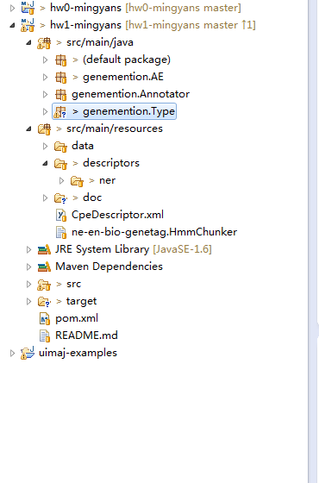
In class folder, Default package is a SimpleRunCPE; Genemention.AE package has all the AnalysisEngine annotators including SentenceAE, GeneTagAE, and PosTagAE(with class PosTagNamedEntityRecognizer) which is an example from class and is not used in the final program. Genemention.Annotator is where Collection and Consumer classes are. Genemention.Type is all TypeSystems generated by typesystem descriptor "GeneMentionType.xml".
In resources folder, all data files are in data folder. All descriptors are in descriptors/ner folder including annotator descriptors and typesystem descriptor. CpeDescriptor.xml is the configuration file for SimpleRunCPE(added in as args 0). Ne-en-bio-geneta.HmmChunker is the Lingpipe Model used in AE.
In conlusion,
1 Simple CPE
3 Analysis Engines (1 as the example)
2 Annotator(Collection and Consumer)
2 Type System
7 Descriptors(1 as the example)
1 CpeDescriptor
3 data txt
1 Lingpipe HMM model txt

My data flow is as follows:
Input File "hw1.in"-->
FileCollection(-->Scanner into Sentence-->CAS)-->
ModelAE(Aggregate)-->
{SentenceAE(-->ID/text into TypeSystem "GeneDoc")-->
GeneTagAE(-->ID/tag into TypeSystem "GeneSentence")}-->
AnnotationConsumer-->
Output File "hw1.mingyans.out"

My system architect design is as follows:
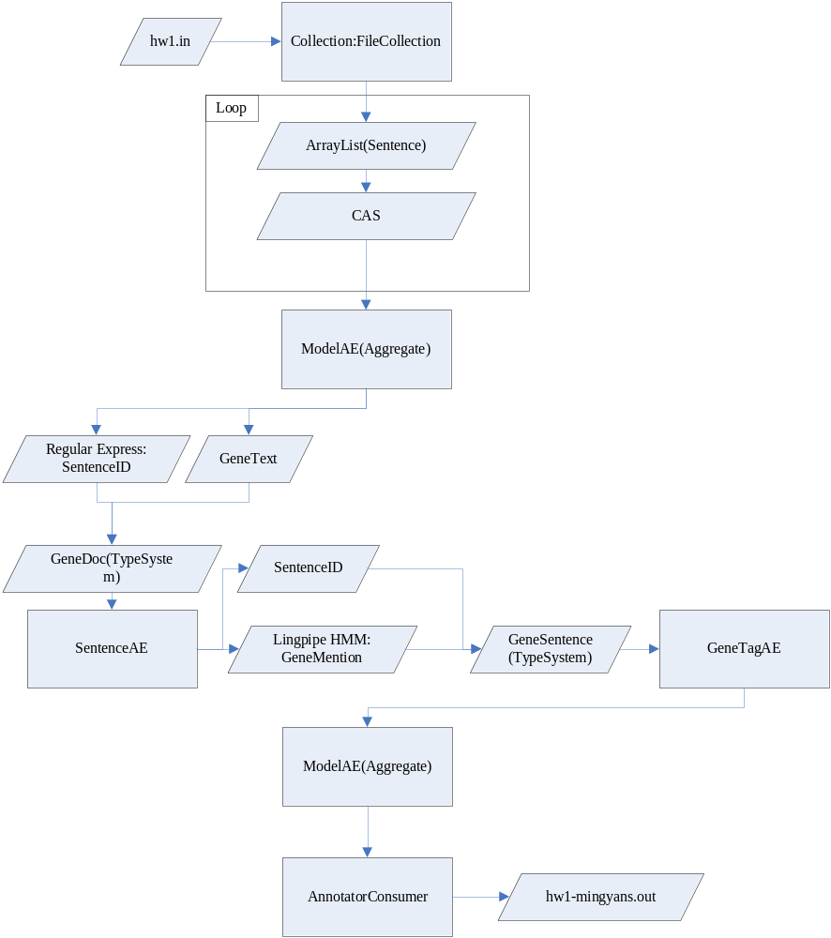

The technique I use is Lingpipe HMM model and I choose Confidence N-best Chunk and leave out any mention with the confidence <= 0.75.

