HW1-Design and Engineering of Intelligent
Information System

Mingyang Song
AndrewID: mingyans

Task 1.1 Domain diagram for IntelligentInformationSystem
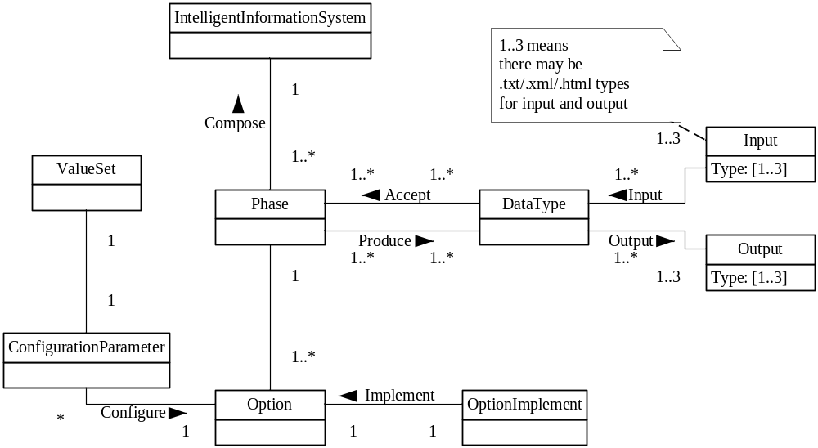

Task 1.2 Domain diagram for AnalysisEngine
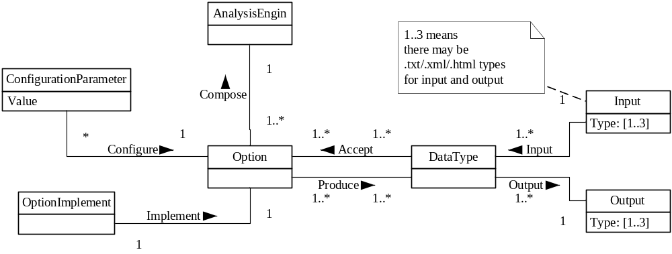

Task 1.3 Sequence Diagram
