if there is a statistically significant difference between AL Divisions?

Class Prep

Data

Evidence of correct data

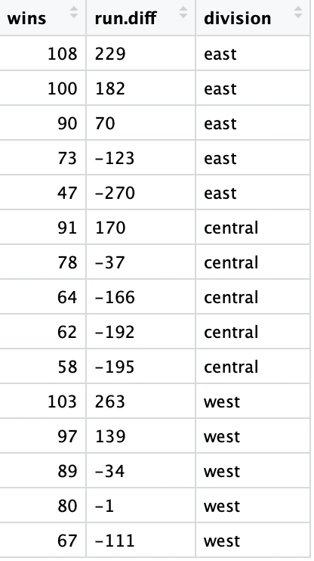

Response variable: the number of wins in a season (Quantitative)

Explanatory variables: Division (Categorical), the run differential (Categorical)

Summary for wins and run difference separated by division

|  |  |  |
| --- | --- | --- |
|  | wins | Run difference |
| west | Min. 1st Qu. Median Mean 3rd Qu. Max.  67.0 80.0 89.0 87.2 97.0 103.0 | Min. 1st Qu. Median Mean 3rd Qu. Max.  -111.0 -34.0 -1.0 51.2 139.0 263.0 |
| central | Min. 1st Qu. Median Mean 3rd Qu. Max.  58.0 62.0 64.0 70.6 78.0 91.0 | Min. 1st Qu. Median Mean 3rd Qu. Max.  -195 -192 -166 -84 -37 170 |
| east | Min. 1st Qu. Median Mean 3rd Qu. Max.  47.0 73.0 90.0 83.6 100.0 108.0 | Min. 1st Qu. Median Mean 3rd Qu. Max.  -270.0 -123.0 70.0 17.6 182.0 229.0 |

Scatterplot of run differential and wins:

