Is there evidence that increasing man-caused greenhouse gases results in higher global average temperatures?

Class Prep

Data

Evidence of correct data

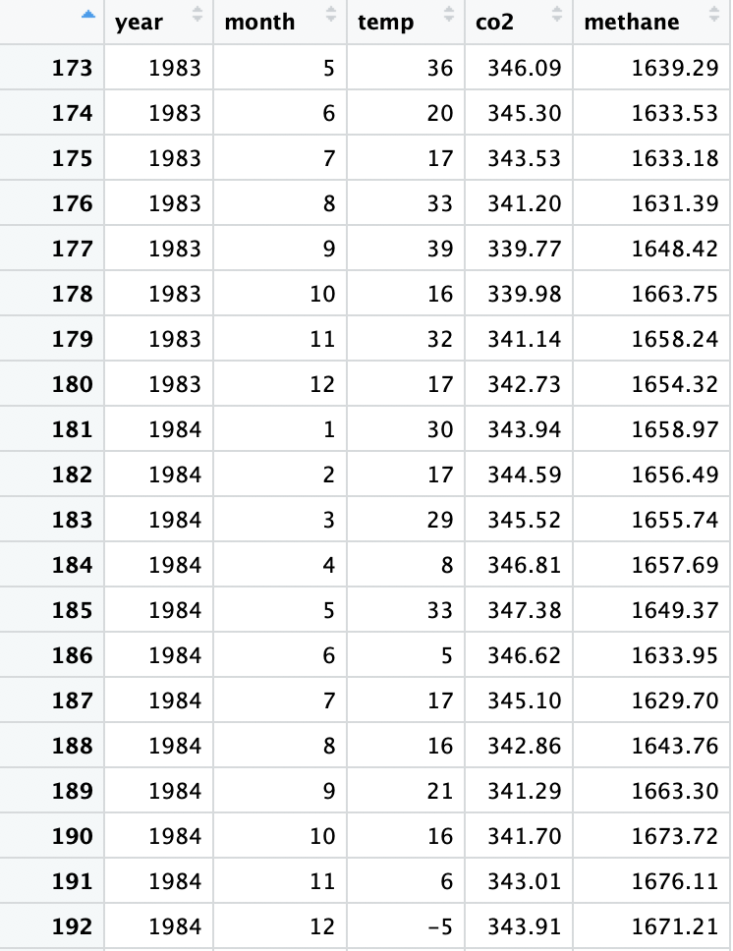

Response variable: The temperature (Quantitative)

Explanatory variables: concentration of co2 gases (Quantitative), concentration of methane gases (Quantitative)

The scatterplot of temperature and co2

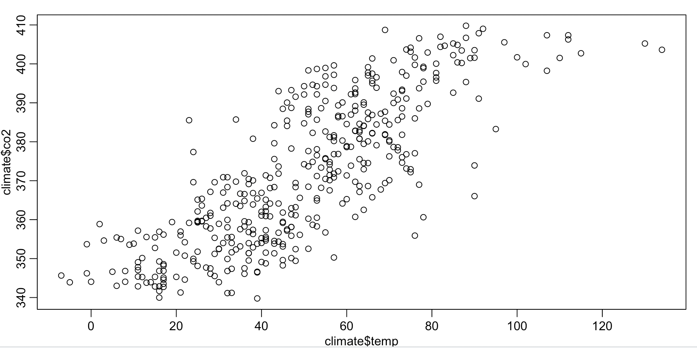

Correlation coefficients:

0.8020017

It appears a positive linear corelations.

Scatterplot of temperature and methane

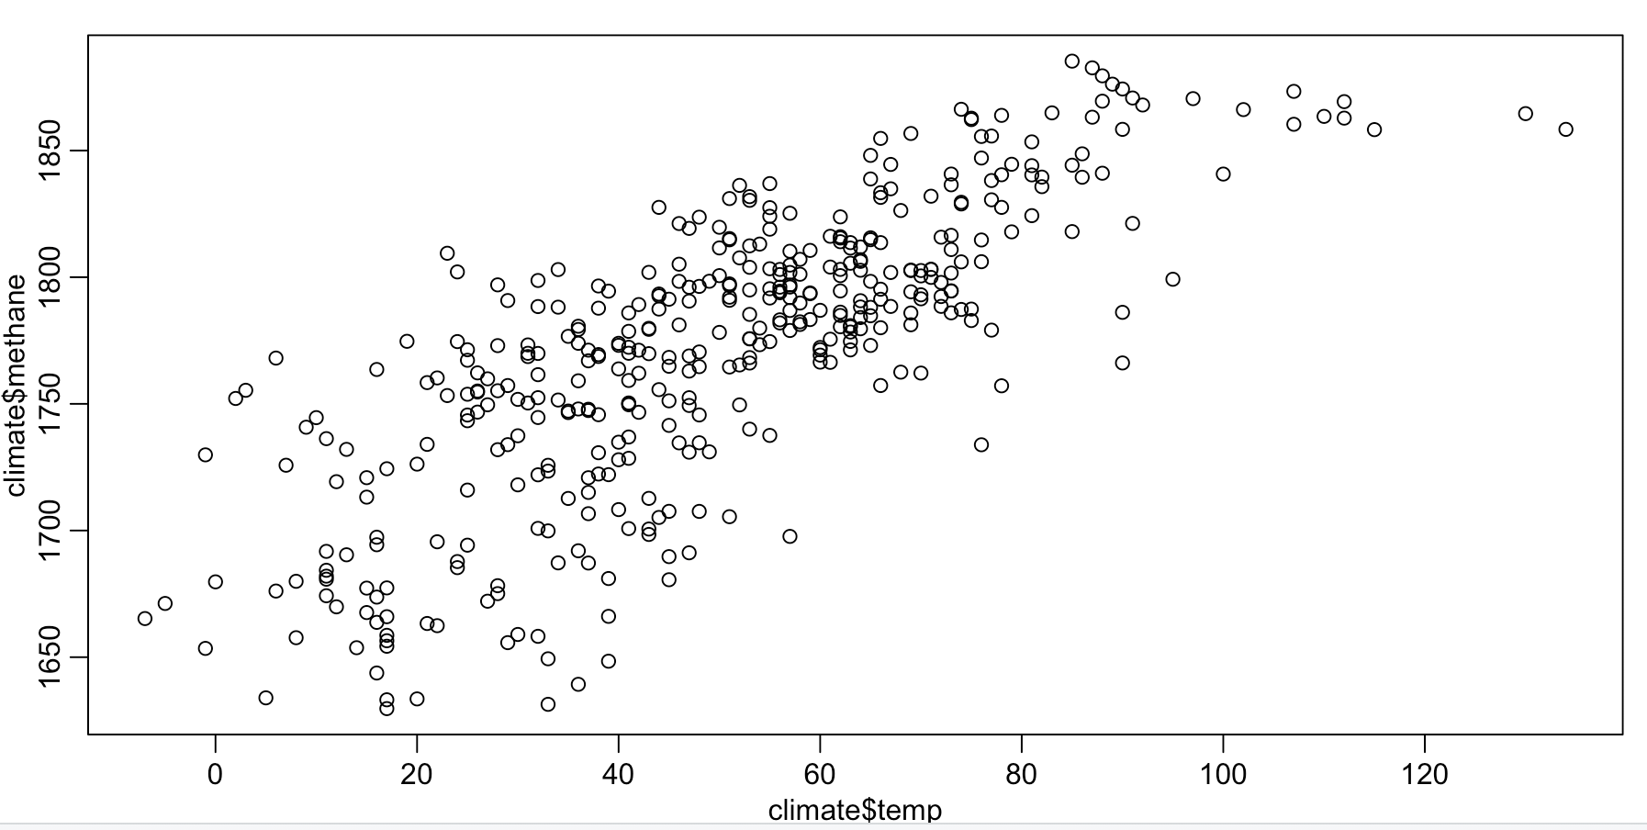

Correlation coefficients:

0.7752279

It appears a linear relations.