Predict the price of a diamond from the four C’s

Class Prep

Data

Evidence of correct data

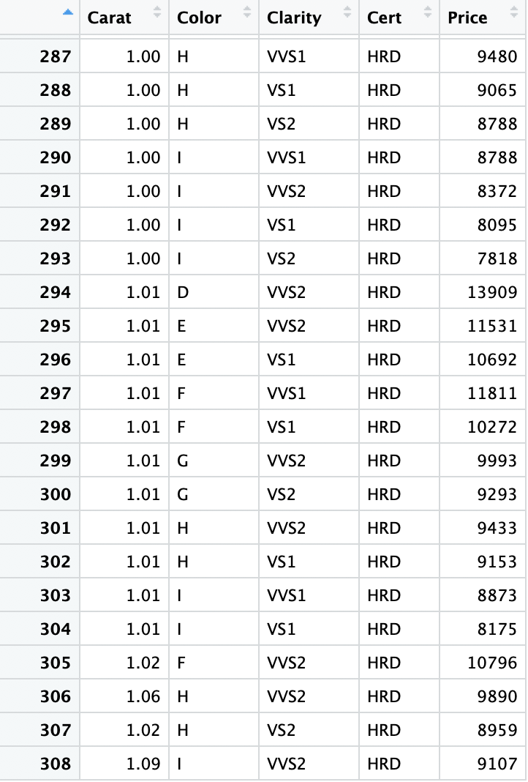

Response variable: The price of Diamonds (Quantitative)

Explanatory variables: The weight of the stone (Quantitative)

The scatterplot of ln(Carat) and ln(Price) is better for the model assumptions of additive relationship, constant mean change, no unusual observations.

Scatterplot of Carat and Price

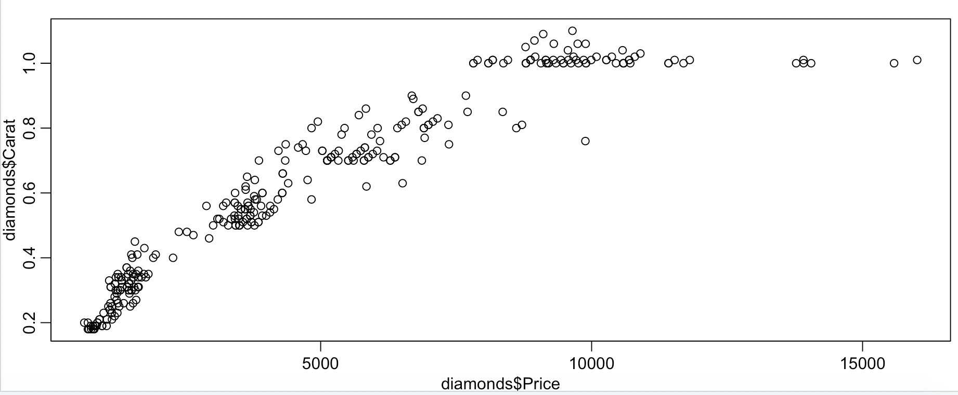

Scatterplot of ln(Carat) and ln(Price

