Is there evidence that increasing man-caused greenhouse gases results in higher global average temperatures?

Class Prep

Data

Evidence of correct data

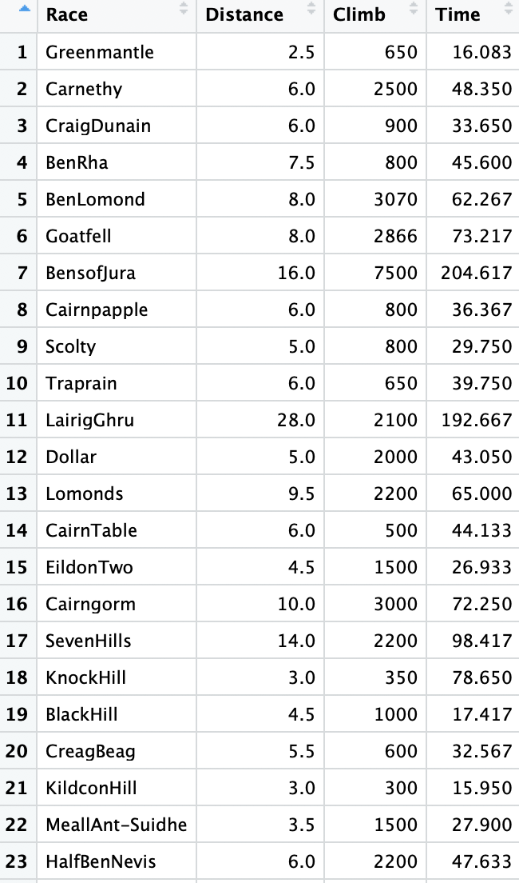

Response variable: Time(Quantitative)

Explanatory variables: Race distance (Quantitative), Hill climb (Quantitative)

The scatterplot of time and distance



Scatterplot of time and hill climb



There are some unusual observations for some races. They are marked with the index in the graph.