Objective: Estimate the effect of GPA and test if the effect is statistically significant

Class Prep

Data

Evidence of correct data

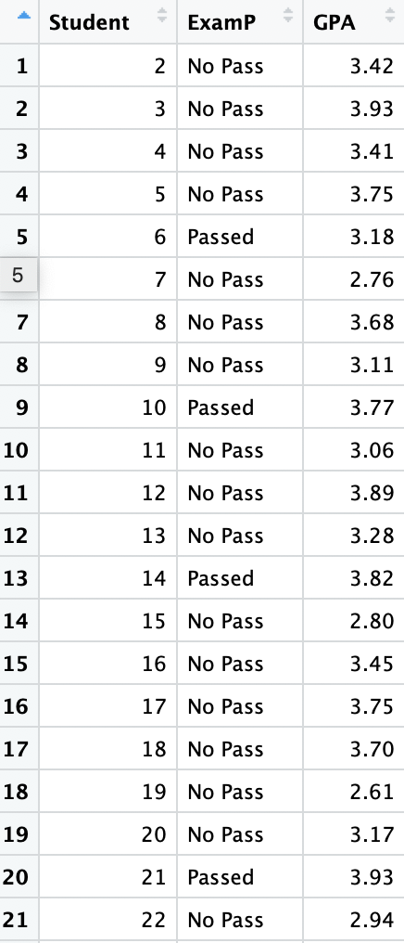

Response variable: whether or not pass the exam (Categorical)

Explanatory variables: GPA (Quantitative)

The table of the proportion of students passing Exam P with GPAs below 3.5 and above 3.5

|  |  |  |
| --- | --- | --- |
|  | Number of observations | Proportion |
| Passed | 9 | 75% |
| Not Passed | 3 | 25% |
| Total | 12 | 100% |

Boxplot of ExamP and GPA

