Monthly US residential energy consumption

Class Prep

Data

Evidence of correct data

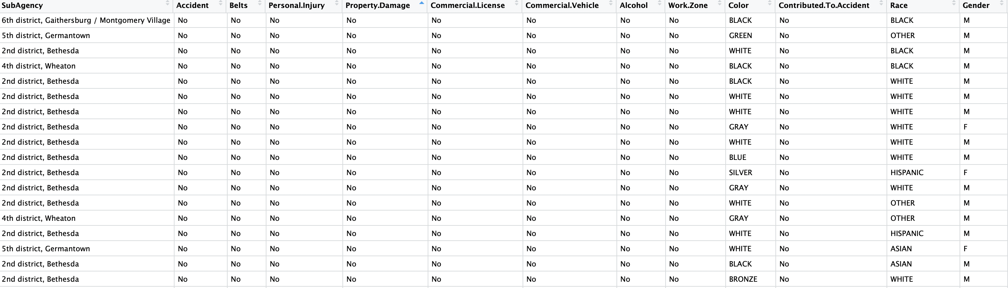

Response variable: How fast over the speed limit? (Quantative)

Explanatory variables: SubAgency(category), Accident Belts(category), Personal.Injury(category), Property.Damage(category), Commercial.License(category), Commercial.Vehicle(category), Alcohol(category), Work.Zone(category), Color(category), Contributed.To.Accident(category), Race(category), Gender(category), AutoYear(Quantative, since ), Month(Quantative), Hour(Quantative), Out.of.State(category).

AutoYear has the largest effect on the predicting speeding. It does appear a linear pattern. Newer cars tend to have higher speeding ticket.

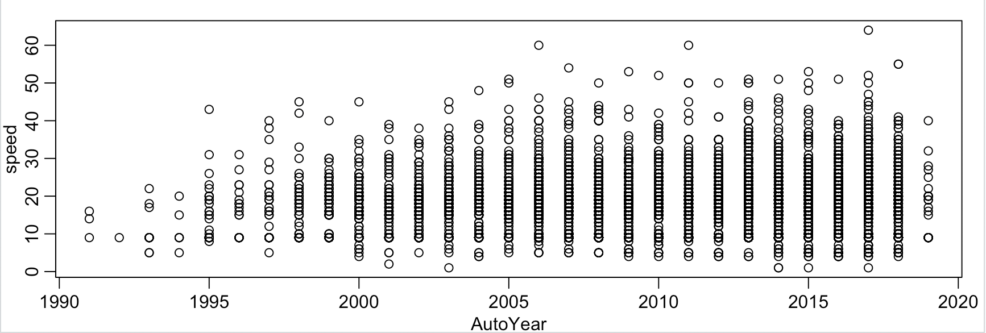

EDA

Speed

Min. 1st Qu. Median Mean 3rd Qu. Max.

1.00 9.00 15.00 15.23 20.00 64.00

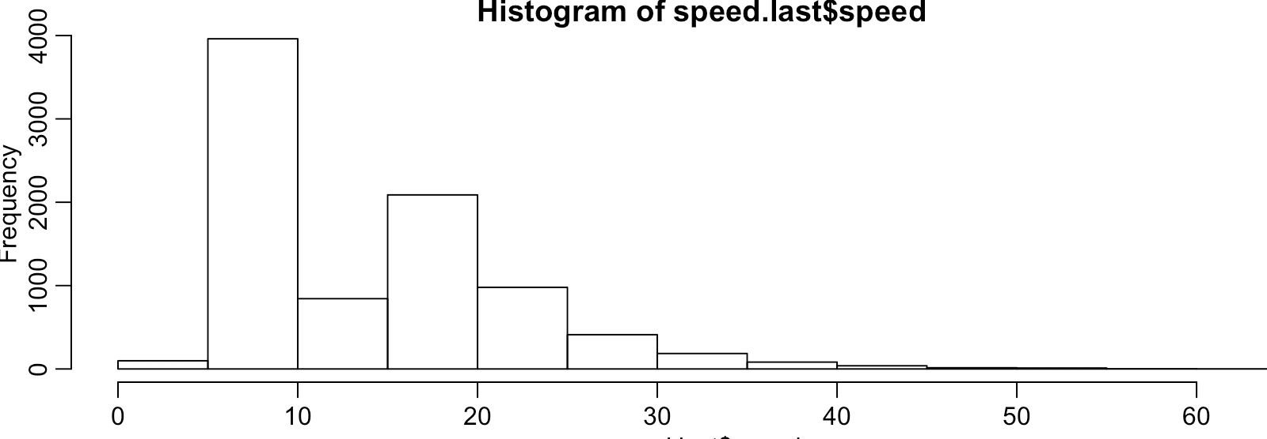

Conclusion: The mean of speed over the speed limit is around 15. Most people who got tickets drove 5-9 mph over the limit. The graph is right skewed.