If pulled over in Washington DC will you get a ticket or a warning?

Class Prep

Data

Evidence of correct data

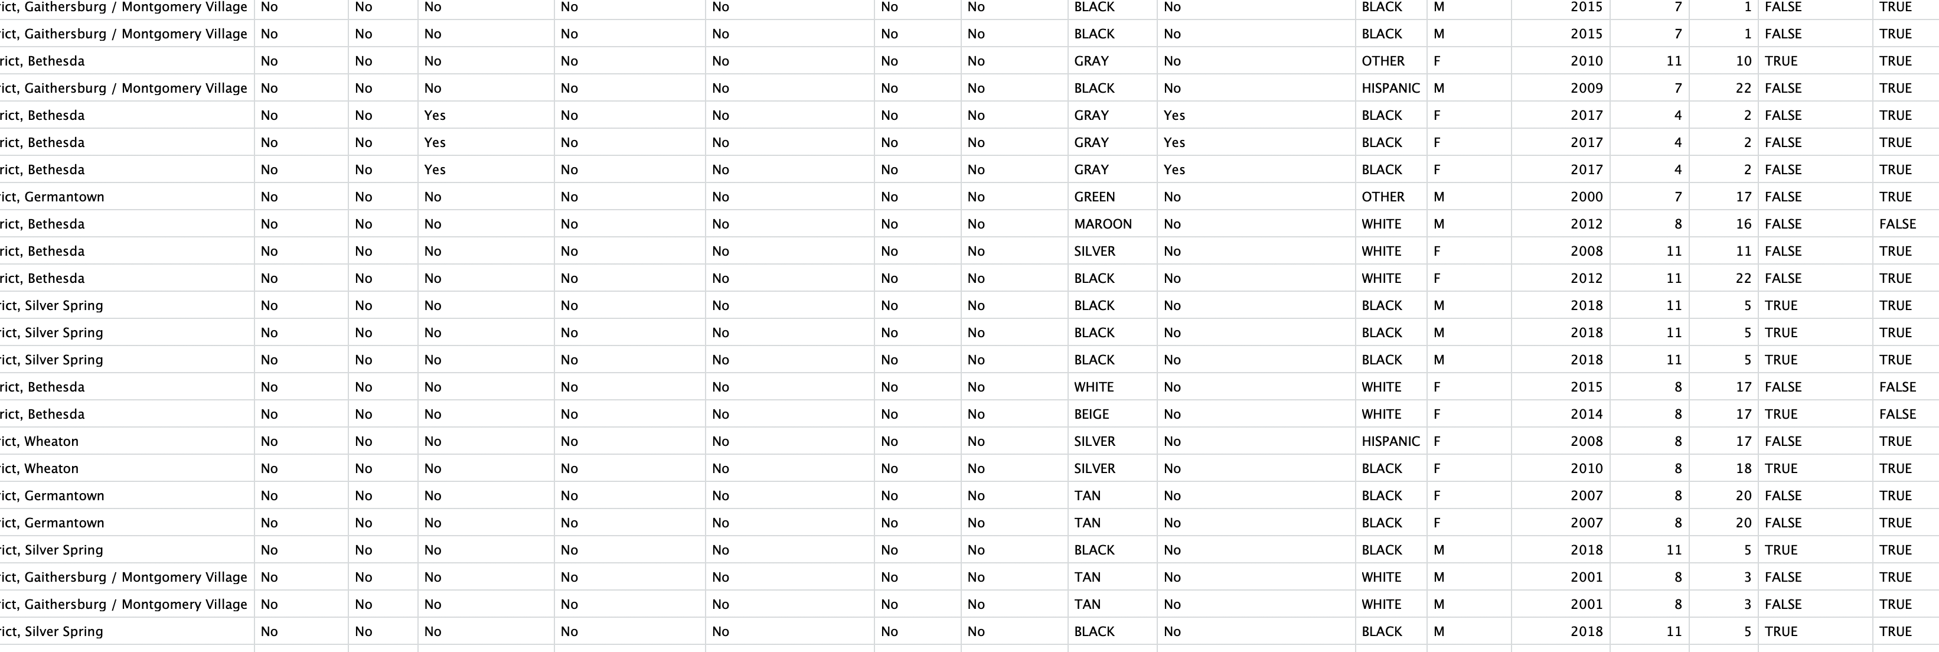

Response variable: Ticket- if the driver gets a ticket or a warning(categorical)

Explanatory variables: SubAgency(categorical), Accident(categorical), Belts(categorical), Personal.Injury(categorical), Property.Damage(categorical), Commercial.License(categorical), Alcohol(categorical), Work.Zone(categorical), Color(categorical), Contributed.To.Accident(categorical), Race(categorical), Gender(categorical), AutoYear(categorical), Month(Quantative), Hour(Quantative), Out.of.State(categorical).

I think Hour has the biggest effect on the on classifying a stop as resulting in a warning or a ticket.

EDA

Ticket

Frequency Table

FALSE TRUE

124587 80488

Proportion Table

FALSE TRUE

0.6075192 0.3924808