ArcNLET Compilation on Visual Studio 2013

Hongzhuan lei, 11/12/2017.

1. Run Visual Studio 2013 as administrator.

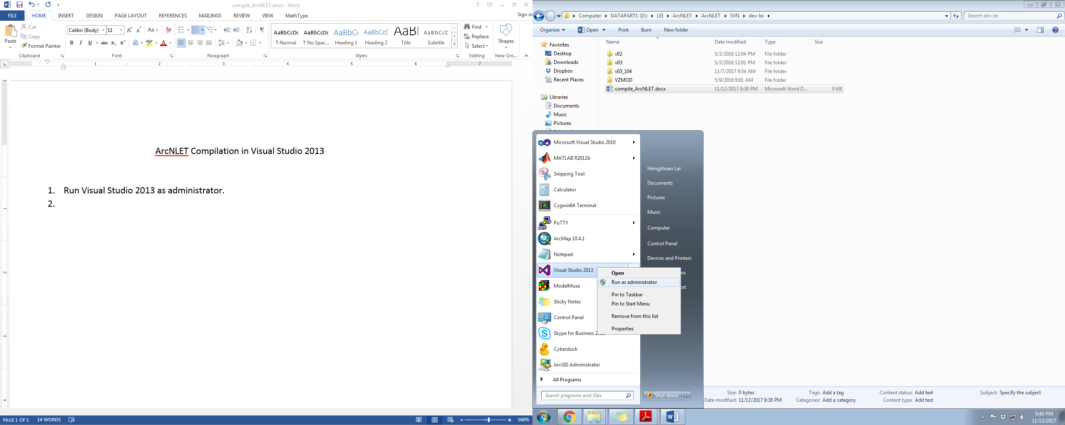

1. Open ArcNLET solution from the source code directory, use Release mode.

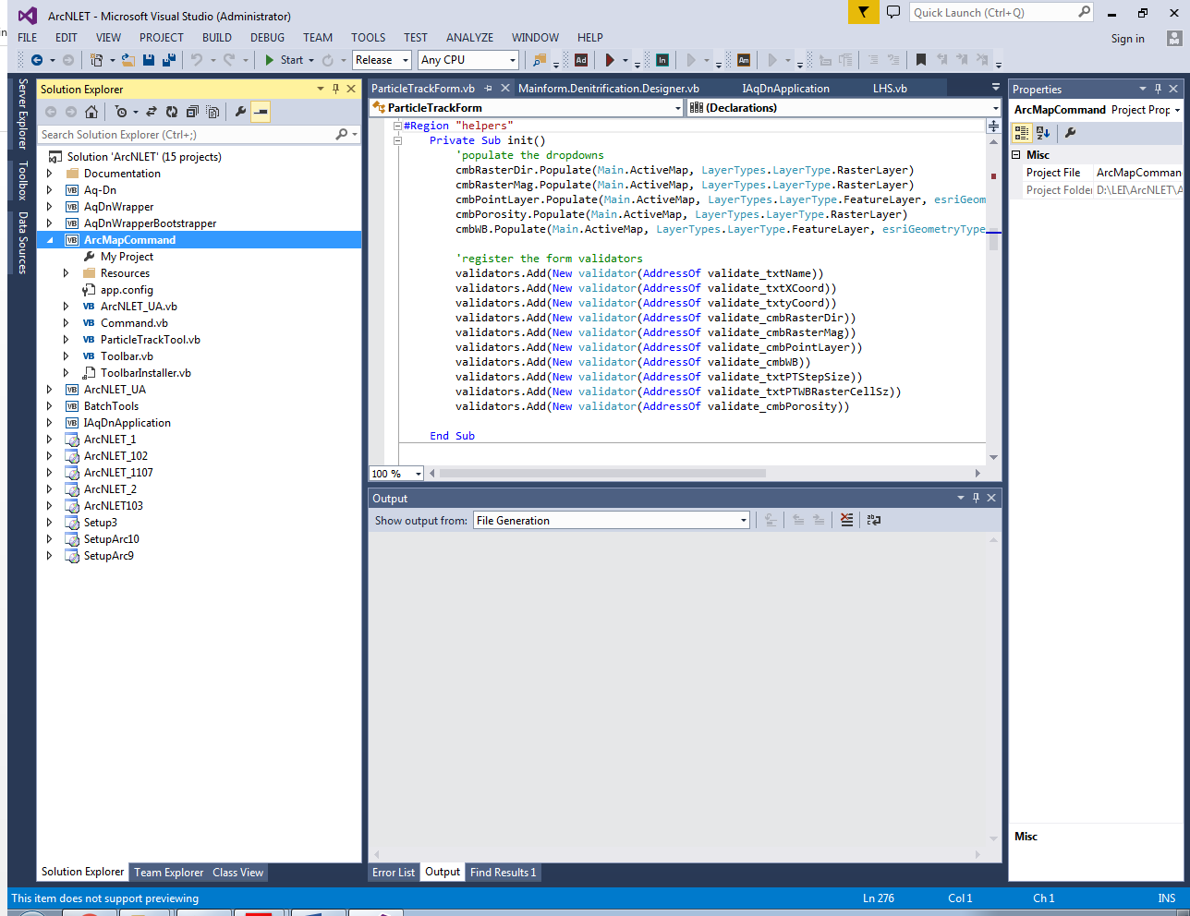

1. Right click on the top “Solution ‘ArcNLET’” to add a new project.

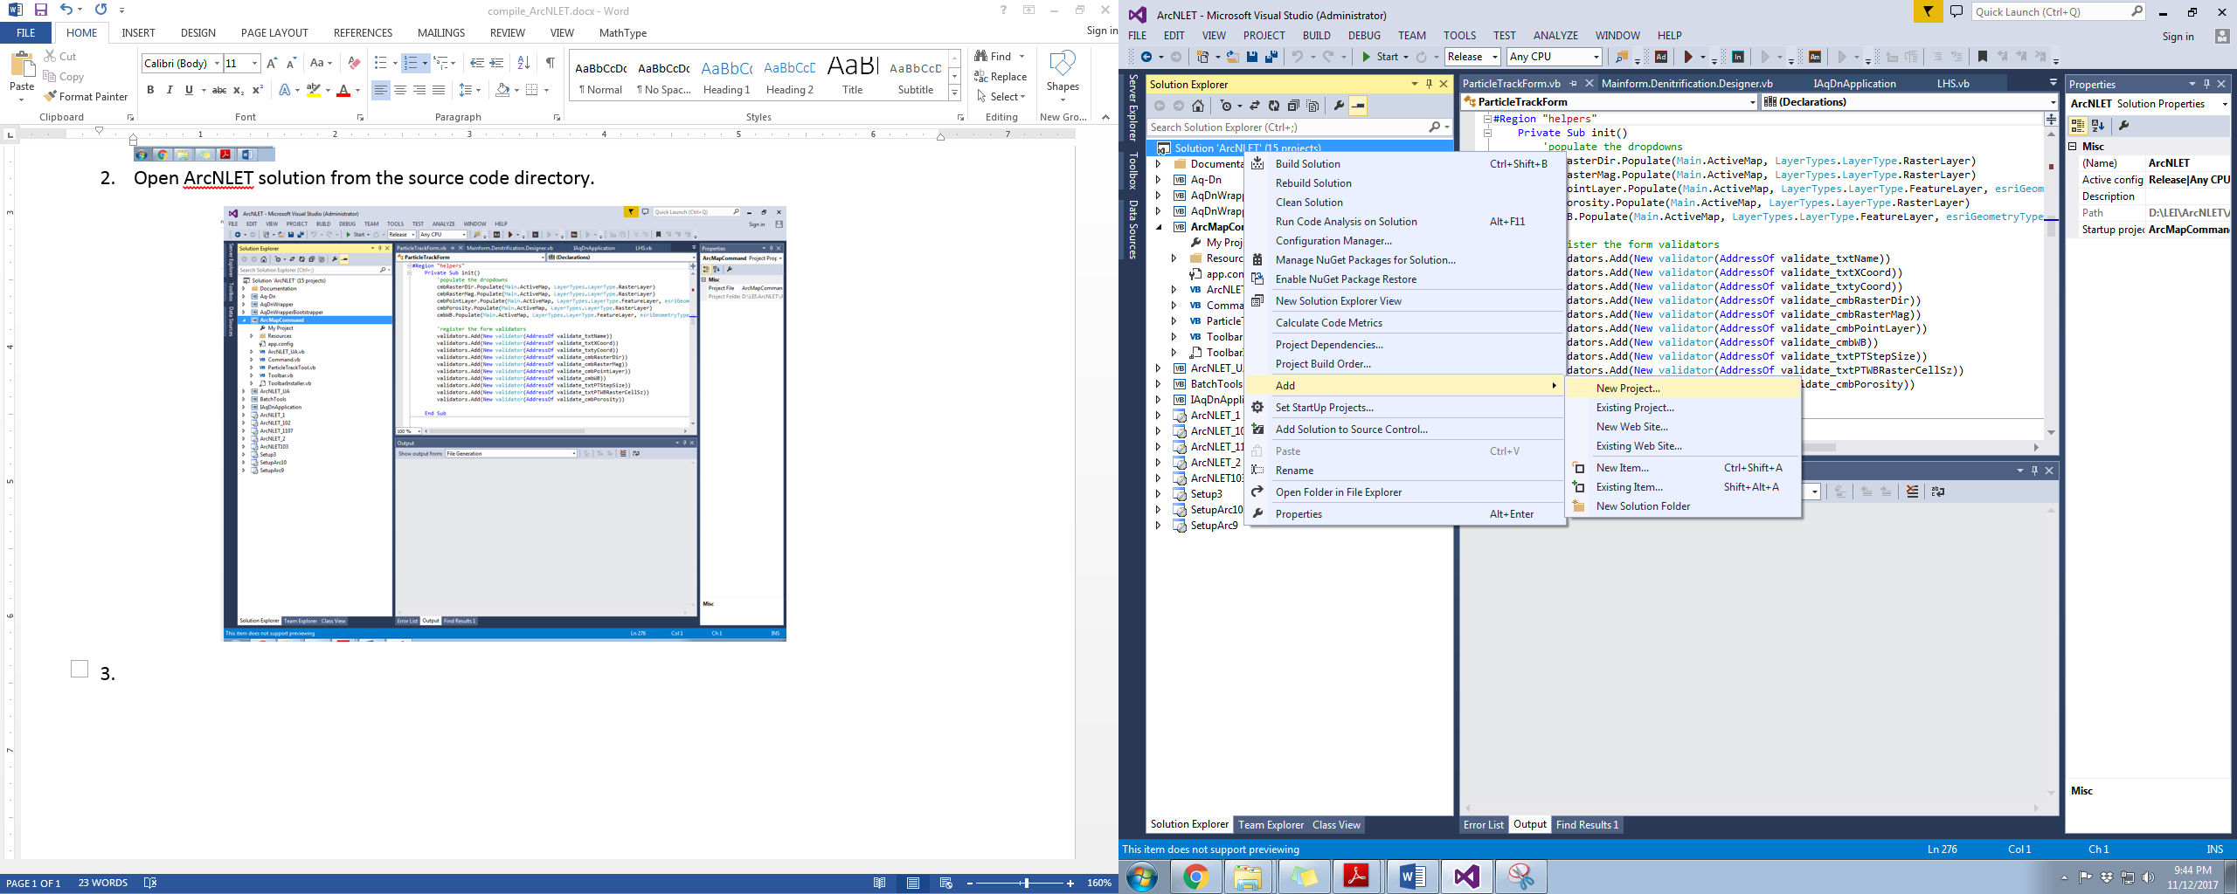

1. Select “Setup Project” under “Other Project Types -> Visual Studio Installer”, choose the location and give a name (e.g., ArcNLET_test).

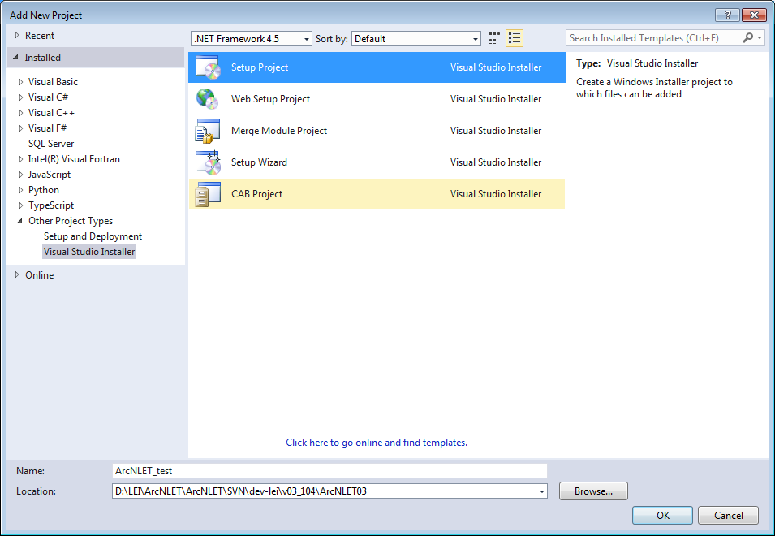

1. Add project output for “ArcNLET_test”.

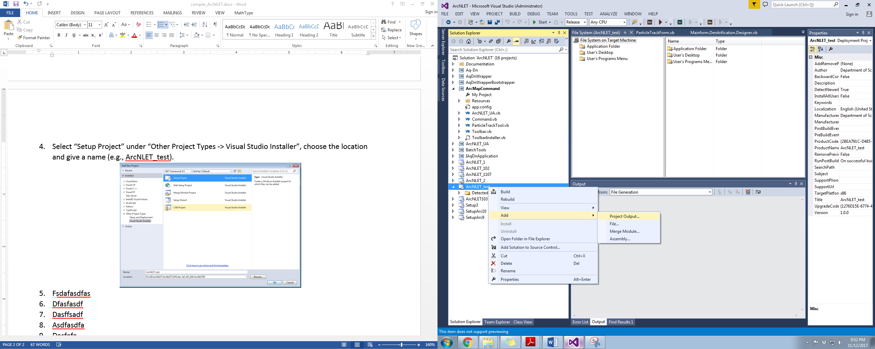

1. Choose “ArcMapCommand” as Primary output.

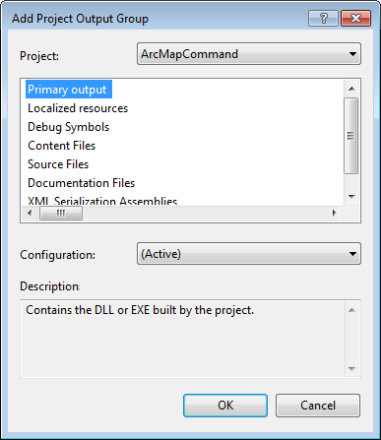

1. Add other three files: “AqDnWrapper.exe”, “AqDnWrapperBootstrapper.dll” and “LHS251.exe” from directory “…\ArcNLET03\ArcMapCommand\bin\Release”.

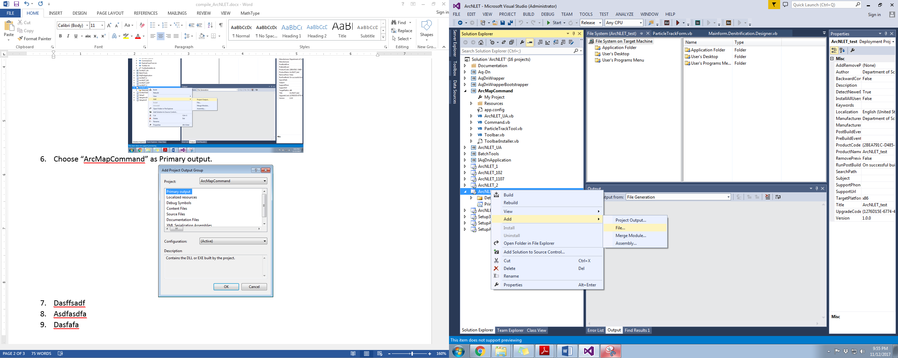

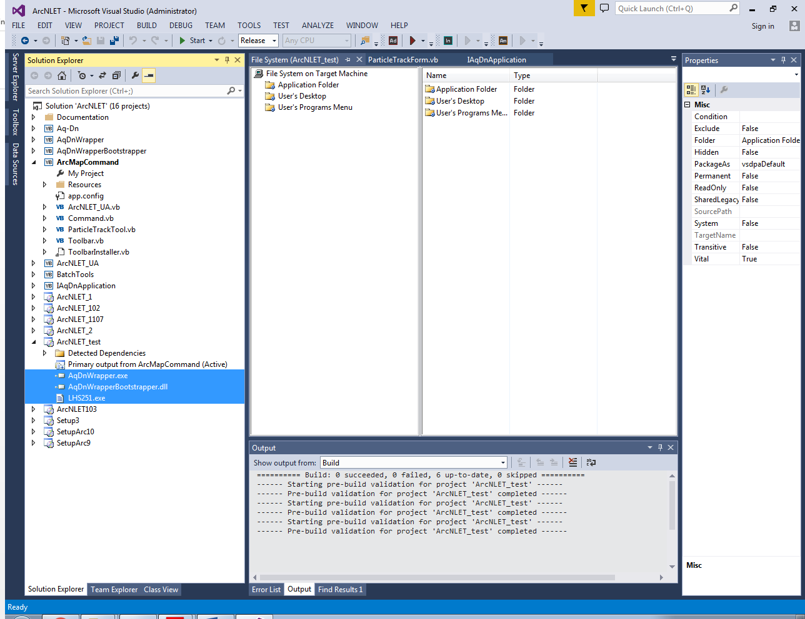

1. Set up “Launch Conditions”.

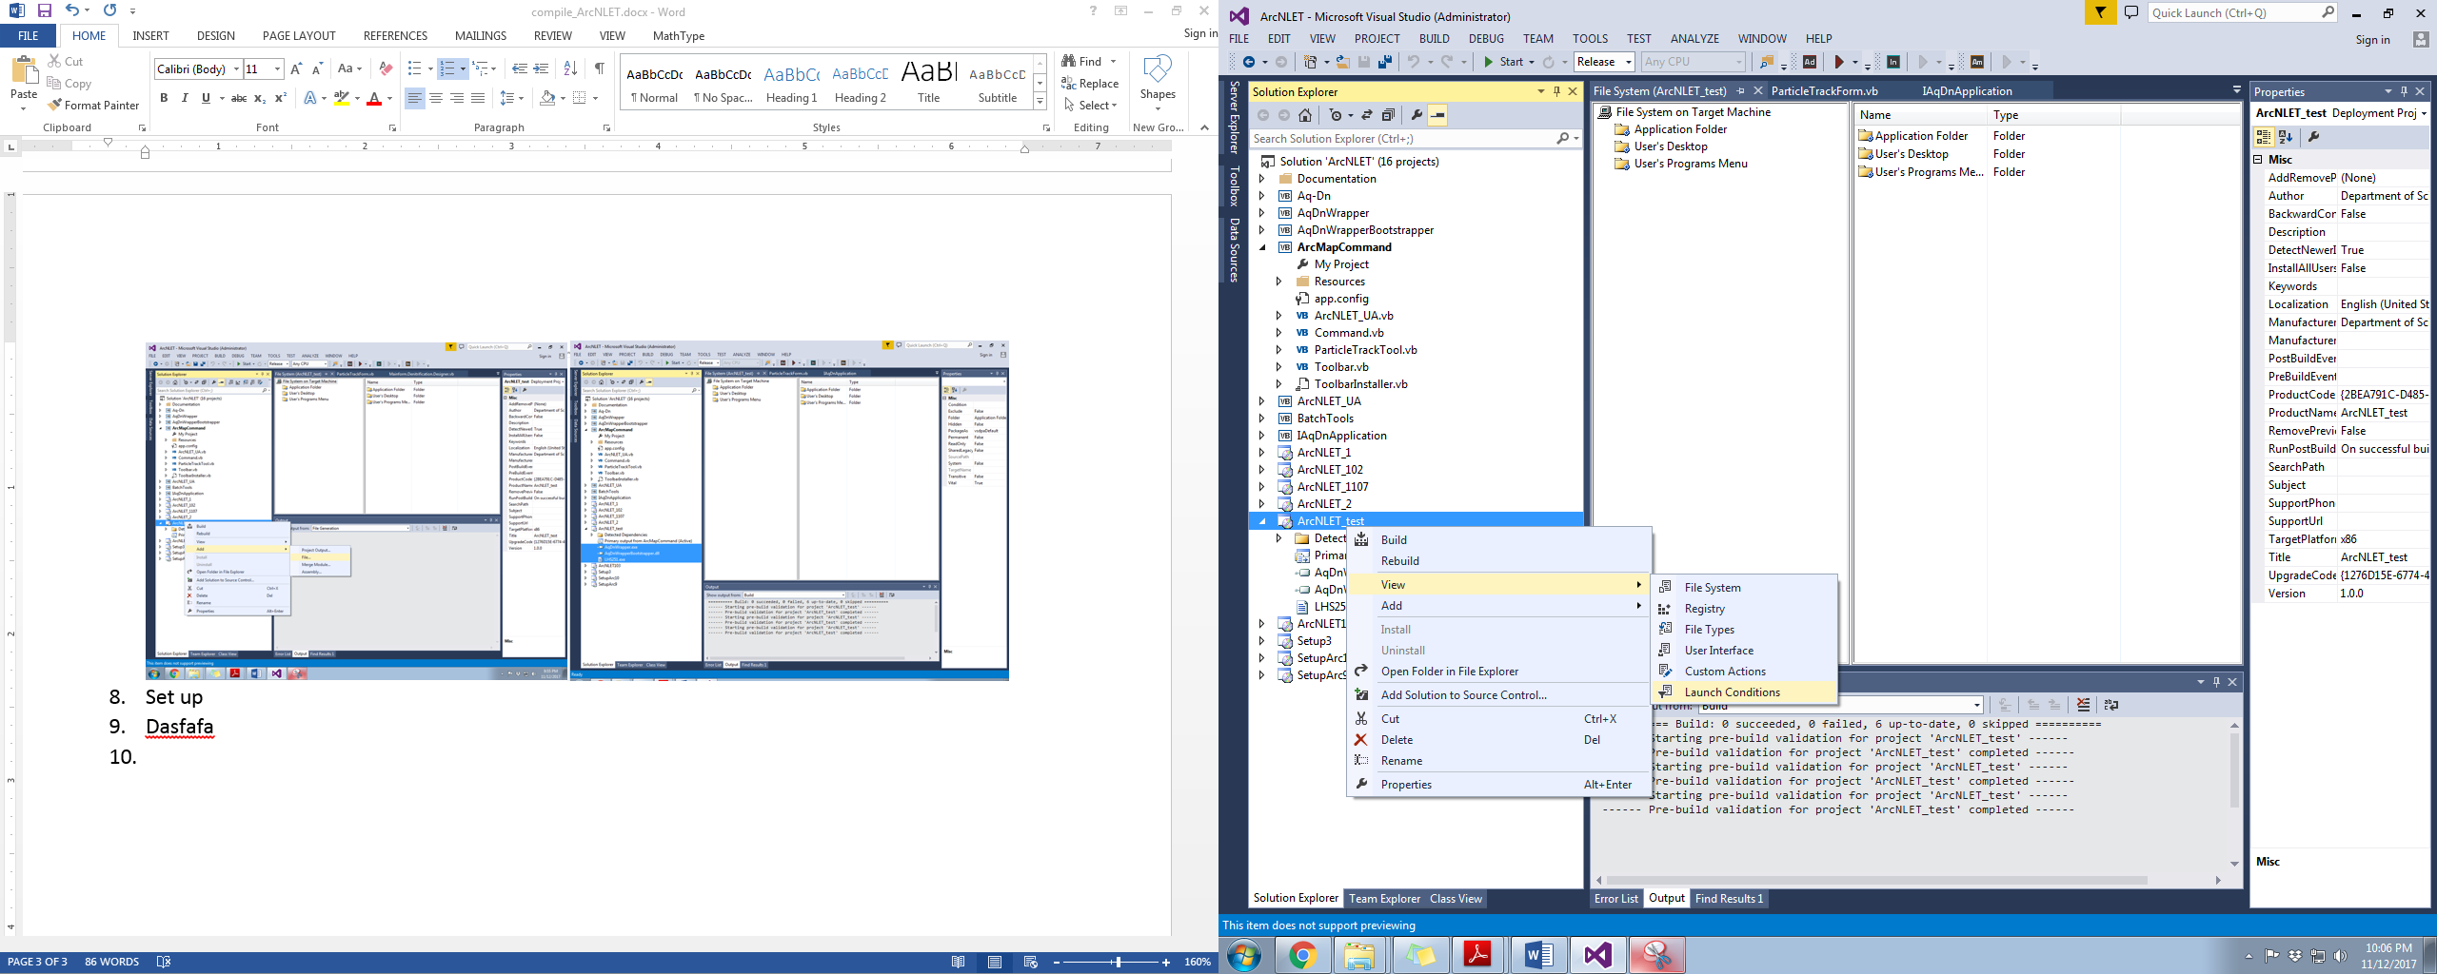

1. Add registry search.

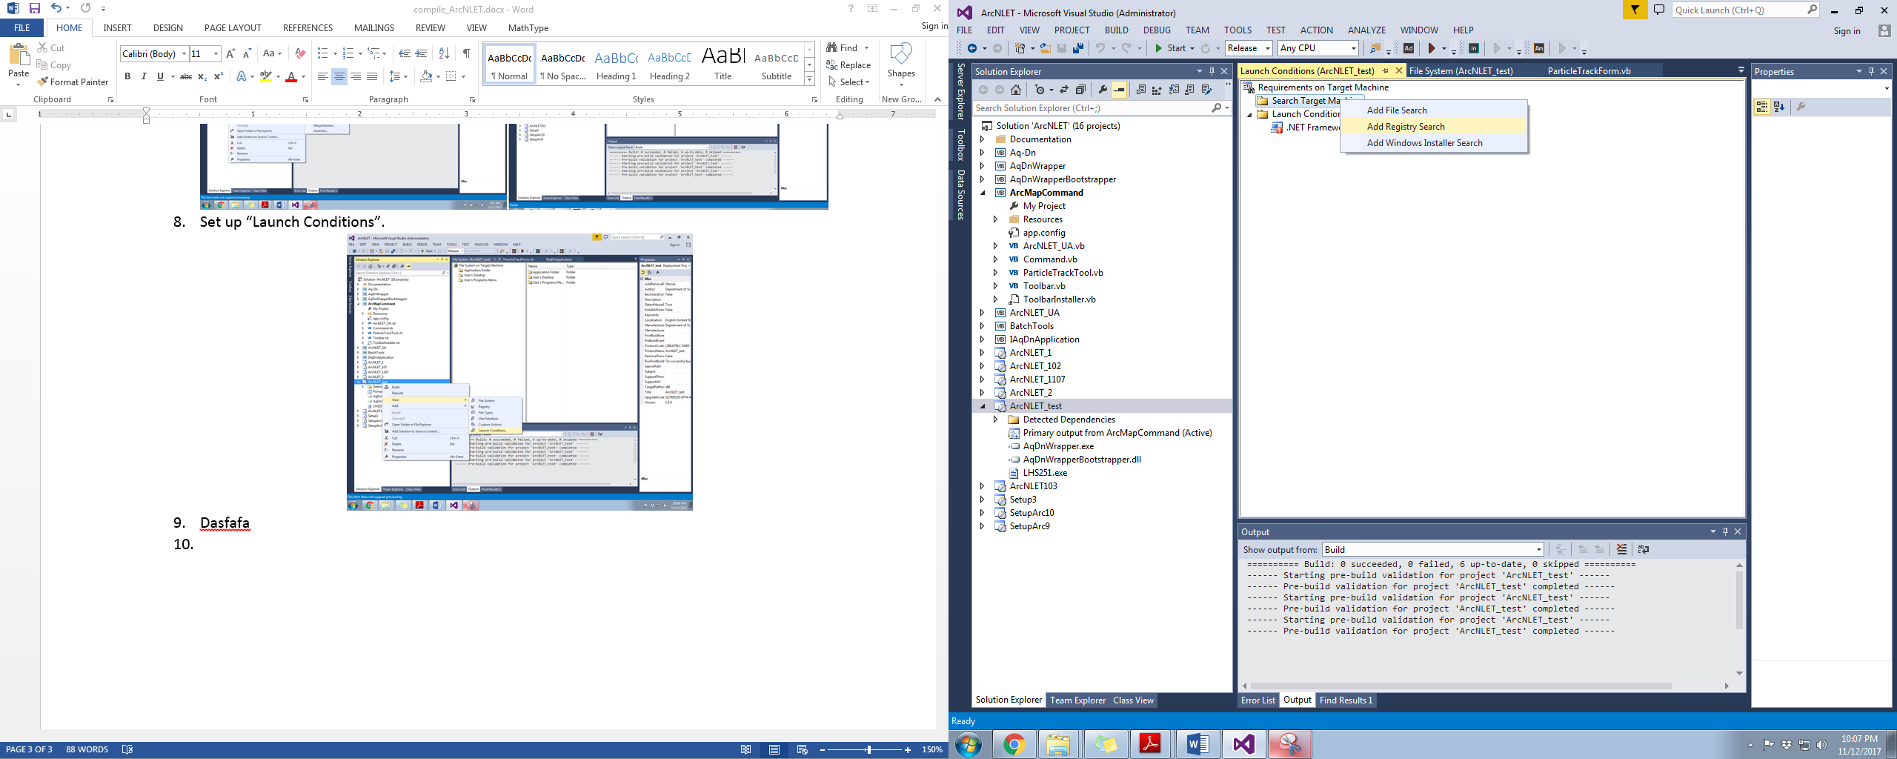

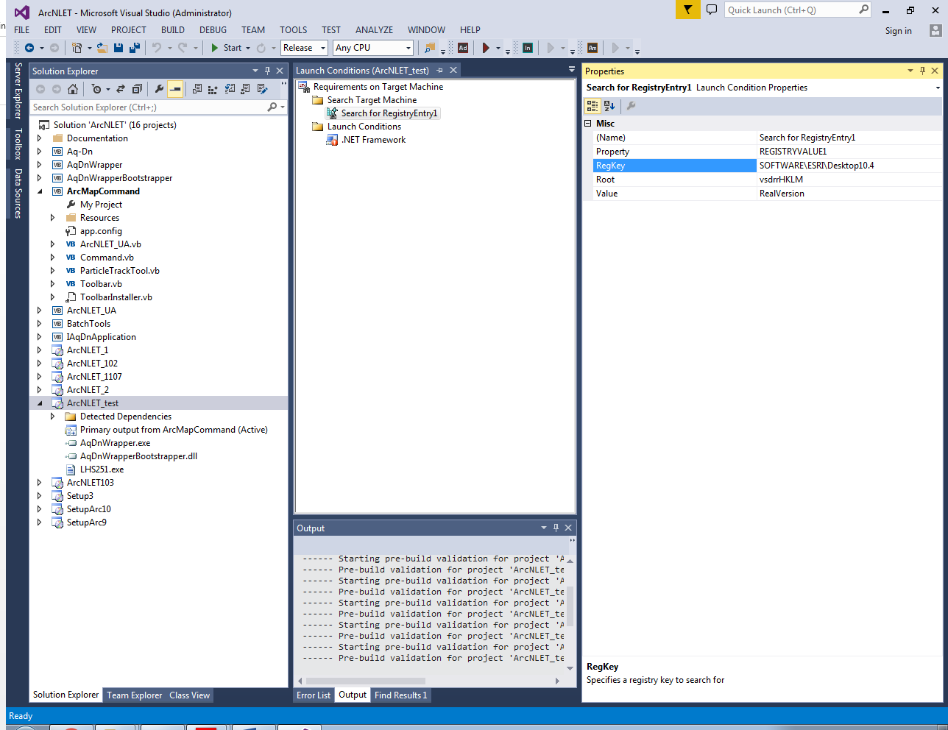

1. Add Launch Condition.

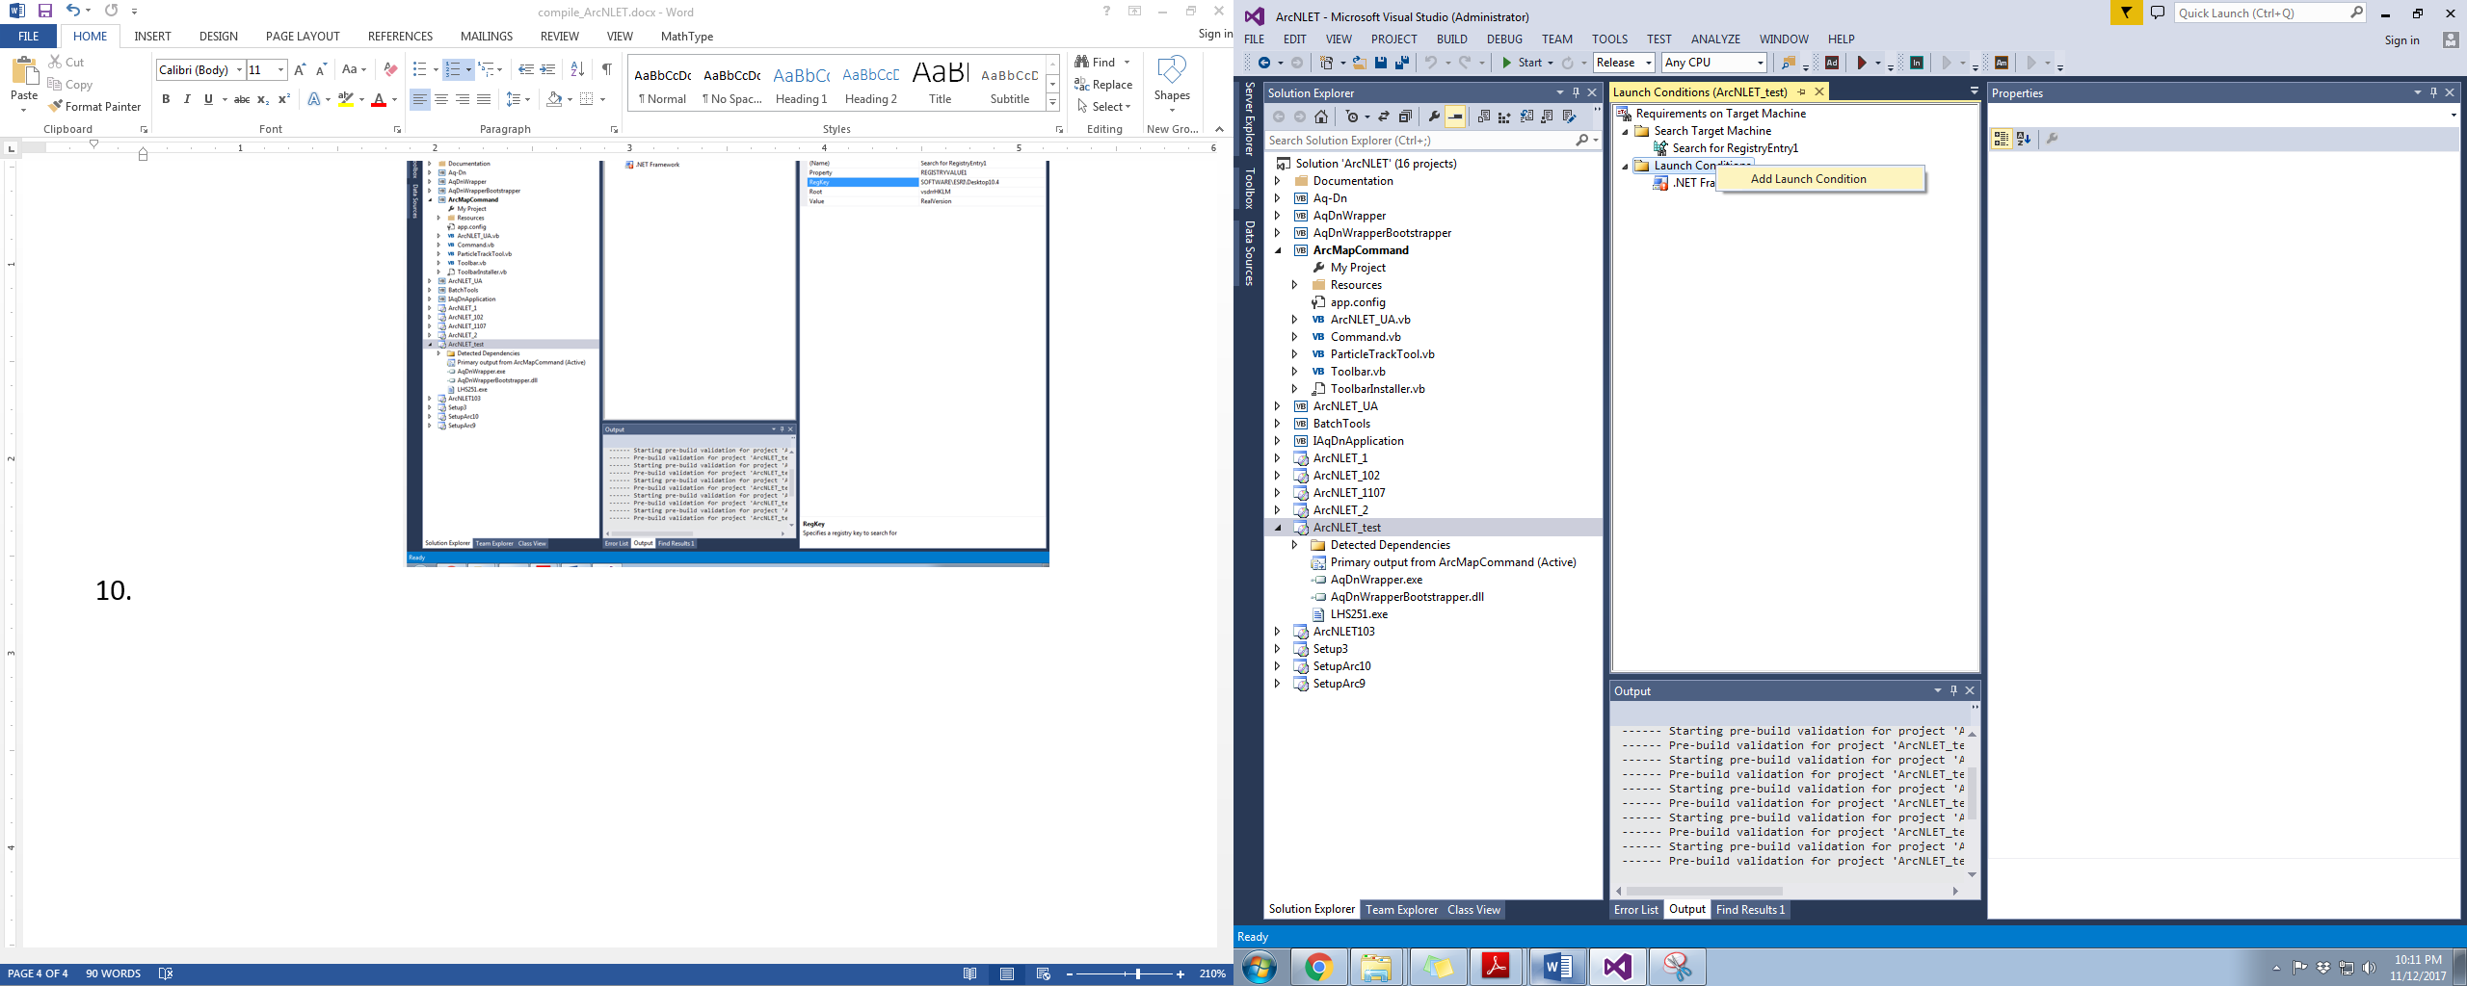

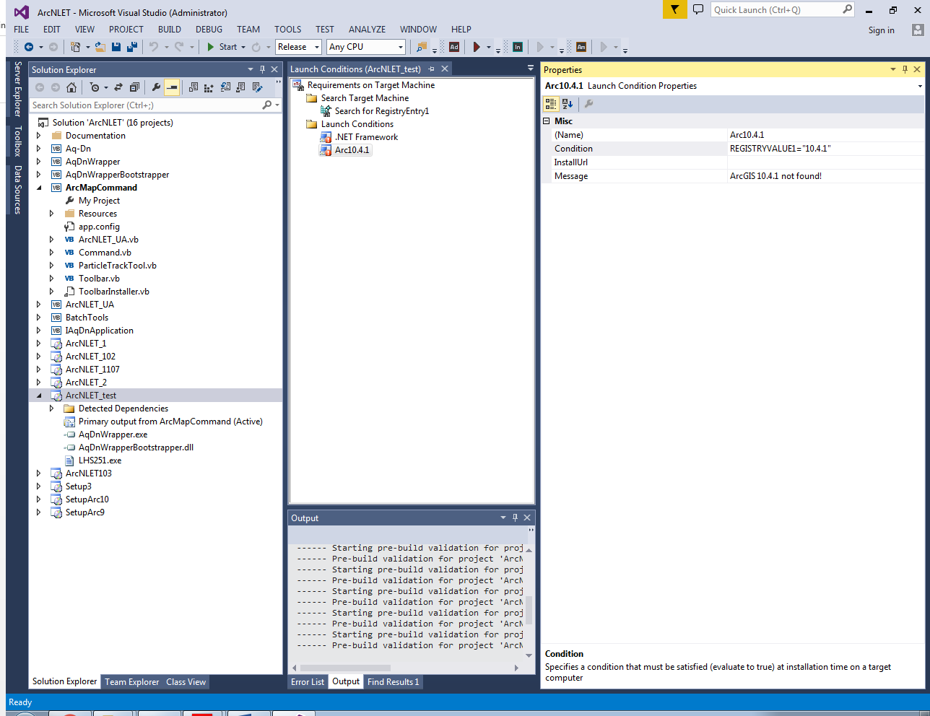

1. Set properties of ArcNLET_test.

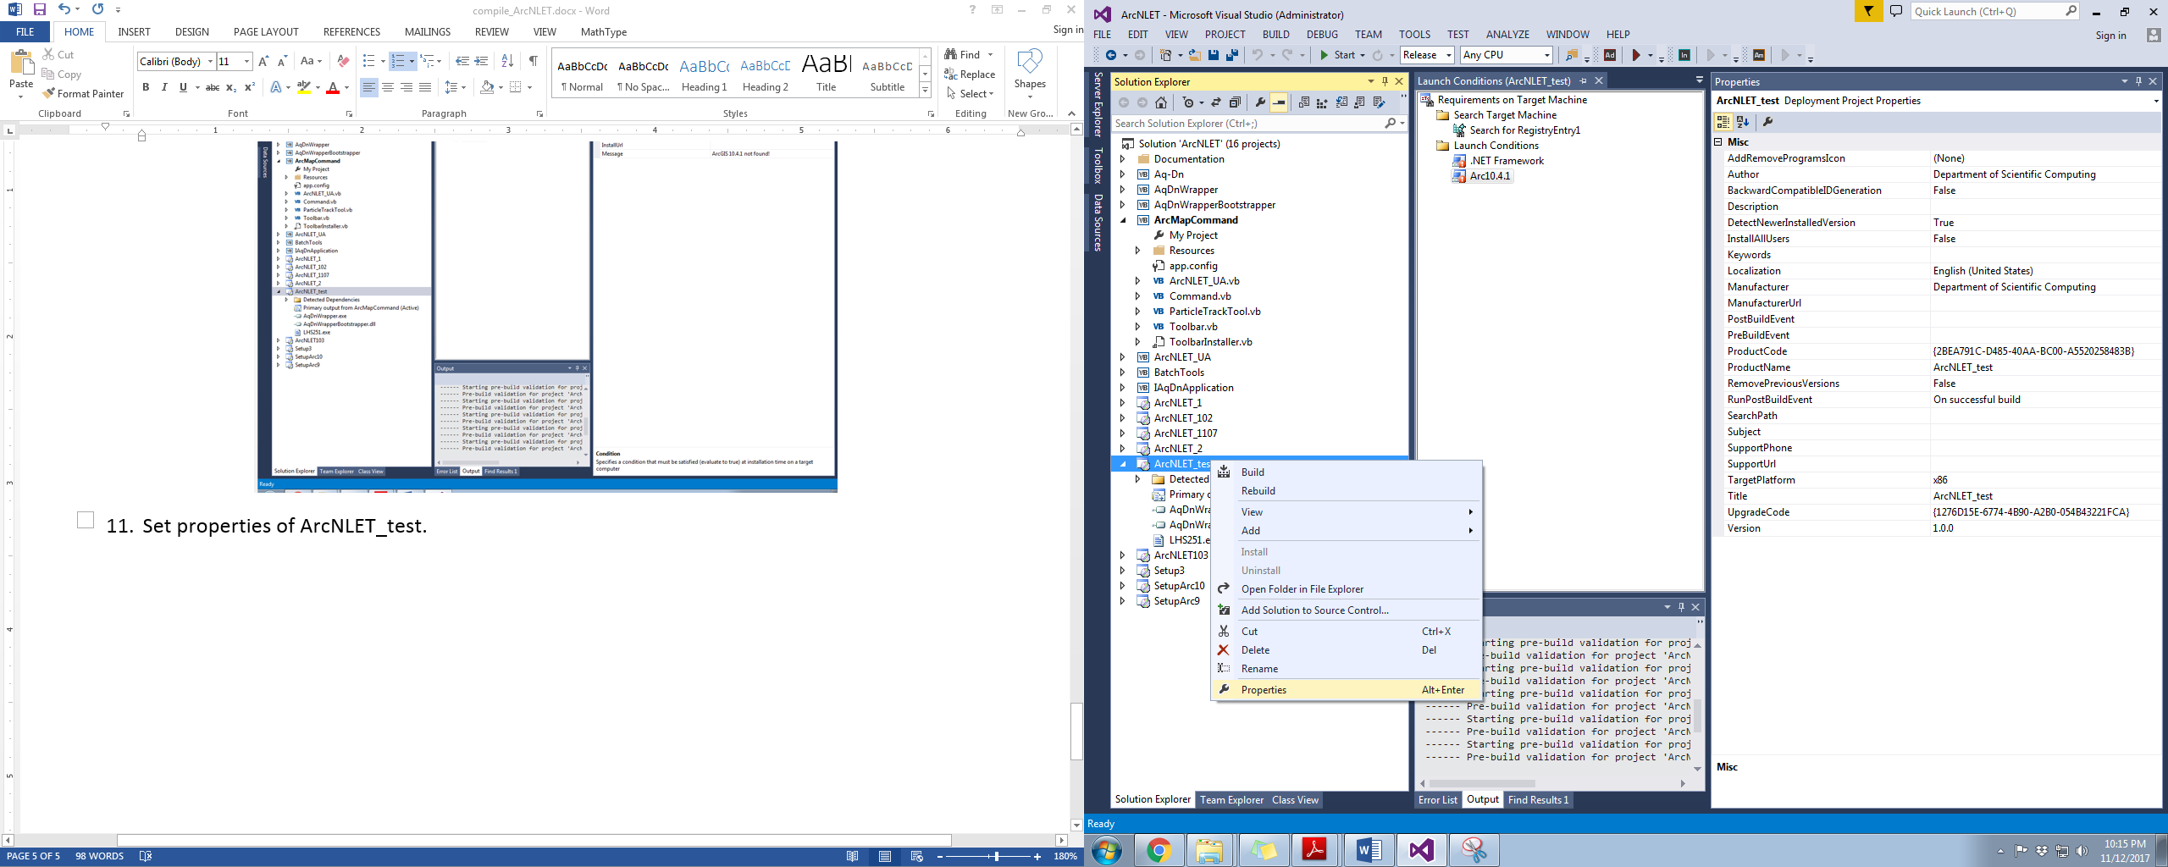

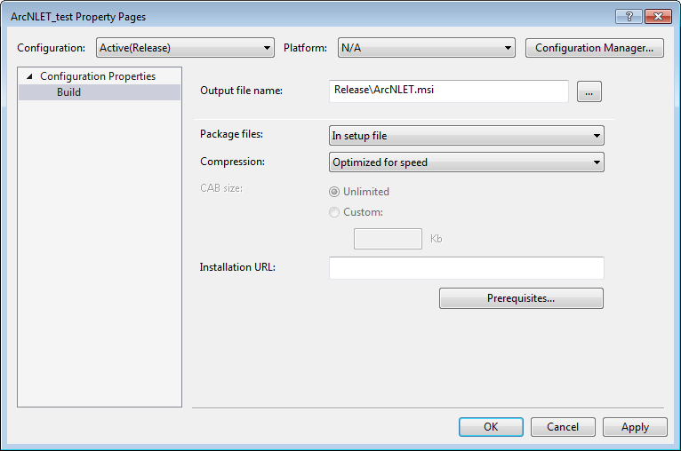

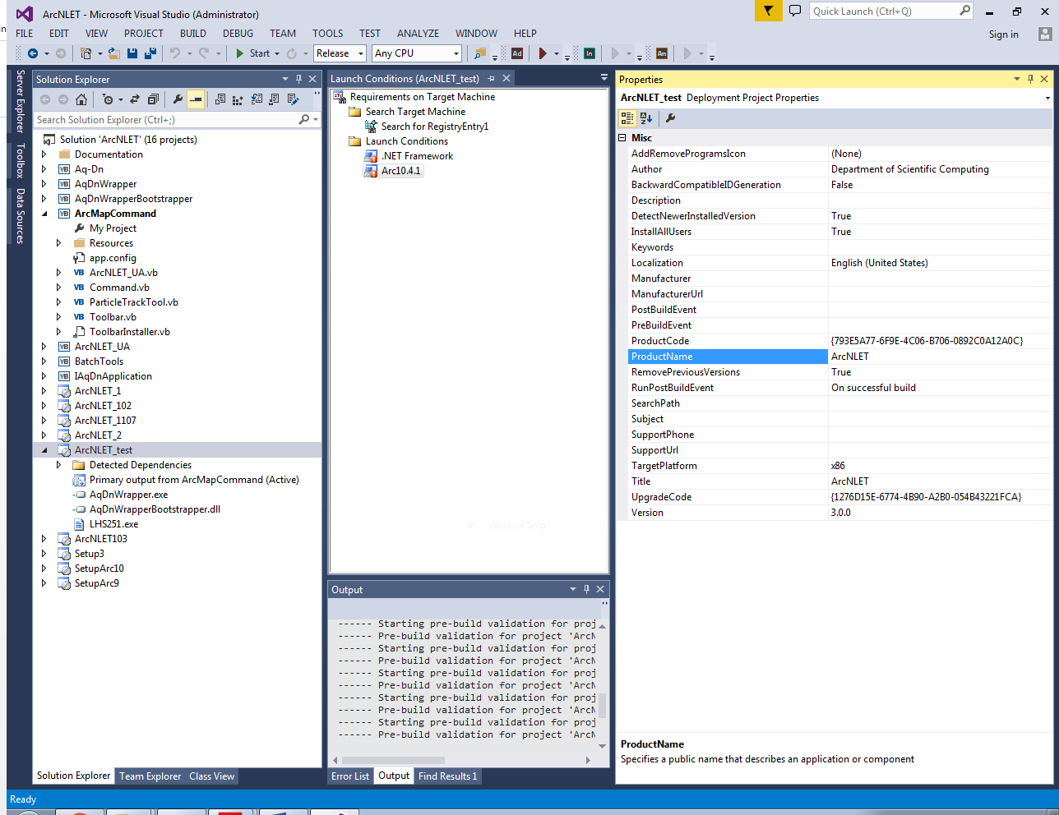

1. Build ArcNLET_test.

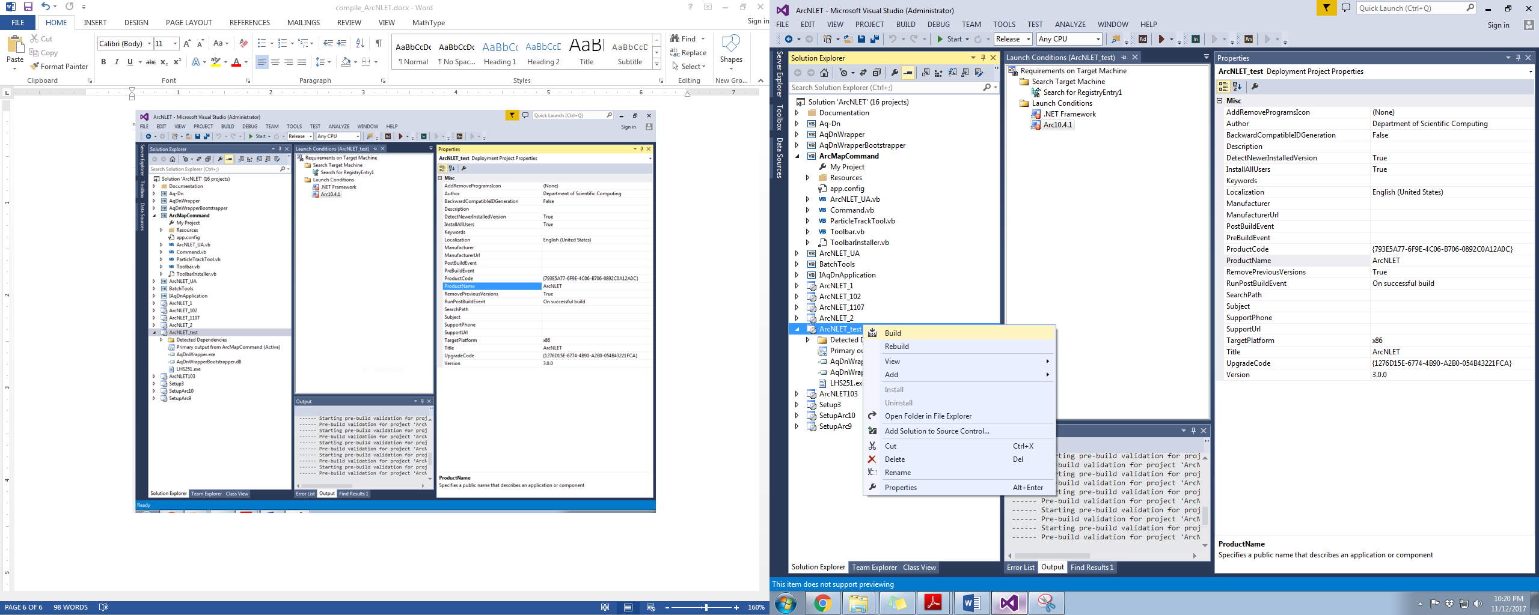

1. After compilation, the release version of ArcNLET should exists under the directory “…\ArcNLET_test\Release“.

