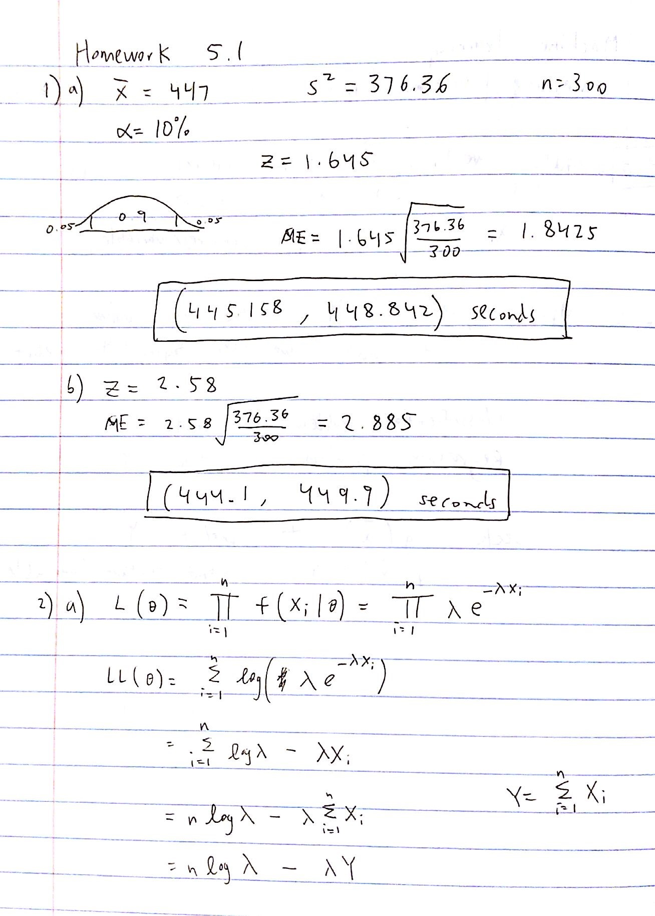

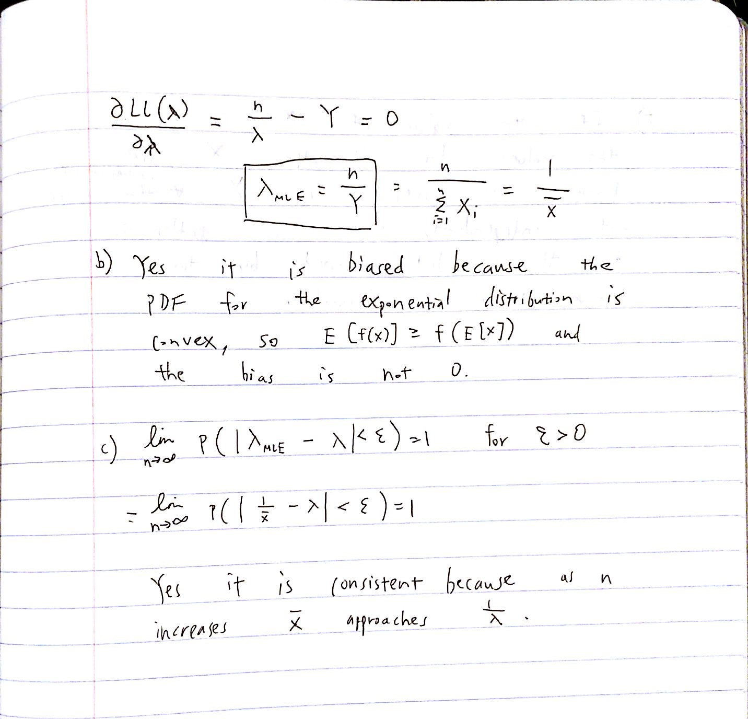

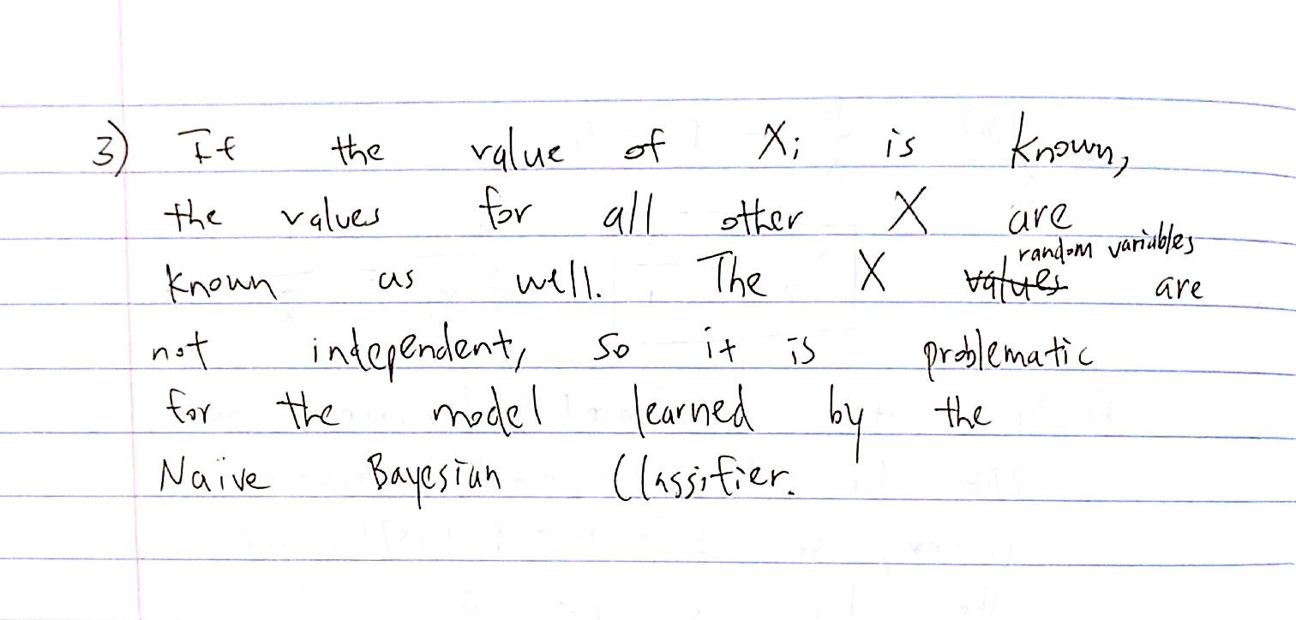

1. No Laplace Estimators

Class 0: tested 2, correctly classified 2

Class 1: tested 2, correctly classified 2

Overall: tested 4, correctly classified 4

Accuracy: 1.000000

With Laplace Estimators

Class 0: tested 2, correctly classified 2

Class 1: tested 2, correctly classified 2

Overall: tested 4, correctly classified 4

Accuracy: 1.000000

1. No Laplace Estimators

Class 0: tested 48, correctly classified 52

Class 1: tested 76, correctly classified 83

Overall: tested 124, correctly classified 135

Accuracy: 0.918519

With Laplace Estimators

Class 0: tested 48, correctly classified 52

Class 1: tested 76, correctly classified 83

Overall: tested 124, correctly classified 135

Accuracy: 0.918519

1. No Laplace Estimators

Class 0: tested 10, correctly classified 15

Class 1: tested 135, correctly classified 172

Overall: tested 145, correctly classified 187

Accuracy: 0.775401

With Laplace Estimators

Class 0: tested 10, correctly classified 15

Class 1: tested 130, correctly classified 172

Overall: tested 140, correctly classified 187

Accuracy: 0.748663

1. Laplace Estimators did not change the accuracy of the vote data, but decreased the accuracy for the heart data. In general, Laplace Estimators improve accuracy when test data produce unrepresentative MLE estimates, such as an MLE estimate of 0 for an event that can actually occur. Otherwise, Laplace Estimators are not better than MLEs for classification accuracy.