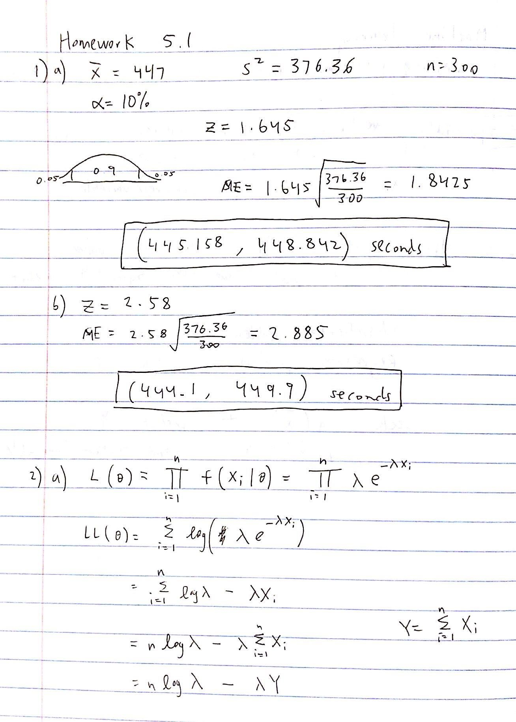

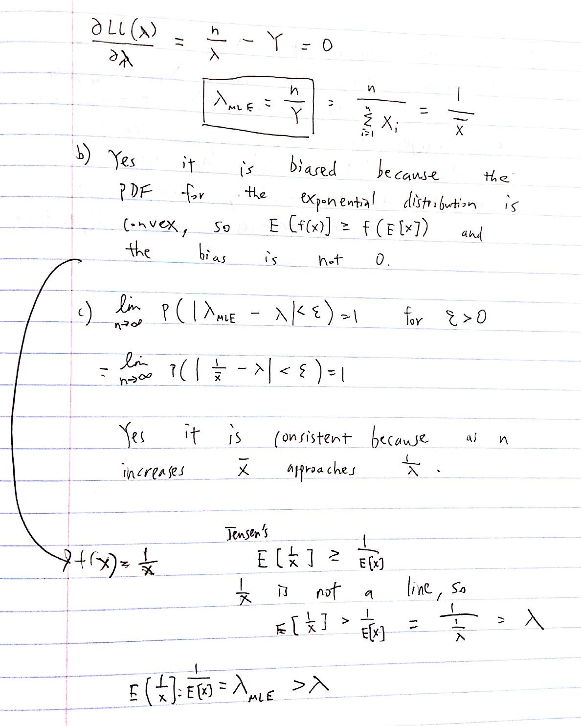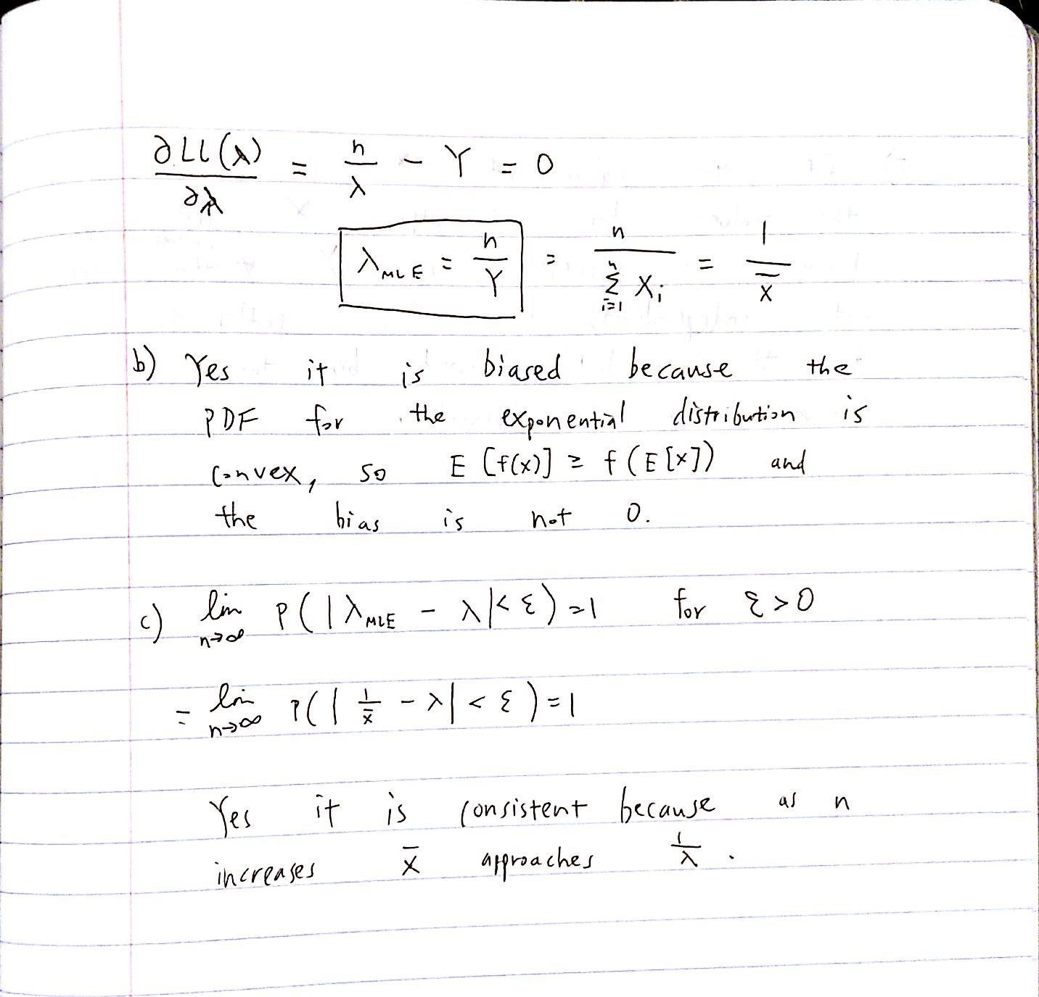

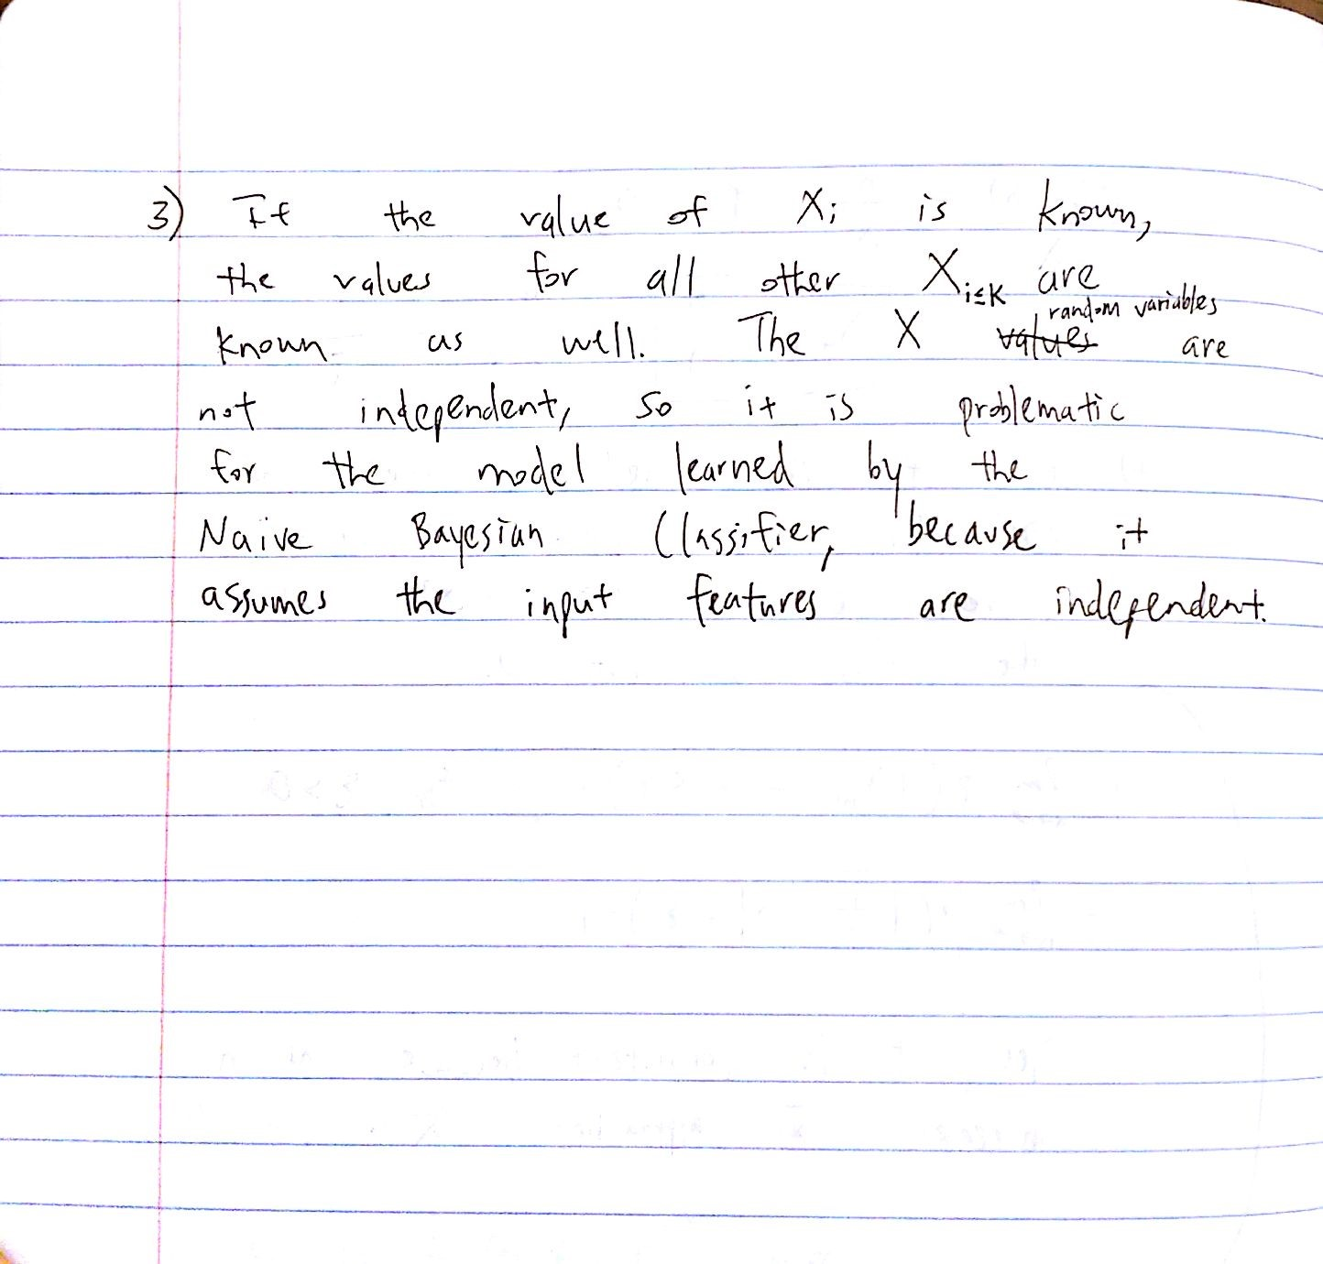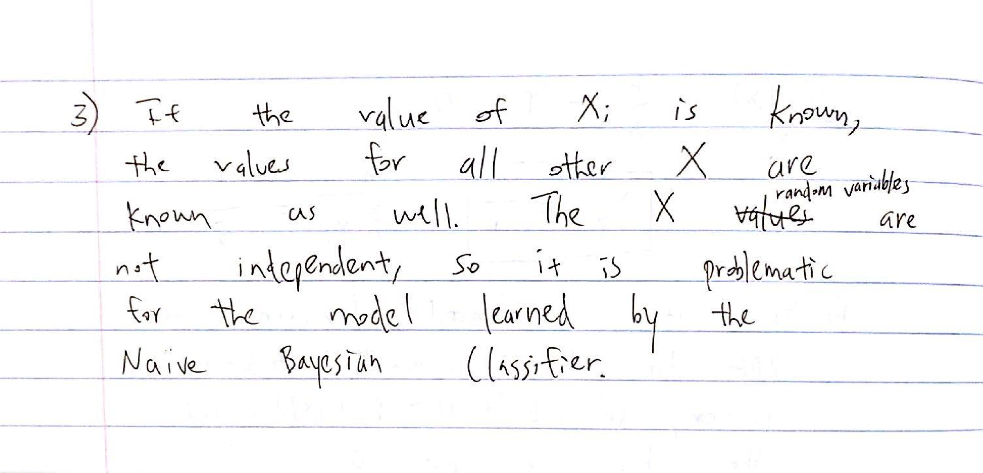

1. No Laplace Estimators

Class 0: tested 2, correctly classified 2

Class 1: tested 2, correctly classified 2

Overall: tested 4, correctly classified 4

Accuracy: 1.000000

With Laplace Estimators

Class 0: tested 2, correctly classified 2

Class 1: tested 2, correctly classified 2

Overall: tested 4, correctly classified 4

Accuracy: 1.000000

1. No Laplace Estimators

Class 0: tested 48, correctly classified 52

Class 1: tested 76, correctly classified 83

Overall: tested 124, correctly classified 135 Accuracy: 0.918519

With Laplace Estimators

Class 0: tested 48, correctly classified 52

Class 1: tested 76, correctly classified 83

Overall: tested 124, correctly classified 135

Accuracy: 0.918519

1. No Laplace Estimators

Class 0: tested 10, correctly classified 15

Class 1: tested 135, correctly classified 172

Overall: tested 145, correctly classified 187 Accuracy: 0.775401

With Laplace Estimators

Class 0: tested 10, correctly classified 15

Class 1: tested 130, correctly classified 172

Overall: tested 140, correctly classified 187 Accuracy: 0.748663

1. Laplace Estimators did not change the accuracy of the vote data, but decreased the accuracy for the heart data. In general, Laplace Estimators improve accuracy when test data produce unrepresentative MLE estimates, such as an MLE estimate of 0 for an event that can actually occur. Otherwise, Laplace Estimators are not better than MLEs for classification accuracy.

/* CS109 HW5.1: Naive Bayes

* ------------------------
* This file contains starter code for your Naive Bayes classifier. Your job
* is to read in the data file and implement the Naive Bayes algorithm.

*

* Note: This starter code is written without the Stanford libraries. If you
* took CS106A and want that style of starter code, download the other

Java

* starter code.

*/

import java.util.*; import java.io.*;

public class NaiveBayes

{

String fileName;

Scanner input;

Table[] table; //table for Y and each Xi, taken from training data int[] classVar; //instances of Y=0 and Y=1 in training data

int[][] accuCount; //cc[y][0] is number of successes for Y=y

//cc[y][1] is number of tests Y=y

public void run()

{

input = new Scanner(System.in);

System.out.print("Select a file (simple, vote, heart): ");

fileName = input.next();

readTrainingInput();

System.out.println("No Laplace Estimators"); calcResults();

reportResults();

System.out.println("\nWith Laplace Estimators");

toggleLaplace(); calcResults();

reportResults();

// sanity check for P(X=1 | Y=1)

// for(int i = 0; i < table.length; i++)

// {

// double py1 = 1-

(double)classVar[0]/(classVar[0]+classVar[1]);

|  |  |  |
| --- | --- | --- |
| //  1)/py1); |  | System.out.println(i+1 + " " + table[i].getMLE(1, |
| // |  |  |
| //  } | } |  |

public void toggleLaplace()

{

// System.out.println(classVar[0] + "\t" + classVar[1]);

for(int i = 0; i < table.length; i++)

{

table[i].toggleLaplace();

}

|  |  |
| --- | --- |
|  | //update the number of Y=0 and Y=1 |
|  | classVar[0] += 2;//limited to binary variables |
|  | classVar[1] += 2; |
| // | System.out.println(classVar[0] + "\t" + classVar[1]); |
| } |  |

public void reportResults()

{

System.out.printf("Class 0: tested %d, correctly classified %d\n", accuCount[0][1], accuCount[0][0]);

System.out.printf("Class 1: tested %d, correctly classified

%d\n", accuCount[1][1], accuCount[1][0]); int num = accuCount[0][0]+accuCount[1][0]; int denom = accuCount[0][1]+accuCount[1][1];

System.out.printf("Overall: tested %d, correctly classified

%d\n", denom, num);

System.out.printf("Accuracy: %f\n", (double)num/denom);

}

public void calcResults()

{

try {

input = new Scanner(new File("src/PC-datasets/" + fileName + "-test-PC.txt"));

} catch (FileNotFoundException e) { e.printStackTrace();

}

int vectorLength = input.nextInt(); int numVectors = input.nextInt();

accuCount = new int[2][2];//limited to binary variables

int[] x = new int[vectorLength]; //input vector

for(int i = 0; i < numVectors; i++)

{

for(int j = 0; j < vectorLength-1; j++)

{

x[j] = input.nextInt();

}

x[vectorLength-1] =

Integer.parseInt(input.next().substring(0, 1));

|  |  |  |
| --- | --- | --- |
| // |  | System.out.print(i + ": "); |
|  |  | int yhat = calcYhat(x); |
| // |  | System.out.println("Yhat = " + yhat); |
|  |  | int y = input.nextInt(); |
|  |  |  |
|  |  | accuCount[y][1]++; |
|  |  | if(y == yhat) |
|  |  | { |
| // |  | System.out.println("Accurate"); |
|  |  | accuCount[y][0]++; |
|  |  | } |
|  |  | else |
|  |  | { |
| // |  | System.out.println("Inaccurate"); |
|  |  | } |
|  | } |  |
|  |  |  |
|  |  |  |
| // | for(int i = 0; i < table.length; i++) | | |
| // | table[i].toggleLaplace(); | | |
| //  } | System.out.println("with laplace: Yhat = " + calcYhat(x)); | | |

public int calcYhat (int[] x)

{

|  |  |
| --- | --- |
| //P(Y=0) | double py0 = (double)classVar[0]/(classVar[0]+classVar[1]); |
|  | double py1 = 1 - py0; //P(Y=1) |
|  |  |
| // | double p0 = Math.log(py0); |
| // | for(int i = 0; i < table.length; i++) |
| // | { |
| // | p0 += Math.log(table[i].getMLE(x[i], 0)) - |

Math.log(py0);

|  |  |
| --- | --- |
| // | } |
| // | double p1 = Math.log(py1); |
| // | for(int i = 0; i < table.length; i++) |
| // | { |
| // | p1 += Math.log(table[i].getMLE(x[i], 1)) - |

Math.log(py1);

|  |  |
| --- | --- |
| // | } |
|  | //P(X, Y=0) |
|  | double p0 = py0; |
|  | for(int i = 0; i < table.length; i++) |
|  | { |
|  | p0 *= table[i].getMLE(x[i], 0) / py0; |
|  | } |
|  | //P(X, Y=1) |
|  | double p1 = py1; |
|  | for(int i = 0; i < table.length; i++) |
|  | { |
|  | p1 *= table[i].getMLE(x[i], 1) / py1; |
|  | } |
|  |  |
| //  p0); | System.out.printf("P(X, Y=1)=%.10f\tP(X, Y=0)=%.10f\n", p1, |
|  | if(p1 < p0) |
|  | { |
|  | return 0; |
|  | } |
| } | return 1; |

public void readTrainingInput()

{

try {

input = new Scanner(new File("src/PC-datasets/" + fileName + "-train-PC.txt"));

} catch (FileNotFoundException e) { e.printStackTrace();

}

classVar = new int[2]; int vectorLength = input.nextInt(); int numVectors = input.nextInt(); table = new Table[vectorLength];

for(int i = 0; i < table.length; i++) {

table[i] = new Table(2, 2);//limited to binary variables

}

for(int i = 0; i < numVectors; i++)

{

int[] x = new int[vectorLength];

for(int j = 0; j < x.length-1; j++)

{

x[j] = input.nextInt();

}

//last x-value has colon attached to it

x[vectorLength-1] =

Integer.parseInt(input.next().substring(0, 1));

int y = input.nextInt(); classVar[y]++;

for(int j = 0; j < x.length; j++)

{

table[j].add(x[j], y);

}

}

}

public static void main(String[] args)

{

//TODO: Fill this out!

NaiveBayes n = new NaiveBayes();

n.run();

}

}

public class Table

{

int[][] table;

boolean laplace;

public Table(int i, int j)

{

table = new int[i][j];

laplace = false;

}

public void toggleLaplace()

{

int d = 1; if(laplace)

{

d = -1;

}

for(int i = 0; i < table.length; i++)

{

for(int j = 0; j < table[i].length; j++)

{

table[i][j] += d;

}

}

laplace = !laplace;

}

public void add(int i, int j)

{

table[i][j]++;

}

public int get(int i, int j)

{

return table[i][j];

}

public double getMLE(int i, int j)

{

return (double)table[i][j] / sum();

}

public void print()

{

for(int i = 0; i < table.length; i++)

{

for(int j = 0; j < table[i].length; j++)

{

System.out.print(table[i][j] + " ");

}

System.out.println();

}

}

private int sum()

{

int res = 0;

for(int i = 0; i < table.length; i++)

{

for(int j = 0; j < table[i].length; j++)

{

res += table[i][j];

}

}

return res;

}

}