Quantification of Formate by HPLC
Lecture notes for the laboratory course: principles of chromatography and HPLC, reading chromatograms, quantification, accuracy and precision
About these notes
These notes follow the same structure as the slide deck, with fuller explanations, page references and verbatim quotes from the sources. Items marked [to be filled in] are completed once the column and mobile phase are fixed.

1. Learning Objectives and Outline
- Understand the principle by which chromatography separates compounds and how an HPLC system is built.
- Read and interpret the basic terms and units of a chromatogram: t₀, void volume, flow-through (FT) and column volume.
- Back-calculate sample concentrations from a formate calibration curve and judge the reliability of the analysis with %CV and %RE.
Formate is one of the metabolites that accumulate in aerobic and micro-aerobic cultures of E. coli; culture conditions and sampling follow the week-13 lecture [3, p.10].
Notation
'CV' is used both for column volume and for the coefficient of variation. In these notes column volume is written out (CV appears only on figure axes) and the coefficient of variation is written %CV. 'FT' stands for flow-through.

2. Principles of Chromatography
Chromatography separates a mixture by exploiting the fact that each compound spends a different share of time in the stationary phase (a solid, or a liquid fixed on a solid, held in the column) and the mobile phase (the liquid that carries the sample) [1, p.12]. As shown in Fig. 1, once the sample is injected and the mobile phase keeps flowing, the compounds split into bands that reach the detector in order of their migration speed.
The distribution between the two phases is described by the partition coefficient K = C_{s}/C_{m} (concentration in the stationary phase over that in the mobile phase at equilibrium). A compound with a large K stays longer in the stationary phase and elutes later; one with a small K elutes early [1, p.13–14]. Each component of a mixture has its own K (Fig. 2), and differences in K drive the separation. Because K depends directly on temperature, pH and solvent polarity, the analyst tunes these conditions to optimize the separation [1, p.15].
The property a separation relies on is called its mode: charge (ion exchange), size (size exclusion or gel filtration), hydrophobicity (reversed phase) or specific binding (affinity). The same mode can be carried out in different formats such as open columns, FPLC and HPLC [1, p.10–11, 16–25]. Preparative chromatography, as in protein purification, collects the separated compounds, whereas analytical chromatography injects a small amount and measures it from the detector signal; today's formate quantification is analytical [1, p.16, 22].
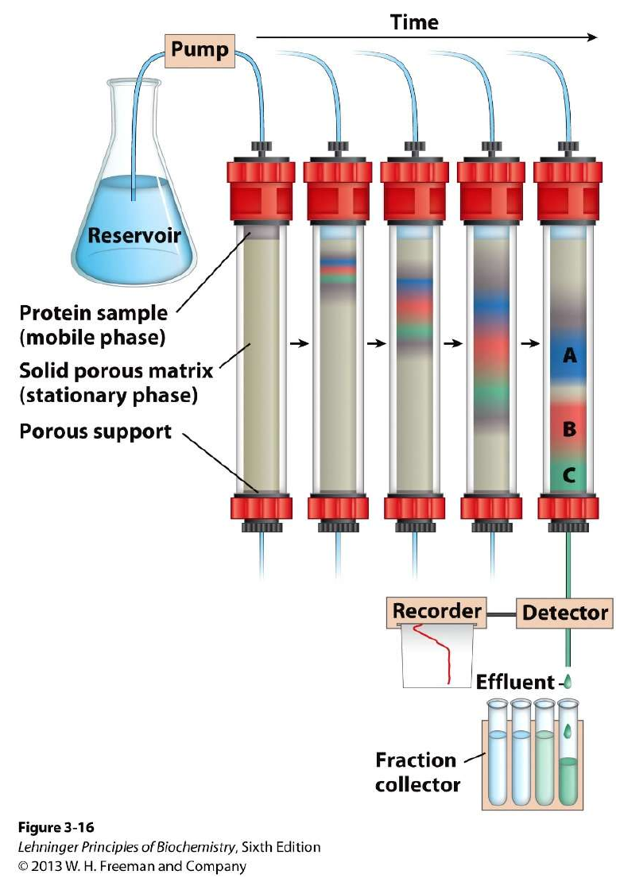  Fig. 1. Column chromatography: sample bands (A, B, C) separate while passing through the stationary phase. Source: [2], Fig. 3-16, Lehninger Principles of Biochemistry, 6th ed., © 2013 W. H. Freeman and Company; reproduced in [1, p.12]. | 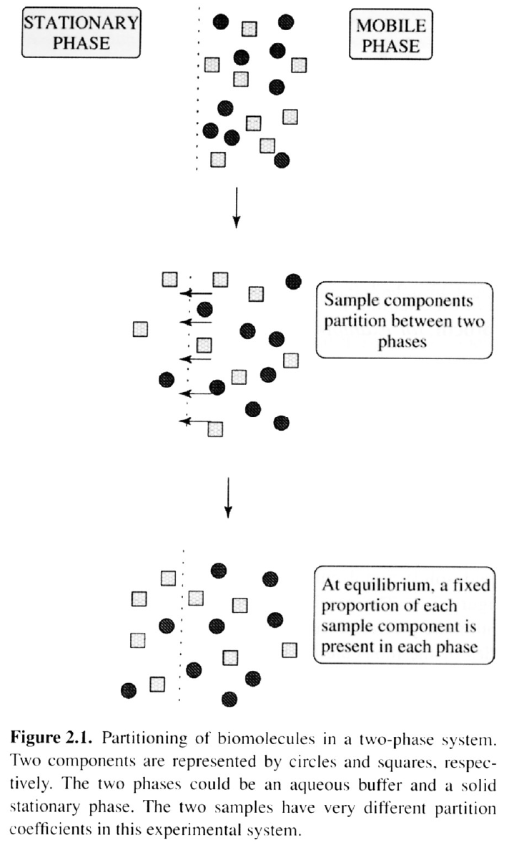  Fig. 2. Two components partition between the stationary and mobile phases and reach equilibrium. Source: [1, p.14], Figure 2.1 (the original book is not named in the class material).

3. HPLC in Brief
HPLC (High Performance Liquid Chromatography) pumps the sample and mobile phase at high pressure through a column packed with small particles to obtain high resolution [1, p.29; 3, p.3]. Smaller particles give narrower peaks and resolve closely eluting compounds, but the narrow gaps between them require high pressure.
The mobile phase flows from the reservoir through (degassing,) the pump, the injector, the guard column and the analytical column to the detector (Fig. 3); stainless-steel tubing is used where the pressure is high [1, p.29]. Solvents must be degassed before use, by gas purging or vacuum [1, p.30]. Common detectors are UV, fluorescence and refractive index (RI) [1, p.29]. In general UV detects compounds that absorb, while RI responds to almost any compound but is less sensitive and sensitive to temperature changes [5]. FPLC works on the same principle but is preparative, using aqueous buffers and much lower pressure to keep biomolecules native [1, p.32].
Mode | Stationary / mobile phase · notes | Source
Normal phase | Polar stationary / non-polar mobile phase. Retention decreases as mobile-phase polarity decreases. Hydrophobic samples, isomers | [3, p.4]
Reversed phase | Hydrophobic stationary / water (buffer) + organic solvent. More polar analytes are retained less | [3, p.5]
Ion exchange | Separation by charge | [3, p.3]
Size exclusion | Separation by molecular size | [3, p.3]

Column and mobile phase in this lab
[to be filled in] (check the mode in the table above once the column is fixed)

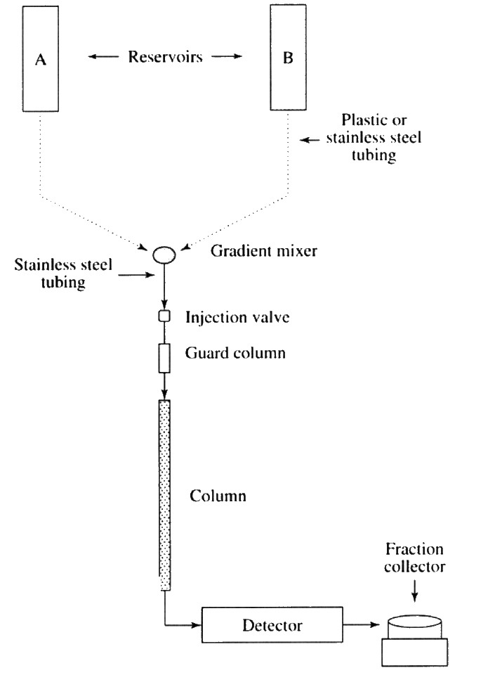
Fig. 3. A typical HPLC system. Original caption: "Overview of typical HPLC system. Low-pressure region of the system where tubing may be plastic is denoted by dashed line. Solid lines denote stainless steel tubing required due to high pressure." Source: [1, p.29], Figure 2.20 (book not named). Overlapping slide text at the edge was removed.

4. Reading a Chromatogram
Term | Definition · equation | Source
t_{R} retention time | Time from injection to the peak maximum | [3, p.6]
t₀ dead time | Elution time of a compound that does not interact with the stationary phase | [3, p.6]
k retention factor | k = (t_{R} − t₀)/t₀ | [3, p.6]
α selectivity | α = k₂/k₁ | [3, p.6]
R resolution | R = 2(t_{R2} − t_{R1})/(w₁ + w₂). R = 1.5 is baseline resolution; R = 2 is preferred in method development | [3, p.7]
N plate number | N = 5.54 (t_{R}/w_{1/2})² (w_{1/2}: width at half height) | [13], [5]
Purnell equation | R = (√N/4)·((α − 1)/α)·(k/(1 + k)) | [6], [5]
van Deemter | H = A + B/u + C·u (H: plate height, u: linear velocity). There is an optimum flow rate | [7]
Tailing factor T | T = W_{0.05}/2f (at 5% height). Definitions differ between methods; check which one is used | [12]

Read a chromatogram in three steps: ① compare with a blank to separate peaks near the void from analyte peaks; ② confirm formate by matching its t_{R} with the standard (identification); ③ calculate the concentration from the peak area (quantification). Resolution depends on N (peak width), α (selectivity) and k (retention). Because N must increase fourfold to double R, α is usually adjusted first [13].
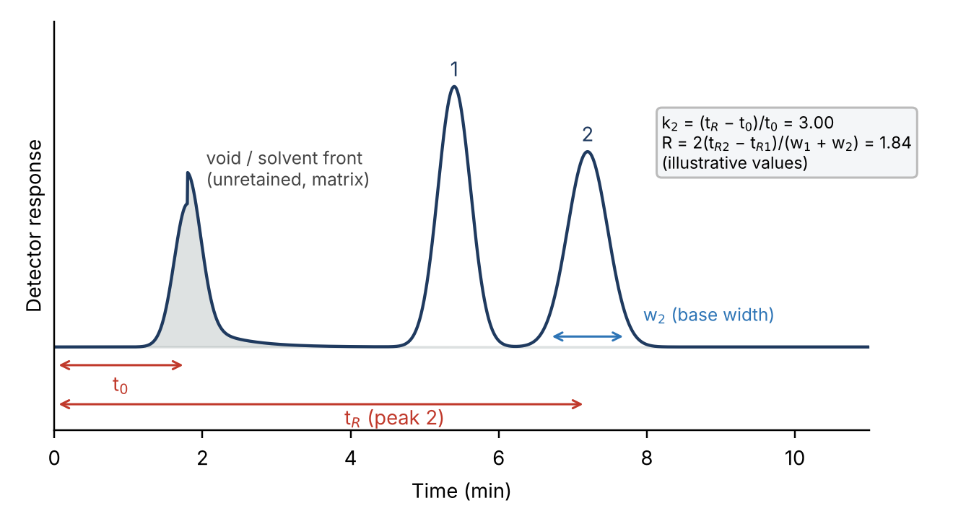
Fig. 4. Elements of a chromatogram (schematic, illustrative values). Terms and equations follow [3, p.6–7] and [5].

5. Column Volume and Other Units; Cautions on the Void Volume
- Column volume is the geometric volume of the packed bed, πr²L; bed volume refers to the same packed volume [9]. Wash, equilibration and elution steps are expressed in multiples of the column volume.
- Flow rate F (mL/min) and linear velocity u = F/(πr²). Elution volume V_{e} = F × t_{R}; total volume V_{t} ≈ column volume.
- Example (actual column dimensions to be filled in): for 7.8 mm i.d. × 300 mm, column volume = π(0.39 cm)²(30 cm) ≈ 14.3 mL; at F = 0.6 mL/min one column volume takes about 24 min.
The void volume (V~0~) is the volume of mobile phase between (outside) the packed particles, i.e. the volume at which a compound that does not interact with the stationary phase elutes (t₀ = V₀/F). In size exclusion nothing elutes before V₀; separation takes place between V₀ and V_{t} and is expressed as K_{av} = (V_{e} − V₀)/(V_{t} − V₀) [9]. Molecules larger than the exclusion limit cannot enter the bead pores and elute in the void (Fig. 6) [1, p.18].
Void volume: cautions
- Large peaks near the void (medium salts, sample matrix) are not the analyte. Identify them by comparison with blank and control chromatograms.
- A measured t₀ or V₀ can include the tubing volume between injector and detector (extra-column volume), so it may read larger than the column's own void [5].
- Keep k large enough that the first analyte peak does not overlap the void peak [5].
- Changing the flow rate changes t₀ (min) but not V₀ (mL); compare results from different conditions on a volume basis.

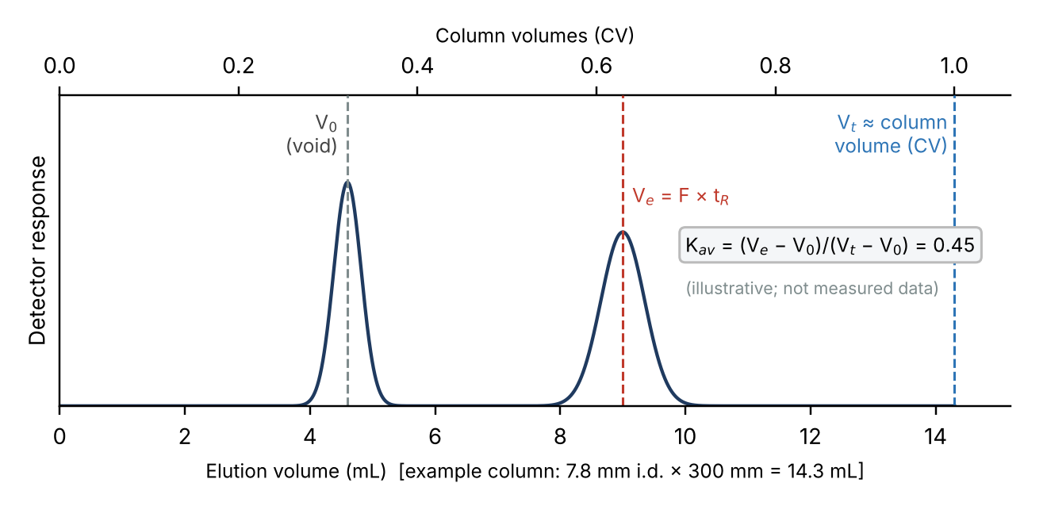
Fig. 5. V₀, V_{e}, V_{t} (= column volume) and K_{av} on an elution-volume axis (schematic, illustrative values). Definitions from [9].
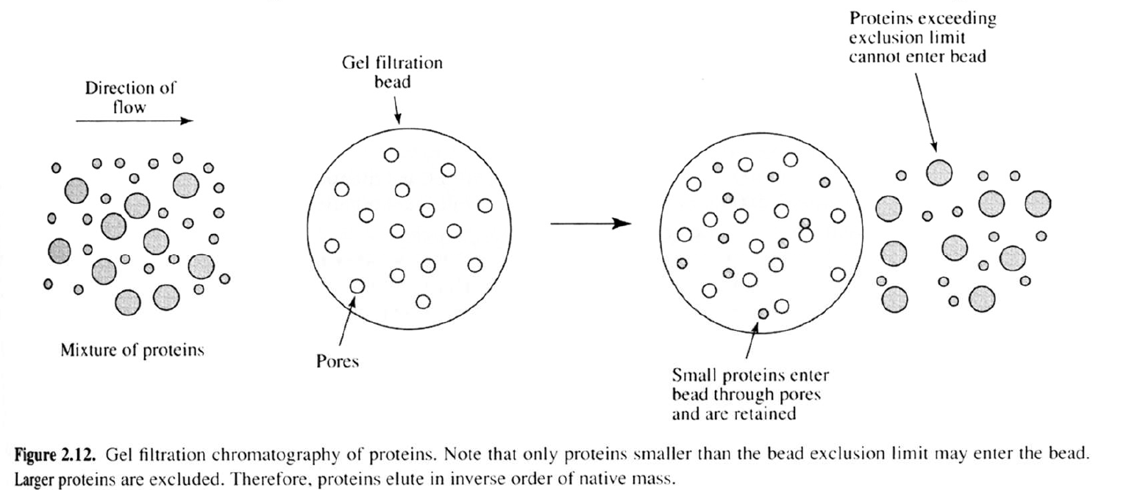
Fig. 6. In gel filtration, proteins larger than the exclusion limit cannot enter the beads and elute first, in the void. Source: [1, p.18], Figure 2.12 (book not named).

6. Cautions on the Flow-Through (FT)
The flow-through (FT) is, in bind–elute chromatography such as ion exchange or affinity, the fraction that passes through the column without binding while the sample is loaded (Fig. 8). In ion exchange, molecules with the same sign of charge as the resin do not bind and pass straight through; the caption of Fig. 7 states that "positively-charged proteins pass straight through the stationary phase" [1, p.21]. Bound molecules are later released with competing ions, for example an NaCl gradient [1, p.21].
FT: cautions
- Collect and keep the FT. Finding the target in the FT signals failed binding (mismatched conditions) or overload (capacity exceeded).
- Match the pH and ionic strength of the load to the equilibration buffer. Excess salt weakens binding and the target leaks into the FT; the class material advises desalting before ion exchange [1, p.21].
- Continue the FT and wash steps until the baseline returns (usually counted in column volumes) before starting elution.
- Net charge depends on pH, so proteins that do not separate at one pH may separate at another [1, p.21].

Relevance to this lab
If formate is separated isocratically by differences in retention rather than by binding to the column, there is no FT fraction; the corresponding idea is the void peak of unretained compounds. Salts and matrix in the sample still elute near the void, so the same care applies (confirm once the column is fixed).

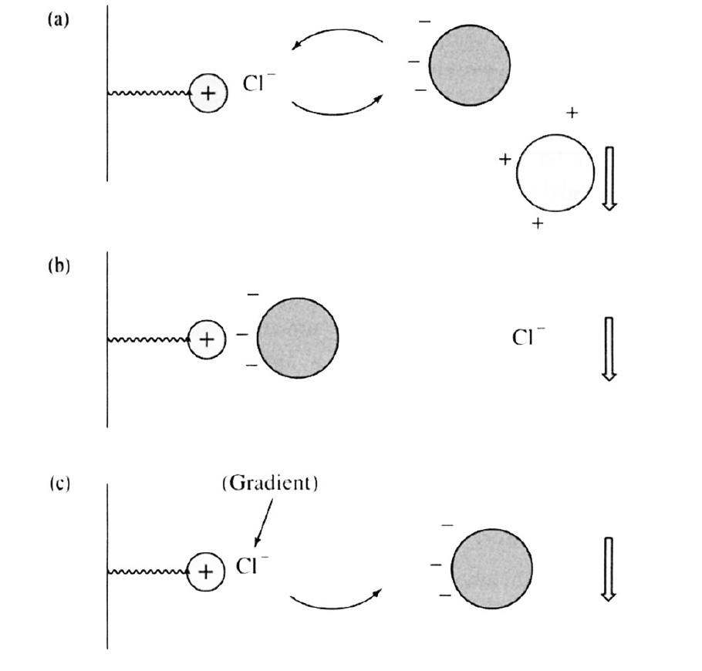  Fig. 7. A typical ion exchange experiment: (a) Cl⁻ bound to a positively charged exchanger, (b) a negatively charged protein exchanges with Cl⁻ and binds, (c) Cl⁻ from an NaCl gradient elutes the protein; positively charged proteins pass straight through. Source: [1, p.21], Figure 2.11 (book not named). | 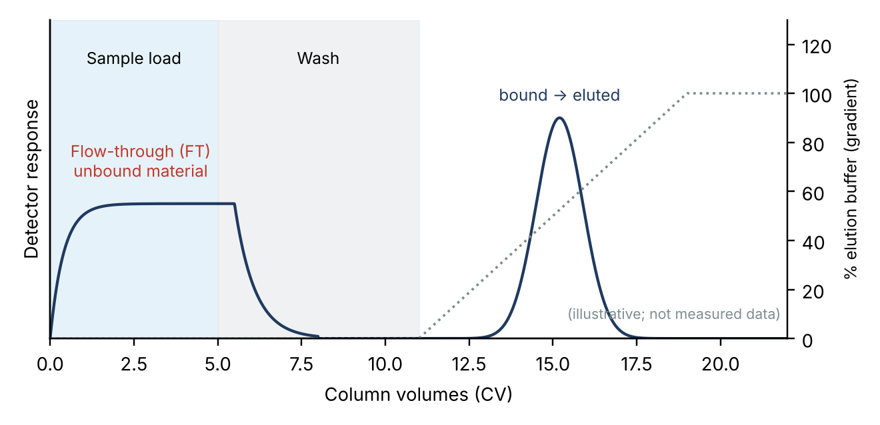  Fig. 8. FT peak during loading and gradient elution peak in bind–elute chromatography (schematic, illustrative values).

7. Main Parameters That Shape a Chromatogram
Parameter | Retention (t_{R}) | Peak width · separation | Practical notes
Flow rate F | F↑ → t_{R}↓ (t_{R} ∝ 1/F); pressure↑ | An optimum flow rate gives maximum efficiency [7] | t₀ and t_{R} change together; use the same flow for standards and samples
Column temperature | Usually T↑ → t_{R}↓ (K depends on temperature [1, p.15]) | Lower viscosity, faster diffusion → narrower peaks, lower pressure | Stay within the column limit; keep oven and detector stable (especially RI)
Eluent strength (organic %, acid or salt) | RP: more organic → t_{R}↓ [1, p.22, 30]; IEX: more salt → t_{R}↓ [1, p.21] | Changes k and α together | Bottle-to-bottle differences shift retention and baseline; one bottle per sequence
Mobile-phase pH, ionic strength | Weak acids and bases change ionization near their pKa | Changes selectivity α | Minimize pH preparation errors; RP is sensitive to pH, polarity and temperature [1, p.22]
Column length L, particle size d_{p} | L↑ → t_{R}↑ | N ∝ L/d_{p}; pressure ∝ L/d_{p}² [3, p.8], [5] | Small particles need filtration and pressure control [1, p.29]
Stationary phase | Defines the interaction | Largest effect on α | Choice of mode [3, p.3–5]
Injection volume, sample solvent | Shifts when overloaded | Broader peaks, tailing | Use a solvent close to the eluent and a fixed volume
Detector settings | Little effect | Wavelength, time constant, sampling rate change shape | RI is sensitive to temperature and flow [5]

These are general trends and depend on conditions; rows without a source are general principles [5]. Since eluent strength, temperature and flow rate all change retention, always run standards and samples under identical conditions, and re-check the calibration and retention times whenever conditions change.
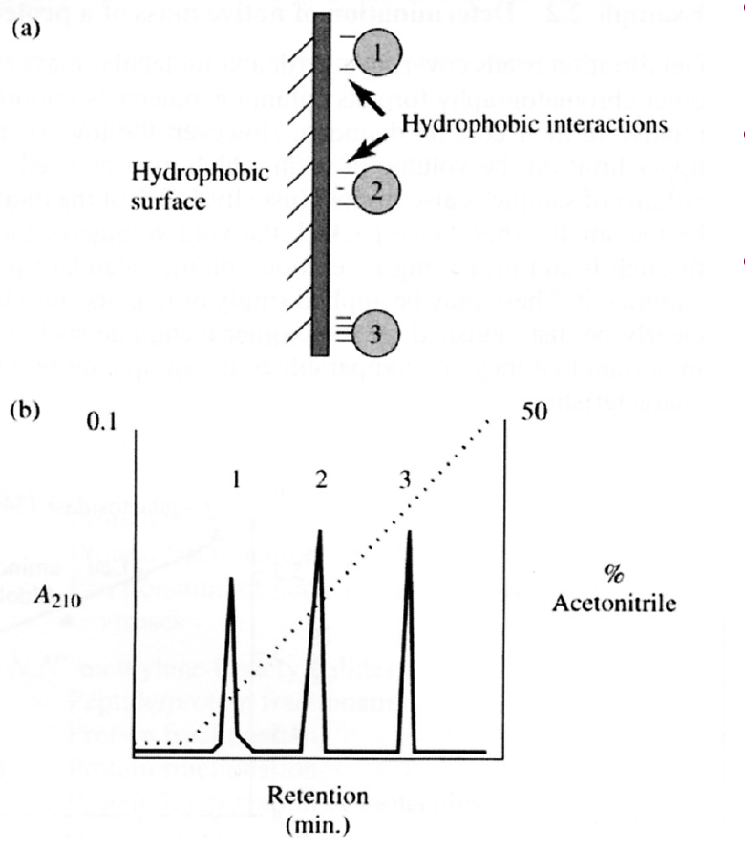  Fig. 9. Reversed-phase chromatography: as acetonitrile (%) increases, more hydrophobic compounds (1 → 3) elute in turn. Source: [1, p.22], Figure 2.13 (book not named). | 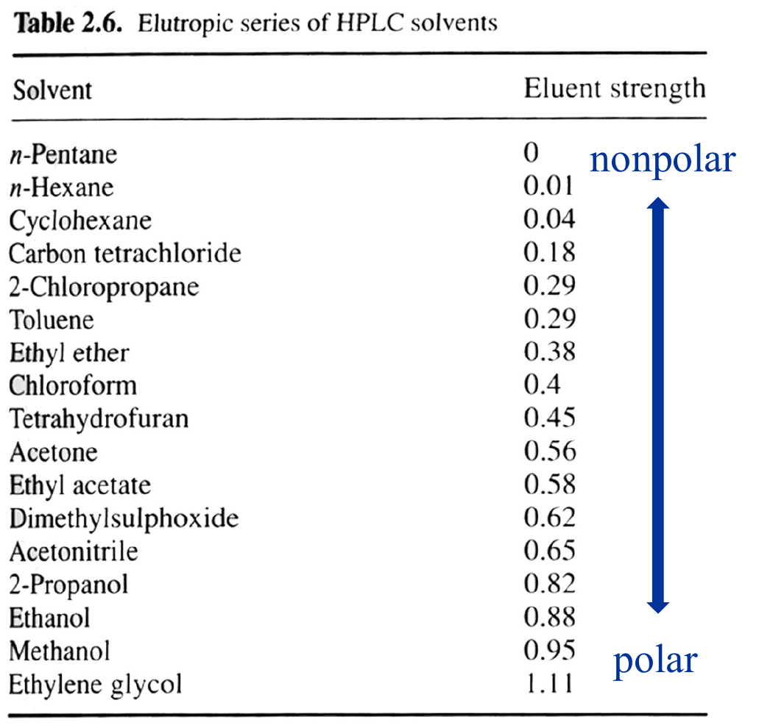  Fig. 10. Eluent strength of HPLC solvents (elutropic series). Source: [1, p.30], Table 2.6 (book not named).

8. Quantification: External Calibration, Standards, Sample Preparation, Dilution
As long as the detector works in its linear range, the peak area is proportional to concentration. The absolute (external) calibration method builds an area–concentration relationship (calibration curve) from standards of known concentration and reads unknowns from it [4]. In chromatography the response is typically a linear function of concentration, and loss of linearity indicates that the method has reached its limits [14, p.2].
- Standards [4]: prepare a 100 mM stock in a 100 mL volumetric flask (glucose: 180.156 g/mol → about 1.80 g; formate as sodium formate, 68.01 g/mol → 0.680 g for 100 mM in 100 mL) → 2-fold serial dilution to 100, 50, 25, 12.5 and 6.25 mM → filter 1 mL through a syringe filter into a vial insert placed in a 2 mL HPLC vial.
- Sample preparation [3, p.10]: dilute 100 µL of broth 10-fold (1 mL final) → centrifuge → filter the supernatant → store at −20 °C → analyze. Centrifugation removes cells; filtration protects the column.
- Back-calculation and dilution: C_{measured} = (A_{sample} − b)/a; C_{broth} = C_{measured} × DF (DF = 10 here). Example (Fig. 11, hypothetical): A = 12,400 → C_{measured} = (12,400 − 99)/1982 = 6.21 mM → × 10 = 62.1 mM.
Cautions
- Sample concentrations must lie within the calibration range; never extrapolate. Re-analyze out-of-range samples at a suitable dilution [14, p.8], and set the range to match expected sample concentrations [14, p.5].
- The handout range (6.25–100 mM) may be higher than formate levels after a 10-fold dilution; consider adding lower standards [to be checked: expected formate level].
- R² and RMSE are designed to minimize the error of the response, not of the reported result [14, p.6]. Do not judge a curve by R² alone; check the back-calculated %RE of the standards.
- The dilution factor of 10 is easy to forget.

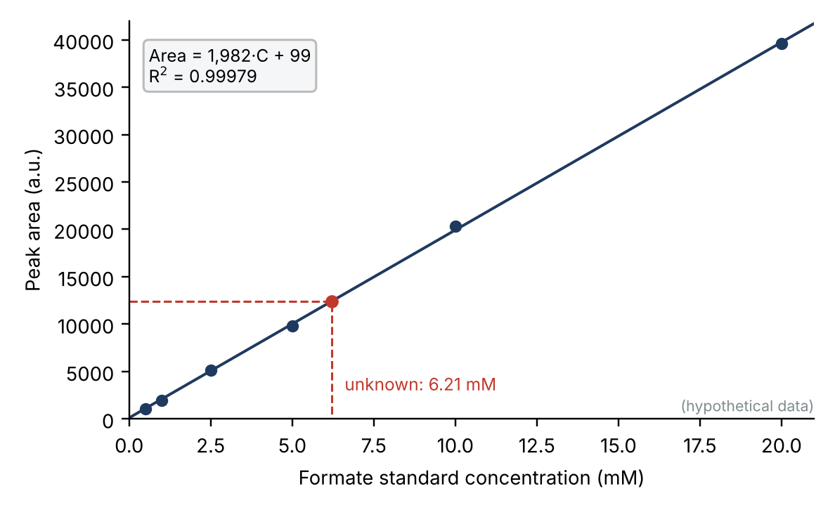
Fig. 11. Calibration curve and back-calculation of an unknown (6 hypothetical levels). Area = 1982·C + 99, R² = 0.99979. Dashed lines show how a sample area is read off. Not measured data.

9. Procedure (Summary) and Analytical Conditions
Step | What to do | Check
1 | Prepare formate standard solutions: stock of sodium formate (e.g. 100 mM) → 2-fold serial dilution to 5–6 levels | Accurate weighing, volumetric flask, low levels covered. Prepare QCs from a separate stock [14, p.2]
2 | Filter samples: filter samples (supernatant) and standards with a syringe filter → vial insert → HPLC vial. Pore size and material [lab standard] | Filter compatibility, no bubbles, labels
3 | Prepare the load: blank (solvent), control (medium matrix), standards (low → high), samples, QCs in sequence. Injection volume [ ] µL | Avoid carry-over; same solvent for standards and samples; re-inject one standard mid-run
4 | Compare peaks with controls: locate void and system peaks in blank and control → confirm the formate peak at the standard's t_{R} | No interfering peak; R ≥ 1.5 to neighbors
5 | Compare areas: integrate standards and samples with the same settings | Same integration rules, stable baseline, tailing
6 | Calibrate and back-calculate: fit y = ax + b → convert sample areas to concentrations → × dilution factor | Within range; no extrapolation
7 | Compute %CV and %RE: precision and accuracy from back-calculated standards and replicate QCs | CV on back-calculated concentrations, not areas [14, p.6]
8 | Judge against acceptance limits: pass/fail; investigate and re-run on failure | Limits [ ± __ %, ≤ __ % ]

Analytical condition | Value (fill in once column and mobile phase are fixed)
Column | [ ]
Mobile phase (composition) | [ ]
Flow rate | [ ]
Column temperature | [ ]
Detector | [ ]
Injection volume | [ ]
Run time | [ ]
Expected formate t_{R} | [ confirm with a standard ]

10. Accuracy (%RE), Precision (%CV) and Acceptance Limits
- Accuracy, %RE (relative error) = (mean measured − nominal)/nominal × 100. Azadeh et al. define RE as "the ratio of the difference between experimental and theoretical values over theoretical value" [14, p.6] and write %Bias = (Determined − Nominal)/Nominal × 100 [14, p.9].
- Precision, %CV = (standard deviation SD/mean) × 100 (sample SD, n−1). For each calibrator, report the CV of back-calculated concentrations, not of the instrument response [14, p.6].
- Back-calculation of standards: feed each standard's area into the regression and check the %RE of the result to verify linearity and range.
- Example: mid QC (nominal 7.5 mM, n = 3): 7.56, 7.45, 7.64 mM → mean 7.55, SD 0.094 → %CV = 1.24 %, %RE = +0.68 %.
Item | HPLC (chromatographic) common criteria [10, 11] | LBA white paper [14, Table I, p.3]
Calibrator RE | ±15% of nominal (LLOQ ±20%) | ±20% (LLOQ ±25%; EMA and MHLW also ULOQ ±25%; ANVISA ±15%/±20%)
Calibrator CV | ≤15% (LLOQ ≤20%) | <20% (LLOQ 25%)
Pass rate | ≥75% of non-zero standards | ≥75%, including LLOQ and ULOQ [14, p.6]
Number of standards | At least 6 levels | At least 6 non-zero, in duplicate
QC accuracy/precision | ±15% / ≤15% (LLOQ ±20% / ≤20%) | Total error ±30% (FDA, EMA)
R² criterion | — | Not set by FDA, EMA, MHLW; ANVISA 0.99

Verification status and scope
The white paper by Azadeh et al. [14] was checked directly in the supplied PDF (●). It covers ligand binding assays for pharmacokinetics (p.2), whose sigmoidal responses justify wider limits than chromatography. The HPLC column could not be checked against the ICH M10 and FDA originals; only ±15% (LLOQ ±20%) was confirmed from secondary summaries, so verify before citing. As primary sources for chromatographic criteria, consult Viswanathan et al. (2007) [18] and the EMA guideline [15], both cited by [14]. Course limits: [ ± __ %, ≤ __ % ]

Nominal (mM) | Area | Back-calculated (mM) | %RE
0.5 | 1,080 | 0.495 | −0.99 %
1 | 1,960 | 0.939 | −6.10 %
2.5 | 5,160 | 2.553 | +2.13 %
5 | 9,800 | 4.894 | −2.12 %
10 | 20,300 | 10.191 | +1.91 %
20 | 39,600 | 19.927 | −0.36 %
Table A. Back-calculated standards (hypothetical). Area = 1982.3·C + 98.7, R² = 0.99979. All |%RE| ≤ 15% (max 6.1%).
Level | Nominal | Back-calculated (mM) | Mean | SD | %CV | %RE
Low | 1.5 | 1.49, 1.47, 1.53 | 1.50 | 0.033 | 2.21 % | −0.07 %
Mid | 7.5 | 7.56, 7.45, 7.64 | 7.55 | 0.094 | 1.24 % | +0.68 %
High | 15 | 14.98, 15.29, 15.06 | 15.11 | 0.160 | 1.06 % | +0.75 %
Table B. QC replicates (n = 3, hypothetical). Values illustrate the calculation and are not measured data.

Appendix. Evidence for %RE and %CV (Azadeh et al., 2017)
The table summarizes the parts of the supplied white paper [14] that concern %RE, %CV and the handling of calibration curves, with page numbers. Quotes are verbatim; the right-hand column states how each point is applied in this lab.
Topic | Quote (summary) | Page | Application here
Scope | "…its focus remains on calibration curves for quantitative pharmacokinetic (PK) LBAs. All other assay types are outside the scope of this paper." | p.2 | Its numbers (±20/25%) are LBA limits; apply only the principles to HPLC
Chromatography differs | "…chromatographic assays where response is typically a linear function of the concentration… loss of linearity is an indication that the assay has reached its limits of the detection." | p.2 | HPLC uses linear calibration; quantify only within the linear range
Definition of RE | "relative error (RE; defined as the ratio of the difference between experimental and theoretical values over theoretical value)"; %Bias = (Determined − Nominal)/Nominal × 100 | p.6, p.9 | Basis of the %RE formula
Limits | Table I: RE ±20% (±25% LLOQ), CV <20% (25% LLOQ), ≥6 non-zero standards, duplicates, 75% passing, R² only by ANVISA (0.99) | p.3 | Comparison limits (Fig. 12)
75% rule | "A minimum of 75% of calibrators, including those at LLOQ and ULOQ levels, must pass…" | p.6 | With 6 levels, at least 5 must pass
Unit of CV | "CVs of back-calculated concentrations, and not those of the instrument response, should be reported for each calibrator." | p.6 | Compute %CV on back-calculated concentrations
Number of standards | "Calibration curves should include a minimum of six non-zero concentrations including LLOQ and ULOQ…" | p.4 | The handout's 5 levels are fewer than this
Independent QCs | "Preparation of calibrators must be independent of assay QCs… calibrators and QCs may not be prepared from the same intermediate stock." | p.2 | Prepare QCs from a different stock
Range | "The calibration range must be appropriate for and correspond to the anticipated concentration range of study samples." | p.5 | Set the range from expected formate levels
Limits of R² | R² and RMSE are "designed to minimize the error of the response instead of the error of the reportable result" | p.6 | Do not judge by R² alone
Editing rules | Mask CV failures first, then exclude one at a time by highest bias; no two consecutive; ≤25%; keep ≥6 points; only for assignable cause; "calibrators should not be excluded to facilitate QC passing" | p.6, p.8 | Record the reason when excluding a standard
Blank (zero) | "…the 2012 EMA bioanalytical guidance (9) provided the recommendation that the zero calibrator not be included in the calculation of calibration curve parameters in chromatographic assays." | p.15 | Do not include the blank in the regression

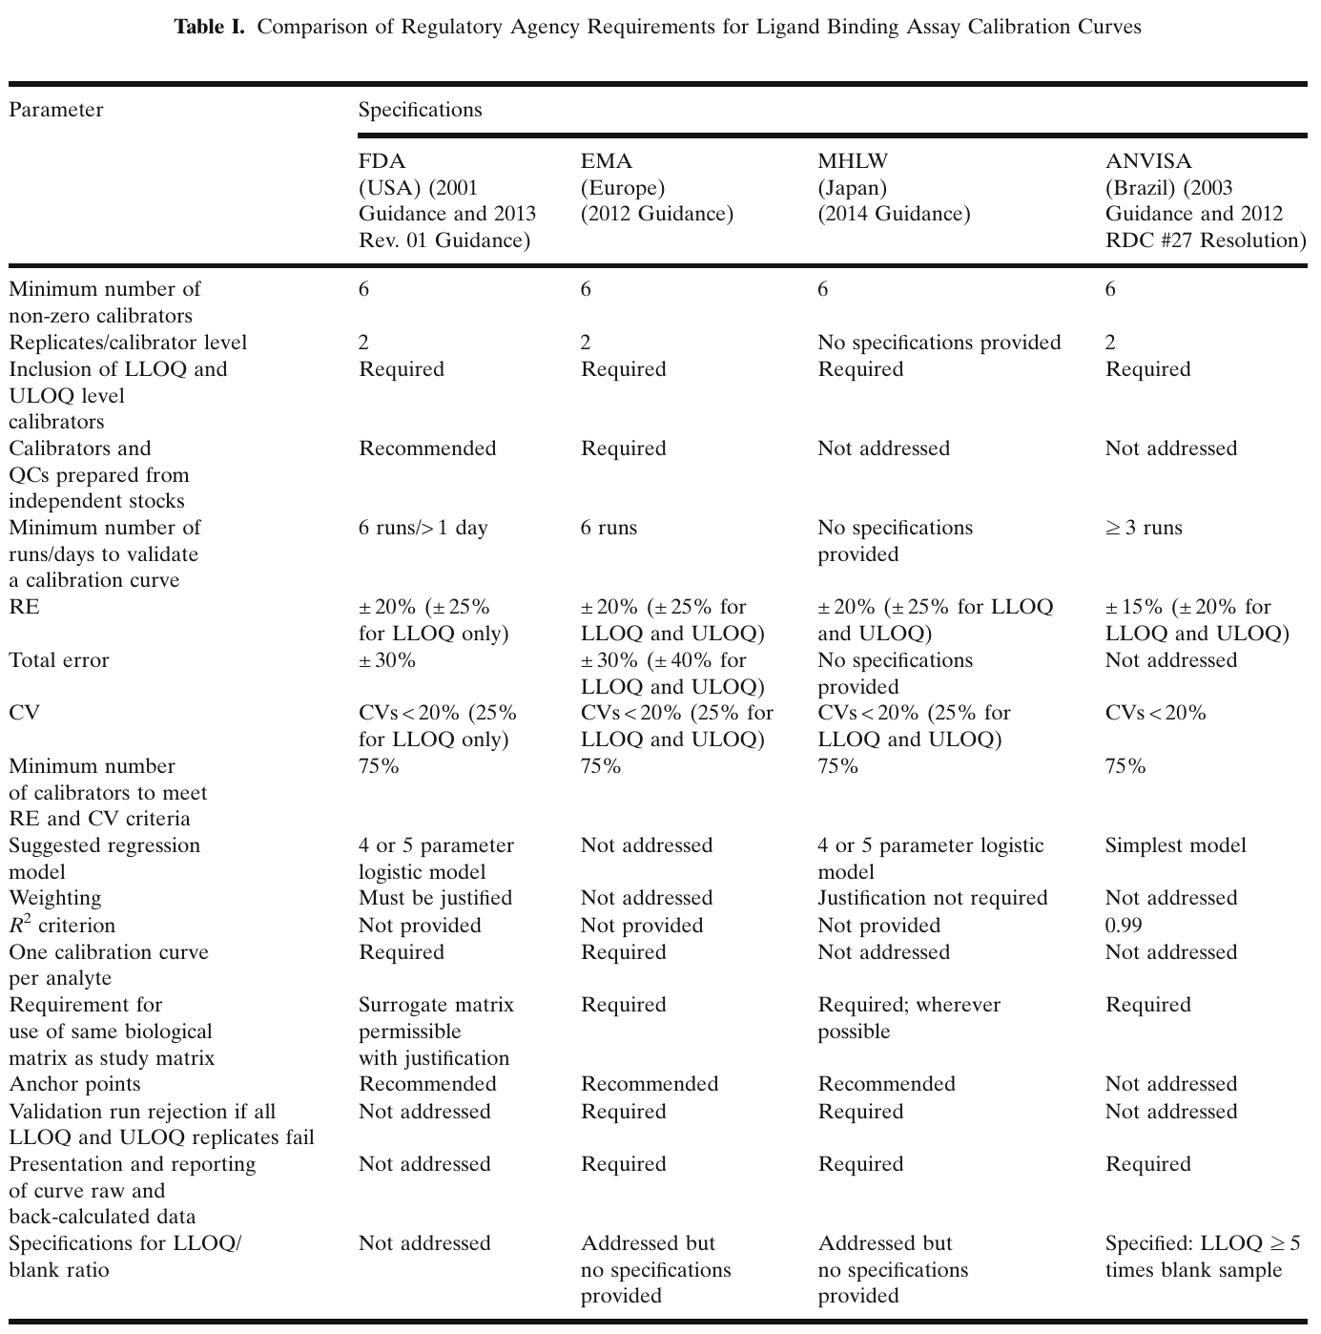
Fig. 12. Regulatory requirements for LBA calibration curves. Source: Azadeh et al. [14], Table I, p.3. Open Access, CC BY 4.0 (reproduced unchanged).

References
Status: ● verified in the supplied file ◐ verified via a secondary source (search result or reference list); original not opened ○ not verified (commonly cited bibliographic data; check before citing)
No. | Reference | Used in | Status
1 | Class material: "Protein purification & Structure determination", UNIST, Fall 2026, 53 slides (ProteinEng_Protein_Purification.pdf). p. = PDF slide number. | Figs. 1–3, 5–10 | ●
2 | Nelson DL, Cox MM. Lehninger Principles of Biochemistry, 6th ed. New York: W. H. Freeman and Company; 2013. Figure 3-16. (credit printed on [1] p.12) | Fig. 1 | ●
3 | Ryu H, Bassey BF. "13th Week — Metabolite analysis: HPLC". ECHE34101/2 Engineering Biology Laboratory, BCE_UNIST. 11 slides (20221201and02_HPLC_Lecture_1.pdf). | Slides 2–4, 7–9 | ●
4 | Class handout: "Standard preparation for HPLC" (in-class material). Absolute calibration method; standard preparation. | Slides 8–9 | ●
5 | Snyder LR, Kirkland JJ, Dolan JW. Introduction to Modern Liquid Chromatography, 3rd ed. Hoboken, NJ: Wiley; 2010. | Slides 3–7 | ○
6 | Purnell H. The correlation of separating power and efficiency of gas-chromatographic columns. J Chem Soc 1960:1268–1274. doi:10.1039/JR9600001268 | Slide 4 | ◐
7 | van Deemter JJ, Zuiderweg FJ, Klinkenberg A. Longitudinal diffusion and resistance to mass transfer as causes of nonideality in chromatography. Chem Eng Sci 1956;5(6):271–289. | Slides 4, 7 | ○
8 | Ettre LS. Nomenclature for chromatography (IUPAC Recommendations 1993). Pure Appl Chem 1993;65(4):819–872. doi:10.1351/pac199365040819 | Terminology | ○
9 | GE Healthcare (now Cytiva). Size Exclusion Chromatography: Principles and Methods, 18-1022-18 (copy found: Edition AI). Definitions of V₀, V_{e}, V_{t}, column volume. | Slide 5 | ◐
10 | ICH. M10: Bioanalytical Method Validation and Study Sample Analysis. Step 4, 24 May 2022. | Slide 10 | ◐
11 | US FDA. Bioanalytical Method Validation: Guidance for Industry. May 2018. | Slide 10 | ○
12 | USP–NF General Chapter <621> Chromatography (tailing factor, system suitability). | Slide 4 | ○
13 | Analytics-Shop. "Terms and equations used in HPLC explained". https://analytics-shop.com/gb/hplc-definition-equations | Slide 4 | ◐
14 | Azadeh M, Gorovits B, Kamerud J, MacMannis S, Safavi A, Sailstad J, Sondag P. Calibration curves in quantitative ligand binding assays: recommendations and best practices for preparation, design, and editing of calibration curves. AAPS J. 2017 (received 1 Aug 2017, accepted 28 Aug 2017). doi:10.1208/s12248-017-0159-4. Open Access (CC BY 4.0). p. = PDF page (1–16). | Slides 8–10, appendix, Fig. 12 | ●
15 | EMA. Guideline on bioanalytical method validation. EMEA/CHMP/EWP/192217/2009, July 21, 2011. (reference 9 of [14]) | Slide 10, appendix | ◐
16 | US FDA. Guidance for industry: bioanalytical method validation. May 2001. (reference 10 of [14]) | Slide 10 | ◐
17 | US FDA. Draft guidance for industry: bioanalytical method validation (Revised). September 2013. (reference 11 of [14]) | Slide 10 | ◐
18 | Viswanathan CT, Bansal S, Booth B, DeStefano AJ, Rose MJ, Sailstad J, et al. Quantitative bioanalytical methods validation and implementation: best practices for chromatographic and ligand binding assays. Pharm Res. 2007;24(10):1962–73. (reference 15 of [14]) | Slide 10 | ◐

Note: the original book of the "Figure 2.x" and "Table 2.x" items in [1] is not named (only the Figure 2.23 caption says "adapted from Doonan, 1996"; not used here). [15]–[18] were taken from the reference list of [14]; the originals were not opened.

Figure and Table Sources
No. | Content | Location | Original caption / label (as printed) | Credit
Fig. 1 | Lehninger Fig. 3-16 (column chromatography) | [1] p.12 | "Figure 3-16 Lehninger Principles of Biochemistry, Sixth Edition © 2013 W. H. Freeman and Company" | [2]
Fig. 2 | Figure 2.1 (partitioning) | [1] p.14 | "Partitioning of biomolecules in a two-phase system. Two components are represented by circles and squares, respectively. The two phases could be an aqueous buffer and a solid stationary phase. The two samples have very different partition coefficients in this experimental system." | Book not named
Fig. 3 | Figure 2.20 (HPLC system) | [1] p.29 | "Overview of typical HPLC system. Low-pressure region of the system where tubing may be plastic is denoted by dashed line. Solid lines denote stainless steel tubing required due to high pressure." | Book not named
Figs. 4, 5, 8, 11 | Own schematics (illustrative values) | — | Concepts from [3] p.6–7, [9], [1] p.21, [4] | —
Fig. 6 | Figure 2.12 (gel filtration) | [1] p.18 | "Gel filtration chromatography of proteins. Note that only proteins smaller than the bead exclusion limit may enter the bead. Larger proteins are excluded. Therefore, proteins elute in inverse order of native mass." | Book not named
Fig. 7 | Figure 2.11 (ion exchange) | [1] p.21 | "A typical ion exchange experiment. … Note that positively-charged proteins pass straight through the stationary phase and that proteins with different net charge are separated by the gradient of NaCl (Figure 2.7)." | Book not named
Fig. 9 | Figure 2.13 (reversed phase) | [1] p.22 | "Reversed phase chromatography. (a) Samples interact with nonpolar stationary phase by hydrophobic interaction and are eluted by increase in hydrophobicity of mobile phase. …" | Book not named
Fig. 10 | Table 2.6 (elutropic series) | [1] p.30 | "Table 2.6. Elutropic series of HPLC solvents" | Book not named
Fig. 12 | Table I (LBA calibration requirements) | [14] p.3 | "Table I. Comparison of Regulatory Agency Requirements for Ligand Binding Assay Calibration Curves" | [14], CC BY 4.0

Note: class-material figures were rendered at 200 dpi and cropped without altering content (overlapping slide text removed in Fig. 3). Check copyright for your distribution. Fig. 12 is reproduced under CC BY 4.0 with attribution.

