In [1]:

**from BSplineBase import** BSplineBase

**from utils import** plotExampleBase,plot2DExample,plotSurface,generate_random_P

**import numpy as np**

绘制双三次**B**样条曲⾯

**B**样条基函数

定义B样条基函数

# import numpy as np

**class BSplineBase**:

**def** init (self,U=np.asarray([0,0,0,0,0.5,1,1,1,1])): self.U=U

**def** GetValue(self,u,i,degree=3):

U=self.U p=degree

**if** degree==0:

**if** u>=U[i] **and** u<=U[i+1]:

# return 1

**else**:

**return** 0

**else**:

degree=degree-1

**if** u>=U[i] **and** u <=U[i+p+1]:

**if** U[i+p]!=U[i] **and** U[i+p+1]!=U[i+1]:

**return** (u-U[i])/(U[i+p]-U[i])*self.GetValue(u,i,degree)+(U[i+p+1]-u)/(U[i+p+1]-U[i+1])*self.G etValue(u,i+1,degree)

**elif** U[i+p]!=U[i]:

**return** (u-U[i])/(U[i+p]-U[i])*self.GetValue(u,i,degree)

**elif** U[i+p+1]!=U[i+1]:

**return** (U[i+p+1]-u)/(U[i+p+1]-U[i+1])*self.GetValue(u,i+1,degree)

# else:

**return** 0

**else**:

**return** 0

In [2]:

U = np.array([0,0,0,0,0.2,0.4,0.6,0.8,0.8,0.8,1,1,1,1])

V = np.array([0,0,0,0,0.2,0.2,0.2,0.4,0.6,0.8,1,1,1,1])

绘制的B样条基函数如下图所示

U ⽅向

In [3]:

plotExampleBase(U=U,n=3)

10

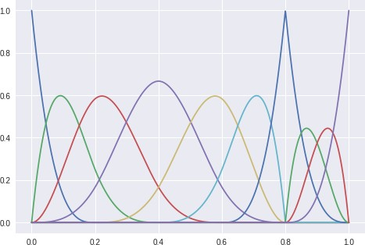

V ⽅向

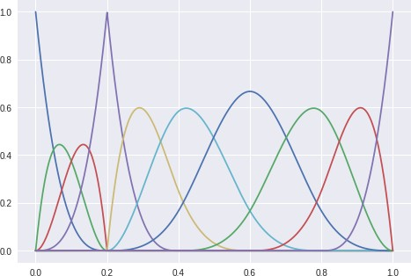

张量积基函数的绘制

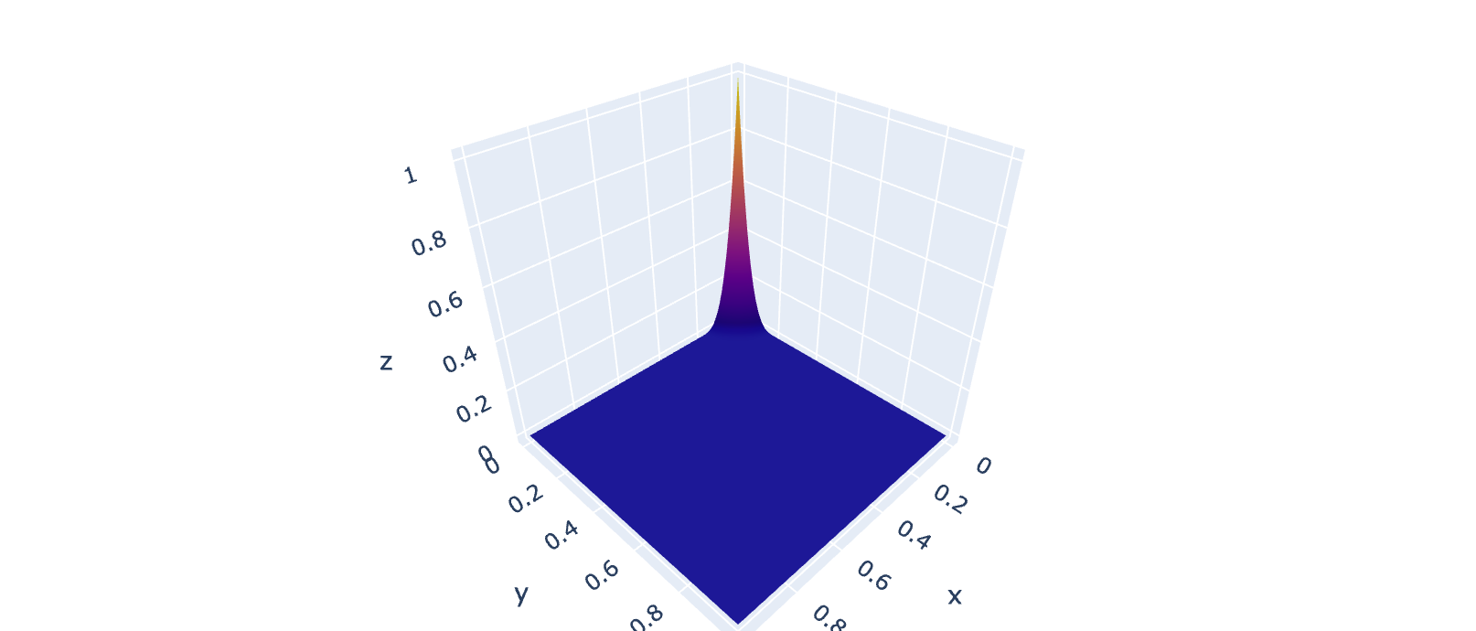

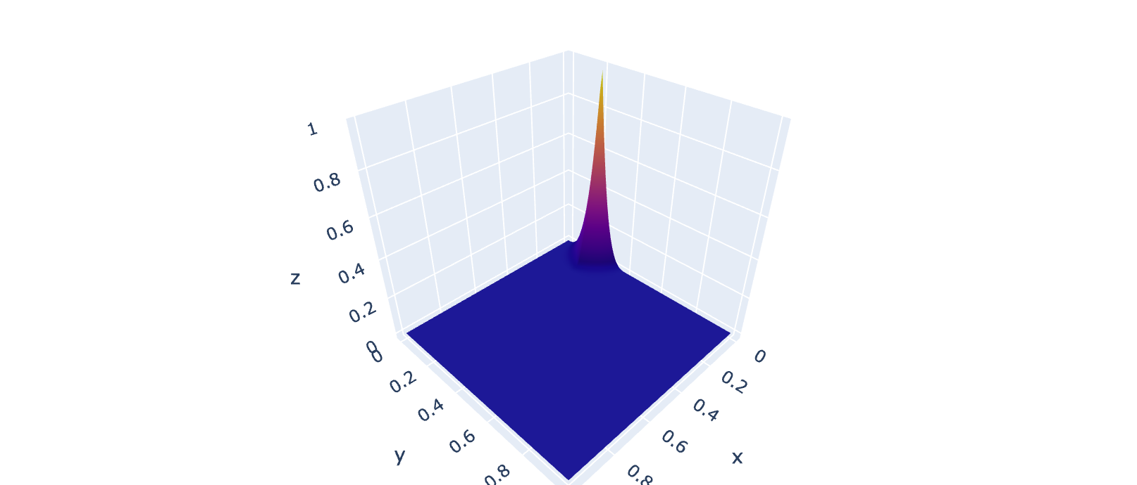

In [7]:

plot2DExample(U,V,i=3,j=6)

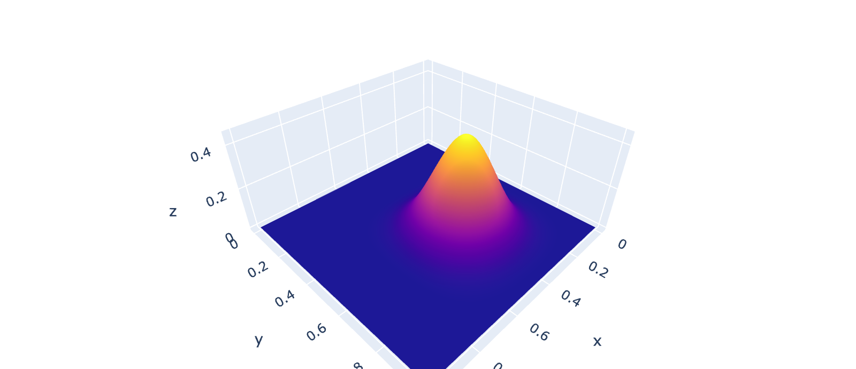

双三次**B**样条曲⾯的绘制

随机⽣成的P

# import numpy as np import math

**def** generate_random_P(): P = []

**for** i **in** range(-5,5): tmp = []

**for** j **in** range(-5,5):

tmp.append([i,j,10-math.floor((i*i+j*j)/20)+np.random.rand()]) P.append(tmp)

P=np.asarray(P)

# return P

In [11]:

P = generate_random_P() print(P)

|  |  |  |
| --- | --- | --- |
| [[[-5. | -5. | 8.40345892] |
| [-5. | -4. | 8.44557891] |
| [-5. | -3. | 9.82681644] |
| [-5. | -2. | 9.86655201] |
| [-5. | -1. | 9.79615623] |
| [-5. | 0. | 9.48181466] |
| [-5. | 1. | 9.23705771] |
| [-5. | 2. | 9.87263815] |
| [-5. | 3. | 9.92803818] |
| [-5. | 4. | 8.92057119]] |
| [[-4. | -5. | 8.26126541] |
| [-4. | -4. | 9.20648574] |
| [-4. | -3. | 9.7903323 ] |
| [-4. | -2. | 9.84592371] |
| [-4. | -1. | 10.90397502] |
| [-4. | 0. | 10.28341045] |
| [-4. | 1. | 10.56462995] |
| [-4. | 2. | 9.24712414] |
| [-4. | 3. | 9.59711187] |
| [-4. | 4. | 9.87036127]] |
| [[-3. | -5. | 9.41784256] |
| [-3. | -4. | 9.60266406] |
| [-3. | -3. | 10.99971199] |
| [-3. | -2. | 10.92796076] |
| [-3. | -1. | 10.51937373] |
| [-3. | 0. | 10.86642652] |
| [-3. | 1. | 10.92584685] |
| [-3. | 2. | 10.00912443] |
| [-3. | 3. | 10.27162369] |
| [-3. | 4. | 9.71330262]] |
| [[-2. | -5. | 9.90670443] |
| [-2. | -4. | 9.1649982 ] |
| [-2. | -3. | 10.62553695] |
| [-2. | -2. | 10.22045737] |
| [-2. | -1. | 10.92299548] |
| [-2. | 0. | 10.33666927] |
| [-2. | 1. | 10.42686432] |

|  |  |  |  |  |
| --- | --- | --- | --- | --- |
| [-2. | | 2. | 10.50820218] | |
| [-2. | | 3. | 10.67503104] | |
| [-2. | | 4. | 9.93733606]] | |
| [[-1. | | -5. | 9.3955832 ] | |
| [-1. | | -4. | 10.53858005] | |
| [-1. | | -3. | 10.04504879] | |
| [-1. | | -2. | 10.12469699] | |
| [-1. | | -1. | 10.35946259] | |
| [-1. | | 0. | 10.69516686] | |
| [-1. | | 1. | 10.66029895] | |
| [-1. | | 2. | 10.82210764] | |
| [-1. | | 3. | 10.15670177] | |
| [-1. | | 4. | 10.0934782 ]] | |
| [[ 0. | | -5. | 9.22254981] | |
| [ 0. | | -4. | 10.42248877] | |
| [ 0. | | -3. | 10.80476173] | |
| [ 0. | | -2. | 10.28647752] | |
| [ 0. | | -1. | 10.81628797] | |
| [ 0. | | 0. | 10.8917794 ] | |
| [ 0. | | 1. | 10.07694181] | |
| [ 0. | | 2. | 10.64895834] | |
| [ 0. | | 3. | 10.61080486] | |
| [ 0. | | 4. | 10.80665907]] | |
| [[ | 1. | -5. | 9.636292 | ] |
| [ | 1. | -4. | 10.61756828] | |
| [ | 1. | -3. | 10.53711928] | |
| [ | 1. | -2. | 10.12948602] | |
| [ | 1. | -1. | 10.83841346] | |
| [ | 1. | 0. | 10.53625719] | |
| [ | 1. | 1. | 10.77639787] | |
| [ | 1. | 2. | 10.95344232] | |
| [ | 1. | 3. | 10.76407113] | |
| [ | 1. | 4. | 10.61515092]] | |
| [[ | 2. | -5. | 9.71650097] | |
| [ | 2. | -4. | 9.71645262] | |
| [ | 2. | -3. | 10.85845072] | |
| [ | 2. | -2. | 10.00805556] | |

|  |  |  |  |
| --- | --- | --- | --- |
| [ | 2. | -1. | 10.21107822] |
| [ | 2. | 0. | 10.20454736] |
| [ | 2. | 1. | 10.78479848] |
| [ | 2. | 2. | 10.82884946] |
| [ | 2. | 3. | 10.35044135] |
| [ | 2. | 4. | 9.23355347]] |
| [[ | 3. | -5. | 9.03241077] |
| [ | 3. | -4. | 9.07150842] |
| [ | 3. | -3. | 10.01823035] |
| [ | 3. | -2. | 10.29600977] |
| [ | 3. | -1. | 10.60321965] |
| [ | 3. | 0. | 10.49554577] |
| [ | 3. | 1. | 10.5792061 ] |
| [ | 3. | 2. | 10.70732042] |
| [ | 3. | 3. | 10.79169745] |
| [ | 3. | 4. | 9.45627108]] |
| [[ | 4. | -5. | 8.6912883 ] |
| [ | 4. | -4. | 9.3817444 ] |
| [ | 4. | -3. | 9.56360327] |
| [ | 4. | -2. | 9.67113859] |
| [ | 4. | -1. | 10.9144551 ] |
| [ | 4. | 0. | 10.68233237] |
| [ | 4. | 1. | 10.3683772 ] |
| [ | 4. | 2. | 9.76501851] |
| [ | 4. | 3. | 9.69002243] |

[ 4. 4. 9.76769399]]]

开始绘制

In [9]:

plotSurface(U,V,P)

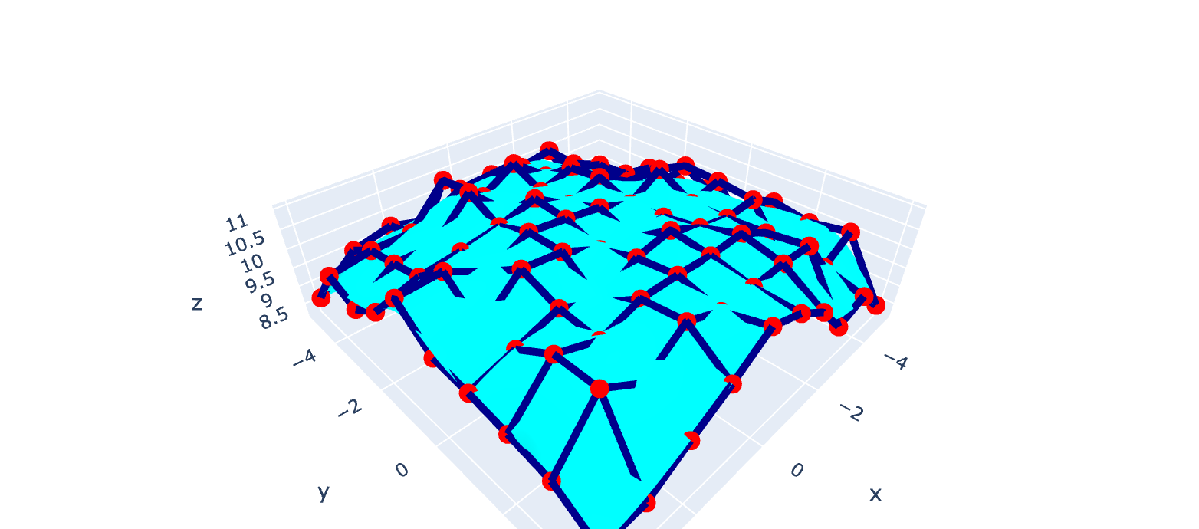In [ ]: