Website start-up instructions

1. Downloads Node.js

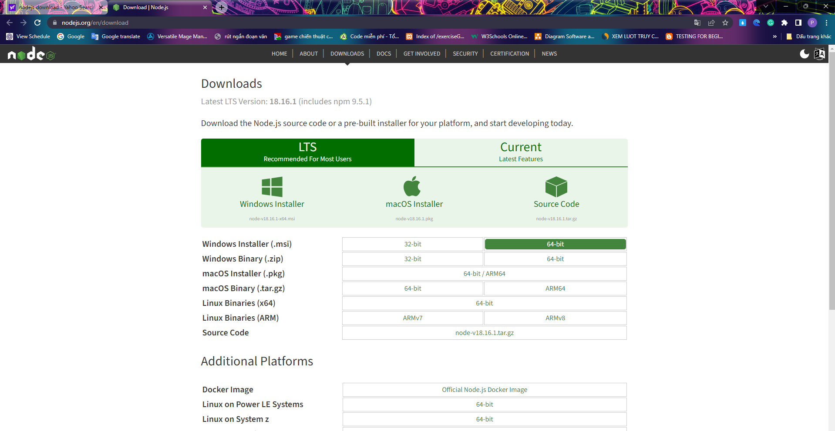

Check Node.js whether it is intalled

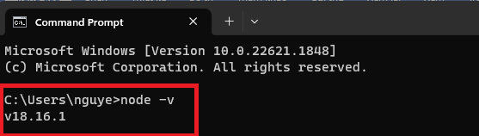

Here is the NodeJS v18.16.1 version after the installation is done . You can install another nodeJS version.

1. Launch website

-Coppy your project folder path

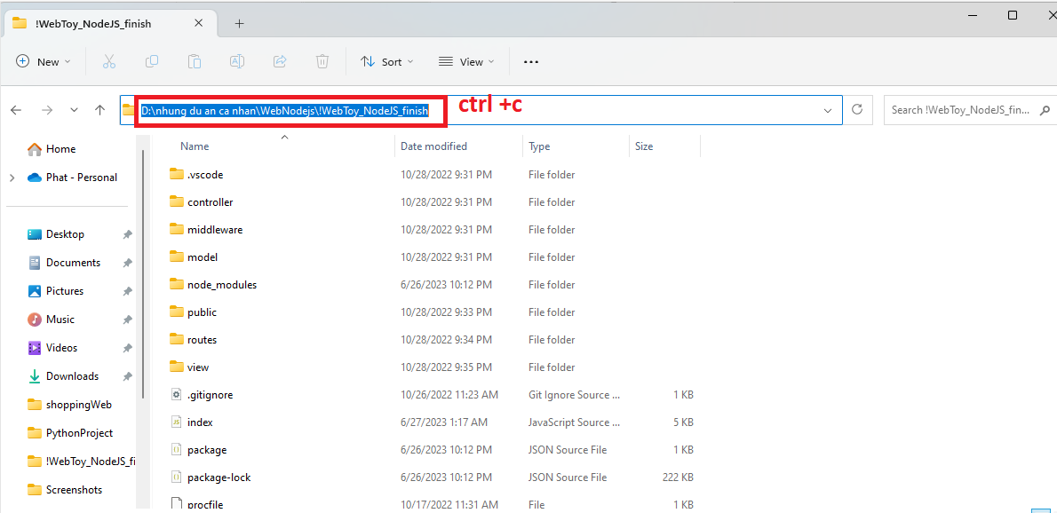

-Open cmd

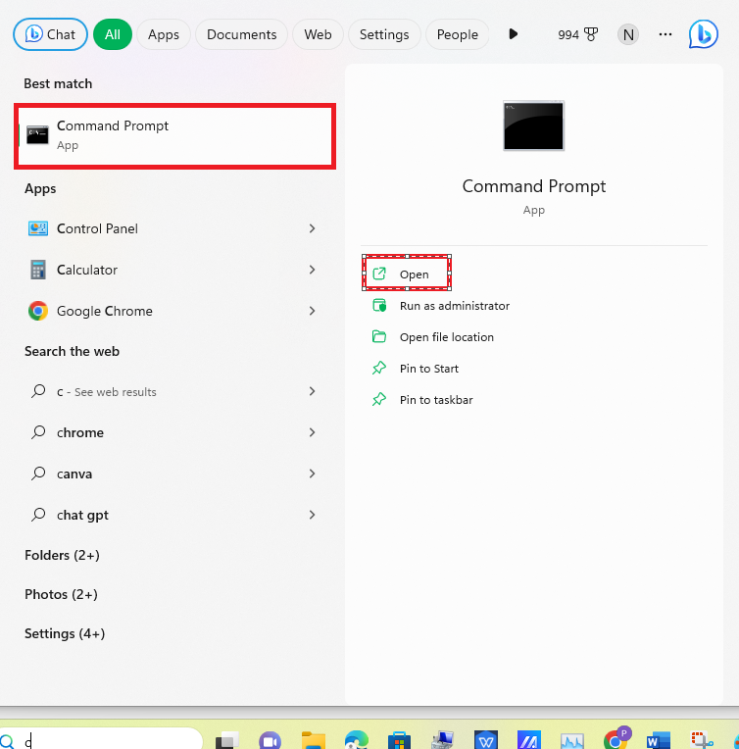

-Move to project folder

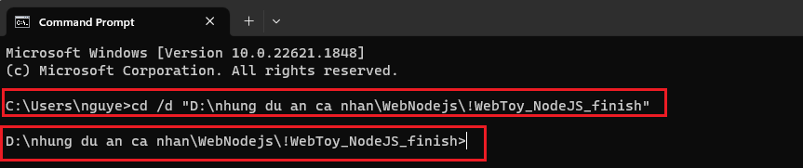

-Enter “node index.js” to run index.js file

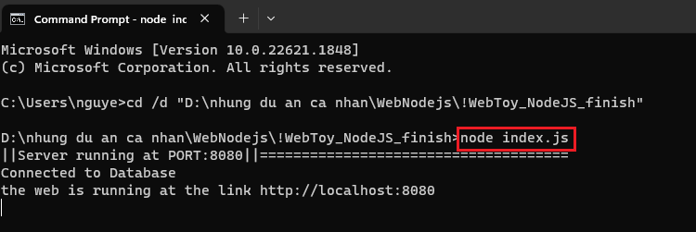

-Enter “<http://localhost:8080>” link on web browser

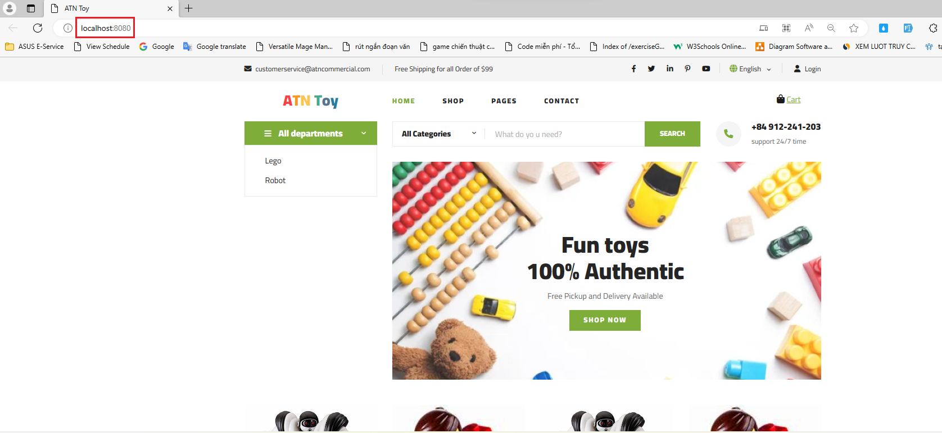

If this page appears ,it means successful