Website Start-up Guide

**The Account to login admin page**  
username: adminadmin  
password: adminadmin

1. Download xampp (software used to launch web php)

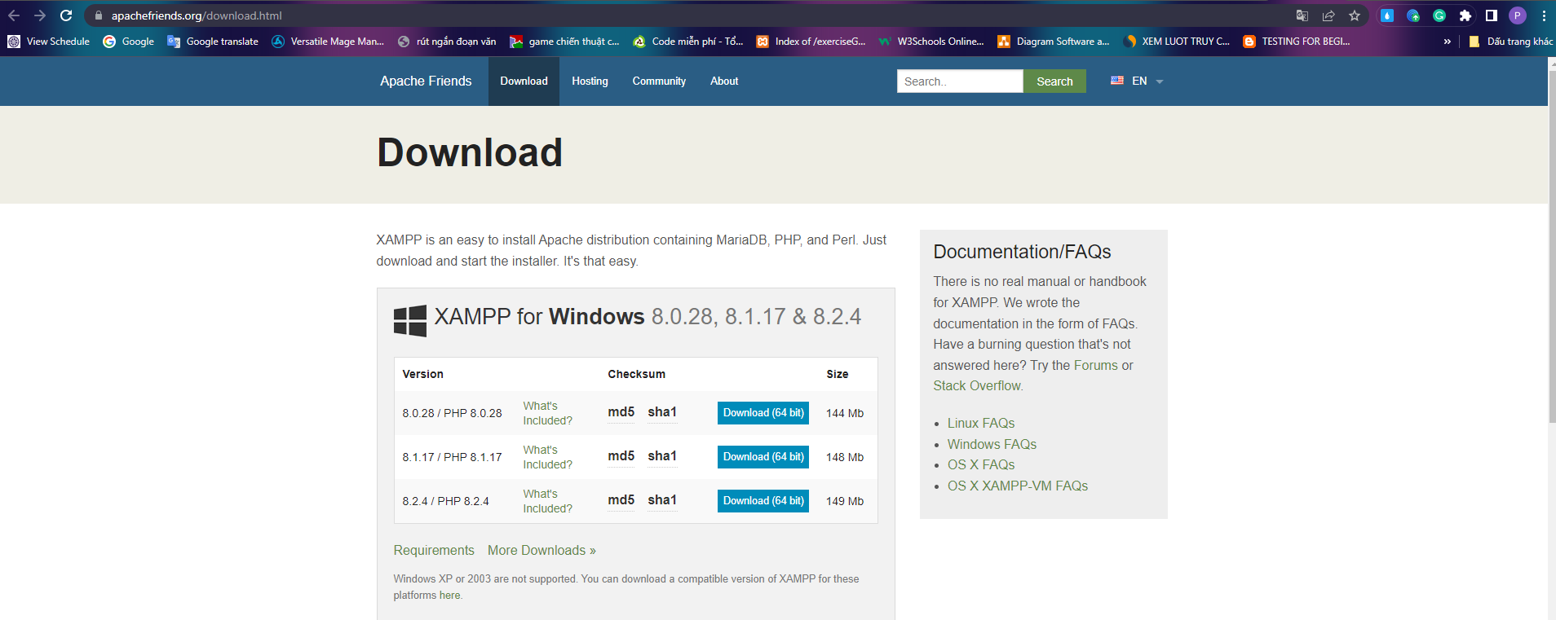

Below is xampp software after download

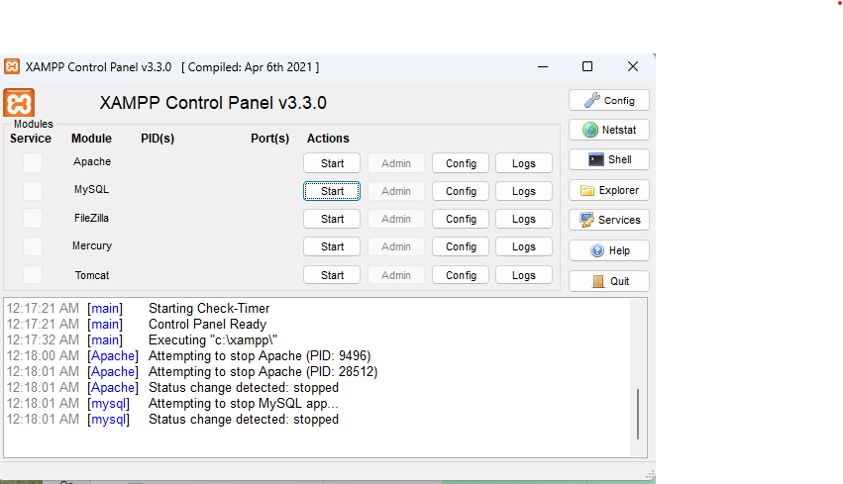

1. Coppy the entire Project folder into the htdocs folder

-Coppy the entire folder in this Project

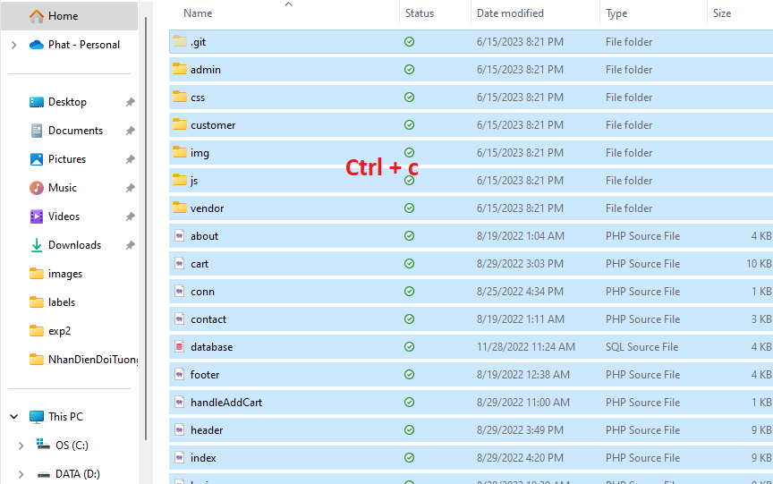

-Open htdocs folder

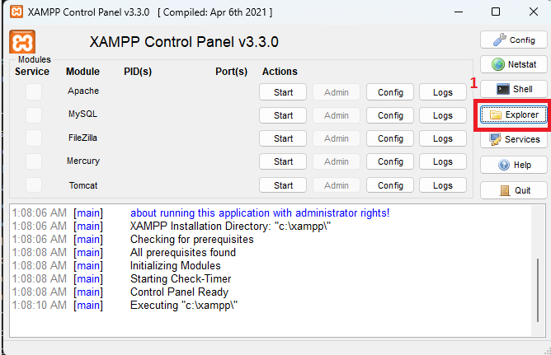

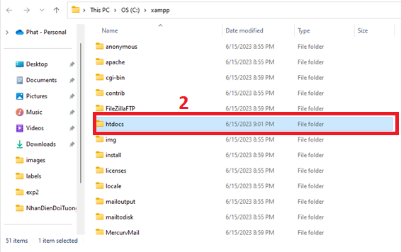

-Paste all the copied folders into the htdocs folder

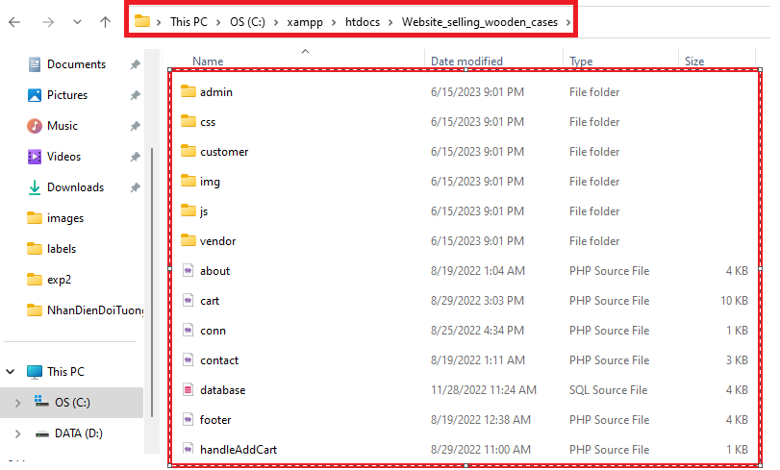

1. Create database

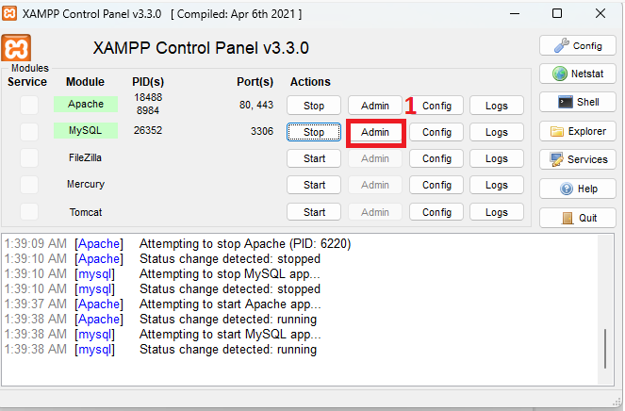

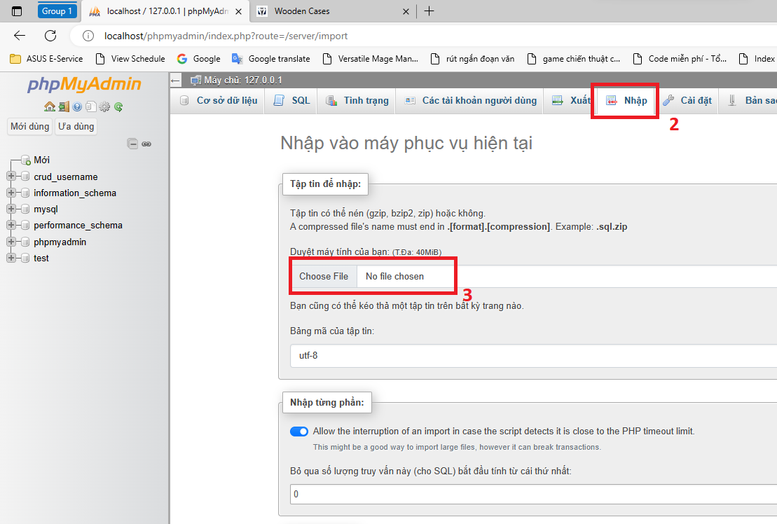

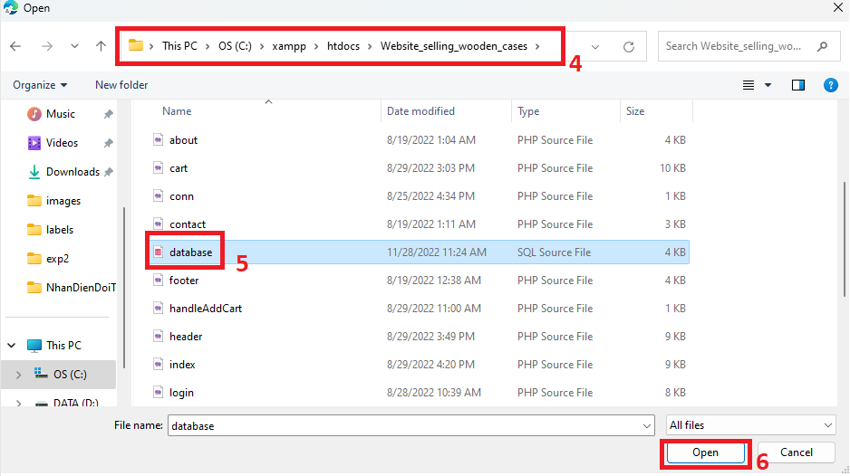

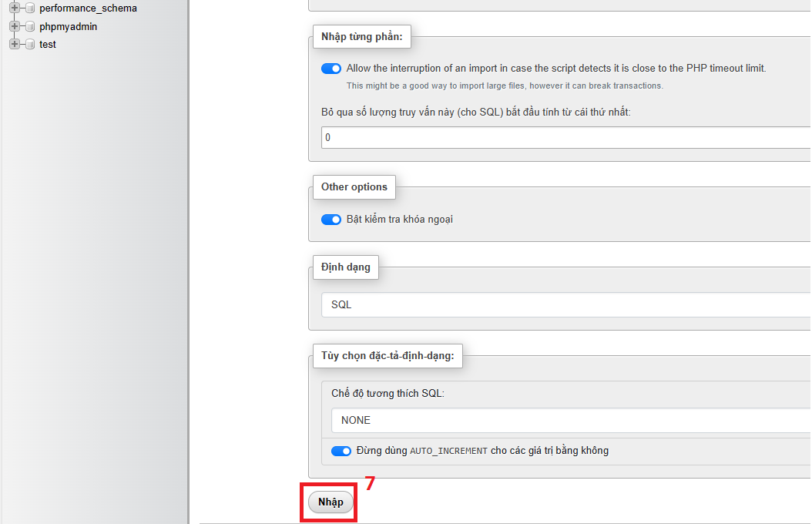

When the message as shown below appears and there is no error, it means that the database was created successfully

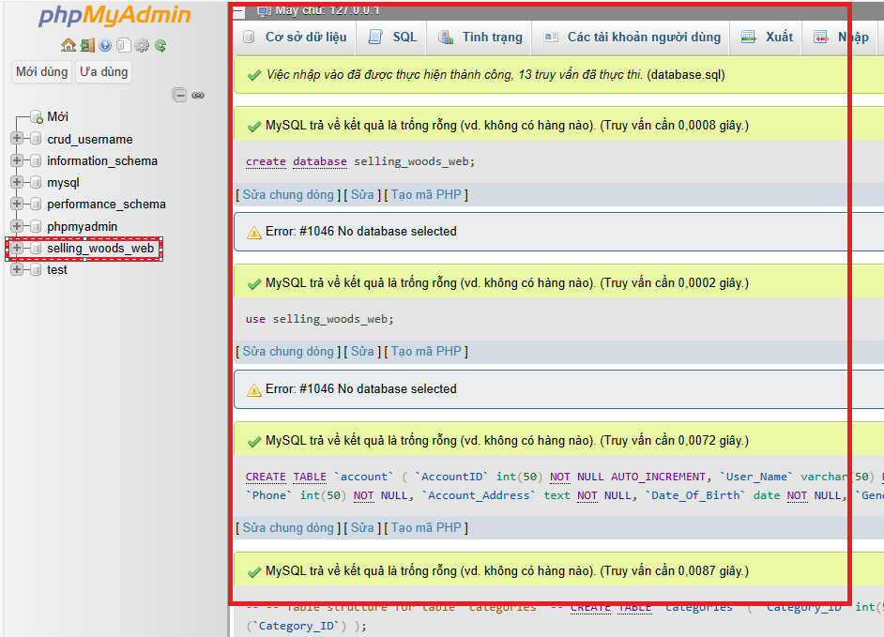

1. Get user account information to create user account in phpmyadmin

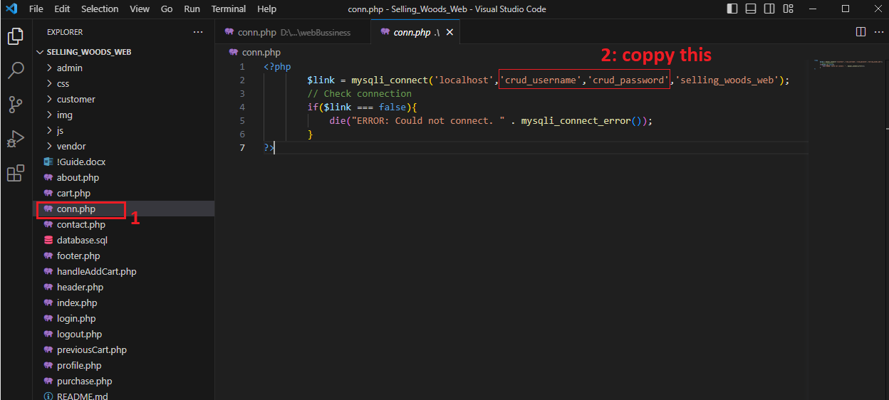

1. create a user account and give permissions (this helps to connect to the database through the user account)

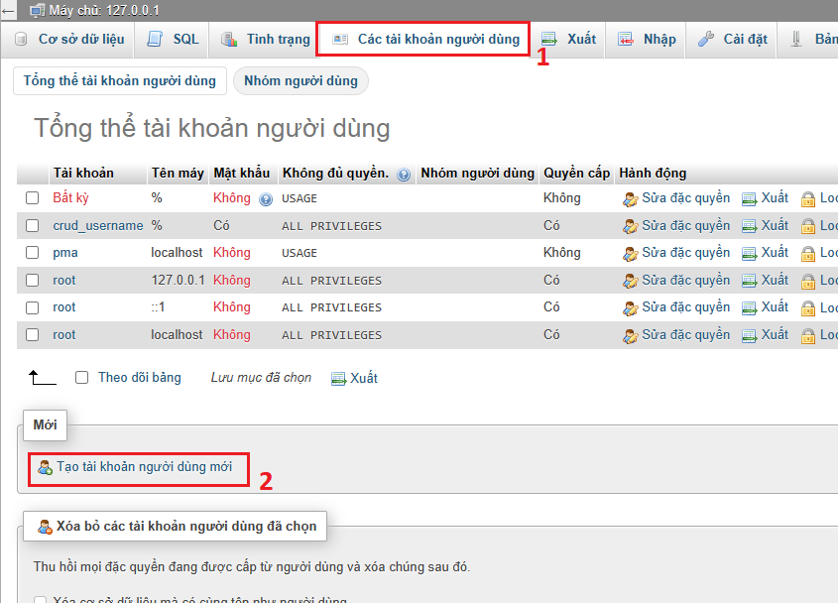

Get account information username and password in file conn.php

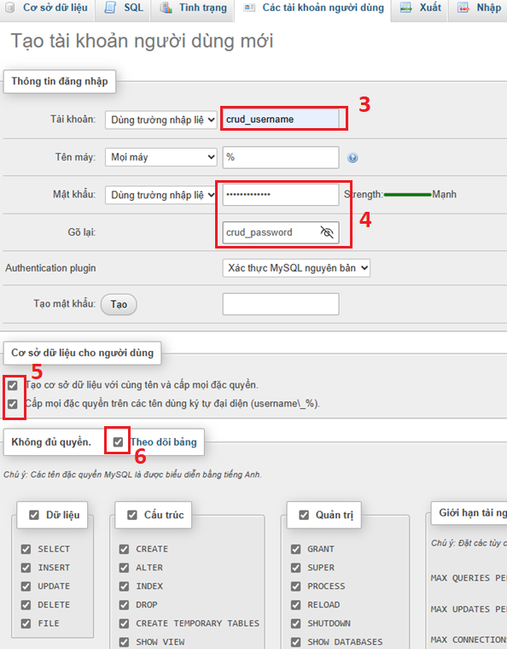

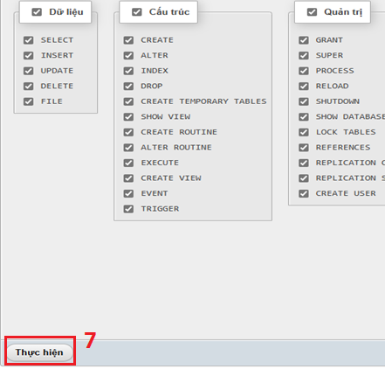

Check if the account just created, if the account appears it means success

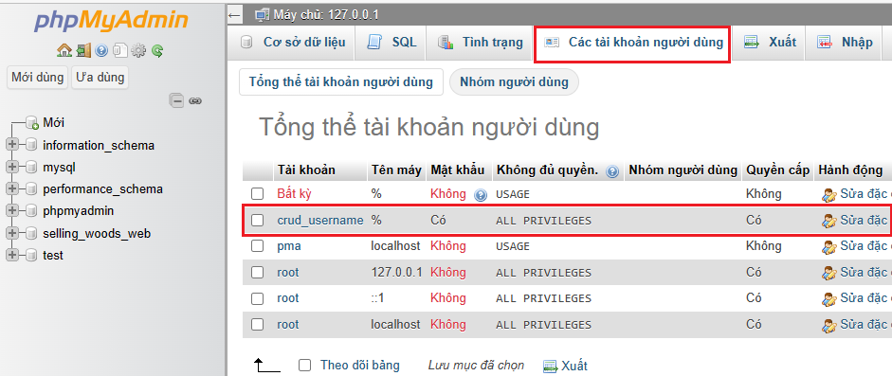

1. Launch website

-Open browser any

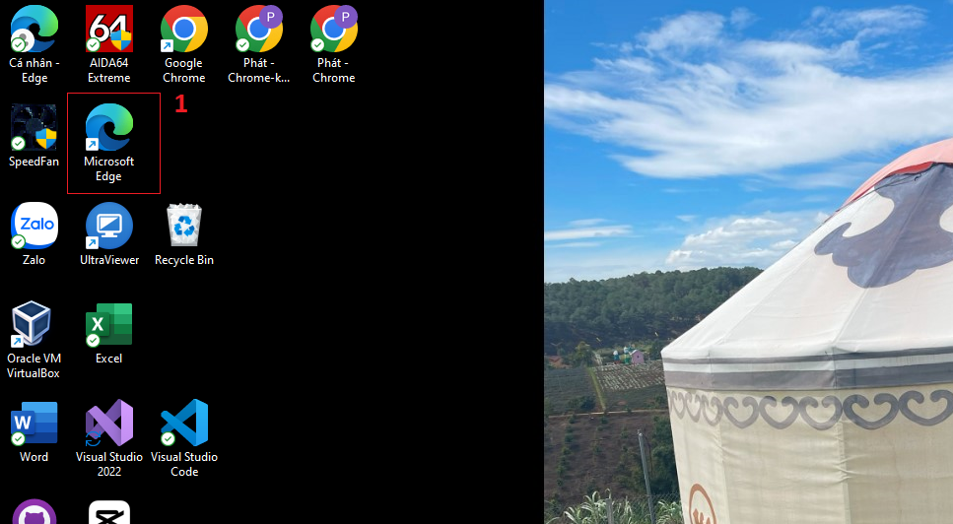

-Enter "http://localhost/Website_selling_wooden_cases/"

Explain "Website_selling_wooden_cases" means the folder name stored in the htdocs folder

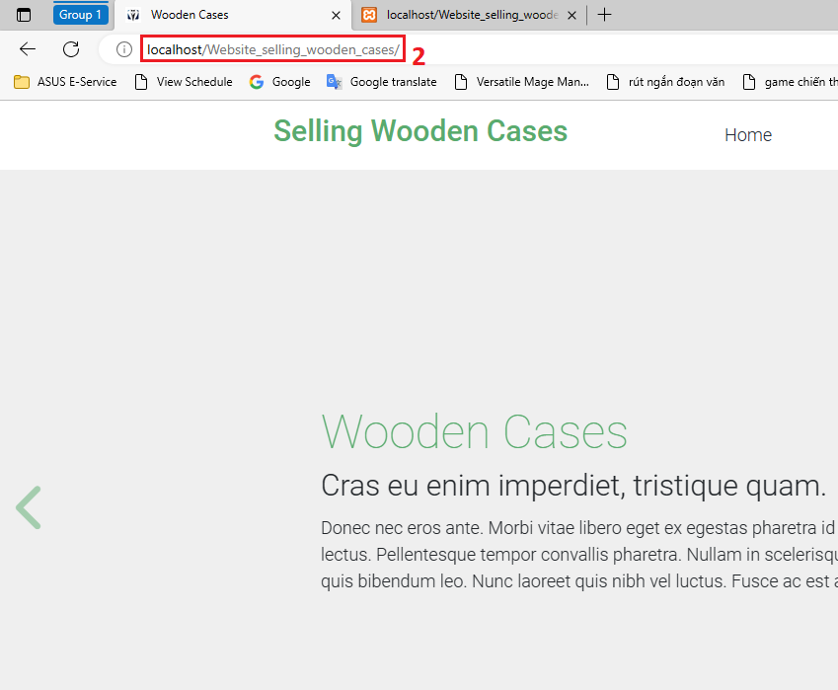

-When this website appears, it means it was successful

