
INTERNAL PROPOSAL — FOR MANAGEMENT
HIGH-AVAILABILITY WEB INFRASTRUCTURE
THE "AX SVR" PROJECT
Deployment completion report and single-phase completion proposal

DATE | 2026-07-10
STATUS | Deployed to production
VERSION | v1.0.0 (Git)
DELIVERED BY | Infrastructure team

No single point of failure at any tier · Automatic failover · RPO = 0 · PITR recovery

1. Executive summary
The AX Svr project builds a complete High Availability (HA) web infrastructure for the client on a virtualization platform, inside an air-gapped network (isolated, no Internet access). The system is designed around the principle of no single point of failure (SPOF) at any tier:
- Edge tier: 2 Nginx proxies + Keepalived/VIP — lose one proxy and traffic fails over in < 3 seconds.
- Web tier: 2 IIS servers (Windows Server 2025) running in parallel behind the load balancer — lose one web node and Nginx drops it from the pool.
- Data tier: a 3-node PostgreSQL 17 cluster (Patroni + etcd) automatically elects a new leader in < 30 seconds when the primary fails, with one synchronous replica guaranteeing no committed data is lost (RPO = 0).
- Data safety: pgBackRest backup with continuous WAL, supporting point-in-time recovery (PITR).
Deliverables include: 10 deployed VMs, ~2,400 lines of operations documentation (10 phase documents), a DB administration toolkit (14 scripts), role-based firewall automation scripts, and an automated installation ISO builder. Everything is version-controlled in Git (tag v1.0.0).
Within the same project scope (delivered as one phase, not split into a phase 2): integrate monitoring into the company's existing Zabbix/Grafana platform (no dedicated monitoring node), add off-site backup to complete the 3-2-1 standard, and establish a recurring failover/recovery drill schedule.

2. Context & objectives

Context
The client needs infrastructure to run a web application (React SPA + a PostgreSQL backend) serving internal users over a private network, with these requirements:
- Uninterrupted service when any single server fails.
- No data loss when a database node fails.
- Air-gapped environment: no Internet — every solution must work offline.
- Only administrators may access servers remotely.

Committed objectives
Objective | Metric | Result
Proxy-tier HA | VIP failover | < 3 seconds
Web-tier HA | Drop a failed node from the pool | Automatic (health check)
DB-tier HA | Elect a new leader | < 30 seconds, automatic
Data-loss protection | RPO on leader loss | = 0 (sync replica)
Data recovery | PITR | To any point in time
Security | Remote access | Admin IP only (ufw + Windows FW)

3. Solution architecture

3.1 System overview
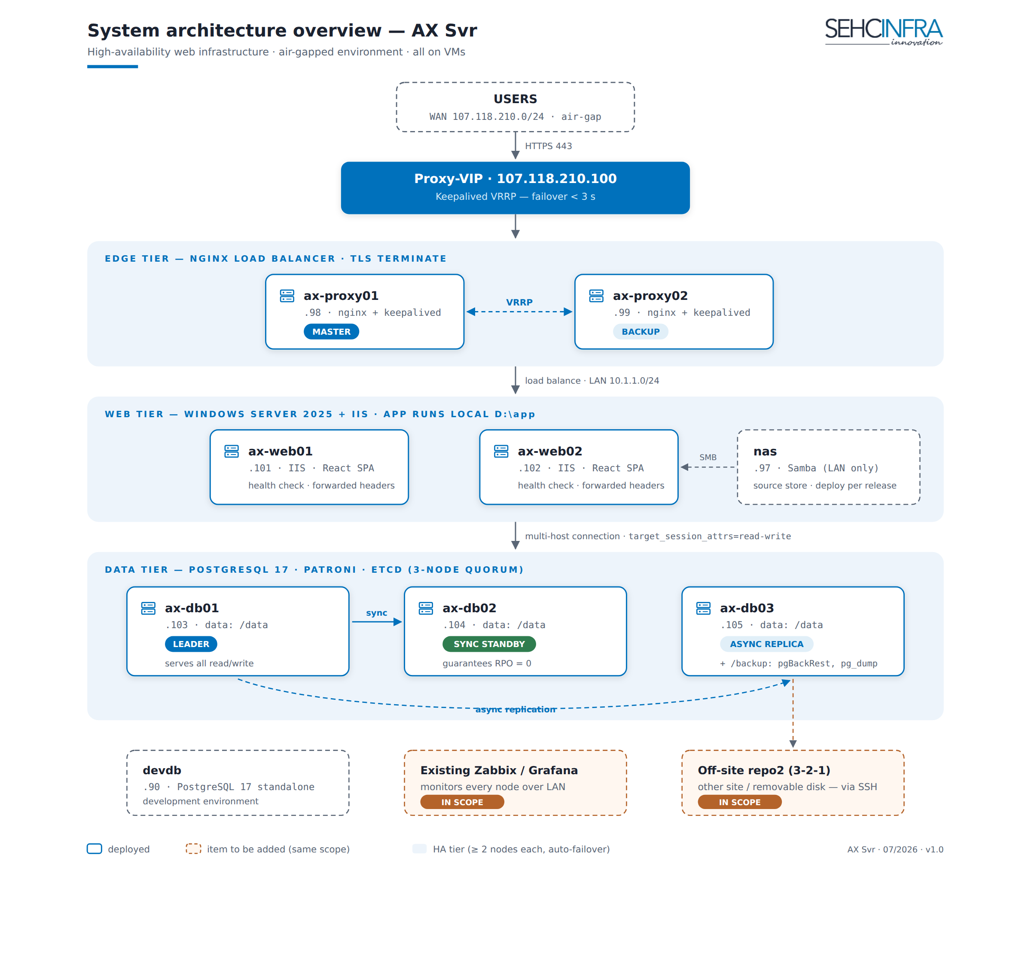
Figure: AX Svr system architecture overview

3.2 Key architecture decisions & rationale
- 2 proxies + Keepalived/VIP (active-passive) — edge HA with a single IP for users; automatic failover via VRRP, no dedicated load-balancer appliance needed.
- Patroni + etcd 3-node DB cluster — industry-standard PostgreSQL auto-failover; odd quorum avoids split-brain; 1 sync standby (RPO=0) + 1 async replica.
- The application connects to the DB via a multi-host connection string (target_session_attrs=read-write) instead of HAProxy/DB-VIP — one fewer middle layer, one fewer point of failure, with equivalent data safety (Patroni handles failover).
- Web runs locally (D:\app), NAS is only a source store — if the NAS fails the web keeps running; this avoids making the NAS a SPOF. Deployment is per versioned release, with rollback.
- Backup centralized on ax-db03's dedicated /backup disk — weekly full + daily differential + continuous WAL streaming; plus a pg_dump logical backup. (Limitation & mitigation: see section 6.)
- TLS terminates at Nginx — certificates managed centrally in one place; IIS runs HTTP internally on the LAN.
- Air-gap compliance — every installation guide has an offline path (APT mirror, internal CA, internal NTP).

3.3 Security — layered model
- Two segregated networks: WAN (user access) / LAN (replication, backup, internal administration). PostgreSQL, etcd, Patroni, and Samba are LAN-bound only.
- Role-based firewall: apply-firewall.sh (Linux/ufw) + apply-firewall-windows.ps1 (Windows/RDP) — SSH/RDP open to admin IPs only.
- Three-layer DB control: ufw (IP filtering) → pg_hba (authentication, per-user IP pinning) → GRANT (per-table privileges). The root postgres account is locked local-only; administration uses a dedicated dbadmin role.
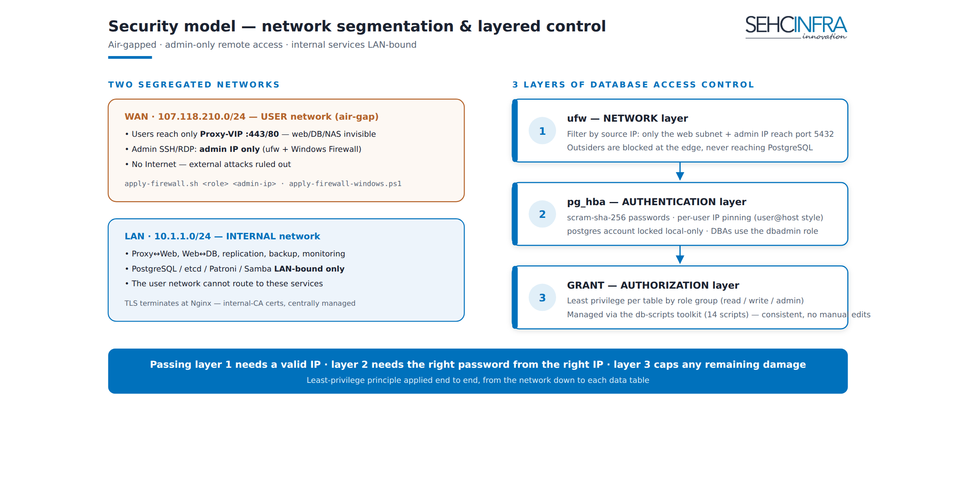
Figure: Layered security model

3.4 Backup & recovery strategy
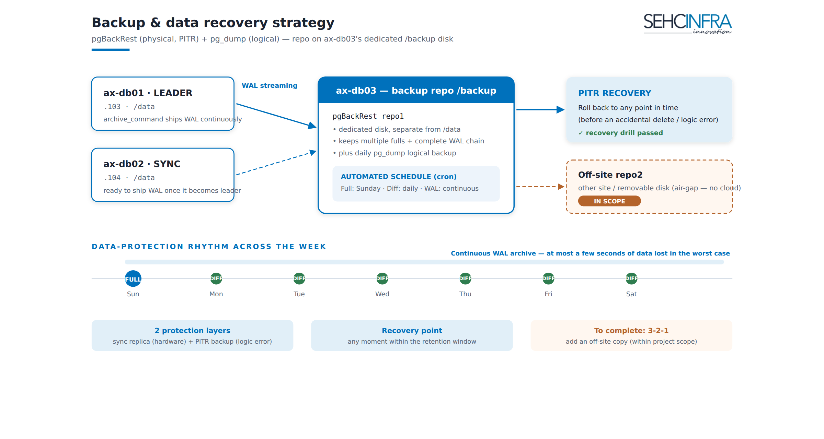
Figure: Backup and recovery strategy

4. Work completed

4.1 Infrastructure deployed (production)
# | Item | Details
1 | 10 VMs fully installed | 2 proxy, 2 web (Win2025), 3 DB, NAS, DevDB + standardized OS / dual-NIC network / hardening
2 | PostgreSQL HA cluster | PostgreSQL 17 + Patroni + etcd 3 nodes, 1 sync + 1 async, data on a dedicated /data disk
3 | IIS web tier | 2 Win2025 nodes, SPA routing, health check, forwarded headers
4 | Proxy HA tier | Nginx LB + Keepalived VIP, upstream health check
5 | NAS source store | Samba LAN-bound, per-release NAS→local deployment workflow
6 | Backup | pgBackRest (full/diff/WAL) + pg_dump, cron on ax-db03, dedicated /backup disk
7 | System-wide firewall | Role-based ufw + Windows Firewall, admin-only remote access
8 | DevDB | Standalone PostgreSQL 17 for the dev team

Monitoring note: the Phase 6 document (Prometheus/Grafana) is complete, but no dedicated monitoring node was built — the decision is to leverage the company's existing Zabbix/Grafana platform (see section 7).

4.2 Deliverables
Deliverable | Scope
Deployment & operations documentation (Phase 0→6, DevDB, off-site, autoinstall) | 10 documents, ~2,400 lines, per-node config separated (copy-paste ready)
PostgreSQL administration toolkit db-scripts/ | 14 scripts: create admin/user/db, group privileges, per-user IP pinning, supports both DevDB & the Patroni cluster
Firewall automation scripts | 2 scripts (Linux + Windows)
Ubuntu 24.04 autoinstall tool | gen-autoinstall.sh generates a seed ISO per host
Go-Live acceptance checklist | Complete per tier, including real node-failure tests
Version control | Private Git repo, tag v1.0.0

4.3 HA test results (per acceptance checklist)
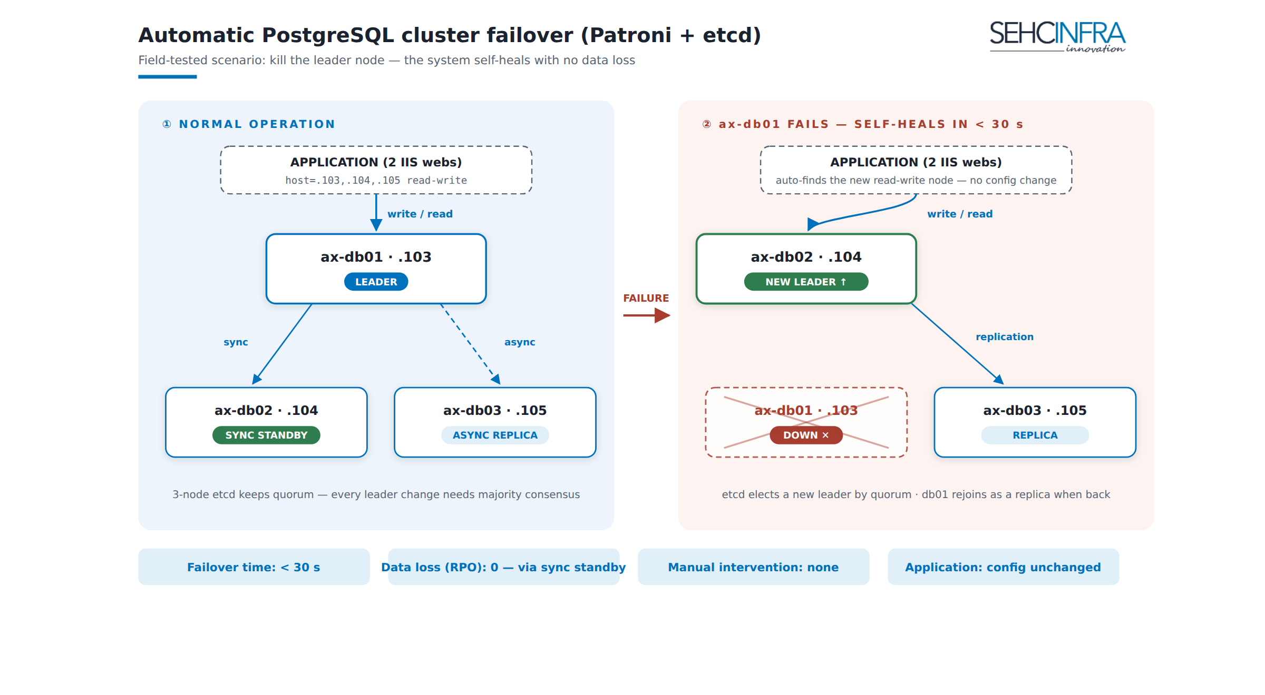
Figure: PostgreSQL cluster failover scenario
- Kill the DB leader → the cluster elects a new leader in < 30 seconds, the application keeps writing normally; the old node rejoins as a replica when restarted.
- Kill the primary proxy → the VIP moves to the standby proxy in < 3 seconds, users are not interrupted.
- Kill one web node → Nginx drops it from the pool, service continues on the remaining node.
- Backup: WAL archiving runs continuously; the PITR recovery drill passed successfully.

5. Value delivered
- No SPOF at any tier — any single server can fail and service keeps running; unplanned downtime is minimized.
- Two layers of data safety — sync replica (RPO=0 on leader loss) + PITR backup (recover from logic mistakes and accidental deletes).
- Simplified operations — failover is fully automatic across all three tiers, with no manual intervention during an incident.
- Knowledge documented — any engineer can operate or rebuild the system from the runbook; no dependence on a single individual.
- Reusable — the documentation + scripts form a standard baseline for deploying to future clients with similar needs.

6. Remaining risks & current limitations
# | Risk / limitation | Severity | Mitigation
1 | Backup currently sits on ax-db03 — the same cluster as the primary data. A disaster that loses the whole cluster (fire, virtualization storage failure) would lose the backup too | High | Add off-site backup (another site / removable disk — cloud is unavailable in an air-gap) → complete the 3-2-1 standard. Documentation already written (axsvr-backup-offsite.md)
2 | No centralized monitoring/alerting yet — a single-node failure (the system keeps running thanks to HA) may go unnoticed until the second node fails | High | Integrate the existing Zabbix/Grafana (section 7.1)
3 | HA only holds when same-role VMs sit on different physical hosts (anti-affinity) | Medium | Confirm anti-affinity configuration at the virtualization layer
4 | TLS certificates use an internal CA — a renewal/CA-distribution process is needed for clients | Medium | Fold into the recurring operations process
5 | Patroni/pgBackRest operational skills must be maintained | Medium | Recurring failover + PITR drills (quarterly) per the existing checklist

7. Completion items — delivered as one phase
The items below belong to the same project scope and are executed in a single pass (not split into a phase 2) to reach full safety and operational maturity:

7.1 Integrate monitoring into the existing Zabbix/Grafana *(high priority)*
No dedicated monitoring node; leverage the monitoring infrastructure the company already runs:
- Install the Zabbix agent on the Linux/Windows nodes; monitor per-tier ports/services (nginx, keepalived, IIS, postgres, patroni, etcd).
- Monitor cluster state via the Patroni REST API (:8008/metrics) and etcd health.
- Minimum alerts: node down, cluster loses leader / loses sync standby, backup failed/overdue, /data and /backup disk usage, certificate nearing expiry.
- Grafana dashboards for the DB cluster + proxy traffic.

7.2 Off-site backup — complete 3-2-1 *(high priority)*
Deploy a pgBackRest repo2 to another site over SSH (or a removable-disk procedure) per the existing axsvr-backup-offsite.md document.

7.3 Recurring operations process
- DB + proxy failover drills, PITR recovery drills: quarterly.
- Check pgbackrest info, disk usage, certificate expiry: weekly (automated once 7.1 is in place).
- OS security updates via the offline APT mirror: on the company's defined cycle.

7.4 Resources to complete (one phase)
Item | Estimate
Zabbix/Grafana integration (7.1) | 3–5 person-days
Off-site backup (7.2) | 2–3 person-days + secondary-site / removable-disk hardware
Set up the schedule & run the first drills (7.3) | 1–2 person-days
Total | ~6–10 person-days, done in one pass

8. Conclusion
The AX Svr infrastructure is fully deployed, meets the committed HA and data-safety objectives, and ships with complete operations documentation and administration tooling. The system currently serves reliably; the two items needed to reach full safety are Zabbix/Grafana monitoring integration and 3-2-1 off-site backup.
We ask management to:
- Accept the completed work (section 4).
- Approve completion of the remaining items (section 7) — executed within a single phase, ~6–10 person-days total.

Appendix A — System IP table
Component | WAN 107.118.210.x | LAN 10.1.1.x | OS / software
Proxy-VIP | .100 | — | (Keepalived VRRP)
ax-proxy01 | .98 | .98 | Ubuntu / nginx, keepalived
ax-proxy02 | .99 | .99 | Ubuntu / nginx, keepalived
ax-web01 | .101 | .101 | Win2025 / IIS
ax-web02 | .102 | .102 | Win2025 / IIS
nas | .97 | .97 | Ubuntu / samba (web source only)
ax-db01 | .103 | .103 | Ubuntu / PostgreSQL 17, Patroni, etcd, pgBackRest
ax-db02 | .104 | .104 | same as above
ax-db03 | .105 | .105 | same as above + /backup disk (backup repo)
devdb | .90 | — | Ubuntu / PostgreSQL 17 standalone

Appendix B — Deliverable document list
Phase | Document | Content
0 | axsvr-phase0-setup.md | OS, dual-NIC network, hardening, role-based software
1 | axsvr-phase1-db.md | PostgreSQL HA cluster (etcd + Patroni)
2 | axsvr-phase2-nas.md | NAS source store (Samba, per-release deploy)
3 | axsvr-phase3-web-iis.md | Win2025 + IIS web
4 | axsvr-phase4-proxy.md | Proxy HA (Nginx + Keepalived/VIP)
5 | axsvr-phase5-backup.md | pgBackRest + pg_dump backup, PITR
5b | axsvr-backup-offsite.md | Off-site backup (3-2-1) — in scope, not yet deployed
6 | axsvr-phase6-monitoring.md | Monitoring (reference; replaced by Zabbix/Grafana integration)
Dev | axsvr-devdb-setup.md | DevDB standalone
Tool | axsvr-autoinstall.md + autoinstall/ | Ubuntu 24.04 autoinstall (seed ISO)
Tool | firewall/ | Role-based firewall (Linux + Windows)
Tool | db-scripts/ | 14 PostgreSQL administration scripts

