***Security, good health and prosperity***

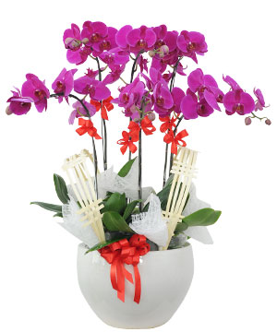

*Luxury purple phalaenopsis orchid pots, with beautiful designs, are planted in high-grade porcelain pots as wishes to the recipient. Wishing you happiness and health. A happy and peaceful life. Suitable for gifting occasions. birthday, grand opening, partner meeting.*