***Bandanas***

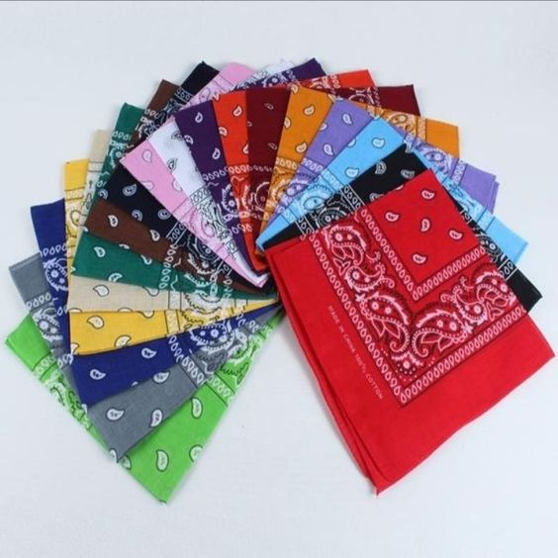

*Bandana is a large square scarf, used to create accents for costumes. This item was very popular in the 70s, associated with the dusty image of the cowboys of the American West. With only one bandana, Kpop idols can create many unique variations for their outfits. Bandana Streetwear or backpacking is extremely versatile with the ability to customize useful accessories*